**FINANCIAL PREDICTION SOFTWARE USING DATA ANALYSIS**



**Software Requirements**

**Specification**

**For**

**FINANCIAL PREDICTION SOFTWARE USING DATA ANALYSIS**

**Prepared by:-**

**Tushar Pandit**

**Bhaumik Vanzara**

**Chirag Shah**

**Sagarika Singh**

**MPSTME, NMIMS**

**17th October, 2015**

**Certificate**

The Report entitled **“Financial Prediction Software Using Data Analysis”** being submitted by

“**Tushar Pandit”(Roll No.:B363)**

**“Bhaumik Vanzara” (Roll No.:B358)**

**“Chirag Shah” (Roll No.:B344)**

**“Sagarika Singh” (Roll No.:B350)**

has been examined by us and is hereby approved for the award of degree

**“Bachelor of Technology in Computer Engineering”**, for which it has been submitted. It is understood that by this approval the undersigned do not necessarily endorse or approve any statement made, opinion expressed or conclusion drawn therein, but approve the report only for the purpose for which it has been submitted.

**(Internal Examiner) (External Examiner)**

**Date: Date:**

**DEPARTMENT OF COMPUTER ENGINEERING**

**Mukesh Patel School of Technology Management & Engineering**

**Table of Contents**

1. **Introduction...……………………………………………………………………………... 1** 
   1. Purpose
   2. Document Conventions
   3. Intended Audience and Reading Suggestions
   4. Product Scope
   5. References
2. **Overall Description ……………………………………………………………………….. 5** 
   1. Product Perspective
   2. Product Functions
   3. User Classes and Characteristics
   4. Operating Environment
   5. Design and Implementation Constraints
   6. User Documentation
   7. Assumptions and Dependencies
3. **External Interface Requirements ……………………………………………………… 9**
   1. User Interfaces
   2. Hardware Interfaces
   3. Software Interfaces
   4. Communications Interfaces
4. **System Features …………………………………………………………………………... 11**
5. **Other Non-functional Requirements ………………………………………………...…… 15**
   1. Performance Requirements
   2. Safety Requirements
   3. Security Requirements
   4. Software Quality Attributes
   5. BusinessRules

# 1. Introduction

### 1.1Purpose

Today the best way to save our money is to invest it somewhere. There is a very famous saying that “Indians are great money savers but poor investors”. The only reason why people don’t invest their money is that they don’t want to risk their asset. These people want someone or something which can help them in deciding whether to invest their money in a particular project or not. Many people who are new in the investment market mostly face loss due to lack of experience in investing .Hence they are unable to judge the probability of success or failure of any project. This application will help the investor to decide whether to invest or not by providing the success or failure probabilities of the project by applying data analysis. The application will take specific parameters as input and provides a complete dashboard of all details as well as the final decision whether to invest in that project or not as output. The result will be provided on the basis of a mathematical model created by using various data analysis algorithms. This mathematical model is first trained on a bulk of training data, then tested and then used for giving decision on user input.

### 1.2Document Conventions

Main Section Titles

* Font: Times New Roman
* Face: Bold
* Size: 18

Sub Section Titles

* Font: Times New Roman
* Face: Bold
* Size: 14

Other Text Explanations

* Font: Arial
* Face: Normal
* Size: 11

### 1.3 Intended Audience and Reading Suggestions

**Clients**: The users of the system will get a clear idea of the software and hardware requirements to be engaged, which includes investors?

**Developers**: Project developers have an advantage of quickly understanding the methodology enabled and personalizing the product.

**Students**: The project shows an infinite path in the field of data analysis

There is always a perspective of development.

The authors would suggest clients to go through the requirement section thoroughly before installing the software. The lab technicians are expected to have certain knowledge in the terms used and hence can go for the security issues directly. Students and Developers can utilize the documentation as a resource in developing the project to a new product.

### 1.4 Product Scope

Future scope of this project lies in the direction requiring work with collaboration, benchmark, and case-study partners to identify specific implementations of effective programs where investment is being addressed from both enterprise and governance perspectives in helping the investor to decide in case of any type of investment project. Initially this software application is for predictions in case of Hotel related project, but further it can be integrated for predictions in various project domains. The project can also be further converted into an android or iOS application so that the user can get his predictions on his smart phones.

## 1.5 References

**PAPERS:**

1. Xu Zhihong, Hu Zhiqiang, **Fixed Assets Investment Analysis,**, Economics and Management School, Wuhan University, Wuhan, China, IEEE 2002.
2. S.I.Ao, **Using Fuzzy Rules for Prediction in Tourist Industry with Uncertainty**, Systems Engineering and Engineering Management, Shatin, Hong Kong, IEEE 2003.
3. T.Vitek, D.Pachner, J. Stecha, **Mathematical Models for Hotel Yield Management,** IEEE 2007.
4. Li Wenyi, **Uncertainty Study of Financial Evaluation of Project Investment**, College of public Administration, China, IEEE 2008.
5. Wang Xu, **Model of Investment Risk Prediction Based on Neural Network and data Mining Technique for Construction Project,** College of Civil Engineering of Northeast Forestry University, China, IEEE 2008.

**WEBSITES:**

<https://msdn.microsoft.com/en-us/library/ms175595.aspx>

<https://www.stackoverflow.com>

<https://www.data.gov.in/catalog/rooms-different-category-hotels-india>

<https://www.r-project.org>

<https://msdn.microsoft.com/en-us/aa336522.aspx>

<https://rdotnet.codeplex.com/>

<http://www.codeproject.com/KB/aspnet/>

<http://ezproxy.svkm.ac.in:2048/login>

<https://msdn.microsoft.com/en-us/library/bb895173.aspx>

http://www.hospitalitynet.org/news/4069422.html

https://catalog.data.gov/dataset?tags=hotel

**BOOKS:**

**(1)An Introduction to Analysis of Financial Data with R**

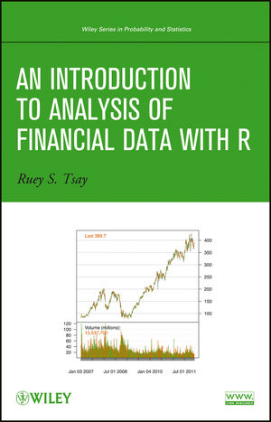By [Ruey S. Tsay](http://as.wiley.com/WileyCDA/Section/id-302477.html?query=Ruey+S.+Tsay)

Publisher: Prentice Hall

Pub Date: October.2010

Pages: 416

# C:\Users\CHIRAG\Desktop\SRS\images.jpg(2)Optimal Data Analysis: A Guidebook with Software for Windows

# By [Paul R. Yarnold](https://www.google.co.in/search?espv=2&biw=1366&bih=705&q=paul+r+yarnold&stick=H4sIAAAAAAAAAOPgE-LRT9c3NErKza1MqzBTgvDyKtLKDJMKtWSyk630k_Lzs_XLizJLSlLz4svzi7KtEktLMvKLAH9b7F08AAAA&sa=X&ved=0CH8QmxMoATAPahUKEwijsrvM5sfIAhVOcY4KHVLzBOQ), [Robert C. Soltysik](https://www.google.co.in/search?espv=2&biw=1366&bih=705&q=robert+c+soltysik&stick=H4sIAAAAAAAAAOPgE-LRT9c3NErKza1MqzBTgvDyyquM4jOMtGSyk630k_Lzs_XLizJLSlLz4svzi7KtEktLMvKLAOyFCtw8AAAA&sa=X&ved=0CIABEJsTKAIwD2oVChMIo7K7zObHyAIVTnGOCh1S8wTk)

Pub Date: January 1, 2005

Pages: 287

# 2.Overall Description

### 2.1Product Perspective

Tourism has now become a significant industry in India. As per the World Travel & Tourism Council, the tourism industry in India is likely to generate US $121.4 bn of economic activity by 2015, and the hospitality sector has the potential to earn US $24 bn in foreign exchange by 2015. The booming tourism industry has had a cascading effect on the hospitality sector with an increase in the occupancy ratios and average room rates. In FY14, the occupancy ratio was around 57%, up 1% from last year. The average room rate decreased over the last one year by about 3.4% due to supply pressures and the general slowdown in the economy. The long term outlook for the Indian hospitality business continues to be positive, both for the business and leisure segments with the potential for economic growth, increases in disposable incomes and the burgeoning middle class.

To develop a framework of the project all the literature surveys were integrated. As a result a correlation was being developed which facilitated the major concerns of the project.

These papers tell about the different aspects of Data Analysis, it tells the step by step procedure that helps in designing a problem statement with respect to prediction in various other fields and helps us to adapt the same in the service industry. Further papers are also related to the hotel industry thus helping us understand the KPI in the Hotel industry and demonstrating mathematical model for Hotel rooms in various part of the world.

The product would start with deterministic Data analysis technique in order to determine the mathematical model. Some common technique that has been already used is neural network.

### 2.2Product Functions

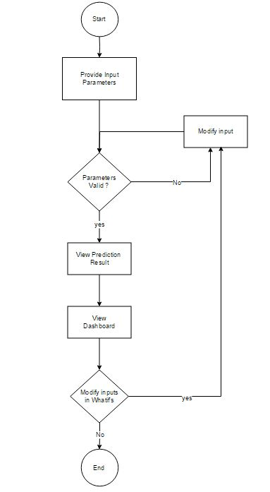

### 2.3User Classes and Characteristics

**Administrators**: They are the core users and are able to see users to the system and permit them to access the Internet resources. They can also view in real time what a user has been performed. They can also get the overall report of the user sessions.

**Client Users**: They login at the client level and this is to get access to the Internet at the client level. They can do analysis for their product and can have access to their previous analysis they had performed. They can also view their account status in the client system.

### 2.4Operating Environment

|  |  |  |
| --- | --- | --- |
| ***Particulars*** | ***Client System*** | ***Server System*** |
| ***Operating System*** | ***Windows XP/7/8/8.1/10 /Linux*** | ***Windows XP/7/8/8.1/10 /Linux*** |
| ***Processor*** | ***1 Ghz*** | ***1 Ghz*** |
| ***Hard disk*** | ***100GB*** | ***100GB*** |
| ***RAM*** | ***512 MB*** | ***512 MB*** |

### 2.5 Design and Implementation Constraints

1. **Security**: The database in which the information regarding the projects is saved should be secured against malicious viruses. As the data is vital
2. **Fault tolerance:** Data should not become corrupted in case of system crash or power failure.
   * Study on the topics widely covering the project domain helped somehow in better understanding the mathematical model to be built.
   * Decision mapping catalogue helped realize some missed out points and few improvement areas could be identified.
   * Further review of the key research papers and generation of the unified inquiry question helped compare the work progress and its appropriateness.
   * Validation/Testing did help in removing certain flaws and shortcomings of the project and improved the implementation.
   * The evaluation matrix template making comparisons of the project work with other existing stuff helped analyse the work done, instilled lot of confidence and encouragement for further improvement to overcome the existing competition.
   * Added more user interactive/appealing interface.
   * Implementing user help/suggestion provision for required areas.
   * Exchange of ideas helped a lot in enhancing the project.
   * Made to look critically at the project and its real time testing which helped improvement altogether.
   * Testing process going on for various versions of software used to provide a beforehand knowledge of compatibility issues.
   * Provision of Shortcuts for most commonly used programs and functionalities.

### 2.6 User Documentation

The product is under development stage and requires a complete implemented prototype to explain the user documentation. Once the prototype is designed and implemented online manuals, user manuals can be provided.

## 2.7Assumptions and Dependencies

* Initially a location is connected, whether an admin or a user is logged on at the remote location or not.
* Each User must have a User ID and password.
* There is only one Administrator.
* Server can run on any web based system.
* Internet connection is a must.
* Proper browsers should be installed.
* Text readers should be installed to view the help files

# 3.External Interface Requirements

The module is divided into two part Administrator module and User module. In user module we have a user inputs of the values. The values will be processed in Prediction module, where the dashboard would be shown. This dashboard represents the values of the predicted statistics.

### 3.1User Interfaces

**Login Screen**: This is for the Administrator and User to get into the software. It requires a user name and password.

**User Input**: This is for the User where he/she inputs the value.

**Prediction**: After thorough Analysis of the Data the user would receive a Data analysis result which will predict the risk of investing a potential project.

**Dashboard**: This module consists of the Data submitted by the client will be showcased with the help of the visual representation.

**History**: This module is accessible for the User. The user will check their own(only) analysis which they had performed previously.

**What if’s:** This module allows user to modify the provided input and simultaneously see the happening changes in the result.

### 3.2Hardware Interfaces

The server is directly connected to the client systems. Also the client has the access to the database for accessing the account details and storing the login time.

The Login page has an input of the username and the password. The user input page has a design to input the user values. By the provided user input values, the predicted data is shown up.

In database the account details, admin and username passwords are stored.

### 3.3Software Interfaces

### Financial Prediction Software Using Data Analysis’s a multi-user environment. It enables the user to interact with the server and attain access to the Internet and also leaves a record in the inbuilt database. It uses .NET as the front end programming tool and MySQL as the backend application tool. The user can run this online website in any basic Operating system with minimum of 512MB, and an IIS server which operates for the server.

### 3.4Communications Interfaces

Financial Prediction Software Using Data Analysis uses .NET and hence requires HTTP for transmission of data. More over this allows easy interaction between the various clients and the server.

# 4.System Features

This document is meant to delineate the features of Secure Enterprise Administration Solution, so as to serve as a guide to the developers on one hand and a software validation document for the prospective client on the other. And in-depth analysis of the intended project work is discussed below.

***4.1*Functional Requirements:**

We describe the functional requirements by giving various use cases.

**Use cases related to system authorization:**

**Use Case 1**: Login

*Primary Actor*: User

*Pre-Condition*: Nil

*Main Scenario*:

1.      Start the application. User prompted for login and password.

2.      User gives the login and password.

3.      System does authentication.

4.      Main screen is displayed.

*Alternate Scenario:*

4(a) Authorization fails

4(a) 1. Prompt the user that he typed the wrong password

4(a) 2. Allow him to re-enter the password.

**Use Case 2**: Providing input

*Actor*: User.

*Pre-condition:* User logged in.

*Main Scenario*

1.     User provides input as per the provided fields.

2.     If user has no information about a field, the field can be left empty (only if it is not a required field).

3.      After completing the required input the user will click the link to display the prediction.

4.       The user will then be redirected to another module.

*Alternate Scenario:*

4(a) an error will be generated if any required field is left empty by the user.

**Use Case 3**: Modifying the input on What if’s module:

*Actor:* User.

*Pre-condition:*

1.  User logged in.

2.  Final prediction displayed to the user.

*Main Scenario:*

1.  The user can modify various input parameters previously provided and see the changes in results/prediction accordingly.

*Alternate Scenario:*

1(a). If the user tries to change the value of input to some invalid value then the application will throw a result.

Use Case Diagram – User

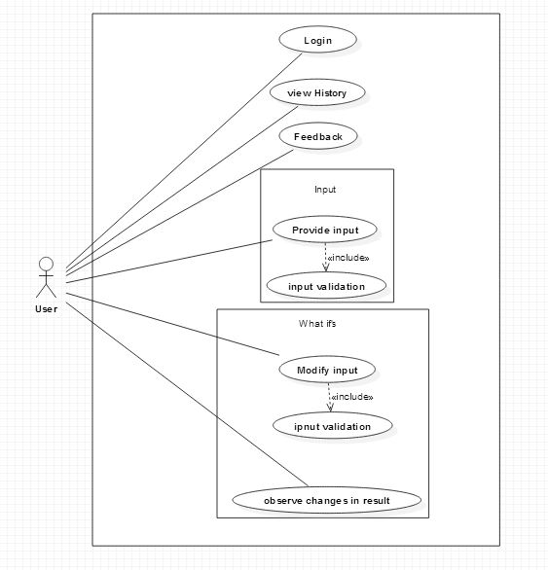

Use Case Diagram - Admin

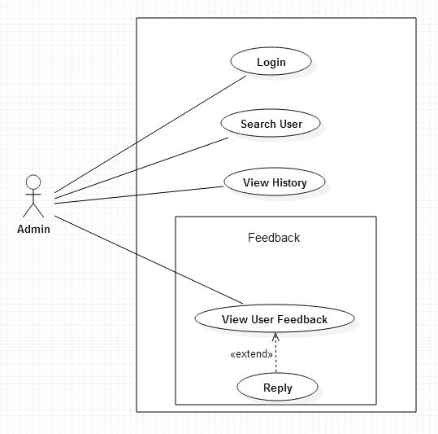

# 5.Other Non-functional Requirements

### 5.1 Performance Requirements

(a)                Should run on 1.0 GHz, 512 MB machine.

(b)               IIS server is recommended.

(c)                .NET framework is must.

(d)               The system should have a browser and an active internet connection.

### 5.2Safety Requirements

The data handled entered should be correct. The parameters entered should be accurate. Power is a significant feature and the power supply should be always taken care of. An Uninterrupted Power Supply is always recommended.

### 5.3Security Requirements

•The Project provides tools to securely interconnect the organizations via web based desktop application implementing secure socket layer and encryption algorithms.

•Authentication of user will be done using Username and Password.

•Authenticated Admin account for database maintenance.

### 5.4Software Quality Attributes

### The source code of the product is going to be open as this is going to be open source software. It will be free for further modifications and improvements.

### 5.5Business Rules

The administrator should have full details of the user while a user is getting registered to the system.

No user will be able to access other user data to ensure safety of data.