PHARMA COMMERCIAL ANALYTICS · CASE STUDY
Physician Segmentation & Commercial Prioritization
Turning a 10.3% adoption rate into a targeted, cost-aware commercial plan for NovaCard

10.3%  Adoption Rate | 800  Physicians Analyzed | 146,292  Eligible Patients | 15,948  Patients Adopted

Executive Summary
A new heart-and-metabolism drug (“NovaCard”) was being prescribed by only 10.2% of doctors, even though the company was spending heavily to make it available. Using data on 800 doctors, we split them into three clear groups, used a machine-learning model to find what really drives prescribing, and turned that into a clear action plan. The core insight reframes the problem: the biggest group of doctors isn’t skipping the drug because they don’t know about it — it’s because the drug is too costly or hard to get for their patients. The smartest move is to focus first on a smaller group that is ready to prescribe but under-reached, and fix the cost problem before spending more on the rest.

01 Business Context & Problem
Pharma sales teams have limited resources — sales-rep time, digital campaigns, and support to get the drug covered by insurance. The key question is simple: which doctors should the team focus on to grow the drug fastest? Reaching every doctor wastes money on people who will never prescribe, and misses the ones who are already ready.
The company needed a clear, data-backed way to group its doctors and decide where to spend next.
Objective: Group the doctors, find out what makes them prescribe, and recommend where to focus limited resources for the most prescriptions per dollar spent.
02 Data
The analysis uses a synthetic dataset of 800 doctors, built to behave like real pharma data. Real doctor-prescription data is hard to obtain and usually locked behind licenses, so the dataset was built with realistic patterns: doctors prescribe more when reps visit them, when they are active online, and when their peers prescribe — and less when the drug costs their patients more or when they are loyal to a rival drug. Keeping the data synthetic is a deliberate choice: it demonstrates the full method transparently, without claiming access to private company data.
Key fields: specialty, region, patient panel size, % of patients on Medicare (a cost-sensitivity signal), formulary tier (how easily the drug is covered), rep visit frequency, digital-engagement score, peer-influence score, competitor-loyalty score, patient out-of-pocket cost, and prescribing status.
03 Approach
Grouping the doctors — K-Means clustering grouped doctors by six behaviors (rep visits, online activity, peer influence, competitor loyalty, patient cost, and drug coverage), then each group was studied and given a plain-English name.
Finding what drives prescribing — Two models — logistic regression and Random Forest — were trained to separate prescribers from non-prescribers (accuracy 0.81 and 0.75). Using two models is a cross-check: both agree on the top drivers, so the result isn’t an artifact of one method.
Deciding where to focus — Plotting the groups on market size vs. current prescribing makes the trade-off — a big untapped group vs. an easy-to-win group — clear at a glance.
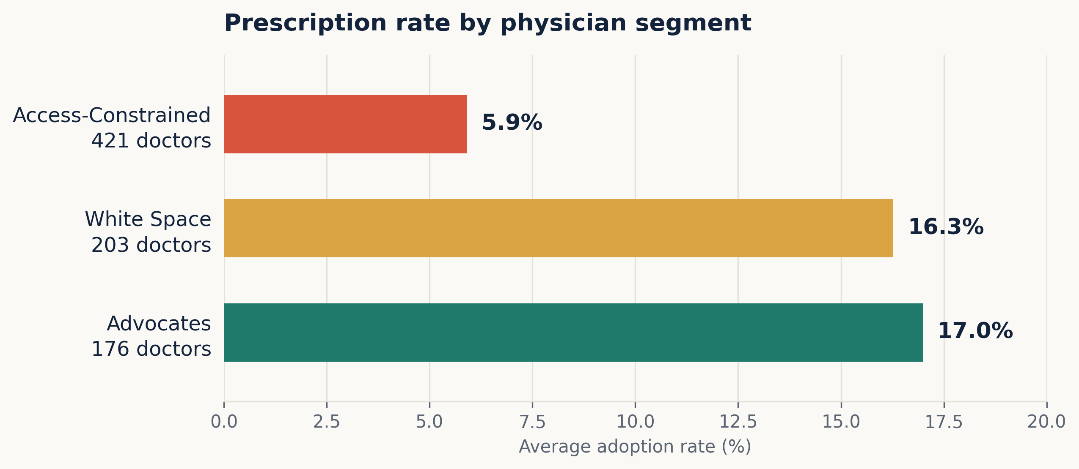
Figure 1. Prescription rate by doctor group. Advocates and White Space prescribe at roughly 3x the Access-Constrained rate.
04 Findings
Three clear, useful groups came out of the data:

 | Group | Drs | Rx Rate | Eligible Pts | What they look like
 | Advocates | 176 | 17.0% | 32,625 | Reps visit often, drug is easy to cover; already prescribing.
 | White Space | 203 | 16.3% | 36,268 | Easy coverage and strong peer influence, but reps rarely visit (~2 visits/quarter).
 | Access-Constrained | 421 | 5.9% | 77,399 | Biggest group (~half the market); 44% face hard drug coverage and the highest patient cost ($103 avg).

What Drives Prescribing
Both models agree on the top three drivers, shown with direction of effect: peer influence (+), competitor loyalty (–), and share of cost-sensitive / Medicare patients (–). Notably, how often a rep visits matters less than peer influence — what other doctors are doing counts for more than how often a rep shows up.
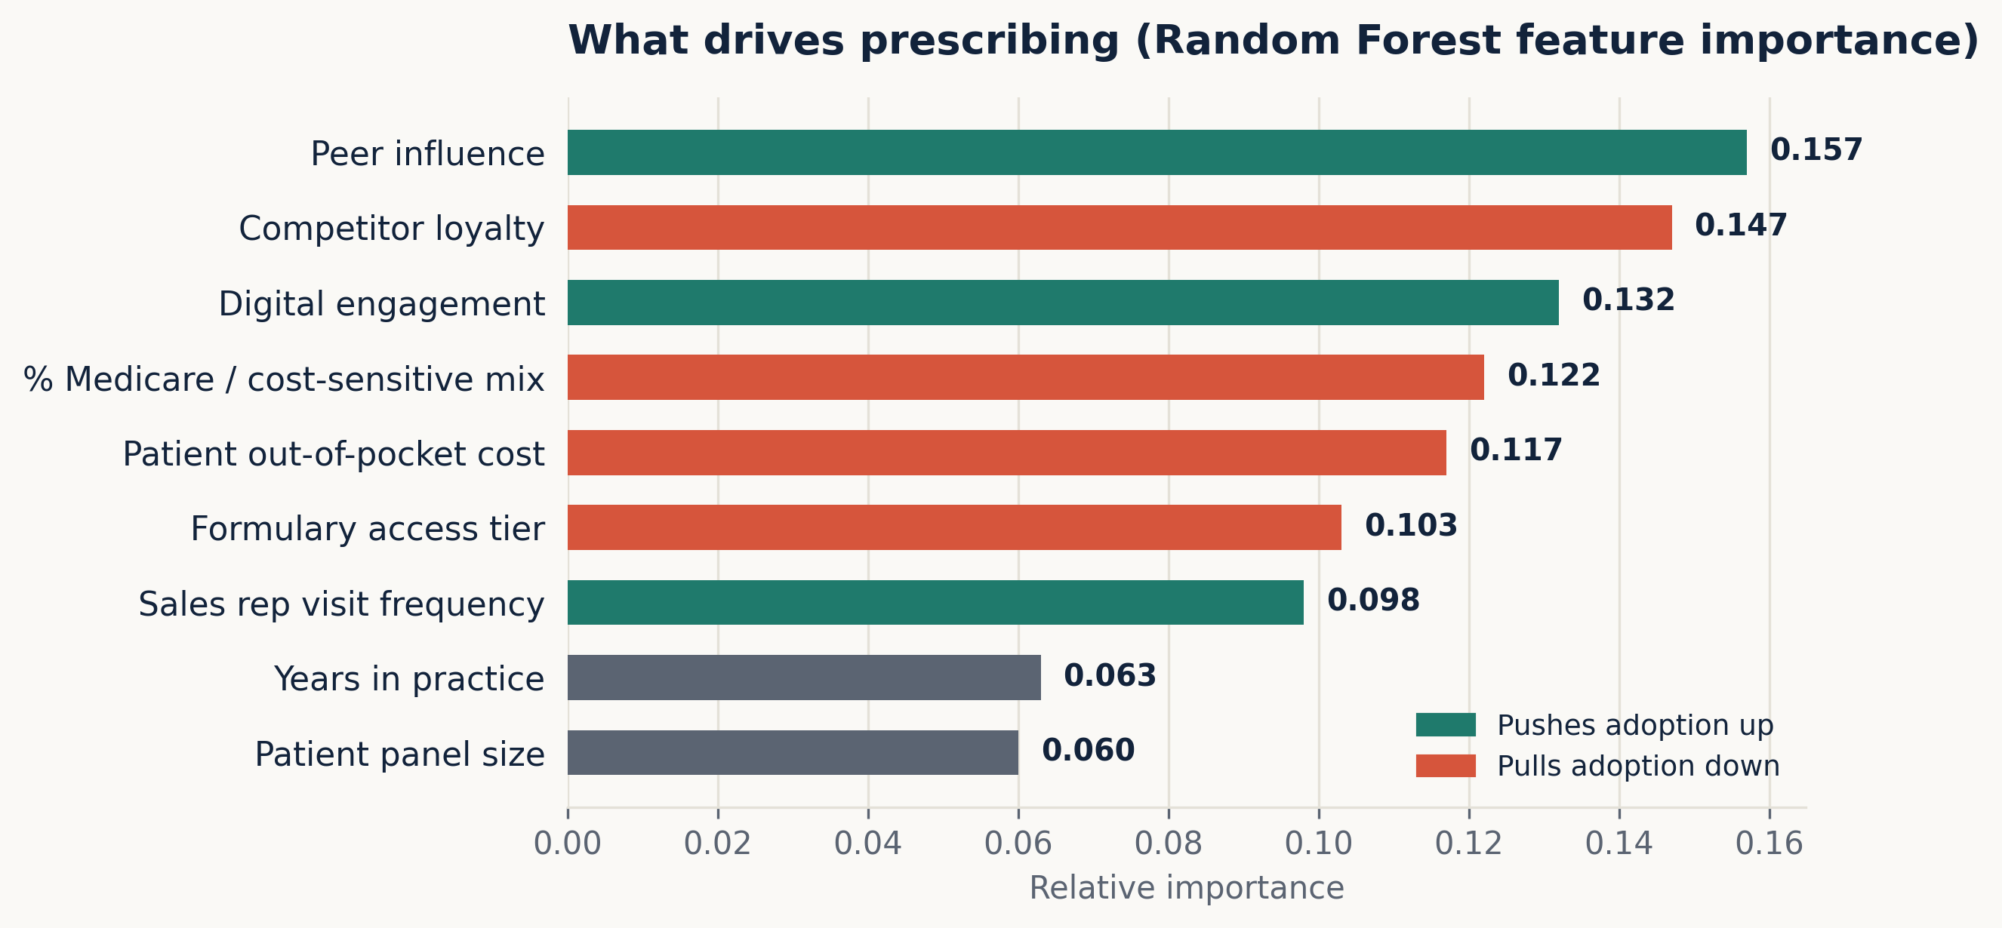
Figure 2. Random Forest feature importance. Peer, competitor-loyalty, and cost/coverage factors lead.
The Cost-and-Coverage Signal
Prescribing drops from 18.8% when the drug is easy to cover (Preferred tier) to 8.9% (Standard) to 4.2% (Restricted). The Access-Constrained group is concentrated in these harder, costlier tiers — proof that the biggest group’s low prescribing is a cost-and-coverage problem, not a lack of awareness.
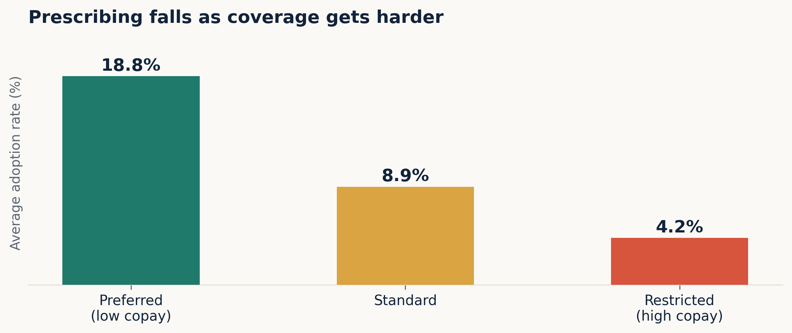
Figure 3. Adoption rate by formulary tier.
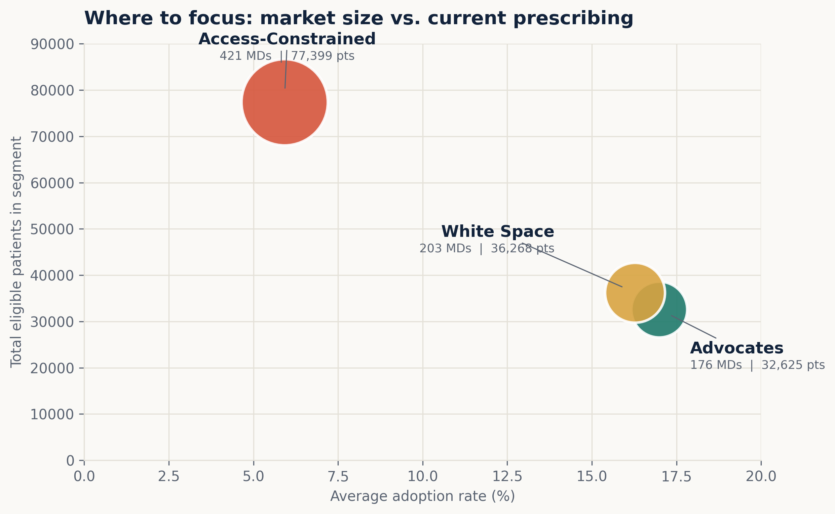
Figure 4. Where to focus — untapped patients vs. current prescribing; bubble size = number of doctors. Access-Constrained sits top-left: a huge untapped group with low prescribing.
05 Recommendation
1 Focus on White Space first
These 203 doctors already find the drug easy to prescribe and their peers prescribe it — but reps barely visit them. More visits, plus peer/KOL programs, will win them over fastest and at the lowest cost. This is the best return for the money.

2 Fix Access-Constrained before spending more on it
This is the biggest group (about half the patients), but the problem is cost and coverage, not awareness. More rep visits won’t help — it needs an access fix first, like co-pay support and help getting insurance approvals.

3 Keep Advocates happy, don’t over-invest
They already prescribe at 17% — protect this group with light-touch effort instead of using up scarce rep time here.

4 Screen out high competitor-loyalty physicians
Competitor loyalty is the single strongest negative driver, so leave the most loyal ones out of the first push — they are unlikely to switch even after the cost problem is fixed.

06 Business Impact
This plan moves limited resources away from spreading thin, and toward the best-return group (White Space) and the biggest group once it is unblocked (Access-Constrained). Knowing when to ‘engage more’ versus ‘fix access first’ is exactly what separates smart spending from wasted budget — the same thinking that underpins pharma sales and patient-access strategy more broadly.
07 Limitations & Next Steps
• The data is synthetic. The next step is to validate the grouping on real doctor data and confirm the same drivers hold.
• Cluster count was chosen for clarity; a formal test (silhouette / elbow) would confirm it, and adding a time dimension (prescribing over quarters) would show urgency.
• Adding expected revenue per new patient would turn the priority list into a clear dollar-ranked plan.
08 Tools & AI-Assisted Workflow
Python (pandas, scikit-learn) powered the data work, clustering, and models; Tableau Public hosts the interactive 3-page dashboard. AI coding tools were used to move faster, with every modeling choice and conclusion reviewed and owned by the authors — AI accelerates the work while humans stay in charge of the thinking.
Interactive dashboard: public.tableau.com/views/NovaCardPhysicianAdoptionDashboard/Story1
Data note: synthetic 800-doctor dataset built with realistic pharma patterns; not real patient or prescriber data. Full code available on request.

