ENGINEERING DESIGN AND MODELLING
NAME: SARVESH.R
EX NO : 2.2 , 3D SOLID MODEL FROM ISOMETRIC DRAWING.
1.AIM
To create a Sketch design using Autodesk Fusion 360 by applying sketch tools, circles, arcs, lines, trimming, mirroring, dimensions, and constraints according to the given engineering drawing.
2.SOFTWARE AND TOOLS REQUIRED
1.Software: Autodesk Fusion 360
2.Tools required:
Create Sketch
Circle Tool
Line Tool
Arc Tool
Sketch Dimension
Trim Tool
Mirror Tool
Constraint Tools
3.PROCEDURE
1.Select the Sketch Plane.
Select the TOP (XY) Plane.
2.Create a Sketch.
Select Sketch > Rectangle > Center Rectangle.
Now hover over the origin (center) of the sketch.
You should see the cursor snap to this location.
Click once to begin placing the rectangle.
Type the Tab button and enter the values 56 mm and 18mm for the width and height respectively.
3.Select Sketch > Arc > Center point arc.
Click again to place the value (Both end of the sketch).
You should see the cursor snap to this location.
Type the Tab button and enter the values R 18mm.
4.Select Sketch > circle > Center point circle.
Click again to place the value (Both side of the sketch).
You should see the cursor snap to this location.
Type the Tab button and enter the values dia 16mm.
Click again to place the sketch.
Click Finish Sketch after completing.
5.Extrude Sketch in XY Plane.
Select Extrude.
Select the sketch.
Click again to place the value.
Type in the value of 8mm.
Press ENTER to accept the value.
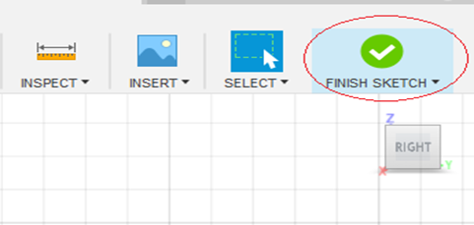
6.Start the sketch command.
Select Sketch > Create Sketch.
Select the Sketch Plane. Select the TOP SURFACE of the 3D block.
7.Create a RECTANGLE
Select Sketch > RECTANGLE > CENTER RECTANGLE.
Now hover over the origin (center) of the sketch.
You should see the cursor snap to this location.
Click once to begin placing the RECTANGLE.
Type the Tab button and enter the values 40mm and 10mm for the width and height respectively.
Click again to place the RECTANGLE.
Click Finish Sketch after completing.
8.Extrude RECTANGLE
Select Extrude.
Select the Rectangle sketch.
Click again to place the value.
Type in the value of 32mm.
Press ENTER to accept the value.
9.Create a TRIANGLE
Select Sketch > TRIANGLE > CENTER TRIANGLE.
Now hover over the origin (center) of the sketch.
You should see the cursor snap to this location.
Click once to begin placing the TRIANGLE.
Type the Tab button and enter the values 32mm and 12mm for the width and height respectively.
Click again to place the TRIANGLE.
Click Finish Sketch after completing.
10.Extrude TRIANGLE
Select Extrude.
Select the TRIANGLE sketch.
Click again to place the value.
Type in the value of 6mm in both direction option.
Press ENTER to accept the value.
11.Create a PENTAGON
Select Sketch > polygon > circumscribed polygon.
Now hover over the origin (center) of the sketch.
You should see the cursor snap to this location.
Click once to begin placing the polygon.
Type the Tab button and enter the values 40mm and 30mm for the width and height respectively and Choose 3 Side.
Click again to place the polygon.
Click Finish Sketch after completing.
12.Extrude PENTAGON
Select Extrude.
Select the PENTAGON sketch.
Click again to place the value.
Type in the value of 10mm.
Press ENTER to accept the value.
13.Create a CIRCLE
Select Sketch > CIRCLE > CENTER CIRCLE.
Now hover over the origin (Pentagon end side) of the sketch.
You should see the cursor snap to this location.
Click once to begin placing the CIRCLE.
Type the Tab button and enter the value DIA 30mm and 20mm, inner and outer diameter respectively.
Click again to place the circle.
Click Finish Sketch after completing.
14.Extrude CIRCLE
Select Extrude.
Select the pentagon sketch.
Click again to place the value.
Type in the value of 10mm on both side.
Press ENTER to accept the value.
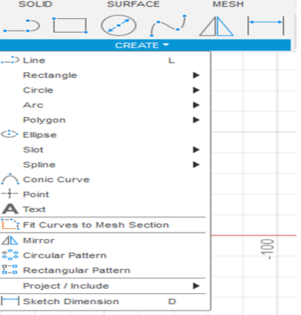
4.OUTPUT
1.Sketch.
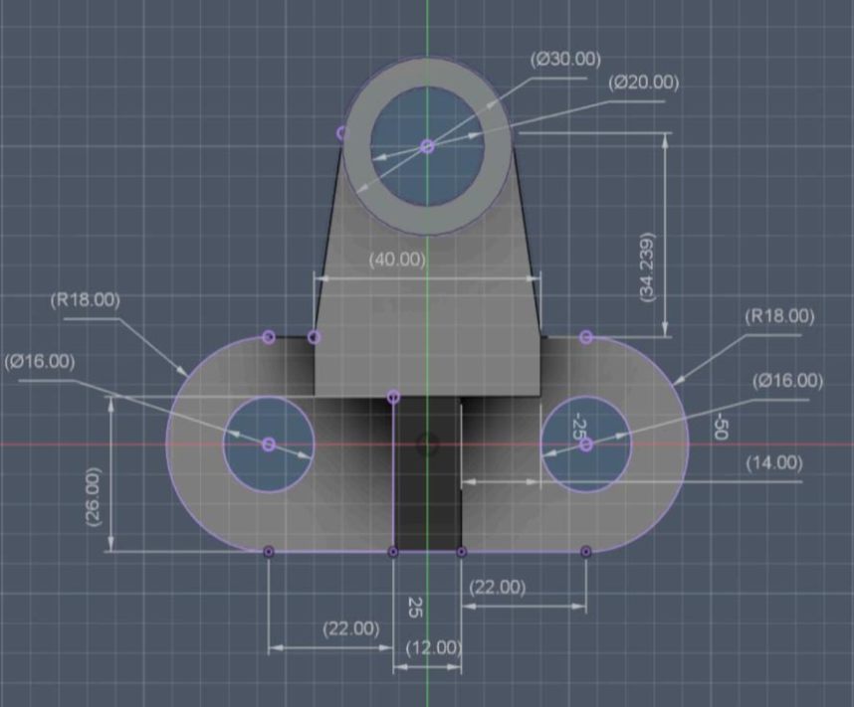
2.Design Sketch.
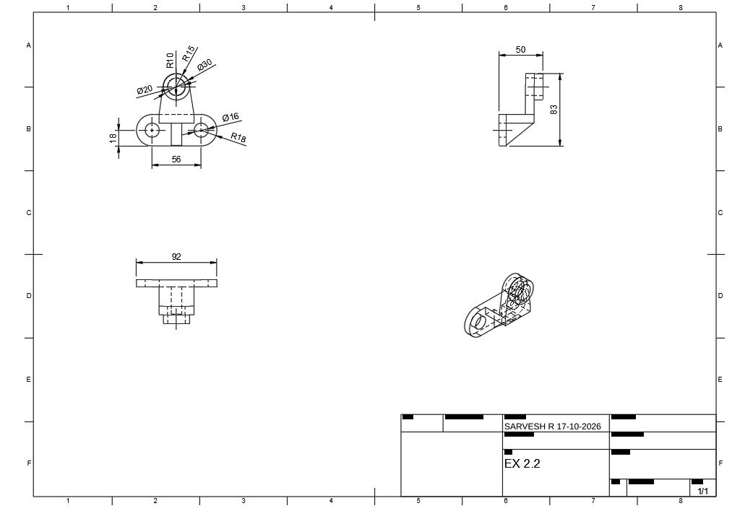
5. RESULT
Thus, the given model is designed and drafted using Autodesk Fusion 360 using sketch tools, circles, arcs, dimensions, constraints, trimming and mirroring according to the given engineering drawing.
------------------------------------x------------------------------------

