**Problem statement**

While transferring the codebase from security analyst’s pc to the HP Fotify server for performing static code scanning, it is observed that some of the code files get missed or corrupted which impacts the secure code review activity by not providing correct scan results.

**Solution**

Wrote a utility which will calculate the checksum value of the zip file containing codebase. The checksum value is calculated and noted before and after the transfer and matched to ensure integrity of the transfer.

**Below are the snapshots of utility:**

*The bat file which calls the utility.*

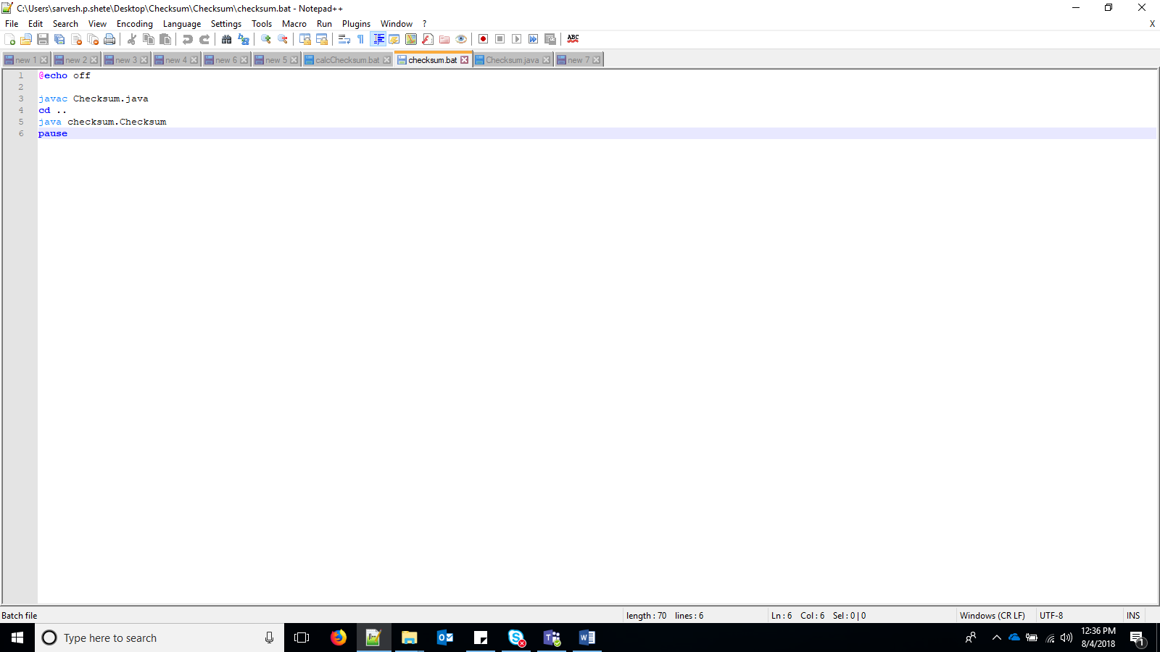

*Code snippet*

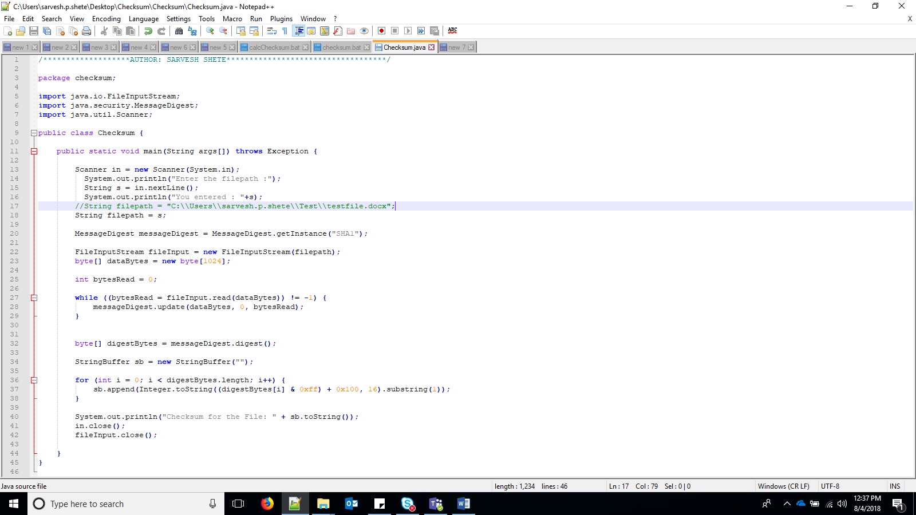

*Checksum generated*

