Sarvesh Parab

sparab@usc.edu

Homework 1 | Task 2

CSCI-548

**Scrapper questions – answers:**

**Q1.** *What are the data science keywords you used for this task? What is the website you are*

*extracting data from (give the base URI and a one-line description about the website)?*

*Name and describe each of the fields (at least 8) you are extracting, provide a representative*

*screenshot of the website and annotate (on the screenshot) the field values that you are*

*extracting. In order to describe the fields, use a table with two columns. The first column*

*will be the name of the field and the second its description.*

**A1.** The website I have used is : <https://www.datacamp.com/>. DataCamp.com provides a wide variety of data science courses for free (9 courses per month). They also have skills and career tracks groomed to master specific areas in data science.

The fields I am extracting :

1. URL: The web URL for the course content *[Mandatory Field]*
2. Title: The title of the course *[Mandatory Field]*
3. Author:
   1. Name: The name of the author *[Mandatory Field]*
   2. Organization: The organization/affiliation the author/speaker has *[Mandatory Field]*
   3. URL: Link to a page for more information about he author and lists more courses related to data science covered by the same author *[Extra Field]*
4. Description: A short brief about the course and its objectives *[Mandatory Field]*
5. Duration: The length of the course in hours *[Extra Field]*
6. Participants: Number of people who have enrolled in this course in the past *[Extra Field]*
7. Videos: The number of videos in the course *[Extra Field]*
8. Exercises: The number of hands-on exercises included in the course *[Extra Field]*
9. Chapters: The list of topics/chapters covered in the course *[Extra Field]*
10. Datasets:
    1. Name: Of the dataset used/leveraged in the course *[Extra Field]*
    2. URL: Link to the dataset files (.csv, .zip, .dat, etc.) *[Extra Field]*

**Q2.** *In 1-3 sentences write the name of the tool you used to scrape the data and describe why*

*you decided to use that tool.*

**A2.**  I have used ‘BeautifulSoup4’ in Python 3 to scrape the data from DataCamp.com. Since the website has a very well-structured HTML and CSS layout, I could leverage the BS4’s API to crawl through and parse the HTML structure of the website.

**Q3.** *In a short paragraph, describe your wrapper. Try to be as specific as possible. We will*

*be looking for details like what kind of wrapper you used (e.g. manual, automatic…?),*

*what is the wrapper model (e.g. HLRT, LR…?), where we can access the wrapper*

*algorithm, if your wrapper is non-manual etc. A good rule of thumb is, can someone*

*familiar with wrappers read your description and be able to (roughly) replicate your*

*wrapper for themselves?*

**A3.** The wrapper I have built is a manual wrapper. I have gone through the website source code and the challenge was to find and isolate tags and their ids or classes which would uniquely identify a specific element of the webpage, like the fields I was interested in. Once I had the specific identifiers, BS4 provides the API to parse and extract the field values from the page source code.

Then I created a dict in python to hold all the extracted values and make a JSON dump of all the data.

I have used beautifulSoup4 and my python code is well commented for easy maintainability.

Few reference links/materials I used to build the wrapper:

* <https://www.dataquest.io/blog/web-scraping-tutorial-python/>
* <https://www.crummy.com/software/BeautifulSoup/bs4/doc/>

**Screenshots and annotations of the fields extracted:**

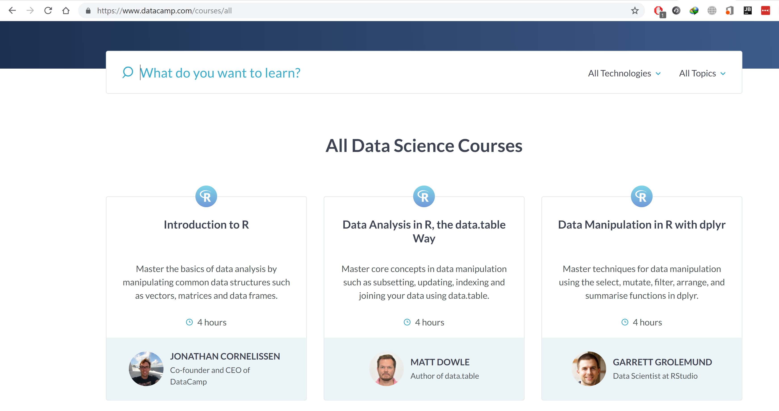

DURATION

TITLE

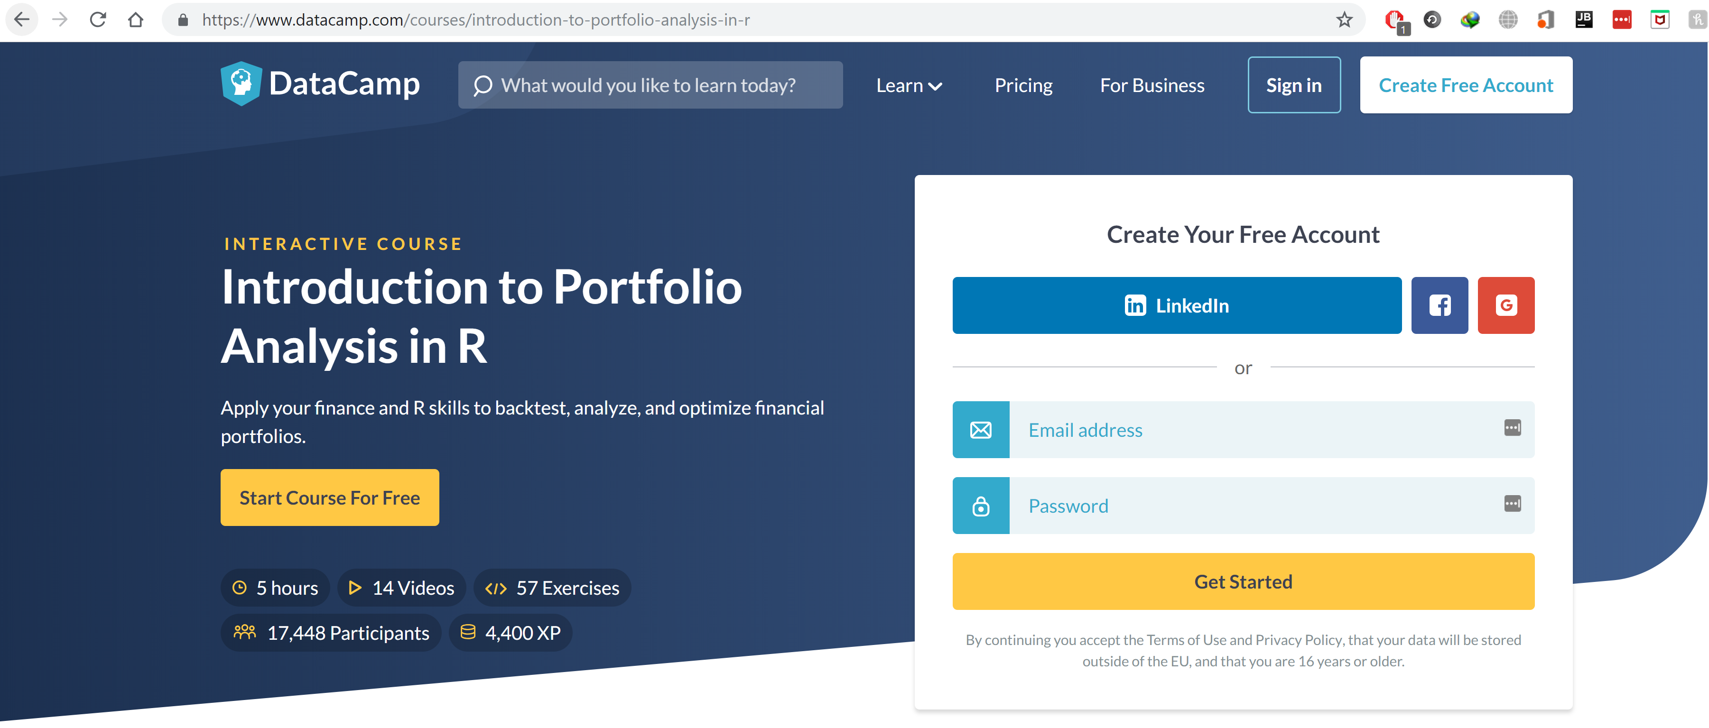

EXERCISES

PARTICIPANTS

VIDEOS

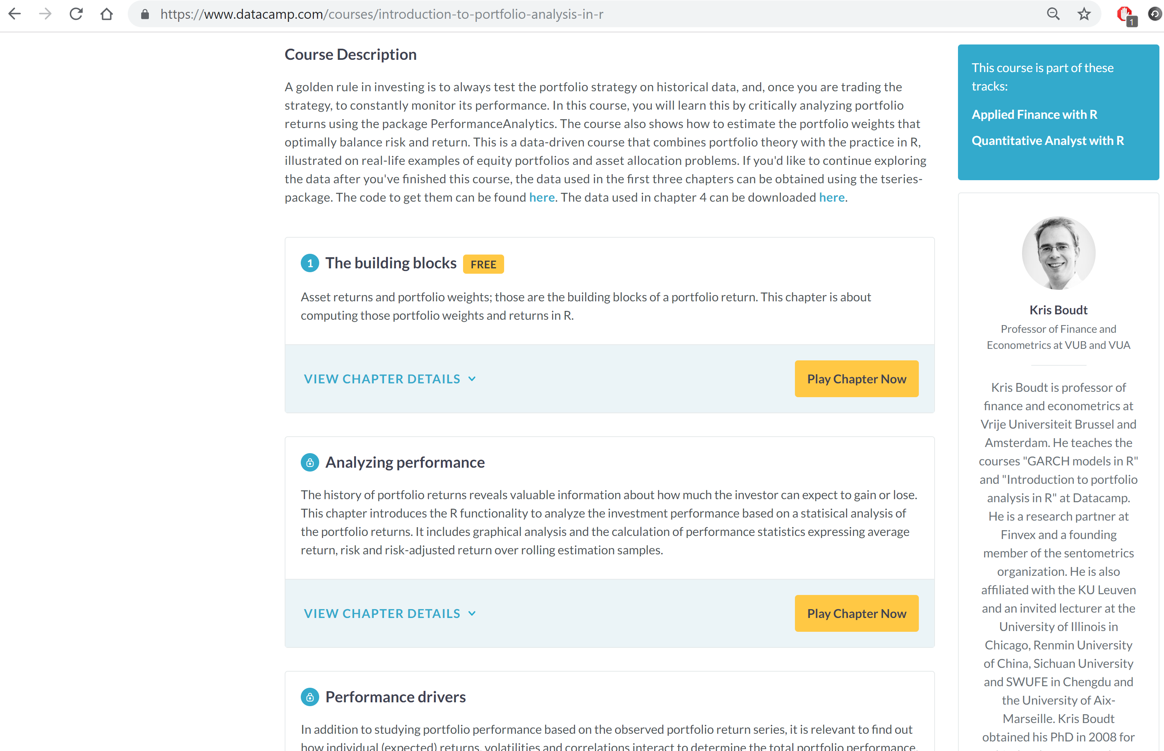

ORGANISATION

AUTHOR

CHAPTERS/TOPICS

DESCRIPTION

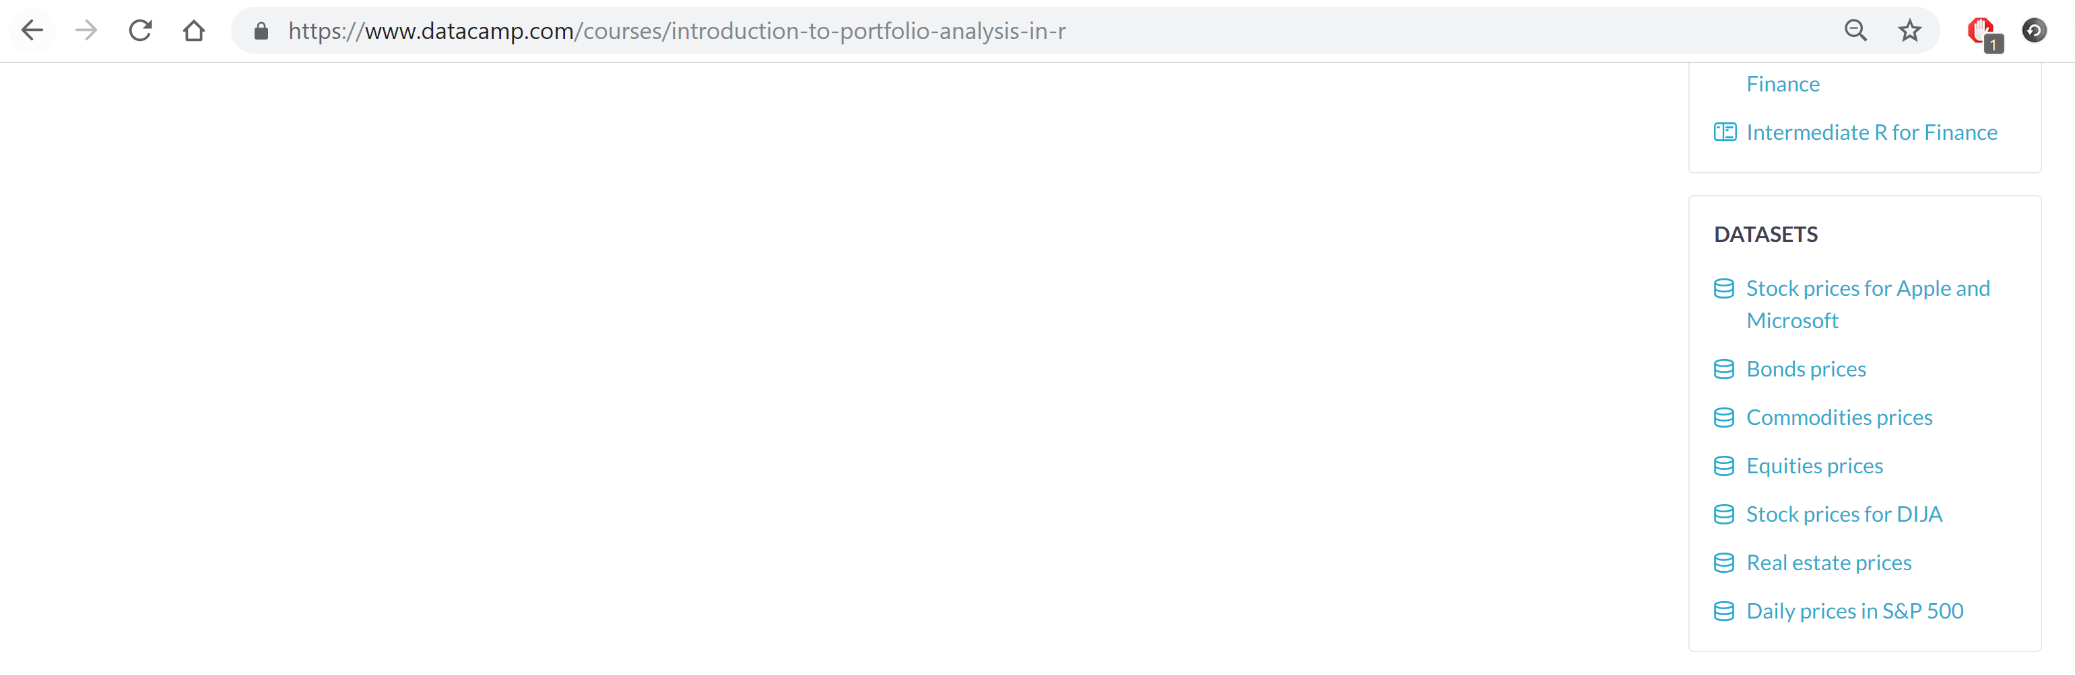

DATASETS

**My JSON Structure: (Sample Course Data)**

"https://www.datacamp.com/courses/introduction-to-portfolio-analysis-in-r": {  
 "id": "985",  
 "title": "Introduction to Portfolio Analysis in R",  
 "duration": "5 hours",  
 "author": [  
 "Kris Boudt"  
 ],  
 "organization": [  
 "Professor of Finance and Econometrics at VUB and VUA"  
 ],  
 "author-profile-url": [  
 "https://www.datacamp.com/instructors/kboudt"  
 ],  
 "description": "A golden rule in investing is to always test the portfolio strategy on historical data, and, once you are trading the strategy, to constantly monitor its performance. In this course, you will learn this by critically analyzing portfolio returns using the package PerformanceAnalytics. The course also shows how to estimate the portfolio weights that optimally balance risk and return. This is a data-driven course that combines portfolio theory with the practice in R, illustrated on real-life examples of equity portfolios and asset allocation problems. If you'd like to continue exploring the data after you've finished this course, the data used in the first three chapters can be obtained using the tseries-package. The code to get them can be found here. The data used in chapter 4 can be downloaded here.",  
 "exercises": "57",  
 "videos": "14",  
 "participants": "17,473",  
 "dataset-name": [  
 "Stock prices for Apple and Microsoft",  
 "Bonds prices",  
 "Commodities prices",  
 "Equities prices",  
 "Stock prices for DIJA",  
 "Real estate prices",  
 "Daily prices in S&P 500"  
 ],  
 "dataset-url": [  
 "https://assets.datacamp.com/production/repositories/156/datasets/19b8706d185f4a46536ede60b2aab77457d139cf/aapl_msft.RData",  
 "https://assets.datacamp.com/production/repositories/156/datasets/16a33b7cf90c561d6b7118778e74b34f96478174/bond_prices.RData",  
 "https://assets.datacamp.com/production/repositories/156/datasets/34c3822b17f6b911c1725da49e90207964509738/comm_prices.RData",  
 "https://assets.datacamp.com/production/repositories/156/datasets/0b39b863d740fa2cd39f408a463cd10eb6c617e6/eq_prices.RData",  
 "https://assets.datacamp.com/production/repositories/156/datasets/f1b7df924abf7f11f7b01284b8874d8fda609f2f/prices.rds",  
 "https://assets.datacamp.com/production/repositories/156/datasets/40978acd3fd7efa00815a5dceaf3dcf8cddb5331/re_prices.RData",  
 "https://assets.datacamp.com/production/repositories/156/datasets/df69bb807d3c6bec45af9ef4d7708970f2a0760a/sp500.RData"  
 ],  
 "chapters": [  
 "The building blocks",  
 "Analyzing performance"  
 ]  
}