**SCHOOLITE**



***A major project report submitted to***

***Rajiv Gandhi Proudyogiki Vishwavidhyalaya, Bhopal in partial fulfillment for the award of***

***the degree of Bachelor of Technology***

***In***

***Computer Science and Engineering***

### DEPARTMENT OF COMPUTER SCIENCE & ENGINEERING

## SRI AUROBINDO INSTITUTE OF TECHNOLOGY INDORE-

### 2023

**SCHOOLITE**



***A major project report submitted to***

***Rajiv Gandhi Proudyogiki Vishwavidhyalaya, Bhopal in partial fulfillment for the award of***

***the degree of Bachelor of Technology***

***In***

***Computer Science and Engineering***

### PROJECT GUIDE SUBMITTED BY

**Sudha Sharma mam**  **Shraddha Shaiv**

Assistant Professor **Himanshu Sharma**

### DEPARTMENT OF COMPUTER SCIENCE & ENGINEERING

## SRI AUROBINDO INSTITUTE OF TECHNOLOGY INDORE-

### 2023

# SRI AUROBINDO INSTITUTE OF TECHNOLOGY INDORE, 40000



## CERTIFICATE

This is to certify that **Shraddha Shaiv** **(0873CS201092)** have completed their project work, titled **“schoolite”** as per the syllabus and have submitted a satisfactory report on this project as a part of fulfillment towards the degree of **“BACHELOR OF TECHNOLOGY” ( Computer Science and Engineering)** from **RAJIVGANDHI PROUDYOGIKI VISHWAVIDHYALAYA, BHOPAL.**

**HEAD OF THE DEPARTMENT PROJECT GUIDE**

**DIRECTOR**

### ACKNOWLEDGEMENT

We express deep gratitude for enthusiasm and valuable suggestions that we got from our guide

**Sudha Sharma mam** for successful completion of the project. This project was not possible without the invaluable guidance of our project guide.

We are also thankful to our project coordinator **Sudha Sharma mam,** for his/her technical guidance, encouragement and support.

We are deeply indebted to **Mr. Sunil Parihar**, Head, Department Of Computer Science and Engineering, for providing us support and resources for successful completion of this project.

We pay deep regards to our Director **Dr. Durgesh Mishra** who is instrumental in setting standards for the students to achieve.

Finally, we are thankful to all the people who are related to the project directly or indirectly.

**SHRADDHA SHAIV**

# SRI AUROBINDO INSTITUTE OF TECHNOLOGY INDORE, 400001



## CERTIFICATE

This is to certify that **SHRADDHA SHAIV (0873CS201092), HIMANSHU SHARMA (0873CS201036),** have completed their project work, titled **“SCHOOLITE ”** as per the syllabus and have submitted a satisfactory report on this project as a part of fulfillment towards the degree of **“BACHELOR OF TECHNOLOGY” (Computer Science and Engineering)** from **RAJIV GANDHI PROUDYOGIKI VISHWAVIDHYALAYA, BHOPAL.**

**INTERNAL EXAMINER EXTERNAL EXAMINER**

**ABSTRACT**

This project is a actually a web based school student requirement shop for their school & education related needs. In this website we have our city top-10 school list in which provide their uniform , syllabus kit , stationery , worksheet or any other requirement related to these schools.

This project is an attempt to provide the advantages of shop, all the student need material related to this schools or any other education related benefits . It helps buying the products in the shop using internet . Thus the customer will get the service of online shopping and free home delivery .

This project proves to be very beneficial for specially those parents who have very busy schedule in their job / works and have time issue with the help of this they can easily shop for their kids related to their school requirements like uniform.

VENDOR MANAGEMENT SYSTEM

1. Introduction
   1. Purpose
   2. Scope
   3. Problem in existing system
   4. Statement of Problem
2. System Requirement Analysis
   1. Information Gathering
   2. Technology Specification
   3. Team Structure
   4. Process Model Used
3. Analysis
   1. Methodology Used
   2. Identified Actors
   3. UML Activity Diagram
   4. Use Case Diagrams

(List the works carried out by users in the system Provide Comprehensive documentation of the system under study.)

* 1. Sequence Diagram
  2. Static UML Class Diagram
     1. Identified Classes
     2. Identified relationships
     3. Identified attributes
     4. Identified methods

1. Conclusion
2. Reference
3. Appendix (User manual, Glossary and other related Material)

**Introduction**

This project is a actually a web based school student requirement shop for their school & education related needs. In this website we have our city top-10 school list in which provide their uniform , syllabus kit , stationery , worksheet or any other requirement related to this schools.

### This project is an attempt to provide the advantages of shop all the student need material related to this schools or any other education related benefits . It helps buying the products in the shop using internet . Thus the customer will

### get the service of online shopping and home delivery .

**Purpose**

The objective of the project is to make website to purchase items related to school. In order to build such an website that support any browser need to be provided. complete and efficient web which can provide the online student material shopping experience is the basic objective of the project.

**Scope**

In the scope , we can say that it can be expand from top-10 city level school to all over city level . 1 more scope is that further colleges can also be added in the future.so that in this expansion providing facilities can also be increased .

### 

### Problem in existing system

The current system for student uniform shopping is to visit the shop manually and from the available product choose the item customer want and buying the item by payment of the price of the item .

## It is less user-friendly.

## User must go to shop and select products.

## It is difficult to identify the required product. Description of the product limited.

## It is a time-consuming process Not in reach of distant users.

### Statement of Problem

In the proposed system customer need not go to the shop for buying the products. The can order the product he wish to buy through the his Smartphone or any other devices . The system also recommends a home delivery system for the purchased products.

### System Requirement Analysis

## SOFTWARE REQUIREMENT –

## Supports any search engine or browser like google chrome , Microsoft edge , firefox etc.

## IMPLEMENTTION REQUIREMENT -

* **SOFTWARE PLATEFORM –**
* **Web Development**: For the web-based platform, using technologies such as HTML, CSS, JavaScript for front-end development.
* **Backend Development**: Consider using language Node.js for server-side scripting. Framework Express.js can help in creating robust and scalable back-end systems.
* **Database Management**: Database technology MongoDB could be used for storing and managing data efficiently

**USER**

**USER LOGIN**

Description of feature

This feature used by the user to login into system. user must login with his user name and password to the system after registration. If they are invalid, the user not allowed to enter the system.

Functional requirement

* Username and password will be provided after user registration is confirmed.
* Password should be hidden from others while typing it in the field

**REGISTER NEW USER**

Description of feature

new user will have to register in the system by providing essential details in order to view the products in the system. The admin must accept a new user by unblocking him.

Functional requirement

## System must be able to verify and validate information.

## The system must encrypt the password of the customer to provide security.

## PURCHASING ITEM

## Description of feature

## The user can add the desired product into his cart by clicking add to cart option on the product. They can view his cart by clicking on the cart button. All products added by cart can be viewed in the cart. User can remove an item from the cart by clicking remove. After confirming the items in the cart the user can submit the cart by providing a delivery address. On successful submitting the cart will become empty.

## Functional requirement

## System must ensure that, only a registered customer can purchase items.

## E-R DIAGRAMS

## DATA FLOW DIAGRAM

**Context level DFD – 0 level**

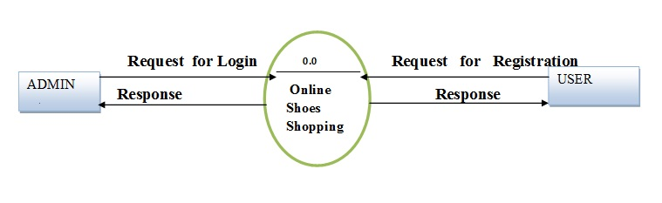

**1st Level Admin  Side DFD**

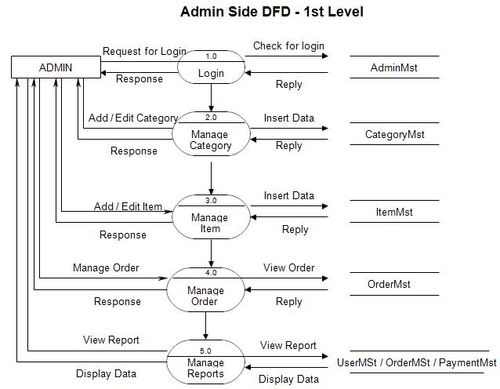

2nd Level – Admin side DFD

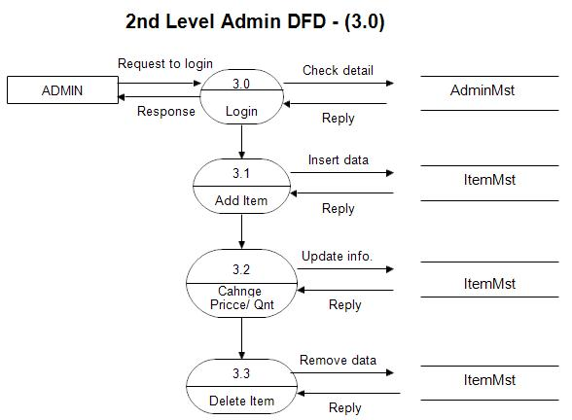

1st level – User side Data flow Diagram

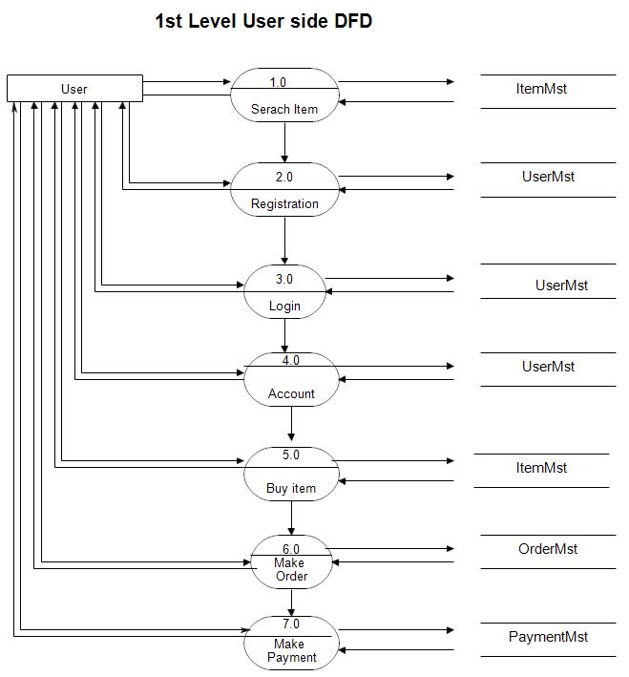

2nd level – User side DFD

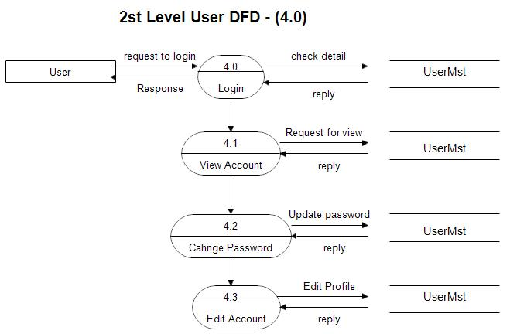

**SYSTEM Dia -**



Class diag -

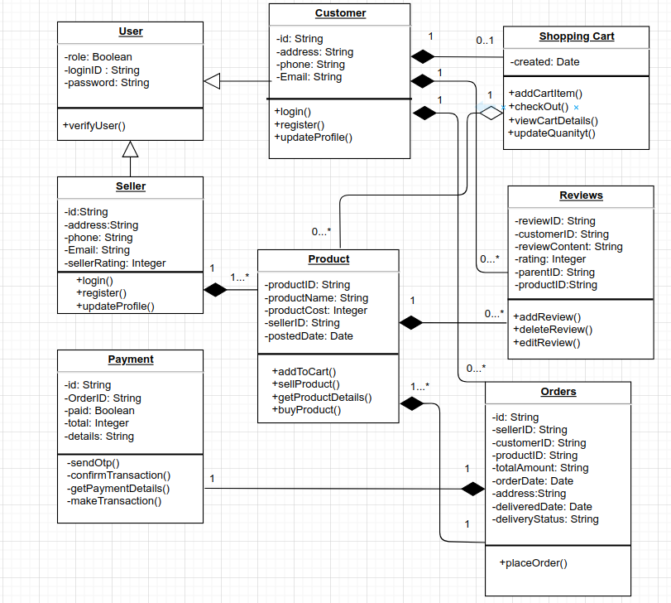

**USE CASE –**

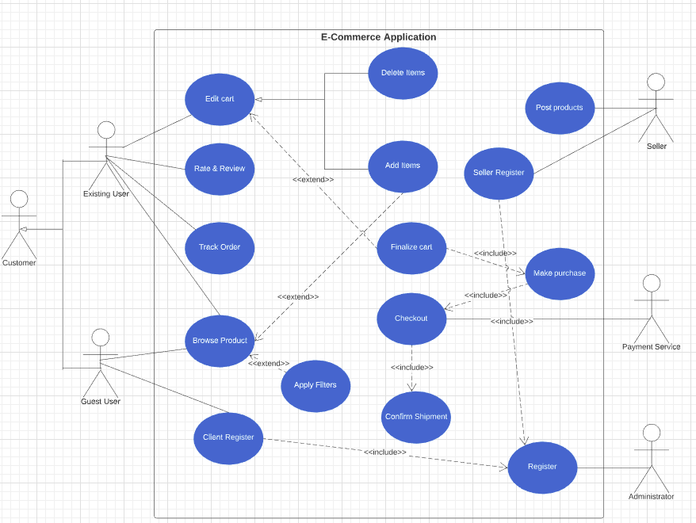

Activity Dia –

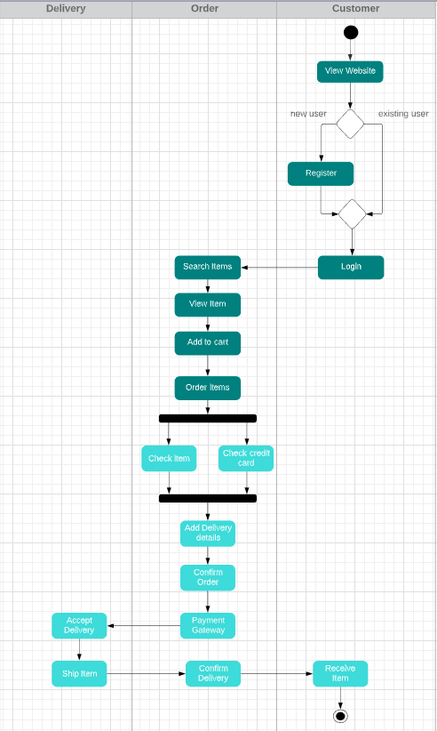

**CONCLUSION**

The project entitled **Schoolite** was completed successfully.

The system has been developed with much care and free of errors and at the same time it is efficient and less time consuming. The purpose of this project was to develop a web-site and for purchasing items from a site.

This project helped us in gaining valuable information and practical knowledge on several topics like designing web pages using html & CSS , usage of responsive templates , Backend with express & MongoDB . The entire system is secured. Also the project helped us understanding about the development phases of a project and software development life cycle. We learned how to test different features of a project.

This project has given us great satisfaction in having designed a complete website which can be implemented .

There is a scope for further development in our project to a great extent . A number of features can be added to this system in future like providing.

**Bibliography and Reference :**

1. W3Schools. (2021). "HTML Tutorial." Retrieved from <https://www.w3schools.com/html/>
2. CSS-Tricks. (2021). "CSS Tutorial." Retrieved from <https://css-tricks.com/>
3. Mozilla Developer Network. (2021). "JavaScript Guide." Retrieved from <https://developer.mozilla.org/en-US/docs/Web/JavaScript/Guide>
4. Oracle. (2021). "Java Server Pages (JSP) Documentation." Retrieved from <https://docs.oracle.com/javaee/7/tutorial/jsf-convert.htm>
5. Node.js. (2021). "Node.js Documentation." Retrieved from <https://nodejs.org/en/docs/>
6. MongoDB. (2021). "MongoDB Documentation." Retrieved from <https://docs.mongodb.com/>