Lightweight Client-Server Network Service Platform
BCSE308P – Computer Networks
PROJECT BASED COMPONENT REPORT
by
[Student Name]
([Register Number])
School of Computer Science and Engineering
October 2026
DECLARATION
I hereby declare that the report entitled “Lightweight Client-Server Network Service Platform” submitted by me, for the BCSE308P – Computer Networks to VIT is a record of bonafide work carried out by me under the supervision of Dr. S. Ebenezer Juliet.
I further declare that the work reported in this report has not been submitted and will not be submitted, either in part or in full, for any other courses in this institute or any other institute or university.
Place : Vellore
Date : [dd-mm-yyyy]
Signature of the Candidate(s)
TABLE OF CONTENTS
1. Introduction
2. Problem Statement
3. Objectives
4. Literature Review and Existing System
5. Abstract of the Proposed Project Work
6. Workflow of the Proposed Project Work / System Design / System Architecture
7. Contribution of Individual Team Member
8. Modules Explanation
9. Project Implementation
a. Experimental Setup with Hardware and Software Requirements
b. Test Cases
c. Results of Execution
d. Performance Analysis – Comparison of Methods / Protocols
e. Critical Evaluation / Optimization
10. Results and Discussion
a. Findings and Inferences
b. Innovation, Novelty, and Evidence
11. Conclusion
12. Limitations and Future Enhancement
References

1. Introduction
Almost every networked application is built on the client–server model: a long-running server process listens on a well-known address, and clients initiate requests to it. The programming interface that exposes this model to applications is the socket API. Sockets give a program direct access to the two transport protocols of the Internet: the Transmission Control Protocol (TCP), which provides a reliable, ordered byte stream at the cost of connection set-up and per-connection state, and the User Datagram Protocol (UDP), which provides unreliable, unordered datagrams with almost no overhead. Choosing between them, and building whatever reliability the application needs on top, is a central design decision in network programming.
This project builds a lightweight client–server network service platform that exposes three classic services from a single server process: Echo (TCP and UDP), File Transfer (TCP) and DNS (UDP, real RFC 1035 wire format). The platform serves many clients at once, writes a structured communication log, detects and survives communication failures, and is measured on response time, throughput, reliability, packet loss and resource utilisation. Each service uses the transport that suits it, so the same code base can be used to compare TCP and UDP behaviour directly.
The implementation is written in Python using only the standard library (socket, threading, struct, hashlib, logging), so every protocol detail, from the 4-byte frame header of the echo service to the compression pointers in DNS responses, is visible in the source rather than hidden in a framework.

2. Problem Statement
Design and implement a lightweight client–server network service platform using TCP and UDP socket programming. The system should provide Echo, File Transfer, and DNS services. The server must support multiple concurrent clients, maintain communication logs, detect communication failures, and provide appropriate error handling. Evaluate the system based on response time, throughput, reliability, packet loss, and resource utilization. (Problem III, Innovative Practices – Computer Networks Lab, Fall Semester 2026-2027.)
The problem therefore has a construction half (four requirements on the server: three services, concurrency, logging, failure detection and error handling) and an evaluation half (five metrics). The report addresses both: Sections 6–8 describe the construction, and Sections 9–10 present the evidence for each metric.

3. Objectives
- Implement an Echo service over TCP (length-prefixed frames) and over UDP (datagram echo).
- Implement a File Transfer service over TCP supporting list, upload, download and status, with end-to-end integrity checking.
- Implement a DNS service over UDP that speaks the real DNS wire format (A, AAAA, CNAME, MX, TXT) and interoperates with standard tools.
- Serve multiple concurrent clients without cross-talk, with configurable limits.
- Maintain communication logs (connections, requests, failures, durations, byte counts) and live server statistics.
- Detect communication failures (crashed or hung peers, idle clients, truncated transfers, malformed packets, lost datagrams) and handle each with an appropriate error response or recovery action.
- Evaluate the platform on response time, throughput, reliability, packet loss and resource utilisation, using repeatable experiments.
- Go beyond measurement: identify bottlenecks, implement optimisations and quantify their effect.

4. Literature Review and Existing System
Transport protocols. TCP (RFC 793, updated by RFC 9293) provides reliable, ordered delivery using acknowledgements, retransmission and congestion control [1]. UDP (RFC 768) adds only ports and a checksum to IP, leaving loss recovery to the application [2]; RFC 8085 gives guidelines for applications that must therefore implement their own timeouts and back-off [3]. Stevens, Fenner and Rudoff [4] and Kurose and Ross [5] describe the socket API and the design trade-offs between iterative, forking, threaded and event-driven servers.
Existing services. The Echo protocol (RFC 862) [6] is the traditional diagnostic service. File transfer is standardised by FTP (RFC 959) [7], which uses separate control and data connections, and by TFTP (RFC 1350) [8], which runs over UDP with lock-step acknowledgements and is therefore simple but slow. DNS is specified in RFC 1034 and RFC 1035 [9], [10]; production implementations include BIND and dnsmasq. Scalability of connection-per-thread servers is discussed in Kegel’s “C10K problem” [11].
Table 1: Comparison with existing systems
System | Transport | Strength | Gap relative to this project
inetd / xinetd echo | TCP+UDP | Standard, tiny | No logging of failures, no metrics, no integrity checks, single service
vsftpd / FTP (RFC 959) | TCP (2 connections) | Feature rich | Heavy: separate data channel, authentication, active/passive modes; not meant for protocol study
TFTP (RFC 1350) | UDP | Simple | Lock-step ACKs limit throughput; no integrity beyond UDP checksum
BIND / dnsmasq | UDP+TCP | Complete DNS | Large code bases; not instrumented for loss/latency experiments
Python socketserver examples | TCP/UDP | Short | Single service, no framing, no limits, no failure handling or evaluation
This platform | TCP+UDP | Four services, one process, shared logging/stats/failure handling, loss injection, reproducible benchmarks | Educational scale: no TLS, authentication or recursion (Section 12)

Gap addressed. Reference implementations are either too large to read in an afternoon or too small to evaluate. The platform sits between them: small enough to inspect completely, complete enough (concurrency, logging, failure handling, loss injection, instrumentation) to support quantitative experiments on the five required metrics.

5. Abstract of the Proposed Project Work
The project delivers a client–server platform in which one server process offers four services: a TCP echo service with length-prefixed framing, a UDP echo service, a TCP file-transfer service with SHA-256 integrity verification in both directions and atomic stores, and an authoritative UDP DNS service that implements RFC 1035 message encoding and decoding and interoperates with the standard dig tool. TCP services use one thread per connection with idle timeouts and a client cap; UDP services use a receive loop and a worker pool. All services write a structured log and update shared counters that clients can query at run time. The server detects timeouts, resets, truncated messages, oversize frames, malformed DNS packets, bad file names and checksum mismatches, and recovers from each without affecting other clients. The client library adds bounded connect retries with exponential back-off and UDP retransmission with per-attempt timeouts.
Evaluation on an Apple M3 Pro machine (12 cores, 18 GB) over the loopback interface shows: TCP echo round-trip times of 0.024 ms (1 KiB, median); a sustained 28,710 echo requests per second (peak 37,301) with 0 errors for 1 to 400 concurrent clients; file transfers at about 1.7 GB/s; 14,782 DNS queries per second; UDP loss measurements that match the analytical model 1−(1−p)² to within 1.1 percentage points, and a retransmission policy that raises DNS success from 63.3% to 94.6% at 20% per-datagram loss; and 53.5 KB of memory per open connection. A digest cache raised single-client download throughput from 1.0 to 1.7 GB/s, and combined with sendfile() it cut server CPU at 8 concurrent downloads from 165% to 42%. An adaptive, RFC 6298-style retransmission timer cut the response time of lossy DNS queries by 4.3–6.7× at the same success rate. The suite of 34 automated tests (34 passing) covers functional, fault-injection and security cases.

6. Workflow of the Proposed Project Work / System Design / System Architecture

6.1 Architecture
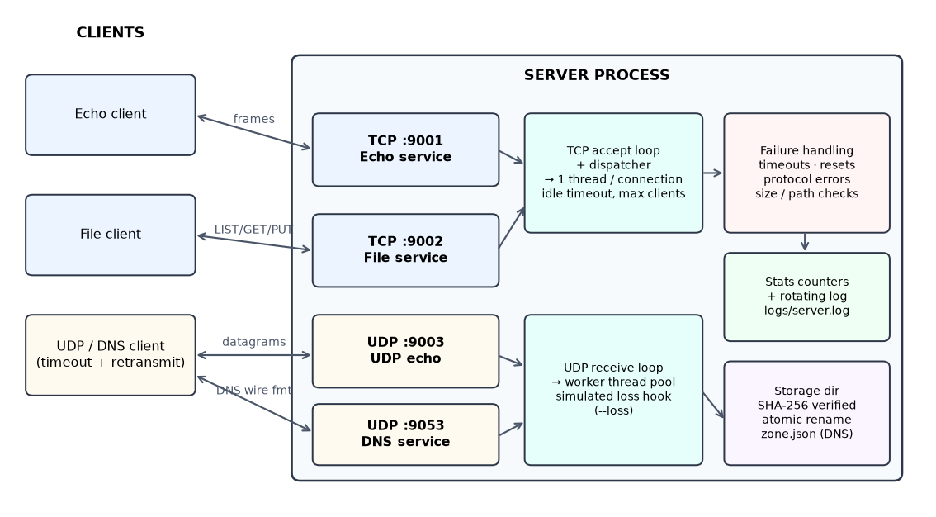
Figure 1: System architecture: four services in one server process, shared logging, statistics and failure handling
Table 2: Service summary
Service | Transport / port | Request → response | Concurrency model | Reliability mechanism
Echo | TCP 9001 | [len:4][payload] → same frame | 1 thread per connection | TCP + frame length check; idle timeout
File | TCP 9002 | text command line (+ binary body) → OK/ERR line (+ body) | 1 thread per connection | SHA-256 end to end; atomic rename; abort cleanup
UDP echo | UDP 9003 | datagram → same datagram | receive loop + 16 workers | client timeout and retransmission
DNS | UDP 9053 | RFC 1035 query → response (rcode, answers) | receive loop + 16 workers | client timeout, retransmission, same transaction ID

6.2 Request workflows
TCP echo. (1) Client connects (bounded retries with exponential back-off). (2) Client sends a 4-byte big-endian length followed by the payload. (3) The server thread reads exactly that many bytes, rejects lengths above 16 MiB, and writes the frame back unchanged. (4) The client verifies the reply equals the request and records the round-trip time. (5) Either side may close; the server logs the session summary (requests, bytes, duration, outcome).
File upload (PUT). (1) Server validates the name against ^[A-Za-z0-9_][A-Za-z0-9._-]{0,127}$ and the size against the limit, then replies READY. (2) Client streams the bytes. (3) Server writes them to a hidden temporary file while hashing. (4) If the digest matches the announced one the file is moved into place with an atomic rename and the server replies OK <size>; otherwise it replies ERR 422 and discards the data. (5) If the client disappears mid-transfer, the temporary file is removed and an aborted event is logged. Download (GET) is symmetric: the server announces OK size sha256, streams the body, and the client verifies the digest.
DNS query. (1) Client builds a query with a fresh transaction ID and sends it. (2) If no matching reply arrives within the timeout it retransmits the same packet, up to the retry budget; replies with a different ID are ignored. (3) The server parses the header and question (rejecting compression loops, truncated names and QDCOUNT≠1 with FORMERR), looks the name up case-insensitively, follows CNAME chains up to 8 hops, and answers NOERROR (with or without data) or NXDOMAIN; unknown names can optionally be forwarded to an upstream resolver and cached.

6.3 Failure-handling design
Table 3: Failure scenarios and handling
Failure | Detected by | Server action | Client action
Client crashes / disconnects mid-message | recv returns 0 with a partial message | Log aborted, delete temp file, free slot | —
Client silent (idle) | Socket idle timeout (default 30 s) | Log idle_timeout, close | Next call raises ConnectionClosed
Connection reset / broken pipe | ConnectionResetError, BrokenPipeError | Log reset, clean up | Retry or report
Server crashes | Peer EOF / RST | — | ConnectionClosed within microseconds
Server hangs | No reply within socket timeout | — | TimeoutError after the configured timeout
Server not running | connect refused | — | 3 attempts with 0.2 s, 0.4 s back-off, then ConnectionError
Too many clients | Semaphore of --max-clients | ERR 503 server busy, log rejected | Error surfaced to caller
Oversize frame / line / file | Length field checked before allocation | Close (echo), ERR 400/413 (file) | Error surfaced
Path traversal, bad names | Whitelist regular expression | ERR 400, session continues | ServiceError
Corrupted upload/download | SHA-256 mismatch | ERR 422, data discarded | ProtocolError
Malformed DNS packet | Parser raises DNSFormatError | FORMERR reply (or drop if no ID), log malformed | rcode shown
Lost UDP datagram | Client timeout | — | Retransmit up to the retry budget, then socket.timeout

6.4 Concurrency and logging design
For each TCP service an accept thread only calls accept() and enqueues the socket, so the kernel listen queue drains as fast as possible; a dispatcher thread then acquires a slot from a bounded semaphore (--max-clients) and starts one handler thread per connection. For UDP, a receive thread reads datagrams and hands them to a ThreadPoolExecutor. A single Stats object (lock-protected counters) is shared by all services and can be read remotely with the STATS command. Logging uses one key=value line per event (svc=file client=127.0.0.1:55635 event=aborted detail=...), written to a rotating file and to stderr, which makes the logs easy to grep and parse.

7. Contribution of Individual Team Member
Table 4: Individual contribution (edit if the project was done by a team)
Name | Register No. | Contribution
[Student Name] | [Register Number] | Sole author. Requirements analysis; protocol design (framing, file protocol, DNS wire format); implementation of server, client library and CLI; test suite (34 tests); benchmark harness; execution of all experiments; analysis; optimisation work; this report.

8. Modules Explanation
Table 5: Module overview
Module (file) | Responsibility | Key design points
protocol.py | Framing helpers shared by TCP services | recv_exact loops until n bytes arrive and distinguishes a clean close from a mid-message close (ConnectionClosed.partial); 16 MiB frame cap; sha256_file
dns_wire.py | RFC 1035 encoder/decoder | Label encoding, compression-pointer decoding with loop limit, A/AAAA/CNAME/MX/TXT RDATA, header flags (AA, TC, RD, RA, rcode), 512-byte UDP limit with TC bit
server.py – Stats, Session | Counters, per-connection accounting | Thread-safe counters, active/peak connections, getrusage CPU and peak RSS
server.py – TCPService | Accept/dispatch/serve lifecycle for TCP services | Accept queue decoupled from thread start, semaphore-bounded clients, idle timeout, TCP keep-alive, uniform exception → log mapping
server.py – EchoService | TCP echo | Frame in, same frame out
server.py – FileService | File transfer | LIST/GET/PUT/STAT/STATS/PING/QUIT; name whitelist; size limit; temp-file + atomic rename; SHA-256 digest cache; chunked or sendfile sending
server.py – UDPService, UDPEchoService | UDP receive loop and worker pool | Per-datagram simulated loss (--loss) applied on receive and on send
server.py – Zone, DNSService | Authoritative DNS | JSON zone, case-insensitive lookup, CNAME chasing, NXDOMAIN/NODATA, FORMERR/NOTIMP/REFUSED, optional forwarding with TTL cache
client.py | Client library and CLI | tcp_connect (retry + back-off), EchoClient, FileClient (verified GET/PUT), udp_request (retransmit, ID matching), RTTEstimator (adaptive RTO), dns_query
tests/ | 34 automated tests | Functional, concurrency, fault injection, security; run_tests.py records results as JSON
bench/run_benchmarks.py | Evaluation harness | Launches the server as a separate process, multi-process load generators, RSS sampling, CPU from getrusage deltas

8.1 Protocol specifications
Table 6: TCP application protocols
Command / frame | Format | Success reply | Errors
Echo frame | len:uint32 BE + payload | same frame | len > 16 MiB → connection closed
PING | PING\n | OK pong | —
LIST | LIST\n | OK <n>\n + n bytes JSON | —
STAT name | STAT report.bin\n | OK <size> <sha256> | 400 bad name, 404
GET name | GET report.bin\n | OK <size> <sha256>\n + size bytes | 400, 404
PUT name size sha | PUT a.bin 1000 <64 hex>\n + bytes after READY | READY, then OK <size> | 400, 413 too large, 422 checksum
STATS | STATS\n | OK <n>\n + JSON counters | —
QUIT | QUIT\n | OK bye | —
Any unknown | — | — | ERR 400 unknown or malformed command; line > 1 KiB closes
Busy | — | — | ERR 503 server busy then close

9. Project Implementation

a. Experimental Setup with Hardware and Software Requirements
Table 7: Experimental setup
Item | Specification
Machine | Apple M3 Pro, 12 cores, 18 GB RAM
Operating system | macOS-27.0-arm64-arm-64bit-Mach-O
Language / runtime | Python 3.15.0 (standard library only for the platform, tests and benchmarks)
Report tooling | matplotlib (figures), python-docx (this document)
Network | Loopback interface (127.0.0.1): server, clients and load generators are separate processes on one host
External tool for interoperability check | dig (BIND utilities) as an independent DNS client
Kernel settings observed | kern.ipc.somaxconn = 128; file-descriptor soft limit raised by the server to 8192
Minimum requirements to run | Any OS with Python 3.9+; ≈30 MB RAM + ≈54 KB per open connection; no third-party packages

Methodology. Each experiment starts a fresh server process (bench/run_benchmarks.py) so that results are independent. Latencies are measured on the client with time.perf_counter() around one request/response. Load generators run in four separate processes to avoid a single-interpreter bottleneck on the client side, with clients started 2 ms apart to model realistic arrivals (the reason is explained in Section 9.e). Server CPU is the difference of getrusage user+system time divided by wall time, so 100% means one fully busy core; server memory is sampled from ps every 100 ms. Single-client results are means of 3 repetitions; concurrent file-transfer results are single runs, so differences below roughly 15% should be treated as noise. Packet loss is simulated inside the server (each datagram received or sent is dropped with probability p), because loopback never drops packets; this makes the loss experiments exactly repeatable and checkable against theory.

b. Test Cases
The automated suite contains 34 test cases; 34 passed, 0 failed, 0 errors, 0 skipped in 11.75 s (python3 tests/run_tests.py).
Table 8: Test cases and results
ID | Area / test | Description and expected behaviour | Result
TC01 | DNS: a_record | An A query for a zone name returns NOERROR with both addresses. | PASS
TC02 | DNS: aaaa_mx_txt | AAAA, MX and TXT records are encoded and decoded correctly. | PASS
TC03 | DNS: case_insensitive | Name matching is case-insensitive (WWW.Campus.LAB). | PASS
TC04 | DNS: cname_chain | A two-level CNAME chain is followed and the final A records are included. | PASS
TC05 | DNS: compression_loop_rejected | A name consisting of a self-referencing compression pointer is rejected, not looped on. | PASS
TC06 | DNS: concurrent_dns | 20 threads x 50 queries all receive correct answers. | PASS
TC07 | DNS: malformed_packet_formerr | A truncated/garbage DNS packet gets FORMERR (or is ignored if no ID) and the server survives. | PASS
TC08 | DNS: matches_system_dig | The server's answers are decodable by the independent dig tool (interoperability). | PASS
TC09 | DNS: nodata | A known name without the requested type yields NOERROR with an empty answer section. | PASS
TC10 | DNS: nxdomain | An unknown name yields rcode NXDOMAIN with no answers. | PASS
TC11 | DNS: unsupported_opcode | A non-QUERY opcode is answered with NOTIMP. | PASS
TC12 | Echo: abrupt_disconnect_mid_frame_is_logged_and_survived | Client dies halfway through a frame: server records an abort and keeps serving others. | PASS
TC13 | Echo: concurrent_echo_clients | 50 concurrent clients each exchange 100 messages with no errors or cross-talk. | PASS
TC14 | Echo: echo_many_messages_one_connection | 500 sequential echoes on a single persistent connection all succeed. | PASS
TC15 | Echo: echo_roundtrip_sizes | TCP echo returns identical bytes for 0 B, 1 B, 1 KiB and 1 MiB payloads. | PASS
TC16 | Echo: oversize_frame_rejected | A frame header announcing more than 16 MiB makes the server drop the connection. | PASS
TC17 | File: aborted_upload_leaves_no_partial_file | Client disconnects mid-upload: server removes the temporary file and stores nothing. | PASS
TC18 | File: checksum_mismatch_detected | An upload whose bytes do not match the announced SHA-256 is rejected and not stored. | PASS
TC19 | File: concurrent_uploads | 8 clients upload 2 MB files simultaneously; every file is stored intact. | PASS
TC20 | File: digest_cache_invalidated_when_file_changes | The SHA-256 cache serves repeat requests but is refreshed when the stored file is modified. | PASS
TC21 | File: empty_file | A zero-byte file can be uploaded and downloaded. | PASS
TC22 | File: list_and_stat | LIST shows uploaded files with sizes and STAT returns the correct size and digest. | PASS
TC23 | File: malformed_commands | Unknown commands get ERR 400; an over-long command line closes the connection. | PASS
TC24 | File: missing_file_404 | Requesting a non-existent file returns ERR 404 and the session stays usable. | PASS
TC25 | File: oversize_upload_rejected | An upload larger than the configured limit is refused before any data is sent (ERR 413). | PASS
TC26 | File: path_traversal_blocked | File names such as ../../etc/passwd or /etc/passwd are refused (ERR 400). | PASS
TC27 | File: stats_command | The STATS command returns live server counters and resource usage as JSON. | PASS
TC28 | File: upload_download_integrity | A 5 MB file uploaded then downloaded is byte-identical (SHA-256 verified end to end). | PASS
TC29 | Limits: idle_timeout_and_max_clients | Idle clients are dropped after the idle timeout; connections beyond max_clients get ERR 503. | PASS
TC30 | Limits: server_shutdown_detected_by_client | If the server dies during a session, the next client call raises instead of hanging. | PASS
TC31 | LossyUDP: adaptive_timeout_learns_rtt_and_recovers | The RFC 6298-style estimator learns a sub-millisecond RTO and still recovers queries under 30% loss. | PASS
TC32 | LossyUDP: client_detects_dead_server | With no server listening, the client reports ConnectionError after bounded retries and UDP times out. | PASS
TC33 | LossyUDP: retransmission_recovers_from_loss | With 30% simulated loss per datagram, 3 attempts recover most queries (>80%) while some still fail. | PASS
TC34 | UDPEcho: udp_echo | UDP echo returns the datagram on the first attempt when there is no loss. | PASS

c. Results of Execution
The screenshots below were captured from an actual run of demo.sh (server in one terminal, clients in another).
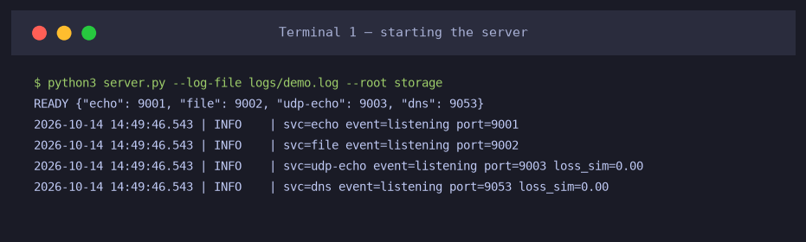
Figure 2: Starting the server: four services listening
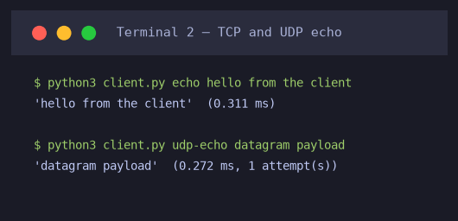
Figure 3: TCP and UDP echo with measured round-trip time
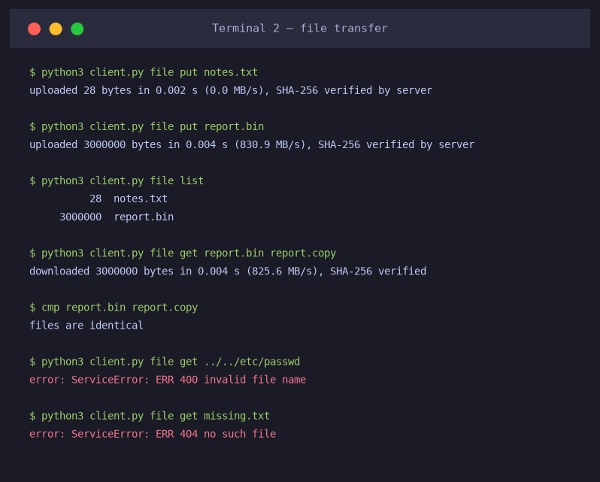
Figure 4: File transfer: upload, list, download with SHA-256 verification, byte-for-byte comparison, and rejected requests
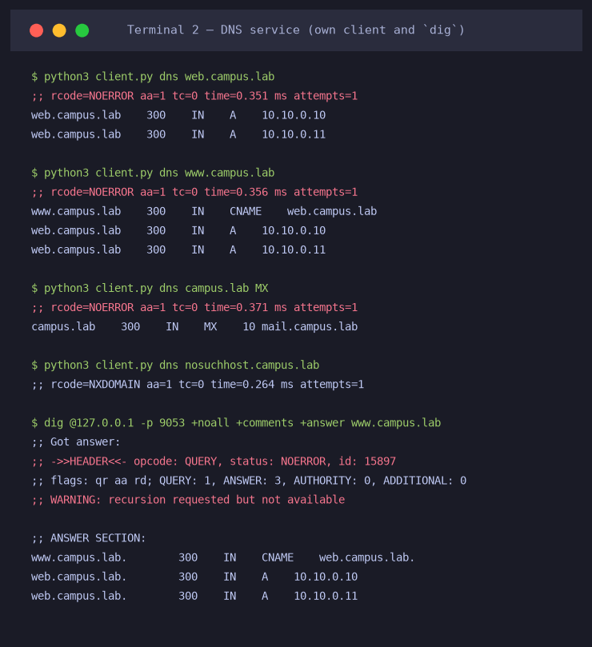
Figure 5: DNS service queried with the project client and with the independent dig tool (CNAME chain, MX, NXDOMAIN)
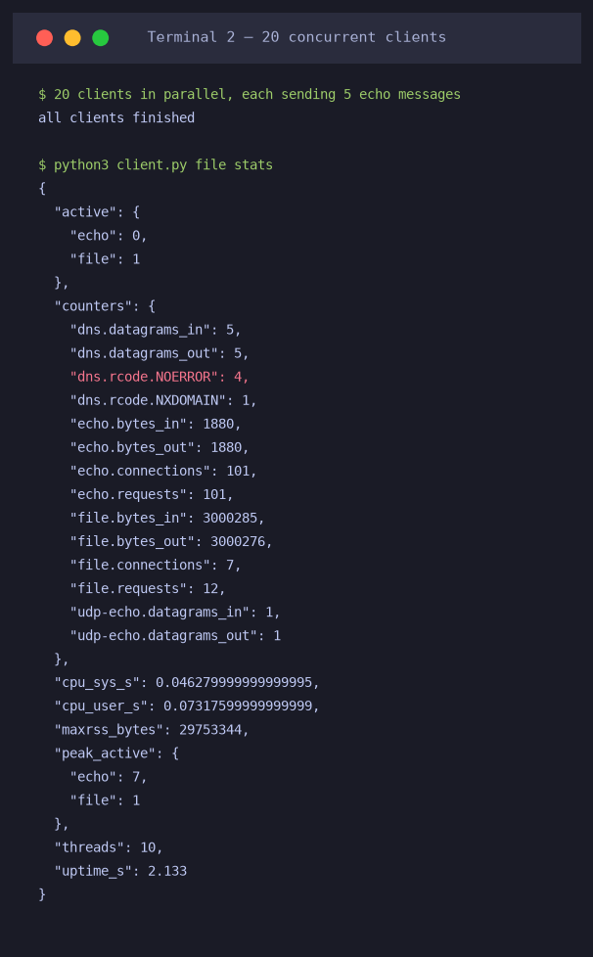
Figure 6: Twenty parallel clients and the live server statistics returned by the STATS command
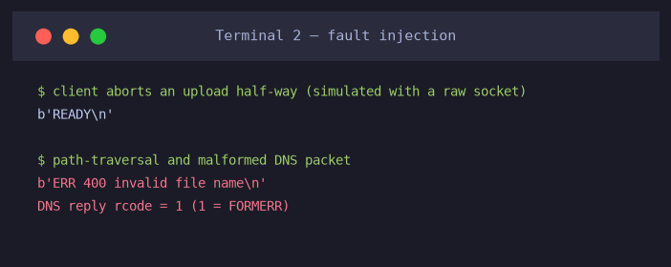
Figure 7: Fault injection: aborted upload, path traversal and malformed DNS packet (FORMERR, rcode 1)
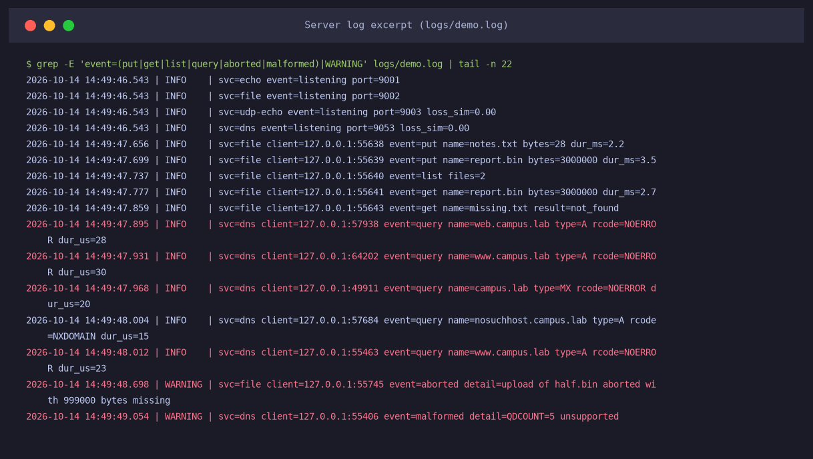
Figure 8: Server log excerpt: uploads, downloads, DNS queries with microsecond service times, a WARNING for the aborted upload and for the malformed packet
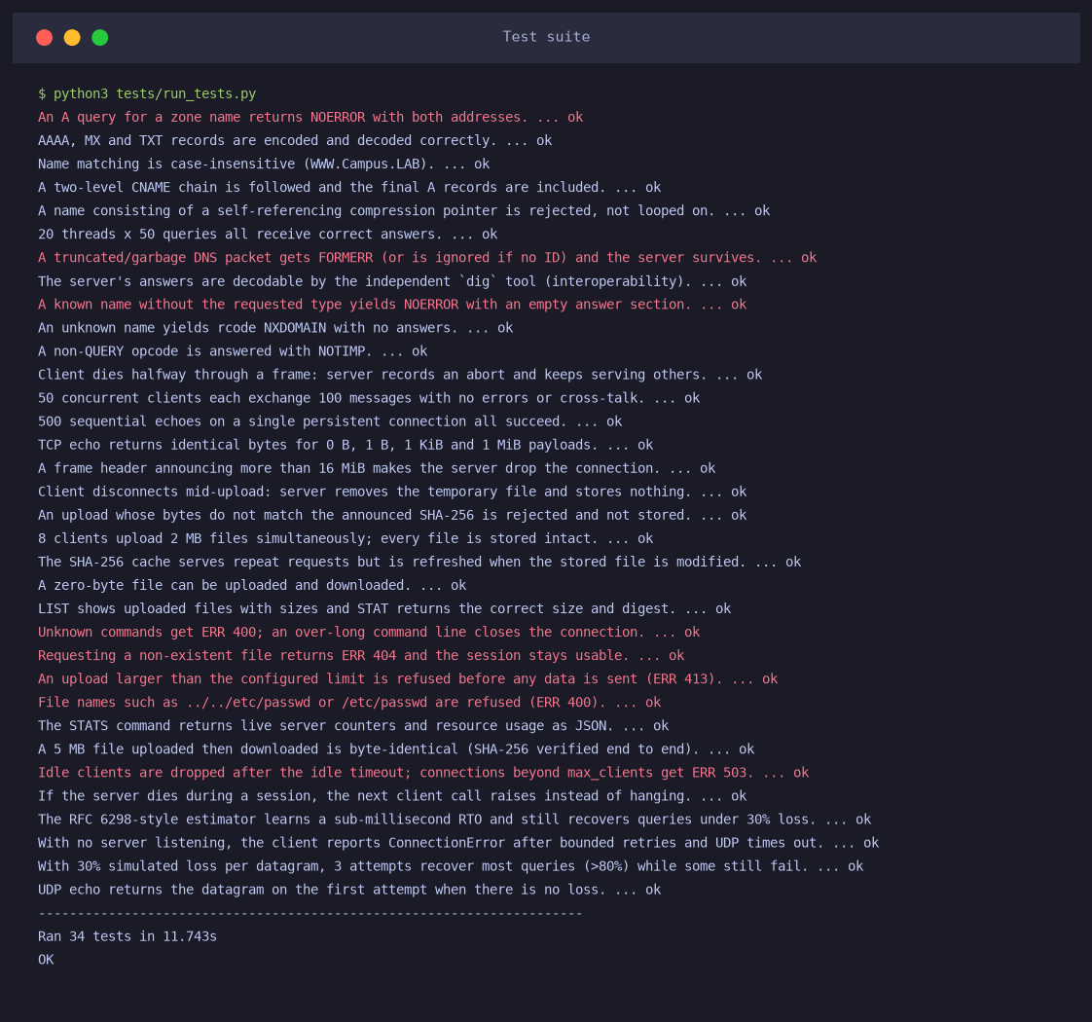
Figure 9: Automated test-suite output (34/34 passing)

d. Performance Analysis – Comparison of Methods / Protocols

d.1 Response time versus message size (TCP versus UDP)
Table 9: Echo round-trip time on a persistent connection (1,000 requests per size; 100 for ≥256 KiB). UDP sizes above 8 KiB exceed the default loopback datagram limit.
Payload (B) | TCP p50 (ms) | TCP p95 (ms) | TCP p99 (ms) | TCP goodput (MB/s) | UDP p50 (ms) | UDP p95 (ms)
16 | 0.023 | 0.028 | 0.031 | 1 | 0.040 | 0.046
256 | 0.024 | 0.028 | 0.031 | 10 | 0.044 | 0.051
1,024 | 0.024 | 0.029 | 0.032 | 41 | 0.049 | 0.057
4,096 | 0.025 | 0.029 | 0.033 | 159 | — | —
16,384 | 0.028 | 0.032 | 0.035 | 575 | — | —
65,536 | 0.045 | 0.050 | 0.054 | 1,443 | — | —
262,144 | 0.091 | 0.096 | 0.097 | 2,857 | — | —
1,048,576 | 0.214 | 0.222 | 0.233 | 4,893 | — | —

One-shot cost: opening a new TCP connection for every request costs 0.142 ms on average (p95 0.159 ms) versus 0.040 ms for a 16-byte UDP request, i.e. UDP is about 3.6× faster for an isolated exchange because there is no three-way handshake or teardown.
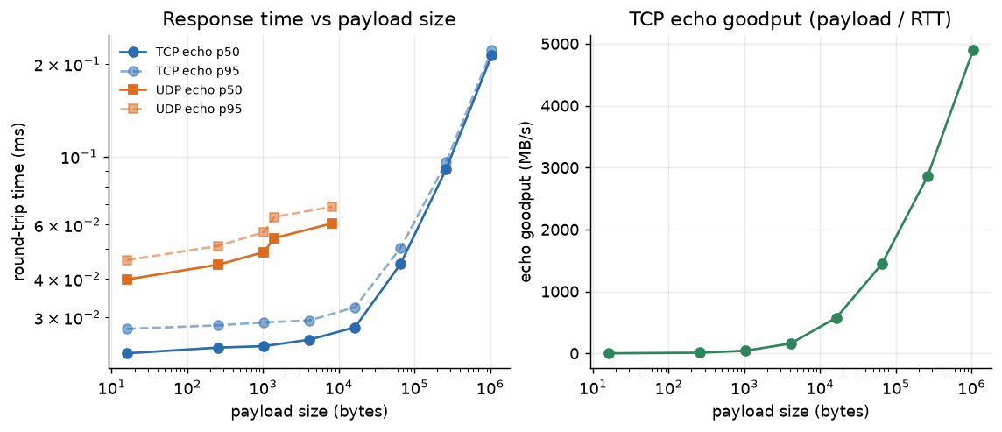
Figure 10: Response time (left) and goodput (right) versus payload size

d.2 Concurrency, throughput and server utilisation
Table 10: TCP echo (1 KiB messages) under increasing concurrency
Clients | Requests/s | p50 (ms) | p95 (ms) | p99 (ms) | Errors | Server CPU (%) | Server RSS (MB)
1 | 11,969 | 0.04 | 0.27 | 0.48 | 0 | 1 | 27.3
2 | 22,246 | 0.05 | 0.25 | 0.35 | 0 | 2 | 27.4
5 | 37,301 | 0.12 | 0.23 | 0.29 | 0 | 10 | 27.6
10 | 29,130 | 0.31 | 0.66 | 0.94 | 0 | 31 | 27.9
25 | 28,870 | 0.76 | 1.73 | 2.34 | 0 | 65 | 28.8
50 | 28,996 | 1.54 | 3.47 | 4.67 | 0 | 93 | 30.1
100 | 27,842 | 3.27 | 6.90 | 8.80 | 0 | 94 | 32.9
200 | 24,926 | 7.08 | 15.12 | 19.38 | 0 | 97 | 38.3
400 | 18,619 | 18.33 | 40.10 | 53.39 | 0 | 112 | 49.3

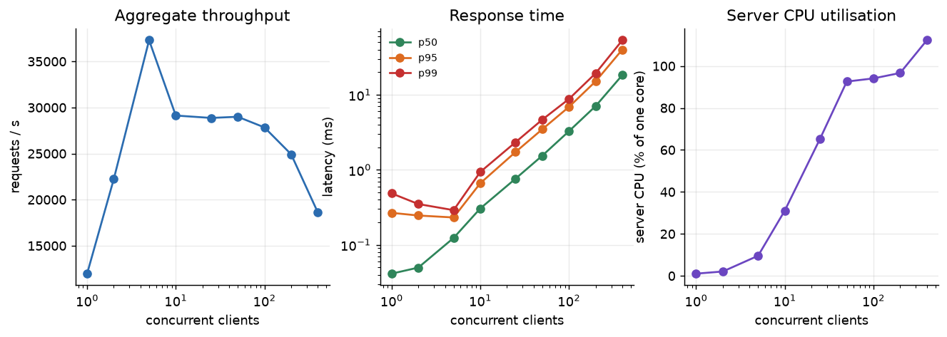
Figure 11: Throughput, response-time percentiles and server CPU versus number of concurrent clients

d.3 File transfer throughput
Table 11: Single-client file transfer throughput (mean of 3 runs; SHA-256 verified on every transfer)
File size | Upload (MB/s) | Download baseline | Download sendfile | Download digest cache | Download cache + sendfile
1 MB | 1,127 | 781 | 624 | 1,134 | 999
10 MB | 1,669 | 1,045 | 958 | 1,402 | 1,745
50 MB | 1,655 | 1,026 | 932 | 1,746 | 1,727
100 MB | 1,684 | 1,036 | 992 | 1,683 | 1,663

Table 12: Aggregate throughput and server CPU for N simultaneous 20 MB downloads
Concurrent downloads | Baseline MB/s | CPU % | sendfile MB/s | CPU % | Digest cache MB/s | CPU % | Cache+sendfile MB/s | CPU %
1 | 1,000 | 16 | 934 | 17 | 1,707 | 8 | 1,686 | 6
2 | 1,579 | 38 | 1,597 | 31 | 2,715 | 15 | 2,545 | 8
4 | 2,839 | 87 | 2,975 | 57 | 4,182 | 58 | 3,849 | 22
8 | 3,090 | 165 | 4,120 | 105 | 3,555 | 101 | 7,645 | 42
16 | 2,597 | 209 | 4,027 | 135 | 4,150 | 109 | 5,707 | 43

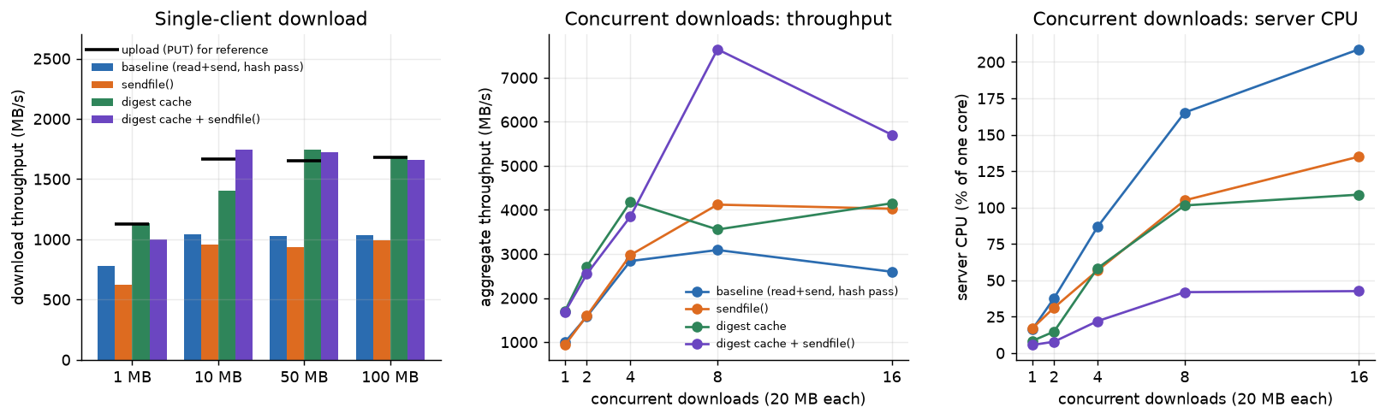
Figure 12: File-transfer throughput and server CPU for the four server variants

d.4 DNS service
Table 13: DNS response time, 3,000 sequential queries per type (client opens a new socket per query)
Query type | Mean (ms) | p50 (ms) | p95 (ms) | p99 (ms)
A (2 records) | 0.078 | 0.075 | 0.100 | 0.136
CNAME chain | 0.099 | 0.099 | 0.111 | 0.120
TXT | 0.104 | 0.103 | 0.121 | 0.133
NXDOMAIN | 0.099 | 0.101 | 0.127 | 0.149

Table 14: DNS query rate under concurrency
Concurrent resolvers | Queries/s | p95 (ms) | Errors | Server CPU (%)
1 | 4,630 | 0.53 | 0 | 3
2 | 9,469 | 0.49 | 0 | 6
4 | 13,631 | 0.49 | 0 | 13
8 | 13,926 | 1.05 | 0 | 26
16 | 14,782 | 1.89 | 0 | 43
32 | 14,553 | 3.04 | 0 | 59
64 | 12,045 | 12.06 | 0 | 77

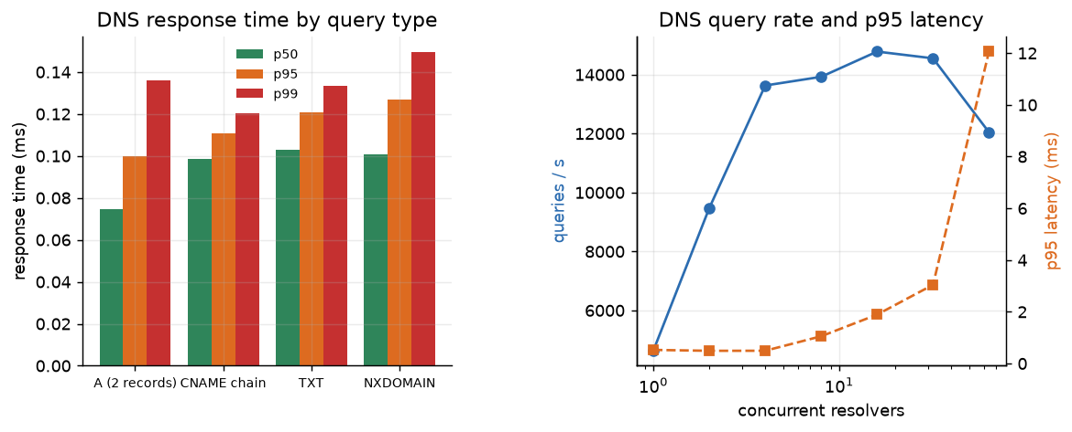
Figure 13: DNS response time by query type, and query rate / p95 latency versus concurrency

d.5 Packet loss and reliability
Table 15: UDP loss and DNS success rate versus retransmission budget (1,000 queries per cell; 2,000 raw datagrams per row; 50 ms timeout)
Loss per datagram p | Round-trip loss, theory | Round-trip loss, measured | DNS success, 0 retries (theory) | 1 retry | 2 retries | 4 retries | TCP echo success
0.0% | 0.0% | 0.0% | 100.0% (100.0%) | 100.0% (100.0%) | 100.0% (100.0%) | 100.0% (100.0%) | 100.0%
5.0% | 9.8% | 9.6% | 90.8% (90.2%) | 99.1% (99.0%) | 100.0% (99.9%) | 100.0% (100.0%) | 100.0%
10.0% | 19.0% | 19.5% | 80.6% (81.0%) | 96.4% (96.4%) | 99.4% (99.3%) | 100.0% (100.0%) | 100.0%
20.0% | 36.0% | 35.3% | 63.3% (64.0%) | 86.7% (87.0%) | 94.6% (95.3%) | 99.8% (99.4%) | 100.0%
30.0% | 51.0% | 50.8% | 48.2% (49.0%) | 73.3% (74.0%) | 84.4% (86.7%) | 96.4% (96.5%) | 100.0%
40.0% | 64.0% | 65.1% | 36.8% (36.0%) | 58.3% (59.0%) | 71.2% (73.8%) | 89.5% (89.3%) | 100.0%

Table 16: Response time of successful DNS queries (mean / p95, ms)
Loss p | 0 retries mean / p95 (ms) | 1 retry | 2 retries | 4 retries | Mean attempts (2 retries)
0.0% | 0.1 / 0.1 | 0.1 / 0.1 | 0.1 / 0.1 | 0.1 / 0.1 | 1.00
5.0% | 0.7 / 1.3 | 5.5 / 52.4 | 7.1 / 52.5 | 6.6 / 52.4 | 1.12
10.0% | 0.9 / 1.5 | 8.7 / 52.6 | 13.0 / 52.8 | 12.9 / 52.8 | 1.25
20.0% | 1.0 / 1.6 | 14.3 / 52.8 | 23.6 / 103.8 | 29.0 / 103.9 | 1.52
30.0% | 1.2 / 1.7 | 17.4 / 52.8 | 30.6 / 103.8 | 45.5 / 155.3 | 1.80
40.0% | 1.0 / 1.6 | 19.2 / 52.8 | 38.4 / 104.0 | 62.6 / 205.3 | 2.10

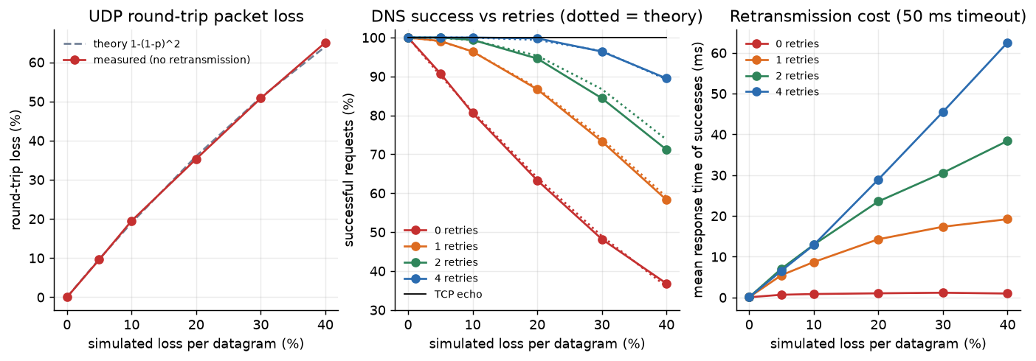
Figure 14: Measured versus theoretical UDP loss (left); DNS success versus retry budget (centre); latency cost of retransmission (right)

d.6 Resource utilisation and scalability limits
Table 17: Memory and thread cost of idle connections, and latency of one active client alongside them
Idle connections | Server RSS (MB) | Server threads | KB per connection | Echo p50 (ms) | Echo p95 (ms)
0 | 27.3 | 8 | — | 0.069 | 0.117
100 | 32.5 | 108 | 54.4 | 0.056 | 0.105
250 | 40.4 | 258 | 53.7 | 0.082 | 0.136
500 | 53.4 | 508 | 53.5 | 0.086 | 0.232
1000 | 79.5 | 1008 | 53.5 | 0.088 | 0.256
2000 | 131.7 | 2008 | 53.5 | 0.085 | 0.312

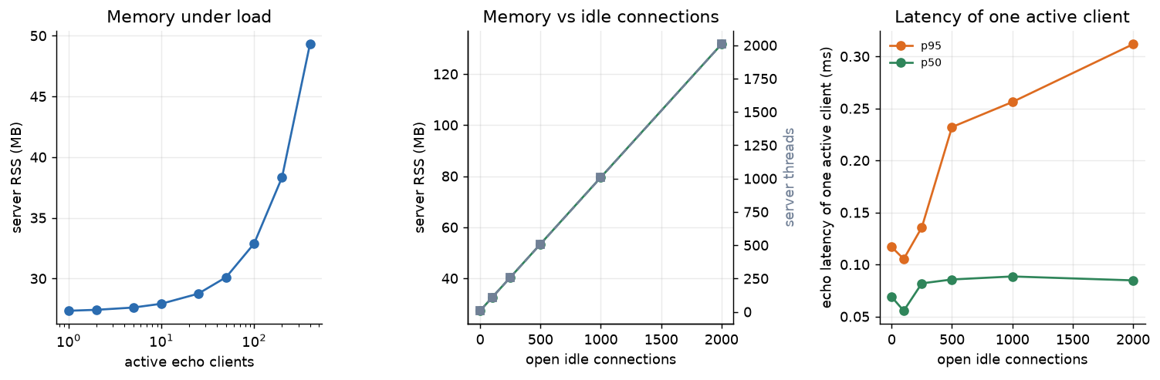
Figure 15: Server memory under load (left), memory and threads versus idle connections (centre), and latency of an active client (right)
Connection bursts. Opening connections back-to-back with no pause, the kernel accept queue overflowed after 208–343 connections in three trials (ConnectionResetError), consistent with kern.ipc.somaxconn = 128; the same server accepted 2,000 connections when they arrived at a realistic pace (10 connections per 3 ms).

d.7 Failure-detection time
Table 18: Time to detect communication failures
Scenario | How the failure appears | Detection time
Server process hung (SIGSTOP) | TimeoutError at client socket timeout of 1.0 s | 1.001 s
Server process killed (SIGKILL) | ConnectionClosed (kernel closes the socket) | 0.18 ms
Server not listening (TCP connect) | ConnectionError after 3 attempts, back-off 0.2 s + 0.4 s | 0.609 s
Server not listening (UDP) | socket.timeout after 3 attempts × 0.2 s – UDP gives no error | 0.604 s
Idle client (server side) | Server closes after configured idle timeout of 1.0 s | 1.002 s

d.8 TCP versus UDP: summary comparison
Table 19: TCP versus UDP in this platform
Criterion | TCP services (echo, file) | UDP services (echo, DNS) | Evidence
Connection set-up | 3-way handshake per connection | No handshake | One-shot request: 0.142 ms (TCP, new connection) vs 0.040 ms (UDP)
Steady-state latency (1 KiB) | 0.024 ms p50 | 0.049 ms p50 | UDP client creates a socket per request and the server hands off to a worker thread (Section 10.a)
Large transfers | Stream, flow/congestion control: 1.0–1.7 GB/s | Datagram-bounded; not suitable for bulk data | Table 11
Loss | Hidden by kernel retransmission (delay, not failure) | Visible: 35.3% round-trip loss at p = 20% | Table 15
Reliability burden | Transport | Application: 63.3% → 94.6% success with 2 retries | Table 15
Server state / memory | Thread + socket: ≈53 KB per connection | No per-client state (worker pool only) | Table 17
Failure detection | Immediate on close/reset; timeout if hung | Only timeouts | Table 18

e. Critical Evaluation / Optimization
This section records what the measurements revealed as weaknesses, what was changed in response, and what remains.
Finding and mitigation 1 – connection bursts and the accept path. The first full benchmark lost one of 400 clients (50 requests) and a test that opened 500 idle connections back-to-back was reset by the kernel. The listen queue holds at most kern.ipc.somaxconn = 128 pending connections, so a client that connects faster than the server can accept overflows it. Two server-side changes were tried: moving thread creation out of the accept loop into a separate dispatcher thread (kept, because it keeps accept() responsive at no cost), and shortening the interpreter’s GIL switch interval (no measurable effect, removed). Neither removed the limit: back-to-back connects still fail after 208–343 connections on this machine, and the exact figure varies from run to run. The limit is therefore documented as a finding, the benchmark ramps clients in at a realistic pace, and the proper fixes are listed in Section 12 (larger somaxconn/backlog, pre-spawned worker pool or event loop). With the ramp, 400 concurrent clients completed with 0 errors and 2,000 idle connections were held.
Optimisation 1 – SHA-256 digest cache. Uploads ran at 1,684 MB/s but downloads at only 1,036 MB/s (100 MB file). The reason is structural: to announce the digest before the body, the server read the whole file once to hash it and a second time to send it. Caching the digest keyed by (path, mtime, size) – populated when a verified upload completes and invalidated automatically when the file changes (test TC20) – raised single-client downloads to 1,683 MB/s (+62%), equal to the upload speed.
Optimisation 2 – `sendfile()`. Replacing the read()+send() loop with socket.sendfile() gave no gain for a single client (992 versus 1,036 MB/s), which is expected when the hash pass dominates. Its benefit shows under concurrency, where the saved user-space copies reduce CPU: with 8 concurrent downloads the baseline needed 165% CPU for 3,090 MB/s, whereas cache + sendfile() needed 42% CPU for 7,645 MB/s – roughly 2.5× the throughput at 25% of the CPU. (Single run; the direction was the same in every repeated run, and with 16 clients the gain is 2.2×.)
Weakness 1 – single-core ceiling. Echo throughput plateaus at 27,842–29,130 requests/s from 10 to 100 clients while server CPU is ≈93% – one saturated core. CPython’s Global Interpreter Lock lets only one thread execute Python bytecode at a time, so adding clients adds queueing delay, not capacity: p95 latency grows almost linearly (Little’s law: 100 clients / 27,842 req/s = 3.59 ms predicted mean versus 3.51 ms measured). At 400 clients throughput falls to 18,619 req/s (35% below the plateau) because 400 runnable threads add scheduling overhead. The fix would be several worker processes sharing the listening port (SO_REUSEPORT) or an event-loop design; it was not implemented because it would change the thread-per-connection teaching model.
Weakness 2 – memory per connection. Thread-per-connection costs ≈53.5 KB per client (131.7 MB at 2,000 connections) and kern.num_taskthreads is 4,096 on this machine, so the design tops out near 4,000 simultaneous clients. Latency of an active client is hardly affected by idle ones (p50 0.069 → 0.085 ms), so this is a capacity limit, not a speed limit.
Optimisation 3 – adaptive retransmission timeout. The loss experiments used a fixed 50 ms per-attempt timeout, so every lost datagram cost a full 50 ms even though the round trip takes about 0.1 ms; at 40% loss with 4 retries the mean response was 57.6 ms. The client now has an optional RTTEstimator that follows RFC 6298 [12]: SRTT and RTTVAR are smoothed from RTT samples (α = 1/8, β = 1/4), RTO = SRTT + 4·RTTVAR clamped to [5 ms, 2 s], only replies to first transmissions are sampled (Karn’s rule), and each retransmission doubles the timeout. Both variants were run against the same seeded loss sequence (500 DNS queries per cell, 4 retries).
Table 20: Fixed versus adaptive retransmission timeout (DNS, 4 retries)
Loss p | Fixed: success | Fixed: mean / p95 (ms) | Adaptive: success | Adaptive: mean / p95 (ms) | Speed-up (mean) | Learned RTO (ms)
0.0% | 100.0% | 0.09 / 0.14 | 100.0% | 0.08 / 0.10 | — | 5.00
10.0% | 100.0% | 13.02 / 52.22 | 100.0% | 1.95 / 6.30 | 6.7× | 5.00
20.0% | 99.0% | 26.66 / 103.34 | 99.0% | 5.21 / 17.65 | 5.1× | 5.00
30.0% | 95.8% | 41.68 / 154.35 | 95.8% | 9.13 / 38.75 | 4.6× | 5.00
40.0% | 88.2% | 57.58 / 204.48 | 88.2% | 13.51 / 78.96 | 4.3× | 5.00

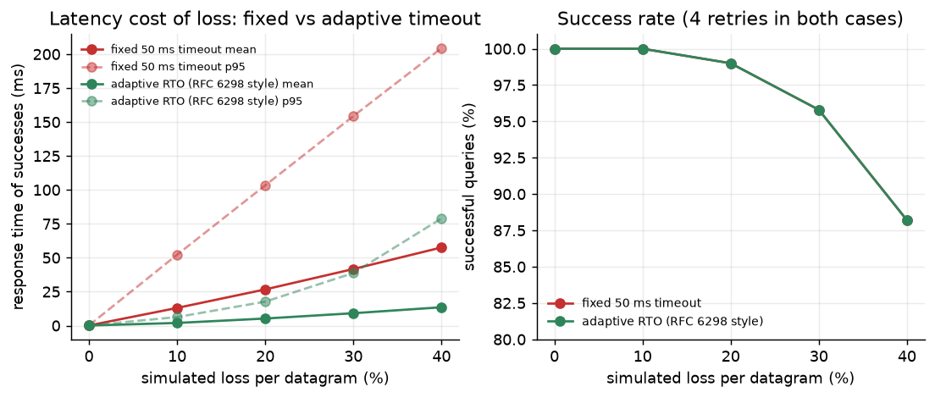
Figure 16: Fixed 50 ms timeout versus adaptive RTO: response time (left) and success rate (right)
The success rate is identical in every row, which confirms that reliability is set by the number of attempts, not by their timing. The response time, however, falls by 4.3–6.7×. On loopback the learned RTO sits at the 5 ms floor, so the floor (not the RTT) now dominates; on a real network with tens of milliseconds of RTT the estimator would track the path instead. The trade-off is that a too-small floor causes spurious retransmissions on a path whose delay suddenly rises, which is why RFC 6298 recommends a conservative minimum on the open Internet.
Threats to validity. All traffic is on loopback, so there is no propagation delay, queueing in routers, MTU fragmentation or real loss; absolute numbers will be lower on a real network and the relative conclusions (TCP versus UDP behaviour, effect of retries, effect of optimisations) are the findings to rely on. Client and server share CPU cores, and the Python load generators contribute their own latency. Results come from one machine and one session.

10. Results and Discussion

a. Findings and Inferences
- Response time. A 1 KiB TCP echo takes 0.024 ms (p50) and 0.032 ms (p99) on a persistent connection; latency is flat up to 16 KiB and then grows with size as copying dominates (1 MiB: 0.214 ms, goodput 4,893 MB/s). Inference: for small messages the cost is per-call overhead in the Python server, not bandwidth.
- TCP versus UDP. On loopback a UDP echo (1 KiB: 0.049 ms) is slower than a TCP echo on an open connection (0.024 ms): the UDP client creates a socket for each request and the server passes each datagram to a worker thread, whereas the TCP handler thread is already waiting in recv. This is an implementation effect; the protocol advantage of UDP appears only when connection set-up is included (3.6× faster for a one-shot exchange). Inference: use UDP for short, independent request/response exchanges such as DNS, and TCP for sessions and bulk data.
- Concurrency. Up to 400 simultaneous clients were served with 0 errors and no cross-talk. Throughput peaks at 37,301 req/s (5 clients) and plateaus around 28,710 req/s with the server bound to one core; latency then rises linearly with the number of clients, as predicted by Little’s law.
- File transfer. Uploads and downloads of 1–100 MB were all SHA-256 verified. Throughput is 1.7 GB/s for uploads and 1.0 GB/s for downloads before optimisation, rising to 1.7 GB/s afterwards. Values are far above any physical link because loopback is a memory copy; they measure the software stack, not a network.
- DNS. Median service time is 0.075 ms for an A query and 0.099 ms for a two-level CNAME chain; the server itself spends only 15–30 µs per query (from the log), so the rest is socket and scheduling cost. It sustains 14,782 queries/s with 0 errors, and its answers are accepted by dig.
- Packet loss. The measured round-trip loss follows 1−(1−p)² within 1.1 percentage points at every setting. With no retransmission, 20% datagram loss means 36.7% of DNS queries fail; two retries restore 94.6% success (theory 95.3%). At 40% loss four retries still reach 89.5%. Across all 24 loss/retry cells the measured success rate is within 2.6 percentage points of the model (binomial standard error at most 1.6 points with n = 1,000 queries per cell). Inference: the success rate follows 1−(1−(1−p)²)^(r+1) closely (slightly below it at 30–40% loss), so the retry budget can be chosen analytically: two retries give ≥99% success up to 10% loss (99.4% measured). Making the timeout adaptive (RFC 6298 style) keeps the same success rate but cuts the response time of lossy queries by 4.3–6.7× (Table 20).
- Reliability under failure. All 34 tests pass, including aborted uploads (no partial file remains), checksum corruption, path traversal, oversize inputs, malformed and looping DNS packets, idle-timeout and busy-server limits. A crashed server is detected in 0.18 ms, a hung one at the configured timeout (1.001 s for 1.0 s), and a dead UDP peer only after the retry budget (0.604 s).
- Resources. Idle server RSS is 27.3 MB; each open connection adds ≈53.5 KB and one thread; server CPU follows load (1% at 1 client, ≈93% at 50). Memory under 400 active clients is 49.3 MB.

b. Innovation, Novelty, and Evidence
Table 21: Innovation and evidence summary
Contribution | What is new / non-trivial | Evidence in this report
Real DNS wire-format server in the same platform as echo and file services | Hand-written RFC 1035 codec with name compression, CNAME chasing, NODATA/NXDOMAIN, TC handling, FORMERR/NOTIMP, loop-safe parser; forwarding resolver with TTL cache | Interoperates with dig (Figure 5, test matches_system_dig); 11 DNS tests
Built-in, reproducible loss injection | --loss p drops datagrams on receive and send, giving exact ground truth for reliability experiments | Measured loss within 1.1 pp of theory (Table 15, Figure 14)
Closed-form retry model validated experimentally | Success = 1−(1−(1−p)²)^(r+1) predicts DNS reliability and lets the retry budget be dimensioned | Table 15: measured vs theory in every cell
Atomic, verified file transfer | SHA-256 announced before data, verified on both ends, temp file + atomic rename, cleanup on abort | Tests on checksum mismatch, aborted upload, concurrent uploads
Measured, root-caused optimisations | Found a download/upload asymmetry through measurement, explained it (double file read), fixed it with a safe digest cache, and quantified sendfile() | +62% download throughput; 25% CPU at 8 clients (Table 12, Figure 12)
Adaptive retransmission timer | RFC 6298 estimator (SRTT/RTTVAR, Karn’s rule, exponential back-off) applied to UDP request/response | Same success, 4.3–6.7× lower latency (Table 20, Figure 16)
Honest scalability analysis | Connection-burst limit, GIL ceiling, per-connection memory and thread cap all measured and explained | Table 10, Table 17; Section 9.e
Observability | STATS command returns live counters, CPU and memory; key=value logs are machine-parseable | Figure 6, Figure 8

11. Conclusion
The project achieved its objectives. A single server process provides Echo (TCP and UDP), File Transfer and DNS services; serves hundreds of concurrent clients without errors; records every connection, request and failure in a structured log with live statistics; and detects and handles the failure modes that matter for a networked service, from a client that vanishes mid-upload to a malformed DNS packet. The evaluation produced quantitative answers on all five required metrics, and the loss experiments validate a simple analytical model, which turns retransmission policy into an engineering calculation instead of a guess.
Two lessons stand out. First, measurement exposes problems that reading code does not: the upload/download asymmetry and the connection-burst failure were both found by benchmarks and both led to concrete changes. Second, the choice between TCP and UDP is about who carries the reliability burden: TCP hides loss at the cost of connection state and set-up time; UDP is cheaper per exchange but the application must supply timeouts and retries, and the data show exactly how many are needed.

12. Limitations and Future Enhancement

Limitations
- Measurements are on the loopback interface only; real networks add latency, jitter, queueing, MTU effects and genuine loss.
- The thread-per-connection design is bounded by the interpreter’s single-core execution (≈29k echo requests/s) and by thread and memory limits (≈54 KB per connection; ≈4,000 threads per process on this macOS machine).
- A burst of more than roughly 200 simultaneous new connections can overflow the kernel accept queue (default somaxconn 128).
- No encryption or authentication: any client that can reach the ports can read, write and list files.
- The DNS service is authoritative only: no recursion (apart from simple forwarding), no EDNS0, no DNS over TCP for truncated answers, no DNSSEC, no wildcard records.
- The file service has no resume, quotas or directories. The adaptive UDP timeout uses a 5 ms floor tuned for a LAN, not the 1 s minimum RFC 6298 recommends for the open Internet.

Future enhancements
- Run the same experiments across two hosts or with Linux tc netem / Mininet to add real delay and loss, and capture traffic with Wireshark to confirm the packet-level behaviour.
- Add TLS (ssl) and token-based authentication; per-client rate limiting.
- Raise kern.ipc.somaxconn and the listen backlog; replace thread-per-connection with an asyncio or epoll event loop, or several processes sharing a port with SO_REUSEPORT, and measure the effect.
- Per-destination RTT estimators shared across requests; DNS over TCP, EDNS0 and negative caching.
- Resumable, chunked file transfer with parallel streams; compare TCP congestion-control algorithms (Cubic, BBR) on the transfer service.
- Export metrics in Prometheus format and add a small dashboard.

References
[1] J. Postel, “Transmission Control Protocol,” RFC 793, 1981; W. Eddy (ed.), “Transmission Control Protocol (TCP),” RFC 9293, 2022.
[2] J. Postel, “User Datagram Protocol,” RFC 768, 1980.
[3] L. Eggert, G. Fairhurst, G. Shepherd, “UDP Usage Guidelines,” RFC 8085, 2017.
[4] W. R. Stevens, B. Fenner, A. M. Rudoff, UNIX Network Programming, Volume 1: The Sockets Networking API, 3rd ed., Addison-Wesley, 2003.
[5] J. F. Kurose, K. W. Ross, Computer Networking: A Top-Down Approach, 8th ed., Pearson, 2021.
[6] J. Postel, “Echo Protocol,” RFC 862, 1983.
[7] J. Postel, J. Reynolds, “File Transfer Protocol (FTP),” RFC 959, 1985.
[8] K. Sollins, “The TFTP Protocol (Revision 2),” RFC 1350, 1992.
[9] P. Mockapetris, “Domain Names – Concepts and Facilities,” RFC 1034, 1987.
[10] P. Mockapetris, “Domain Names – Implementation and Specification,” RFC 1035, 1987.
[11] D. Kegel, “The C10K problem,” 1999. http://www.kegel.com/c10k.html
[12] V. Paxson, M. Allman, J. Chu, M. Sargent, “Computing TCP’s Retransmission Timer,” RFC 6298, 2011.
[13] Python Software Foundation, “socket – Low-level networking interface” and “threading”, Python 3 documentation. https://docs.python.org/3/library/socket.html
[14] R. Jain, The Art of Computer Systems Performance Analysis, Wiley, 1991.

