PocketSmart AI
AI-Powered Smart Planning Assistant
Project Documentation
FastAPI • Gemini AI • SQLite • Jinja2 • HTML/CSS/JavaScript

Project Area | Details
Project Name | PocketSmart AI
Application Type | AI-powered recommendation and planning platform
Main Modules | Home Interior Planner, Party Budget Planner, Jewelry Planner
Backend | Python + FastAPI
AI Layer | Google Gemini
Database | SQLite + SQLAlchemy
Frontend | Responsive Jinja2 + HTML/CSS/JavaScript

Prepared as a structured project document with coding snapshots

1. Project Description
PocketSmart AI is an AI-powered planning assistant designed to generate practical, budget-aware recommendations for everyday planning tasks. The platform combines a responsive browser frontend, a FastAPI backend, modular planning routes, SQLite-based data storage, authentication, and Google Gemini for AI-generated recommendations.

Use Case Scenarios
Scenario | User Action | System Response
Home Interior Planning | Enter room, style and budget | Generates a practical interior plan and budget-aware recommendations
Party Budget Planning | Enter event type, guests and budget | Generates an event plan with estimated budget allocation
Jewelry Planning | Provide occasion, budget and outfit image | Uses multimodal AI context to suggest suitable jewelry ideas
History & Account | Register/login and view previous plans | Stores and retrieves user-related recommendation history

Core Objective
The project aims to reduce the effort needed to plan common lifestyle activities by combining user inputs, budget constraints and AI-generated recommendations in one web application.

2. Architecture Overview
PocketSmart AI follows a modular web architecture. The browser frontend collects user inputs and sends requests to FastAPI endpoints. The backend validates requests, invokes the relevant planner route and connects to Gemini. SQLite/SQLAlchemy supports application data and history.
Layer | Main Responsibility
Frontend UI | Forms, planner selection, image upload, result display and user interaction
FastAPI API Layer | REST endpoints, validation, authentication and routing
Planner Routes | Home, Party and Jewelry recommendation workflows
Gemini AI Layer | Prompt-based and multimodal recommendation generation
Database Layer | SQLite storage through SQLAlchemy models
Authentication | Registration, login, logout and session/token handling
Fallback Engine | Local fallback response path when AI service is unavailable

Technology Stack
- Python – backend application language
- FastAPI – REST API framework
- Uvicorn – ASGI development server
- Google Gemini API – AI generation
- SQLAlchemy + SQLite – application data and recommendation history
- Pydantic – request and response validation
- Jinja2 – server-rendered frontend templates
- HTML, CSS and JavaScript – browser interface
- python-dotenv – environment configuration

3. Project Structure & Prerequisites

Important Project Structure
Path | Purpose
requirements.txt | Python dependencies
.env.example | Environment variable template
run.py | Application run entry point
app/main.py | FastAPI application
app/config.py | Configuration and environment settings
app/database.py | SQLite/SQLAlchemy database setup
app/models.py | Database models
app/schemas.py | Pydantic schemas
app/auth.py | Authentication helpers
app/gemini_utils.py | Gemini AI integration
app/fallback.py | Fallback recommendation engine
app/routes/ | Home, Party and Jewelry API routes
templates/ | Jinja2 HTML pages
static/ | CSS and JavaScript assets

Prerequisites
- Python 3.10 or newer
- Visual Studio Code
- Gemini API access
- Internet connection for AI generation
- Modern browser such as Google Chrome
- Dependencies installed from requirements.txt

Environment Configuration
Store secrets in environment variables and do not place API keys inside frontend JavaScript.
Example .env values:
GEMINI_API_KEY=your_key_here
GEMINI_MODEL=gemini-2.5-flash

4. Core Modules & API Endpoints

Planner Modules
Module | Function
Home Planner | Generates home interior ideas using room, style and budget inputs
Party Planner | Creates party planning recommendations with budget allocation
Jewelry Planner | Generates jewelry recommendations using occasion, budget and outfit image
Authentication | Handles user registration, login, logout and session/token flow
History | Stores and retrieves generated recommendations
Fallback Engine | Provides local fallback responses when external AI generation fails

API Endpoints
Endpoint | Method | Purpose
/generate-home | POST | Generate home interior recommendation
/generate-party | POST | Generate party budget recommendation
/generate-jewelry | POST | Generate jewelry recommendation with image context
/register | POST | Create a user account
/login | POST | Authenticate a user
/logout | POST | End the current session
/token | POST | Authentication token flow
/session-info | GET | Return session information
/session-data | GET | Return stored session-related data
/docs | GET | Open FastAPI Swagger documentation

Request Validation & Error Handling
- Reject missing or malformed request data before sending it to the AI layer.
- Validate uploaded image type and size for the Jewelry planner.
- Handle Gemini authentication and temporary service errors.
- Return clear HTTP error messages to the frontend.
- Log backend failures for easier troubleshooting.

5. Frontend User Interface
The frontend is designed as a responsive browser interface. Users can select a planner, enter required information, submit the request and view the generated recommendation.

Main UI Components
- PocketSmart AI title and navigation
- Login and registration controls
- Planner selection for Home, Party and Jewelry
- Budget and preference input fields
- Image upload for the Jewelry planner
- Generate button and loading state
- Formatted recommendation result area
- History/session controls
- Error and validation messages

Frontend-to-Backend Workflow
User Input → JavaScript → FastAPI Endpoint → Planner Route → Gemini AI → Response → UI

Expected User Flow
Step | Action
1 | Open PocketSmart AI in the browser
2 | Register or log in
3 | Choose Home, Party or Jewelry planner
4 | Enter preferences and budget
5 | Upload outfit image when using Jewelry planner
6 | Generate the recommendation
7 | Review the result and access saved history

6. Coding Reference – Backend
The following coding snapshots show the core FastAPI application and planner integration used in PocketSmart AI.
Figure 1: FastAPI application entry point
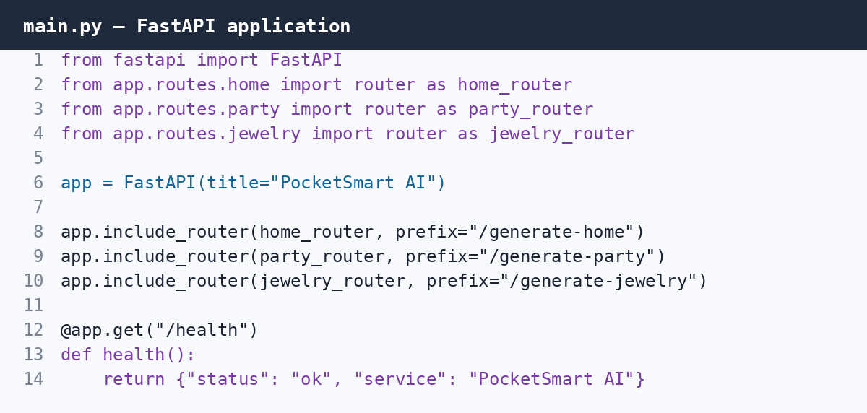
Figure 2: Gemini client integration
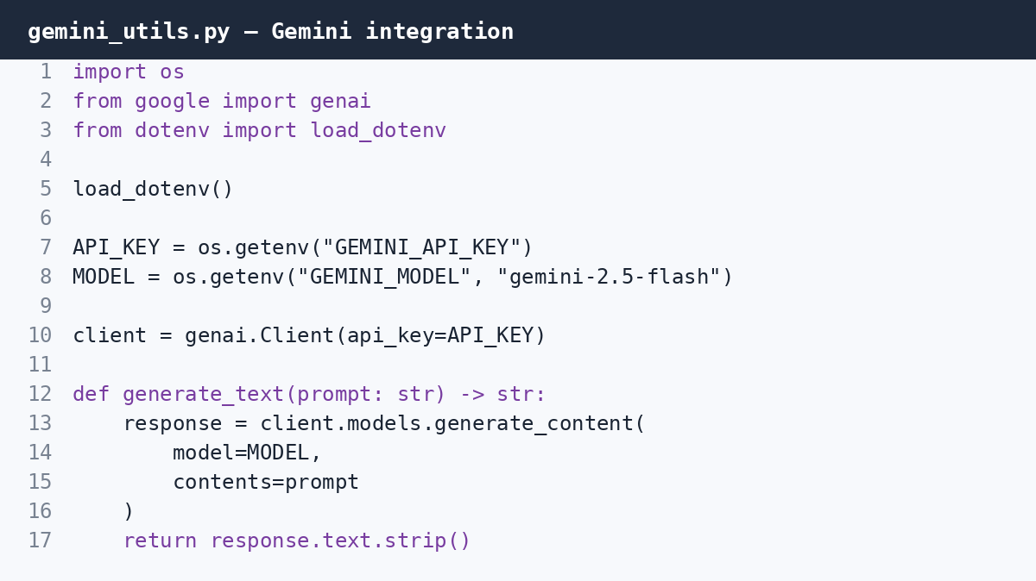

7. Coding Reference – Planner Routes
Figure 3: Home planner API route
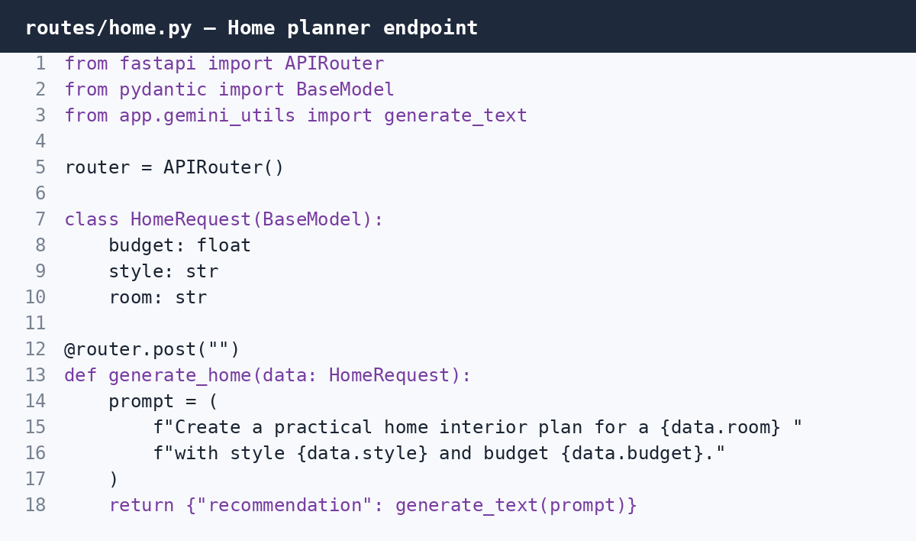
Figure 4: Party budget planner route
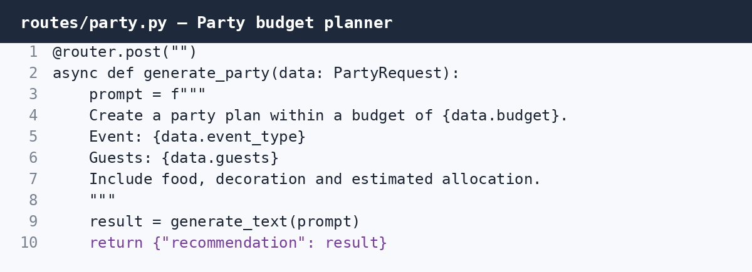

8. Coding Reference – Multimodal AI & Frontend
Figure 5: Jewelry planner with outfit image context
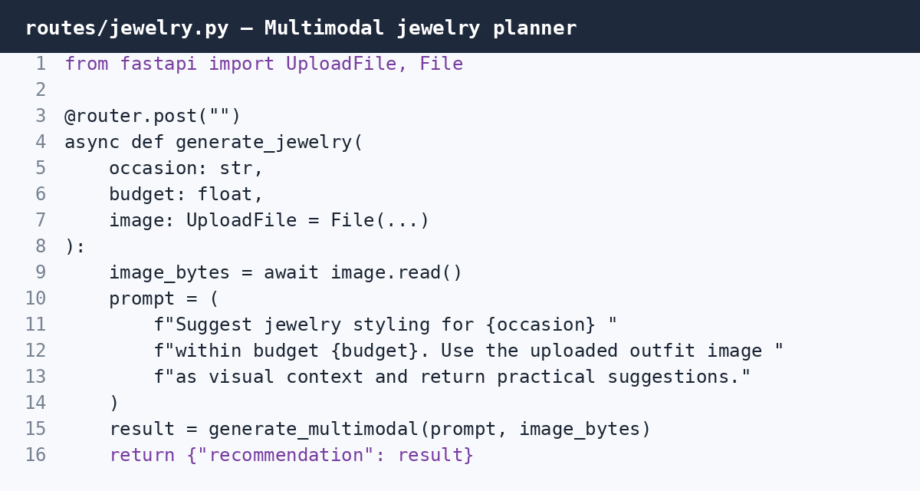
Figure 6: Frontend JavaScript API integration
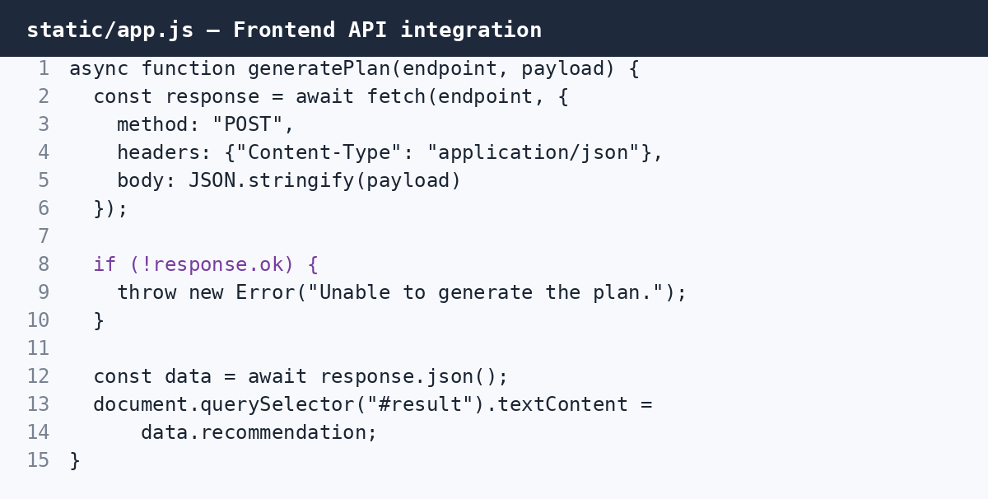
These six code screenshots are included as project-documentation figures so the implementation can be demonstrated clearly during review, viva or presentation.

9. Testing, Deployment & Troubleshooting

Testing Plan
- Test registration, login and logout flows.
- Test valid and invalid Home planner inputs.
- Test Party planner budget and guest inputs.
- Test Jewelry image upload validation and AI generation.
- Test history/session retrieval.
- Test Gemini authentication failures and temporary service failures.
- Test complete workflow: browser → FastAPI → planner → Gemini → browser.

Local Deployment
1. Open PocketSmart AI in VS Code.
2. Create and activate the virtual environment.
3. Install dependencies from requirements.txt.
4. Configure GEMINI_API_KEY and GEMINI_MODEL.
5. Run the FastAPI application.
6. Open the application in a browser.
Run command: python run.py

Useful Local URLs
Resource | URL
Application | http://127.0.0.1:8000
FastAPI Swagger | http://127.0.0.1:8000/docs

Troubleshooting
Issue | Check
API key missing | Check GEMINI_API_KEY in .env
Model error | Check GEMINI_MODEL and supported model access
Gemini temporary error | Retry after service recovery
Frontend request fails | Check browser console and API endpoint
CORS/session issue | Check backend configuration and request origin
Database issue | Check SQLite path and SQLAlchemy configuration

10. Security, Conclusion & Future Enhancements

Security Notes
- Never expose the Gemini API key in frontend JavaScript.
- Do not commit .env secrets to GitHub.
- Validate all user inputs before AI generation.
- Validate uploaded images before processing.
- Use secure authentication/session handling in deployment.

Conclusion
PocketSmart AI combines modular planning services, FastAPI APIs, authentication, database storage and Gemini-powered generation into one web application. The project provides separate workflows for home interior planning, party budgeting and jewelry recommendations while keeping the backend organized into reusable modules.

Future Enhancements
- More personalized budget optimization
- Saved favorites and comparison views
- Advanced recommendation history
- Voice-based planning requests
- Tamil and English language support
- PDF/report export
- Improved multimodal recommendations
- Analytics dashboard
- Streaming AI responses

Project Workflow Summary
User → Frontend → FastAPI → Authentication/Validation → Planner Module → Gemini AI → Database/History → Frontend

PocketSmart AI — AI-assisted planning for practical, budget-aware decisions.

