## **Project Archons 1.5-Page GDD**

*A powerful god stuck in forest*

**Genre:** RPG, 3rd person Action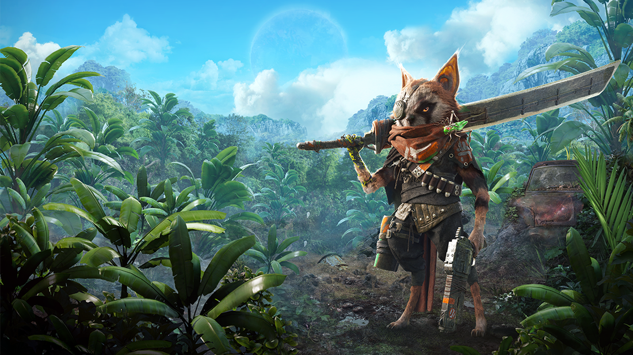  
**Target Audience:** 13 +

**Controls:** Keyboard or controller

**Thematic Setting:** In a forest

**Tech Stack:** Github, Unity

**Platform(s):** Mac

**MVP Game Moment:**

**Game Summary:**

**Core Player Experience:**

**Central Story Theme:**

**Design Pillar:**

**Remarkability:**

**Anticipated Steam Early Access Launch date:**

**Feature Development Priorities:**

**Reference Games:**