“Academind Community” on Discord: https://academind.com/community/

##################################################################
================== flutter =================
flutter create my_app
flutter run
================== start android studio =================
source /home/sarvottam/.bashrc
studio.sh
================== emulator =================
./emulator -list-avds
./emulator -avd Pixel_3a_API_32

##################################################################

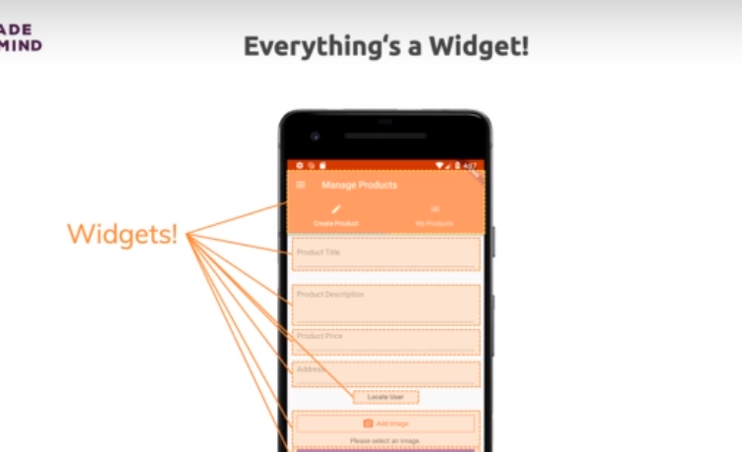

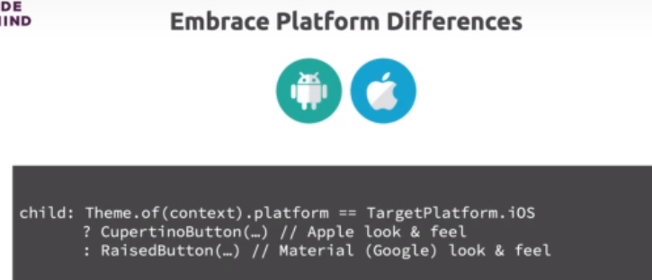
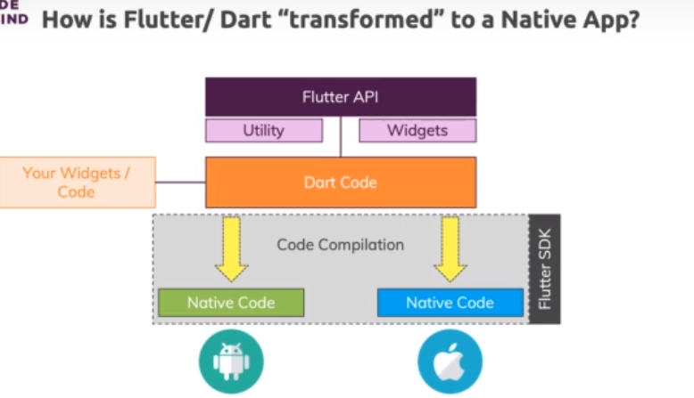
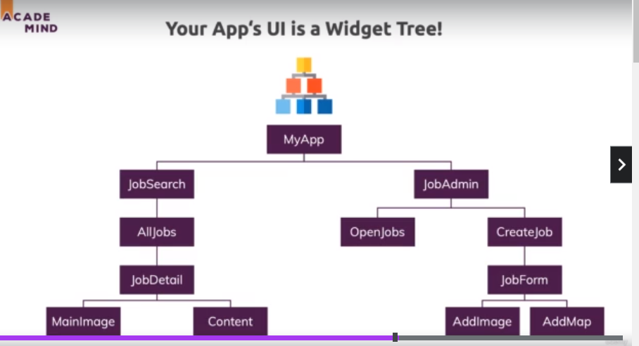

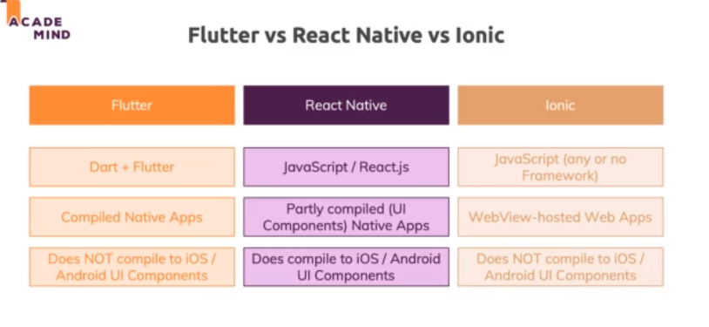

https://www.simplilearn.com/enable-virtualization-windows-10-article

data types
int
double
String
var automatic
-----------------------------------------------------------------------------------
classs myApp{
}
var pi = person();
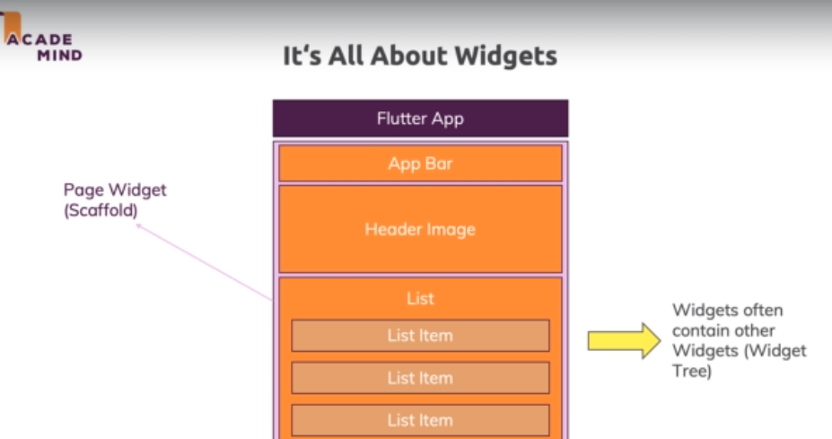
class asd {
Person (String name, int age){
name =
this.age //same varibale to put “this”
}

====================

call variable by name
class asd {
Person ({String name, int age}){
name =
this.age //same varibale to put “this”
}
}

----------- object
var p2 = Person(age: 31, name: ‘menu’);

@required
------- --------------------------sortcut constructor
Person({this.name, this.age =30});

