Comparison of Configurations E2 and E3: Solar–Heat Pump Coupling Topology
Case study: Kathmandu, Autumn (Oct–Nov), A_c = 10 m², ε_HRX = 0.70

1. Objective
Configurations E2 and E3 both combine a sensible-counterflow heat-recovery exchanger (HRX), a flat-plate solar air collector, and a vapour-compression heat pump (HP) to raise fresh ambient air to the drying setpoint T_set = 45 °C. They differ only in the relative ordering of the solar collector and the condenser on the air path that feeds the drying chamber. This document quantifies the resulting performance gap under identical boundary conditions and explains the difference from first principles so that the topology choice can be defended in the thesis discussion.

2. Topology and Control

2.1 Air paths
In Config E2 the solar collector is placed upstream of the condenser, so the air entering the collector is cold HRX-preheated ambient air. In Config E3 the order is reversed: the condenser heats the air first, and the collector performs a final top-up before the chamber inlet. The evaporator side and the HRX are identical in both configurations.
Config | Condenser stream | Evaporator stream | Control strategy
E2 | Amb → HRX → Solar → Cond → Chamber | Exhaust (post-HRX) + iterative ambient make-up | Fixed T_cond = 55 °C; HP idles when T_after_solar ≥ T_set
E3 | Amb → HRX → Cond → Solar → Chamber | Exhaust (post-HRX) + iterative ambient make-up | Variable T_cond ≤ 55 °C, solar-priority: HP OFF when solar alone meets T_set, partial lift otherwise

2.2 Solar-priority control in E3
E3 exploits the freedom to let the condenser operate below its nominal setpoint. At each time step the simulator back-calculates the highest collector inlet temperature T_cond,out that still allows the downstream collector to reach T_set, using the Hottel–Whillier–Bliss relation
T_out = T_in + (F_R · (τα) · G · A_c − F_R · U_L · A_c · (T_in − T_amb)) / (ṁ · c_p)
If the required T_cond,out is lower than T_set, the HP is asked to deliver a smaller lift; if the HRX output alone satisfies the equation above, the compressor is switched off entirely and the collector supplies the whole heating duty. E2 has no such degree of freedom — its condenser always targets 55 °C and the excess solar heat, when T_after_solar exceeds 45 °C, is simply clipped at the chamber inlet.

3. Numerical Results
Both configurations were simulated on the Kathmandu PVGIS-TMY autumn subset (October + November, 1464 hourly records). The drying batch is 3.0 kg of apple on 10 trays, initial moisture 5.20 kg/kg d.b., target 0.10 kg/kg d.b. The solar collector area is 10 m² and the HRX effectiveness is 0.70. Fan power and drying kinetics are identical across both runs.
Quantity | E2 (Solar→Cond) | E3 (Cond→Solar) | E3 − E2
Drying time [h] | 16.93 | 16.93 | 0.00
Water removed [kg] | 19.31 | 19.31 | 0.00
W_comp total [kWh] | 1.956 | 2.157 | +0.201 (+10.3 %)
W_fan total [kWh] | 0.415 | 0.415 | 0.000
SEC [kWh/kg_water] | 0.1228 | 0.1333 | +0.0105 (+8.6 %)
Q_cond total [kWh] | 9.95 | 11.16 | +1.21
Q_solar useful [kWh] | 20.95 | 19.78 | −1.18 (−5.6 %)
HP on-fraction | 0.618 | 0.618 | 0.000
T_cond mean (HP-on) [°C] | 55.0 | 53.5 | −1.5
T_cond minimum [°C] | 55.0 | 36.2 | −18.8
Lift mean (HP-on) [K] | 39.74 | 38.28 | −1.46
Lift minimum [K] | 36.38 | 23.49 | −12.90
COP mean (HP-on) | 5.22 | 5.47 | +0.25 (+4.8 %)
COP peak | 5.63 | 8.56 | +2.93 (+52 %)
Collector η energy-weighted | 0.467 | 0.442 | −0.025
Collector T_in mean (day) [°C] | 30.2 | 34.9 | +4.7
Collector T_out mean (day) [°C] | 50.5 | 54.1 | +3.6
The headline result is that E2 dries the same batch with 8.6 % less specific energy consumption, even though E3 attains a 52 % higher peak COP and a lower mean thermodynamic lift. The remainder of this document resolves that apparent paradox.
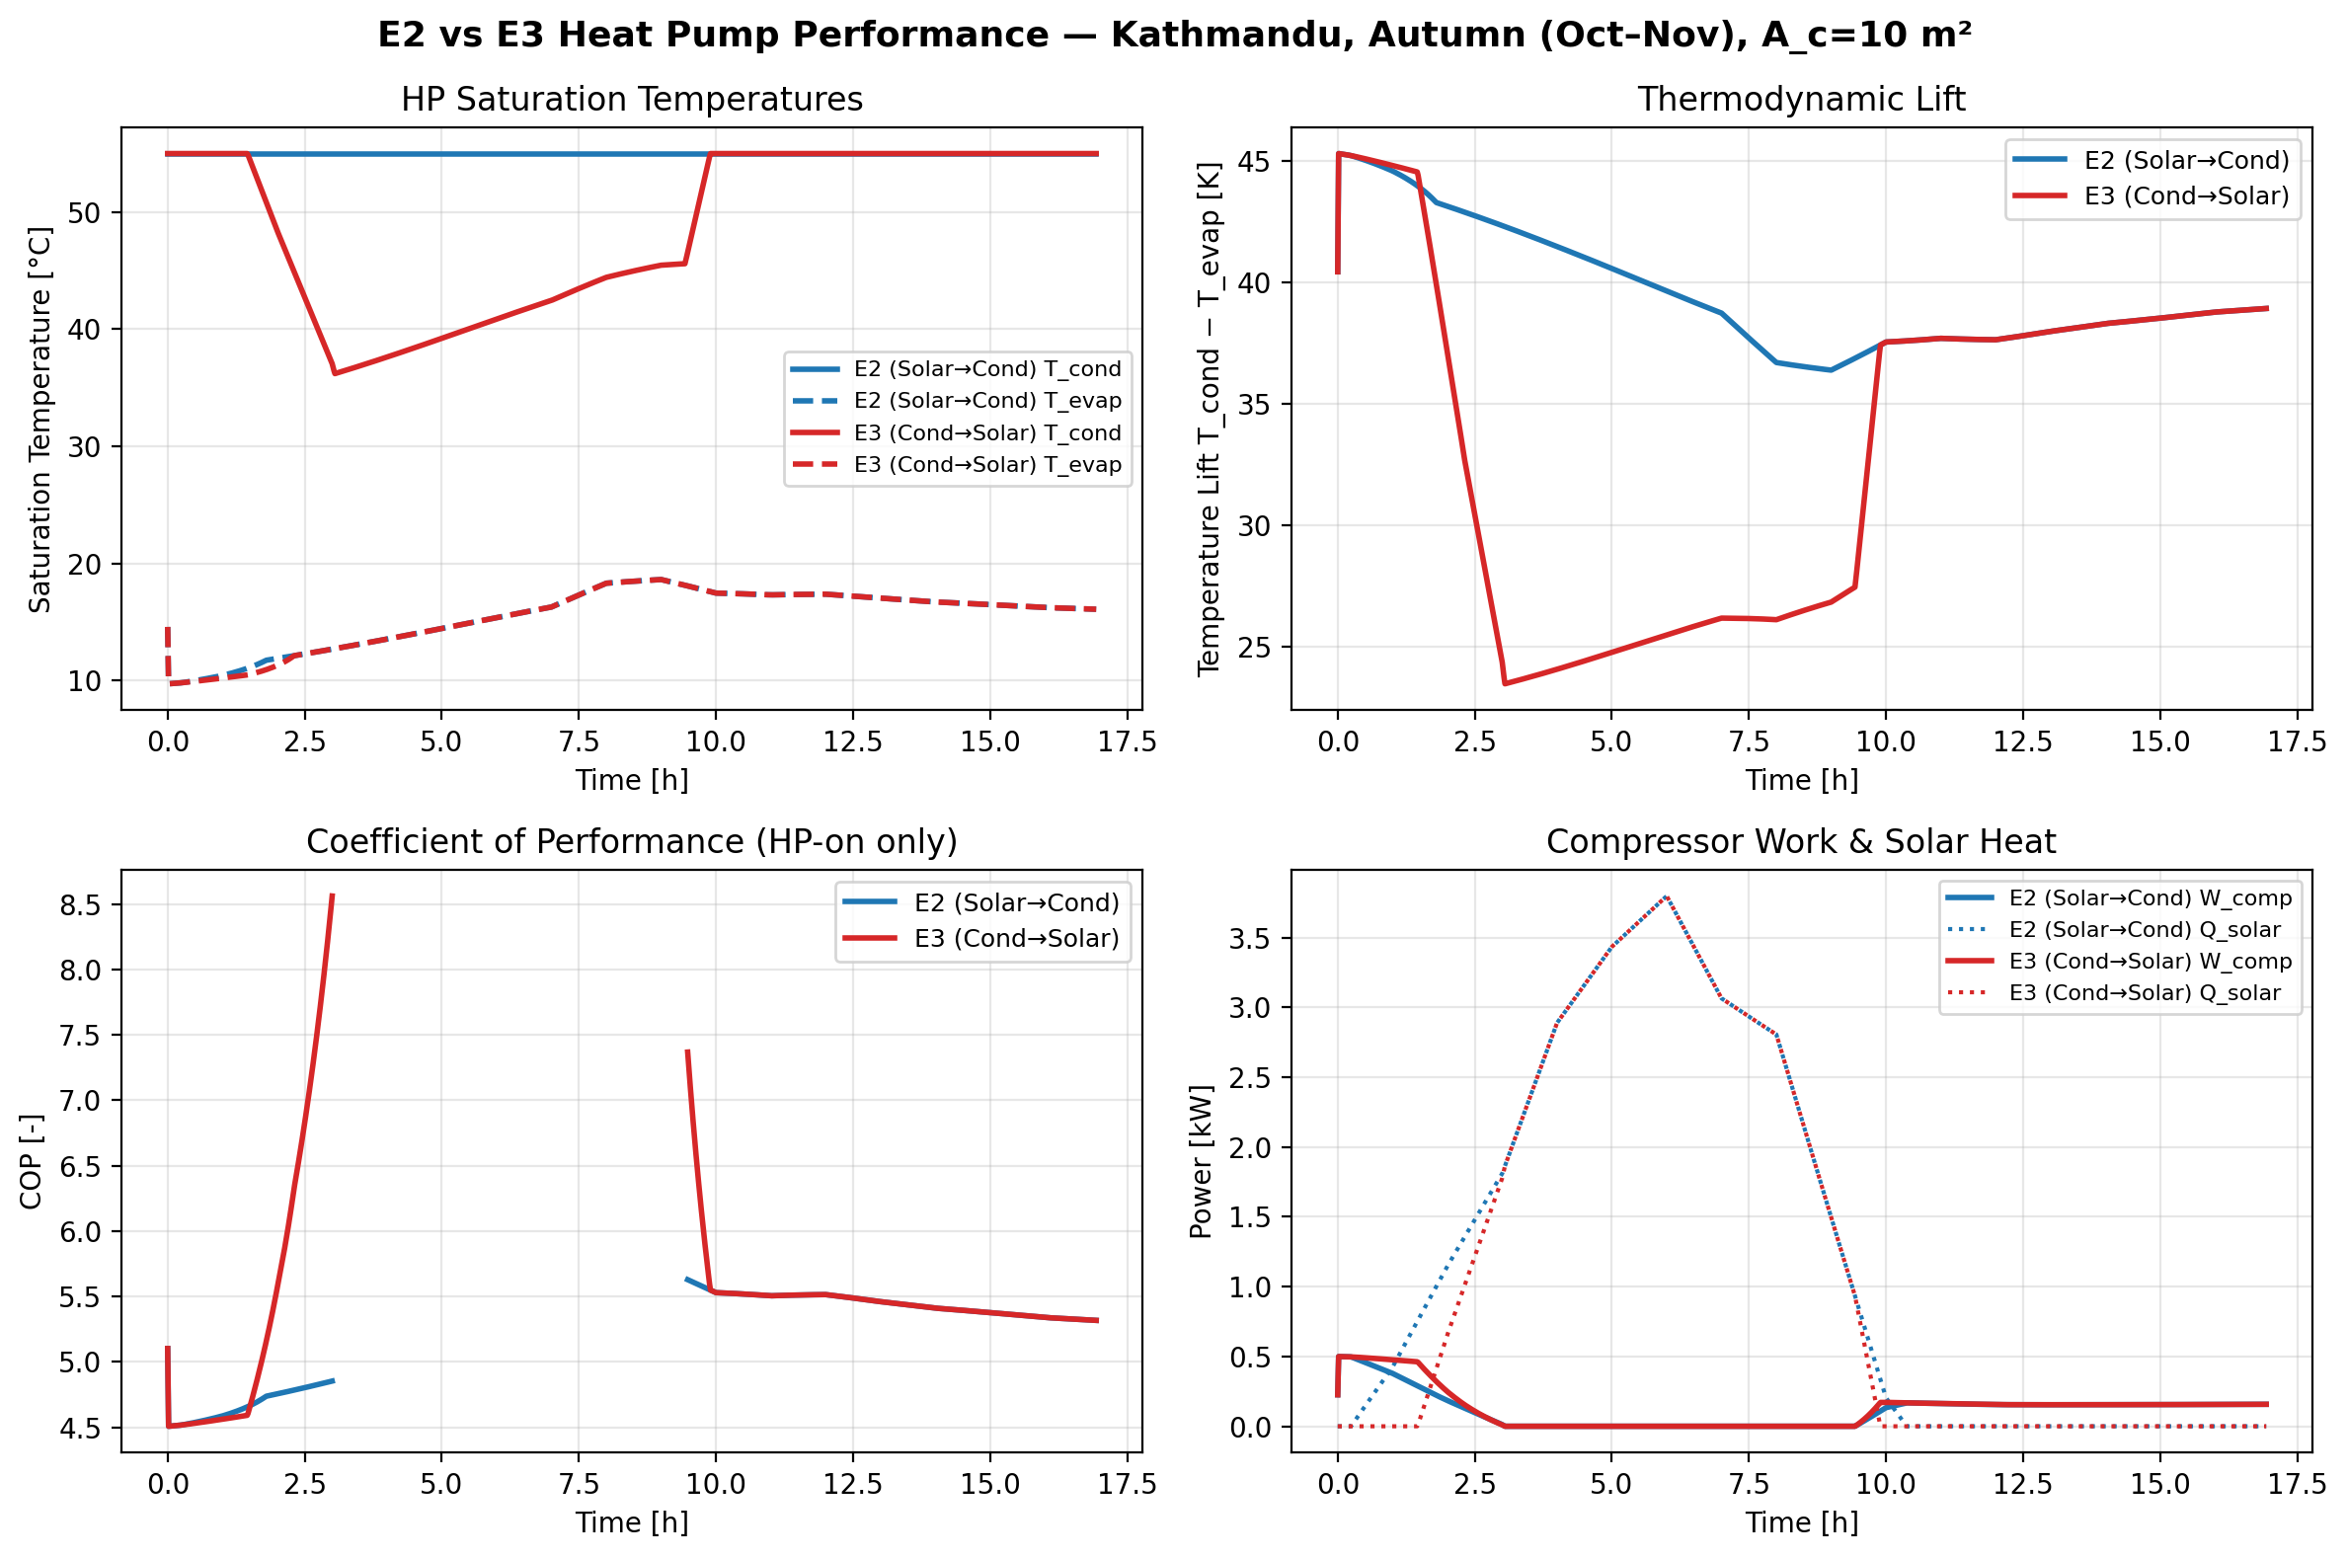
Figure 1. Heat-pump performance of Config E2 (blue) and Config E3 (red) over a representative autumn drying batch in Kathmandu. Top-left: saturation temperatures. Top-right: thermodynamic lift. Bottom-left: instantaneous COP when the compressor is running. Bottom-right: compressor work and useful solar heat.

4. Physical Explanation

4.1 Carnot framing of the heat pump
For a vapour-compression cycle with fixed isentropic efficiency, the actual COP tracks the Carnot bound
1COP_Carnot = T_cond / (T_cond − T_evap)
with an approximately constant second-law efficiency (0.61–0.62 in our validation set for η_is = 0.75). E3’s solar-priority control reduces T_cond during peak insolation hours, shrinking the denominator and producing the dramatic COP spike visible in Figure 1 (peaks at 8.56 when T_cond dips to 36 °C). E2’s fixed condenser target keeps the lift nearly flat at ~40 K, so its COP only varies through the small swing in T_evap.

4.2 Hottel–Whillier–Bliss collector efficiency
The flat-plate collector efficiency is the ratio of useful air-side enthalpy gain to incident radiation:
η_c = F_R · (τα) − F_R · U_L · (T_in − T_amb) / G
The second term — the loss term — is linear in the inlet-to-ambient temperature difference (T_in − T_amb). Placing the collector upstream of the condenser (E2) gives it cold HRX-warmed ambient air, typically 22–35 °C, so (T_in − T_amb) rarely exceeds 10 K and collector losses are minimised. Placing the collector downstream of the condenser (E3) forces it to operate with air that has already been lifted part of the way to T_set, so (T_in − T_amb) is 5–15 K larger at every moment. The measured energy-weighted efficiency drops from 0.467 (E2) to 0.442 (E3), a 2.5 percentage-point penalty.
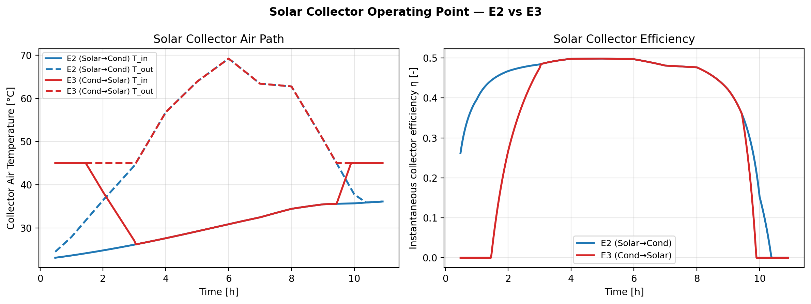
Figure 2. Solar collector operating point. Left: air temperatures at the collector inlet (solid) and outlet (dashed). E3’s inlet is consistently warmer because the condenser precedes the collector. Right: instantaneous collector efficiency η_c. Both configurations approach the same peak value at midday, but E3 starts producing useful heat later and E2 holds its efficiency over a longer window.

4.3 Why higher peak COP does not translate to lower SEC
The apparent paradox is resolved by noting that the COP gain and the collector-efficiency loss act on different quantities. E3 improves the quality of a smaller quantity of heat-pump output: during peak sun the HP provides only a partial lift, so although each kWh of compressor work buys more condenser heat, the compressor is supplying less of the total thermal demand. E2 instead improves the quantity of useful solar heat delivered to the air stream by keeping the collector on its efficient operating branch. Over the whole batch the balance favours E2:
Q_solar,E2 − Q_solar,E3 ≈ +1.18 kWh > (W_comp,E3 − W_comp,E2) · COP_E2 ≈ +1.05 kWh
In other words, the extra solar heat that E2 extracts is larger than the thermal equivalent of the extra compressor work E3 needs, so the net electrical energy consumption is lower for E2 despite its lower peak COP.

4.4 Solar clipping in E2 is a small effect
An obvious concern with E2 is that on high-insolation hours the collector outlet can exceed T_set. The simulator enforces T_air_in,cond = min(T_after_solar, T_set), so any surplus is effectively wasted. In the autumn Kathmandu run this clipping is active for ~6 h per batch, but the collector efficiency during those hours is already near its Hottel–Whillier ceiling (η ≈ 0.49). Moving the same collector behind the condenser (E3 topology) to avoid clipping does not reclaim that energy — instead it degrades the collector’s loss term and the HP has to make up the shortfall.

5. Discussion and Design Implication
The E2-versus-E3 comparison isolates a design principle that is easily obscured by heat-pump-centric reasoning: in a hybrid solar-HP dryer the dominant optimisation target is the collector loss term, not the HP lift. Within the range of conditions studied here (dry-bulb 15–28 °C, GHI up to 900 W m⁻²), the flat-plate collector’s heat-loss coefficient U_L is large enough that a 5 °C increase in inlet temperature costs about the same amount of delivered heat as a 1 K reduction in HP lift buys. The correct design move is therefore to place the collector where the air is coldest, which in this hybrid family means upstream of the condenser (Config E2).
Three caveats are worth stating explicitly for the thesis:
(i) The result is specific to air-based collectors with relatively high U_L (~6 W m⁻² K⁻¹ in our model). Evacuated-tube or selective-surface collectors with lower U_L would narrow the gap because the loss penalty of the E3 topology scales directly with U_L.
(ii) E3’s variable-T_cond strategy is still valuable as a control concept: it is the mechanism that lets the HP decouple from the setpoint when renewable heat is abundant. The present result only says that placing the collector behind the condenser is the wrong physical location to realise that benefit in an air system.
(iii) At very low insolation, both configurations degenerate to a Configuration D (HRX-only) solution, so the E2/E3 gap closes at night. The quoted 8.6 % SEC advantage is therefore season- and site-specific; the physical direction of the inequality, however, is not — it follows directly from the sign of ∂η_c / ∂T_in.

6. Conclusion
Under identical weather, kinetics, HRX, and heat-pump parameters, Config E2 (Solar → Condenser) reaches the same dryness with 8.6 % less specific energy consumption than Config E3 (Condenser → Solar) on a representative Kathmandu autumn batch. The advantage arises because the solar collector in E2 operates with a cooler inlet stream (~30 °C) than in E3 (~35 °C), reducing its heat-loss term and increasing the energy-weighted collection efficiency from 0.442 to 0.467. E3’s higher peak COP (up to 8.56 versus 5.63 in E2) is a real but smaller benefit that does not compensate for the lost solar yield. The design recommendation for air-based solar-assisted heat-pump dryers is therefore to place the collector upstream of the condenser whenever the collector is the dominant source of thermal losses.

