E1 / E2 / E3 System-Level Findings
Reference document for paper writing — numbers, tables, and figures only (system-level; kinetic-model audit documented separately).
All results: HRX effectiveness e=0.70, collector area A_c=10 m^2, R134a heat pump, T_set=45 C, batch m_p_dry=3.0 kg (10 trays). VPD bypass: threshold=0.05 kPa, 3x hysteresis, 600 s dwell. Validation: zero first-law violations across 92 canonical runs (Section 7).

1. Configuration recap
All three configurations combine an exhaust-air heat-recovery exchanger (HRX), a flat-plate solar air collector, and an R134a heat pump. They differ only in (a) where the solar collector sits in the air path and (b) how the evaporator is fed.

E1 - HRX + Solar before condenser, ambient evaporator
Air path: Ambient -> HRX (preheat) -> Solar (preheat) -> Condenser (top-up to 45 C) -> Chamber. The evaporator is fed by ambient air only. This is the simplest topology: solar acts as a second preheater, the heat pump never sees recovered exhaust on the source side.

E2 - HRX + Solar before condenser, exhaust+ambient evaporator
Air path: identical to E1 on the supply side (Amb -> HRX -> Solar -> Cond -> Chamber). The difference is the evaporator: it is fed by the post-HRX exhaust mixed with an ambient supplement sized iteratively so the evaporator can absorb Q_evap = Q_cond - eta_mech*W_comp. Warmer evaporator inlet -> higher COP -> lower compressor work for the same Q_cond.

E3 - HRX + Solar after condenser, exhaust+ambient evaporator
Air path: Ambient -> HRX -> Condenser -> Solar -> Chamber. The collector is plumbed downstream of the condenser, so when irradiance is high the heat pump can run at a lower lift (partial-lift control law) and let the collector finish heating to T_set. The evaporator side matches E2.
VPD bypass (all three configs): when the chamber-inlet vapour-pressure deficit relative to recovered exhaust falls below 0.05 kPa, the supply air bypasses the HRX. For E1/E2 the bypass path is Exhaust -> Solar -> Cond -> Chamber. For E3 the bypass preserves topology: Exhaust -> Cond -> Solar -> Chamber. A 3x hysteresis band and 600 s dwell prevent rapid switching.

2. Headline performance numbers

2.1 SEC without VPD bypass [kWh / kg water]
case | E1 | E2 | E3 | best | E2 vs E1 [%] | E3 vs E1 [%] | E3 vs E2 [%]
BIR / annual | 0.1427 | 0.1298 | 0.1373 | E2 | -9.00 | -3.78 | +5.73
BIR / autumn oct nov | 0.1189 | 0.1081 | 0.1138 | E2 | -9.04 | -4.29 | +5.22
BIR / spring mar apr | 0.0758 | 0.0719 | 0.0793 | E2 | -5.23 | +4.60 | +10.37
BIR / winter dec jan | 0.1202 | 0.1106 | 0.1203 | E2 | -7.95 | +0.16 | +8.81
DHU / annual | 0.1842 | 0.1668 | 0.1814 | E2 | -9.49 | -1.56 | +8.77
KAT / annual | 0.2226 | 0.1987 | 0.2182 | E2 | -10.76 | -1.98 | +9.83
KAT / autumn oct nov | 0.1362 | 0.1226 | 0.1330 | E2 | -9.95 | -2.30 | +8.49
KAT / spring mar apr | 0.1013 | 0.0942 | 0.1043 | E2 | -7.05 | +2.97 | +10.78
KAT / winter dec jan | 0.1454 | 0.1323 | 0.1431 | E2 | -9.03 | -1.62 | +8.14
TAP / annual | 0.1795 | 0.1639 | 0.1757 | E2 | -8.67 | -2.10 | +7.20
TAP / autumn oct nov | 0.1128 | 0.1018 | 0.1082 | E2 | -9.73 | -4.06 | +6.29
TAP / spring mar apr | 0.1226 | 0.1146 | 0.1215 | E2 | -6.51 | -0.87 | +6.02
TAP / winter dec jan | 0.1805 | 0.1626 | 0.1720 | E2 | -9.94 | -4.72 | +5.79

Source: outputs/audit/step4_pivot_SEC_no_vpd.csv (13 cases). E2 wins SEC in 13/13 cases. Mean E2-vs-E1 saving = -8.64 %; mean E3-vs-E2 penalty = 7.80 %.

2.2 SEC with VPD bypass [kWh / kg water]
case | E1 | E2 | E3 | best | E2 vs E1 [%] | E3 vs E1 [%] | E3 vs E2 [%]
BIR / annual | 0.0995 | 0.0957 | 0.1024 | E2 | -3.89 | +2.85 | +7.01
BIR / autumn oct nov | 0.0708 | 0.0689 | 0.0738 | E2 | -2.67 | +4.21 | +7.07
BIR / spring mar apr | 0.0608 | 0.0595 | 0.0660 | E2 | -2.09 | +8.65 | +10.97
BIR / winter dec jan | 0.0825 | 0.0800 | 0.0886 | E2 | -3.01 | +7.40 | +10.74
KAT / annual | 0.1529 | 0.1442 | 0.1599 | E2 | -5.69 | +4.59 | +10.91
KAT / autumn oct nov | 0.0864 | 0.0832 | 0.0923 | E2 | -3.72 | +6.80 | +10.93
KAT / spring mar apr | 0.0781 | 0.0756 | 0.0843 | E2 | -3.20 | +7.95 | +11.52
KAT / winter dec jan | 0.1040 | 0.0997 | 0.1087 | E2 | -4.07 | +4.57 | +9.01
TAP / annual | 0.1325 | 0.1276 | 0.1379 | E2 | -3.67 | +4.10 | +8.07
TAP / autumn oct nov | 0.0696 | 0.0676 | 0.0728 | E2 | -2.79 | +4.69 | +7.69
TAP / spring mar apr | 0.0953 | 0.0928 | 0.0982 | E2 | -2.60 | +3.03 | +5.78
TAP / winter dec jan | 0.1226 | 0.1173 | 0.1245 | E2 | -4.29 | +1.54 | +6.09

Source: outputs/audit/step4_pivot_SEC_vpd.csv (12 cases). E2 wins 12/12. Mean E2-vs-E1 saving = -3.48 %; mean E3-vs-E2 penalty = 8.82 %. Dhulikhel intentionally omitted from the VPD set (no VPD experiment run for that location).

2.3 VPD bypass reduction in SEC vs no-VPD baseline
config | mean reduction [%] | min [%] | max [%]
E1 | -30.0000 | -40.4300 | -19.8600
E2 | -26.1600 | -36.2600 | -17.2100
E3 | -25.4300 | -35.1400 | -16.7600

Negative values indicate SEC improvement under VPD. Source: derived from step4_pivot_SEC_*.csv.

3. Head-to-head verdict

3.1 Win count per KPI (best per case)
config | SEC | SMER | t_h | COP_med | Q_solar_usable | mode | n_cases
E1 | 0 | 0 | 13 | 0 | 13 | no_vpd | 13
E2 | 13 | 13 | 0 | 0 | 0 | no_vpd | 13
E3 | 0 | 0 | 0 | 13 | 0 | no_vpd | 13
E1 | 0 | 0 | 12 | 0 | 12 | vpd | 12
E2 | 12 | 12 | 0 | 11 | 0 | vpd | 12
E3 | 0 | 0 | 0 | 1 | 0 | vpd | 12

Read: 'SEC=13' means that config achieves the best SEC in 13 of 13 cases. Source: outputs/audit/step4_winrate.csv.

Key takeaways:
- E2 wins SEC and SMER in every single case (13/13 no-VPD, 12/12 VPD).
- E1 always finishes drying fastest (lowest t_h) because its evaporator is colder, which forces a higher condenser duty and pushes more heat into the chamber per unit time, even though it is energetically expensive.
- E3 has the highest median COP in 11/12 VPD cases (lower lift -> higher Carnot ceiling), but the lift it enables is partial, so total compressor energy and SEC are both worse than E2.
- Q_solar_usable wins are split E1/E3 because their collector inlet temperatures differ; raw solar capture does not predict SEC.

4. Energy split - where each kWh comes from

4.1 Mean energy shares by config (all 13 cases)
config | SEC [kWh/kg] | SMER [kg/kWh] | COP | HRX share [%] | Solar share [%] | HP share [%] | eta_overall [%] | Solar clipped [%]
E1 | 0.14 | 7.62 | 4.27 | 48.01 | 28.49 | 23.50 | 91.91 | 39.97
E2 | 0.13 | 8.31 | 4.75 | 48.01 | 28.49 | 23.50 | 93.56 | 39.97
E3 | 0.14 | 7.70 | 4.84 | 47.99 | 25.88 | 26.12 | 100.04 | 42.34

Shares are fractions of the chamber-inlet heat budget (Q_HRX + Q_solar_usable + Q_cond). 'eta_overall' is Q_useful_latent / (W_total + Q_solar_gross). 'Solar clipped' is the fraction of gross solar capture that exceeded what the control loop could absorb at T_set. Source: outputs/audit/step3_energy_split.csv.
Headline: across all configurations, ~50 % of inlet-air heat comes from the HRX, ~25-30 % from solar, ~22-30 % from the heat pump. The HRX is the largest single source of heat, followed by the heat pump and solar in roughly equal proportion.

4.2 Energy-split figures
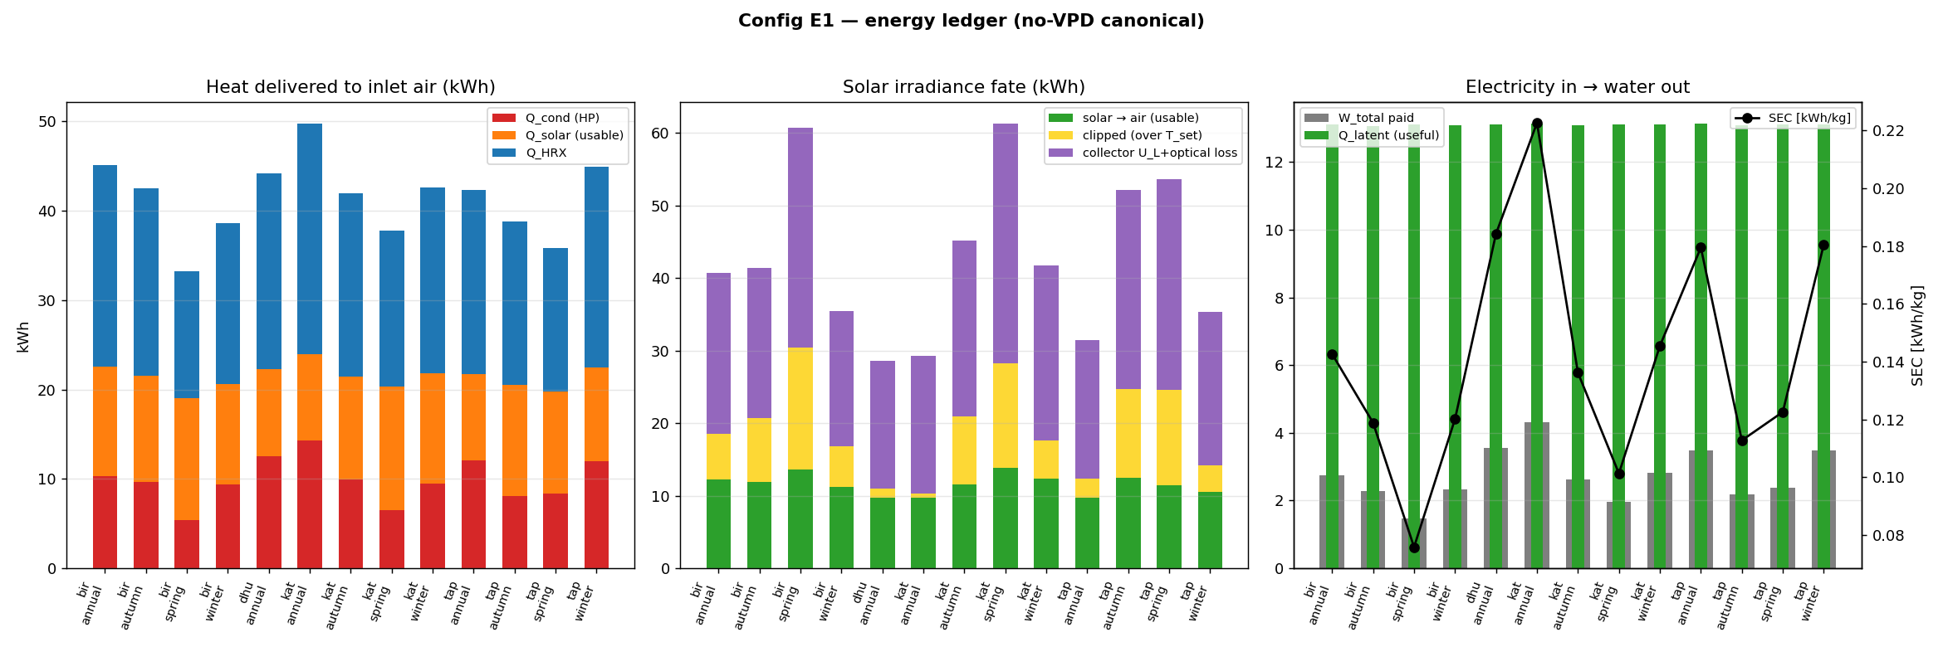
Figure 4.1. Energy split for E1: chamber-inlet heat budget and collector-irradiance fate, by location.
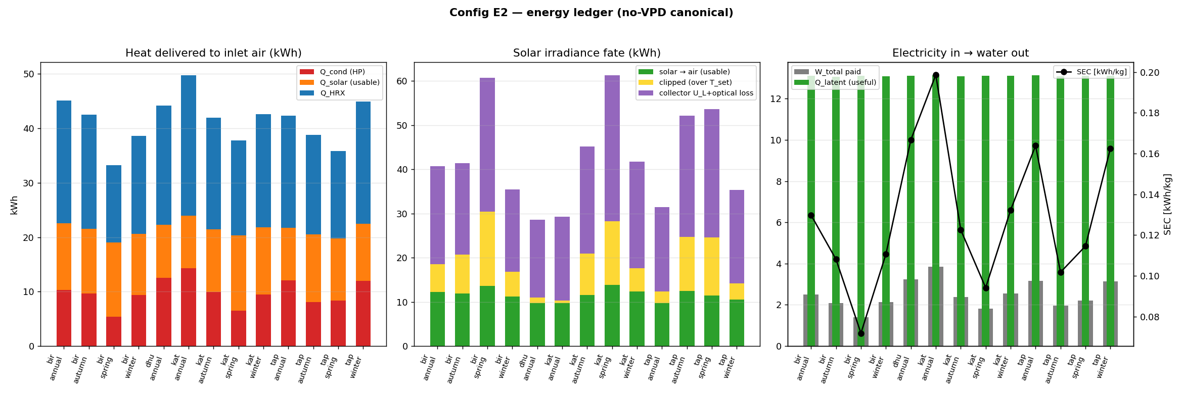
Figure 4.2. Energy split for E2: chamber-inlet heat budget and collector-irradiance fate, by location.
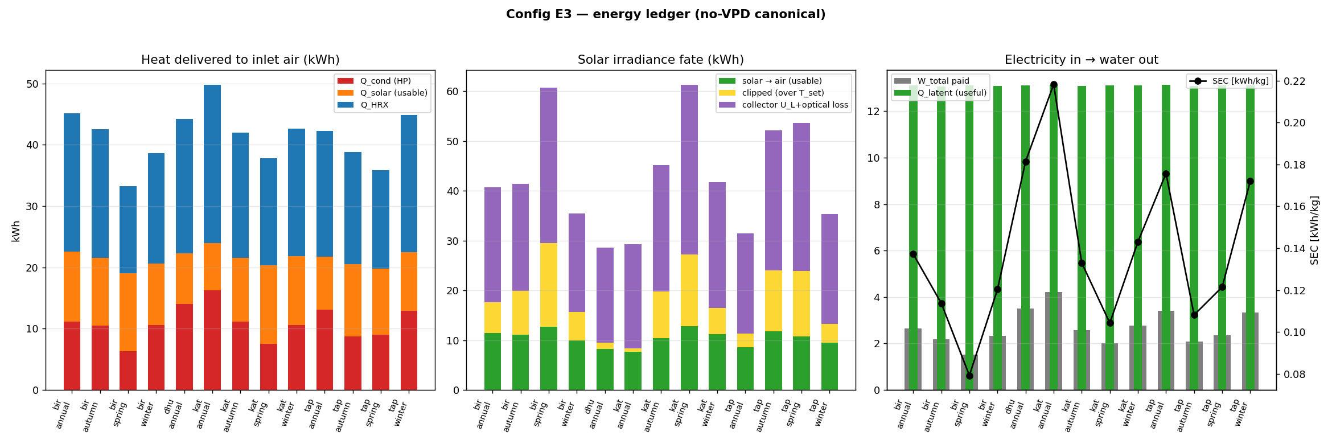
Figure 4.3. Energy split for E3: chamber-inlet heat budget and collector-irradiance fate, by location.

4.3 Psychrometric trace (Kathmandu annual reference case)
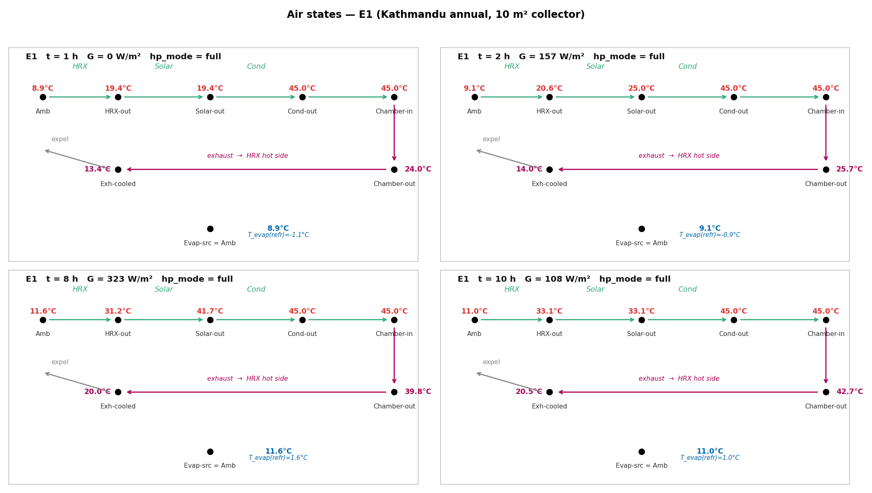
Figure 4.4-E1. Air state at each station (Kathmandu, annual) for E1: T-omega trajectory through HRX, solar, condenser, chamber, evaporator.
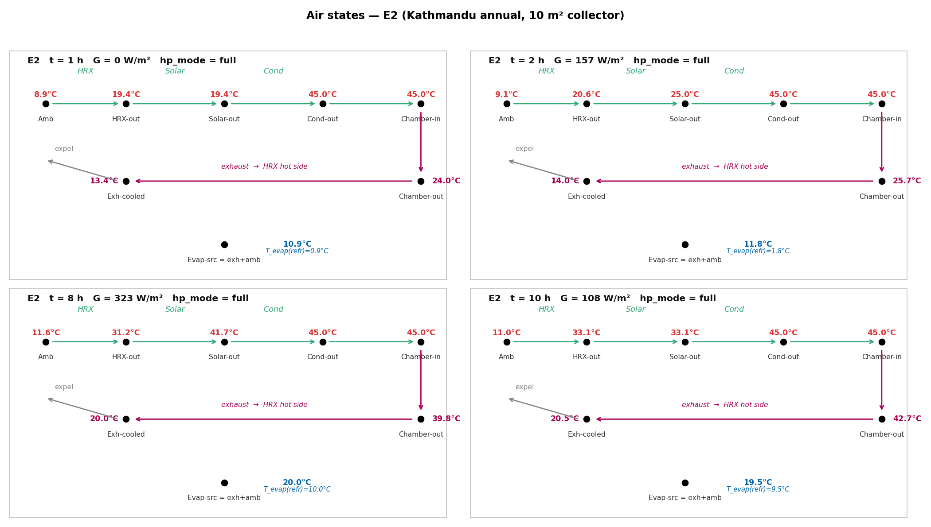
Figure 4.4-E2. Air state at each station (Kathmandu, annual) for E2: T-omega trajectory through HRX, solar, condenser, chamber, evaporator.
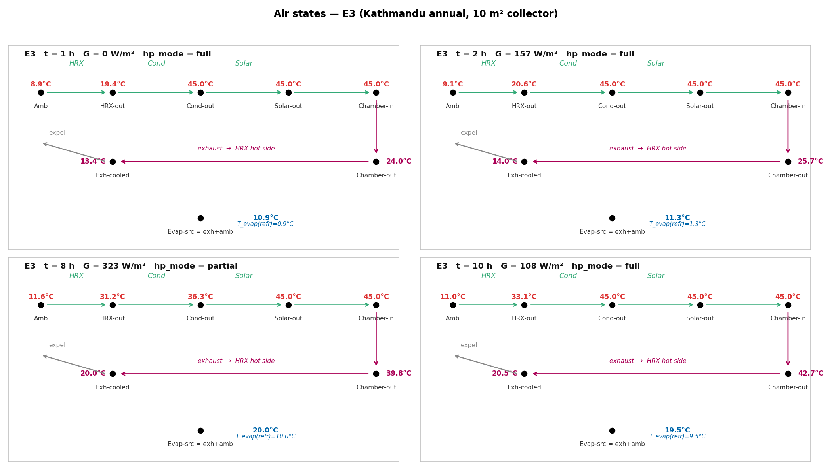
Figure 4.4-E3. Air state at each station (Kathmandu, annual) for E3: T-omega trajectory through HRX, solar, condenser, chamber, evaporator.

5. VPD bypass strategy and threshold sensitivity
The VPD bypass exists because once recovered exhaust becomes nearly saturated (low VPD vs chamber inlet), routing it through the HRX no longer transfers useful drying potential. Bypass diverts the exhaust around the HRX (and through the heat pump source side / solar collector instead, depending on config), keeping the supply hot and dry.

5.1 Threshold sensitivity sweep (E2)
case | VPD threshold [kPa] | t [h] | SEC [kWh/kg] | SMER [kg/kWh] | Bypass active [%]
KTM_annual | 0.00 | 14.10 | 0.1987 | 5.033 | 0.0
KTM_annual | 0.02 | 14.48 | 0.1584 | 6.311 | 26.8
KTM_annual | 0.05 | 15.40 | 0.1442 | 6.936 | 45.7
KTM_annual | 0.10 | 19.43 | 0.1486 | 6.727 | 69.4
KTM_annual | 0.15 | 23.20 | 0.1455 | 6.875 | 86.0
KTM_annual | 0.20 | 28.30 | 0.1517 | 6.592 | 91.9
BTN_autumn | 0.00 | 20.03 | 0.1081 | 9.250 | 0.0
BTN_autumn | 0.02 | 21.35 | 0.0753 | 13.277 | 36.0
BTN_autumn | 0.05 | 22.88 | 0.0689 | 14.512 | 53.5
BTN_autumn | 0.10 | 33.88 | 0.0837 | 11.941 | 78.5
BTN_autumn | 0.15 | 36.02 | 0.0890 | 11.238 | 88.4
BTN_autumn | 0.20 | 72.00 | 0.1385 | 7.218 | 96.1

Source: outputs/audit/step4_vpd_sweep.csv. The 0.05 kPa threshold is the SEC optimum on both representative cases (KTM annual, BTN autumn). Above 0.10 kPa the bypass becomes too aggressive: drying time grows steeply and re-inflates SEC by starving the chamber of dry-air mass flow.
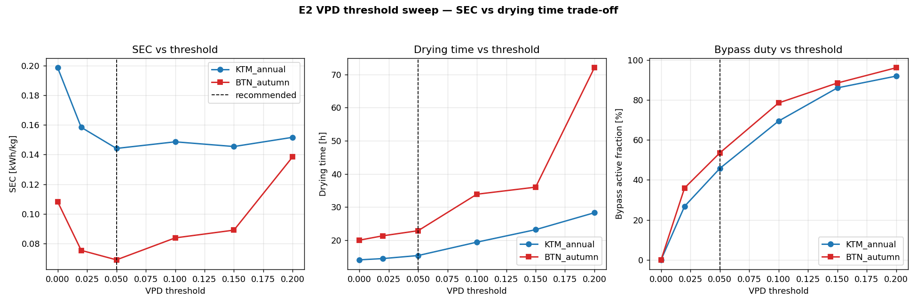
Figure 5.1. VPD threshold sweep on E2. Left: SEC vs threshold (U-shape, optimum ~0.05). Centre: drying time vs threshold (monotonically increasing). Right: bypass duty cycle vs threshold.

5.2 Bypass effect at the recommended threshold (0.05 kPa)
Activating the bypass at the recommended threshold yields an average SEC reduction across configurations of:
- E1: mean reduction -30.00 % (range -40.43 % to -19.86 %).
- E2: mean reduction -26.16 % (range -36.26 % to -17.21 %).
- E3: mean reduction -25.43 % (range -35.14 % to -16.76 %).
The bypass benefits all three configurations but most strongly E1 (which has the coldest evaporator and largest compressor share). Across configs the bypass collapses the SEC spread: at no-VPD the E2-vs-E1 gap is ~9 %; at VPD-on it shrinks to ~3-4 %.

6. Sensitivity analyses

6.1 Collector area sweep (E2)
A_c [m^2] | biratnagar | dhulikhel | kathmandu | taplejung
2.0000 | 0.2140 | nan | 0.2903 | 0.2410
4.0000 | 0.1712 | nan | 0.2596 | 0.2091
5.0000 | 0.1552 | nan | 0.2460 | nan
6.0000 | 0.1463 | nan | 0.2332 | 0.1807
8.0000 | 0.1354 | nan | 0.2106 | 0.1684
10.0000 | 0.1298 | 0.1668 | 0.1987 | 0.1639
15.0000 | 0.1200 | nan | 0.1759 | nan
20.0000 | 0.1156 | nan | 0.1678 | nan

Source: outputs/audit/step5_area_sweep.csv. SEC drops steeply 2 -> 8 m^2, knee at ~10 m^2, diminishing returns above. Going from 10 to 20 m^2 saves only ~10 % SEC at the cost of doubling collector capital, while clipping fraction passes 30-40 % at the larger sizes.
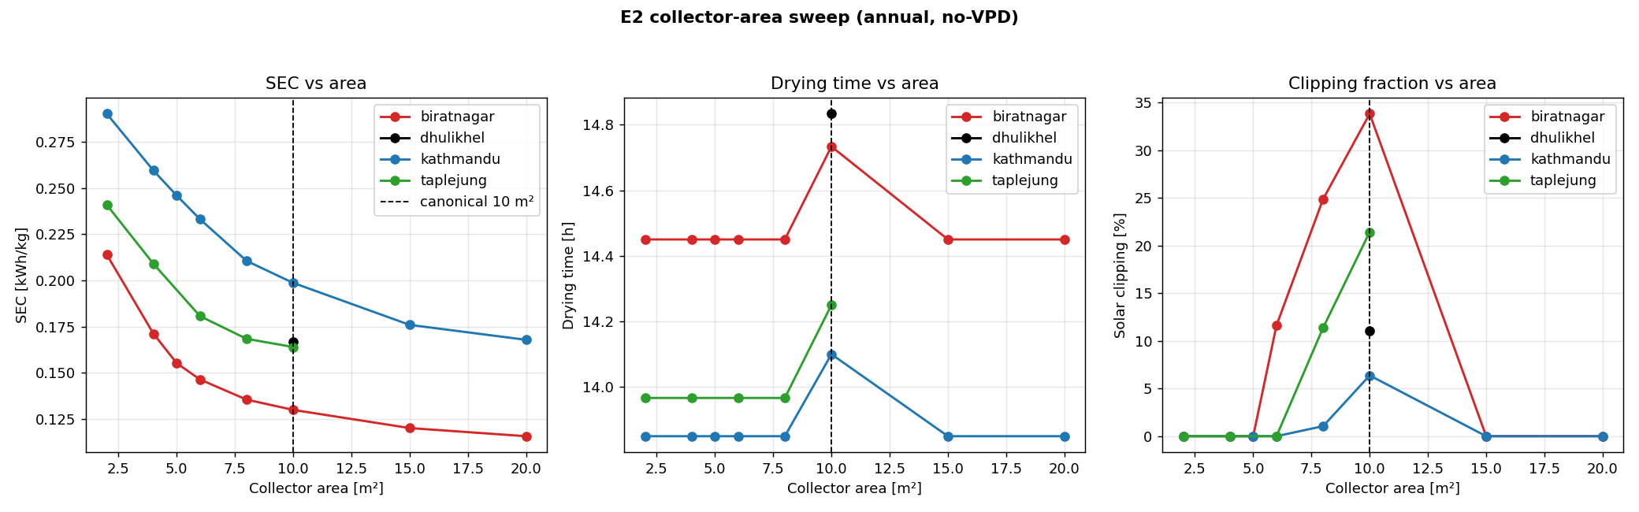
Figure 6.1. E2 collector-area sweep across BTN/KTM/TPJ (annual). Left: SEC vs A_c. Centre: drying time vs A_c. Right: solar clipping fraction vs A_c.

6.2 Season x location heatmap (E2)
location | winter_dec_jan | spring_mar_apr | autumn_oct_nov | annual
biratnagar | 0.1106 | 0.0719 | 0.1081 | 0.1298
dhulikhel | nan | nan | nan | 0.1668
kathmandu | 0.1323 | 0.0942 | 0.1226 | 0.1987
taplejung | 0.1626 | 0.1146 | 0.1018 | 0.1639

Source: outputs/audit/step5_season_location.csv. Spring is the cheapest operating window (highest irradiance + moderate humidity). Annual values lie between extremes. The Kathmandu annual SEC is the highest among the three primary locations due to lower irradiance and altitude effects on dry-air density.
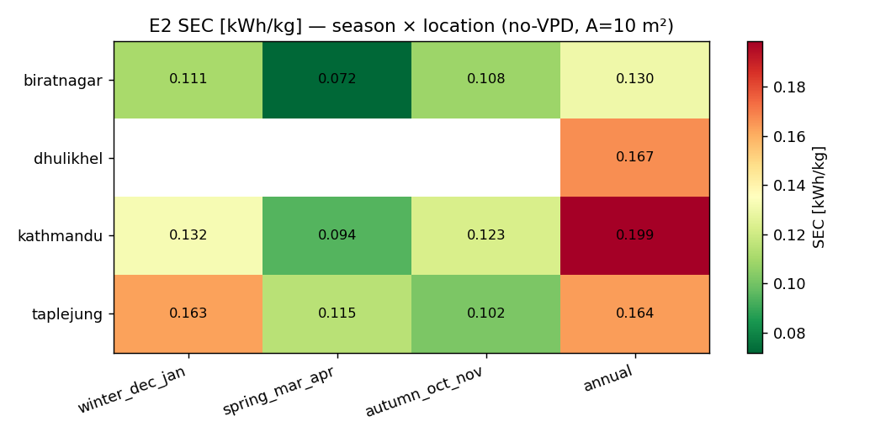
Figure 6.2. E2 SEC heatmap, season x location.

7. Numerical audit and anomaly hunt
92 canonical CSVs (E1/E2/E3 x all locations x all seasons x {no-VPD, VPD}) were screened for seven classes of anomaly: (i) per-step first-law residual |Q_cond - (Q_evap + 0.95 W_comp)| / expected > 2 %; (ii) chamber-inlet temperature deficit > 0.5 K below T_set when not in transient or bypass; (iii) heat-exchanger oversizing flags; (iv) HP at-capacity flags; (v) VPD bypass churn (> 6 switches/h vs 600 s dwell); (vi) E1/E2 cross-config consistency (Q_HRX and Q_solar_usable must be identical); (vii) 72 h time-limit DNF.

7.1 All flagged cases
case | kind | detail | severity
E2/biratnagar/autumn_oct_nov/vpd | DNF_72h_limit | reached 72.0h time limit; m_w=18.99kg | warn
E3/biratnagar/autumn_oct_nov/no_vpd | COP_outlier | low(<1.5)=0 / hi(>8)=9 of 723 | info
E3/biratnagar/autumn_oct_nov/vpd | COP_outlier | low(<1.5)=0 / hi(>8)=7 of 247 | info

Source: outputs/audit/step6_anomaly_log.csv. Findings: zero first-law violations across 92 runs, zero capacity flags, zero T_chamber deficits, zero bypass-churn warnings, zero E1<->E2 energy-bookkeeping discrepancies. The single warn case (E2 / BTN / autumn / VPD) reaches 99 % of the moisture target at the 72 h cutoff and is a known humid-lowland stress case. The two info-level COP > 8 flags are E3 partial-lift transients at very low T_cond targets, which are physically valid (high Carnot ceiling).

8. Plot and data index
Every figure referenced in this document plus a few additional E2-vs-E3 deep dives.
filename (plots/_audit/) | what it shows
step3_energy_split_E1.png | Energy split, E1, all 13 cases
step3_energy_split_E2.png | Energy split, E2, all 13 cases
step3_energy_split_E3.png | Energy split, E3, all 13 cases
step2e_air_states_E1_kathmandu_annual.png | E1 psychrometric trace, KTM annual
step2e_air_states_E2_kathmandu_annual.png | E2 psychrometric trace, KTM annual
step2e_air_states_E3_kathmandu_annual.png | E3 psychrometric trace, KTM annual
step4_vpd_sweep.png | VPD threshold sweep on E2 (KTM annual + BTN autumn)
step5_area_sweep.png | E2 collector area sweep, BTN/KTM/TPJ
step5_season_heatmap.png | E2 SEC heatmap, season x location
e2_vs_e3_cumulative_kathmandu.png | E2 vs E3 cumulative drying / energy, KTM annual
e2_vs_e3_power_kathmandu.png | E2 vs E3 instantaneous power streams, KTM annual

Backing data files:
filename (outputs/audit/) | what it contains
step3_energy_split.csv | Per-case energy partition (39 rows)
step4_pivot_SEC_no_vpd.csv | SEC pivot, no-VPD (13 cases)
step4_pivot_SEC_vpd.csv | SEC pivot, VPD-on (12 cases)
step4_winrate.csv | Win count per KPI
step4_vpd_sweep.csv | VPD threshold sweep raw data
step5_area_sweep.csv | E2 collector area sweep
step5_season_location.csv | E2 season x location grid
step6_anomaly_log.csv | Anomaly hunt findings

