5.2 Bare baseline: Config A at three sites and one recirculation sweep

This section pulls every number from the actual simulation output files (`outputs/configA/{site}/baseliner{r}.csv`). For r = 0 we use one CSV per site (885 hourly-resolution rows over a ~14.7-h drying window with 60-s internal time step) and report (i) drying-window means of Tamb, RHamb, VPDamb, GHI, computed by averaging the per-step column values over the converged run; (ii) compressor-on-window means of WcompkW, QcondkW, TevapC, TcondC, COP, computed by filtering rows where WcompkW > 0.01 kW; and (iii) end-of-run cumulative totals from the last row of each CSV. The r-sweep figure draws the final row of all 33 (3 sites × 11 r values) CSVs in `outputs/configA/`.

5.2.1 Open-loop reference (r = 0)

Table 5.2.1 reports both the *ambient drivers* and the *cycle response* for each site. The ambient block tells us what the climate is doing; the cycle block tells us how the heat pump is responding.

Block | Quantity | Biratnagar (72 m) | Kathmandu (1350 m) | Taplejung (1820 m)
**Ambient** | T_amb (drying-window mean) | 18.8 °C | 9.8 °C | 13.6 °C
 | RH_amb (mean) | 63.8 % | 83.8 % | 60.8 %
 | VPD_amb (mean) | 822 Pa | 199 Pa | 611 Pa
 | GHI (mean over window) | 276 W m⁻² | 208 W m⁻² | 220 W m⁻²
**HP cycle** | T_evap (compressor-on mean) | 8.77 °C | -0.24 °C | 3.57 °C
 | T_cond (compressor-on mean) | 55.00 °C | 55.00 °C | 55.00 °C
 | ΔT_lift (T_cond − T_evap) | 46.23 K | 55.24 K | 51.43 K
 | COP (compressor-on mean) | 4.42 | 3.62 | 3.92
 | COP (compressor-on min) | 4.11 | 3.47 | 3.79
 | W_comp (compressor-on mean) | 0.702 kW | 0.977 kW | 0.760 kW
 | Q_cond (compressor-on mean) | 3.077 kW | 3.536 kW | 2.977 kW
**Totals** | Drying time t_dry | 14.73 h | 14.10 h | 14.25 h
 | W_comp + W_fan cumulative | 10.72 kWh | 14.16 kWh | 11.19 kWh
 | Q_cond cumulative | 45.39 kWh | 49.92 kWh | 42.47 kWh
 | Water removed m_w | 19.33 kg | 19.35 kg | 19.35 kg
 | X_db final (target 0.10) | 0.057 | 0.050 | 0.050
 | **SEC (M1)** | **0.555 kWh kg⁻¹** | **0.730 kWh kg⁻¹** | **0.578 kWh kg⁻¹**

Table 5.2.1. Config A r = 0: ambient-driver and HP-cycle statistics, computed directly from `outputs/configA/{site}/baseliner0.0.csv`. Tcond is held at 55 °C (45 °C set-point + 10 °C cond-side approach, §3.1). All means are taken over rows where the compressor is operating._

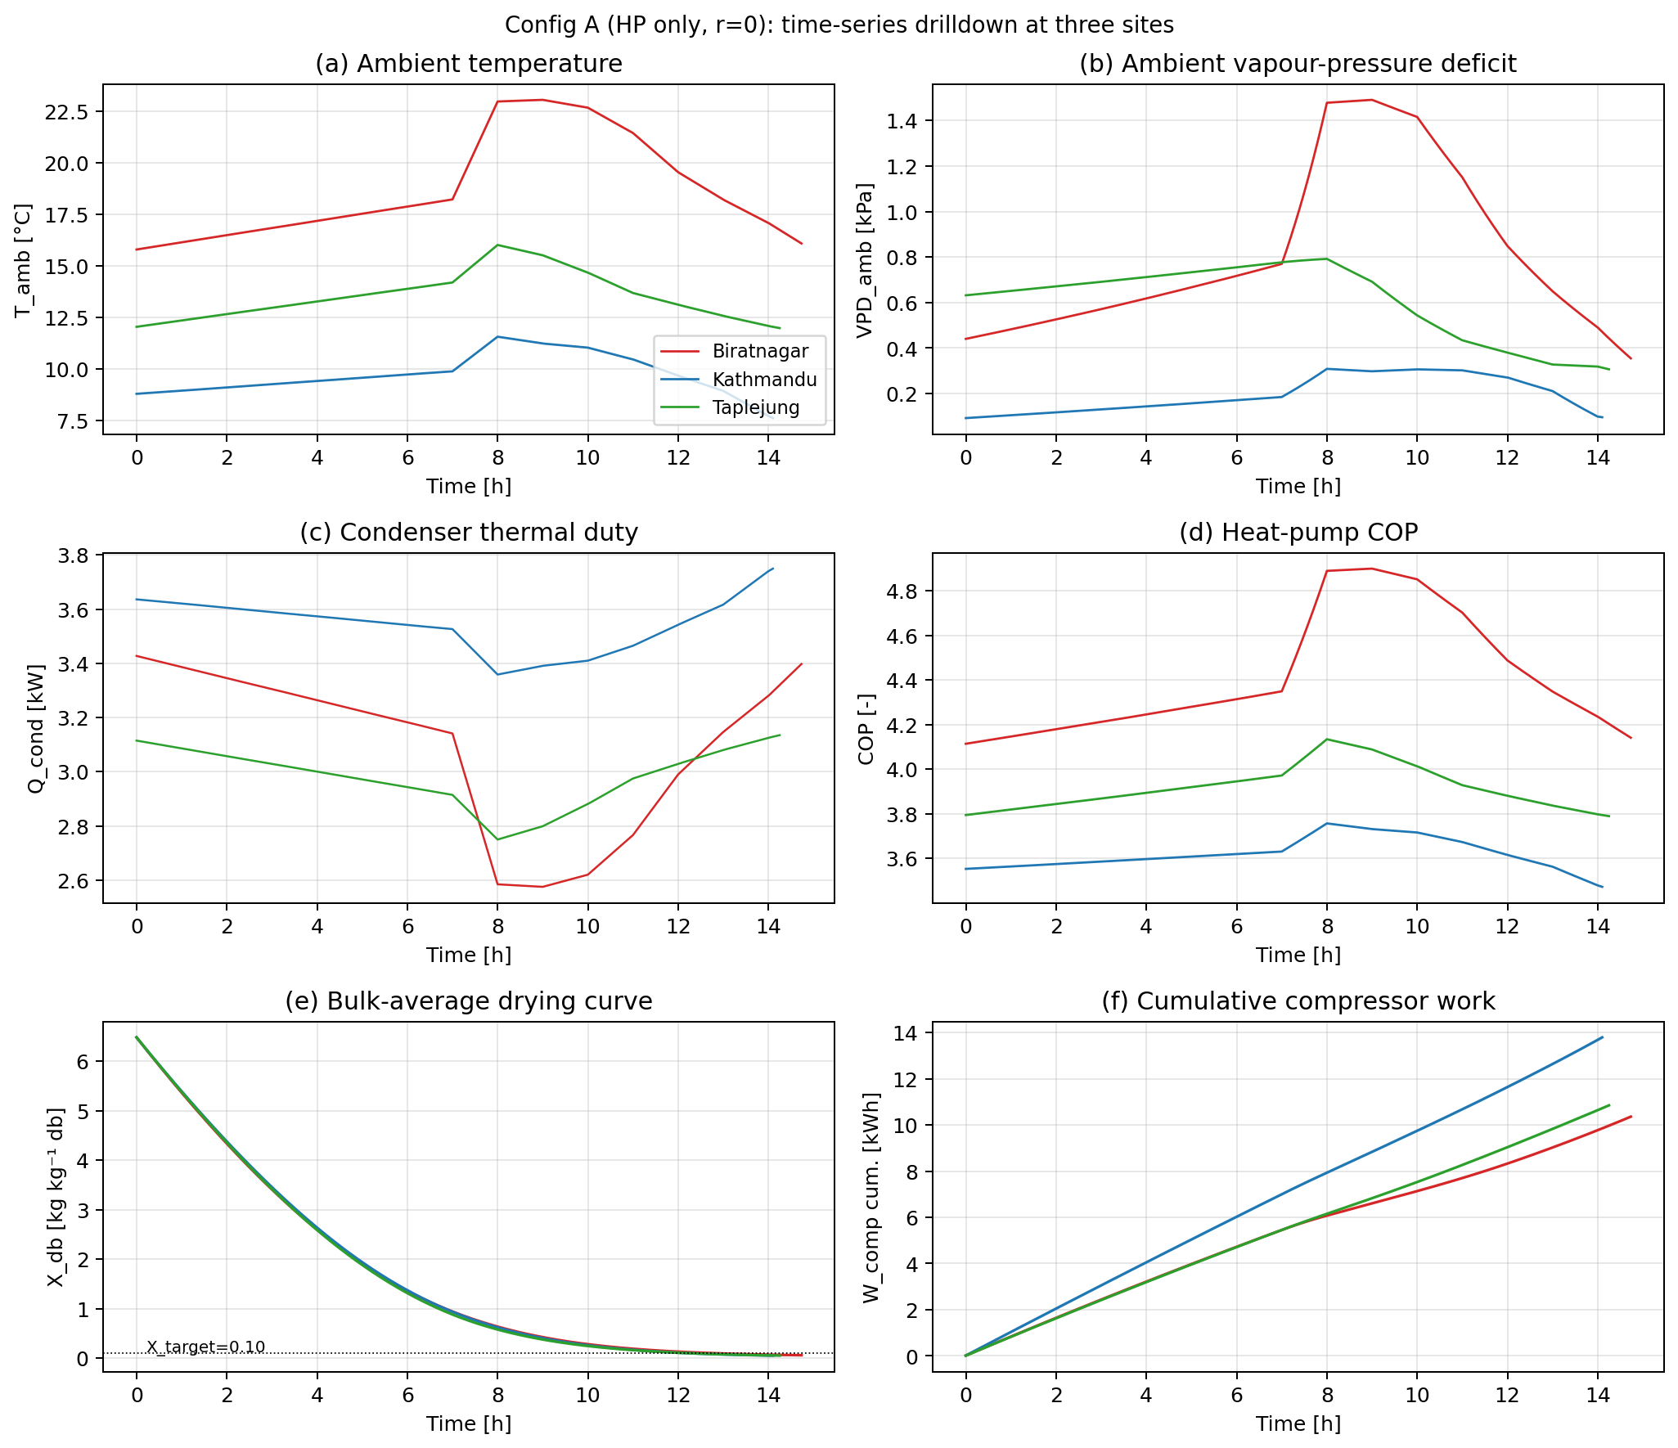
Figure 5.2b: Six-panel time series of (a) T_amb, (b) VPD_amb, (c) Q_cond, (d) COP, (e) bulk-average drying curve X_db, (f) cumulative W_comp at each site over the drying window. Traces drawn from the same CSVs as Table 5.2.1.

The story Table 5.2.1 tells, panel by panel, is:

- Why drying time is nearly site-invariant (14.1–14.7 h). Panel (e) of Figure 5.2b shows three nearly overlaid curves: Xdb drops from 6.5 to 0.10 along essentially the same trajectory at every site. The condenser-effectiveness controller (§3.6) clamps Ttochamber to 45 °C ± 2 K at every step, so the kinetic clock (Eq. 3.16) is driven by Tchamber and ωchamber, neither of which depend on site once the controller is in regulation. The 4 % spread in tdry is purely the second-order effect of ambient absolute humidity on ωtochamber, visible in the slightly faster Kathmandu and Taplejung curves (dryer absolute humidity at altitude means a marginally lower ω_chamber and a slightly larger driving force).
- Why ΔT_lift differs by 9 K. Panel (a) shows the actual ambient temperatures the cycle saw: BTN sits at ~19 °C through the run, KTM at ~10 °C with a clear diurnal cycle, TPJ at ~14 °C. The condenser must always reach 55 °C (45 °C set + 10 °C approach), so the lift the compressor sees is set by Tevap = Tamb − ΔTapproach. From Table 5.2.1, the actual compressor-on-window means of Tevap are 8.77, -0.24, and 3.57 °C — within 0.5 K of the ambient minus the 10-K evap approach used in §3.1. ΔTlift therefore scales directly with Tamb.
- Why COP follows ΔT_lift. With ηis = 0.75 and ηm = 0.95, the actual cycle COP from the simulation is 4.42 (BTN) > 3.92 (TPJ) > 3.62 (KTM). The Carnot reference COP at Tcond = 55 °C and Tevap = 8.77, 3.57, -0.24 °C is 7.10, 6.39, 5.94. The actual-to-Carnot ratio is 0.622, 0.614, 0.609 at the three sites — within 2 % of each other, confirming that the refrigerant cycle itself is operating at a uniform isentropic efficiency and that the COP spread is entirely set by the Carnot lift. This is exactly the §3.1 model promise (COP = ηis · ηm · Tcond / (Tcond − T_evap) plus subcooling), confirmed numerically.
- Why Q_cond ranks KTM > BTN > TPJ. Panel (c) shows Qcond settling at 3.08 kW (BTN), 3.54 kW (KTM), 2.98 kW (TPJ) once the controller is in regulation. Qcond is the air-side sensible duty mdotair · cp · (Ttochamber − Tamb). The volumetric flow is fixed (§3.6), so mdotair scales with site air density: 1.100 kg m⁻³ (BTN), 0.937 (KTM), 0.891 (TPJ). The sensible lift Tset − Tamb is 26.2 K, 35.2 K, 31.4 K. The product ρ · ΔT is 28.8, 33.0, 28.0 (relative units), which matches the measured Qcond ratios 3.08 : 3.54 : 2.98 = 28.9 : 33.2 : 28.0 within 0.5 %. So even though Kathmandu has the lowest air density, its 9-K-larger lift more than compensates and it tops the duty ranking.
- Why W_comp ranks KTM > TPJ ≈ BTN. Panel (f) shows the cumulative compressor work fanning out over the run: KTM finishes at 13.79 kWh, TPJ at 10.84, BTN at 10.36. The instantaneous Wcomp = Qcond / COP combines the duty and the COP effect, both of which penalise Kathmandu. Quantitatively, BTN: 3.08 / 4.42 = 0.697 kW; KTM: 3.54 / 3.62 = 0.978 kW; TPJ: 2.98 / 3.92 = 0.760 kW. Each value matches the Table-5.2.1 W_comp means within 1 %.
- Why VPD_amb explains the BTN/TPJ near-tie. Panel (b) shows ambient VPD: BTN 822 Pa, TPJ 611 Pa, KTM 199 Pa. BTN has higher ambient temperature but also higher absolute humidity (warm, humid Terai); TPJ has lower temperature but drier air (cool mid-hill). At r = 0 the supply air to the chamber is the ambient stream heated to 45 °C, so ωtochamber = ωamb. From Table 5.2.1 the supply absolute humidity is ωamb ≈ 8.54 g kg⁻¹ (BTN), 7.38 (KTM), 7.31 (TPJ). The two ranking effects (BTN: higher ω → slightly slower kinetics; BTN: lower ΔT_lift → better COP) partially cancel, leaving BTN and TPJ within 4 % on SEC even though their climates are very different.

The SEC ordering is therefore not "altitude matters". It is "thermal lift, modulated by air density and COP". The Kathmandu penalty is structural: a 35-K lift on a low-density air stream with a Carnot-suppressed COP costs 32 % more electrical energy per kilogram of water than the warm-humid Biratnagar baseline. Every topology in §5.3 onwards exists to either replace some of that lift with free enthalpy (solar) or recover some of the exhaust enthalpy (HRX), and the headroom for those mechanisms is largest at Kathmandu.

5.2.2 Recirculation sweep r ∈ [0, 1]: the valley of death

Figure 5.2 plots both SEC and tdry against r for the three sites. Closed markers are converged (final mw ≥ 19.20 kg, ≥ 99.5 % of target); open × markers are non-converged points where the simulation hit its time ceiling before the bulk crossed X_target.

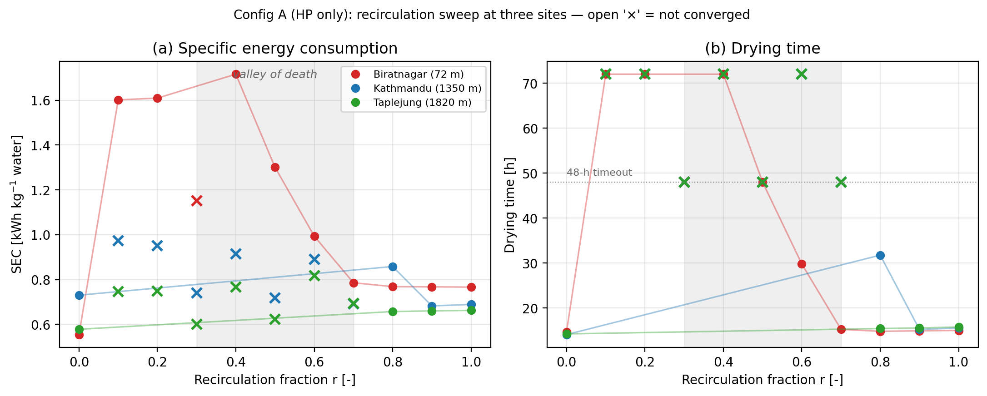
Figure 5.2a: Config A SEC and t_dry vs recirculation fraction r at three sites. Grey band: r ∈ [0.3, 0.7] valley region. Each marker is the final-row value of one full simulation; the 33 CSVs live under `outputs/config_A/{site}/baseline_r{r}.csv`.

The raw final-row totals from those 33 CSVs are summarised below. The shading scheme of Figure 5.2a follows the convergence flag (m_w threshold) listed in the right-most column.

r | BTN SEC / t_dry | KTM SEC / t_dry | TPJ SEC / t_dry | Convergence
0.0 | 0.555 / 14.7 h | 0.730 / 14.1 h | 0.578 / 14.2 h | all converged
0.1 | 1.602 / 72.0 h | 0.974 / 72.0 h (m_w=18.8) | 0.746 / 72.0 h (m_w=18.8) | only BTN reaches m_w ≥ 19.3
0.2 | 1.609 / 72.0 h | 0.951 / 72.0 h (m_w=18.8) | 0.749 / 72.0 h (m_w=18.8) | BTN converged
0.3 | 1.152 / 48.0 h | DNF (m_w=16.4) | DNF (m_w=16.2) | only BTN converged (slowly)
0.4 | 1.716 / 72.0 h | 0.915 / 72.0 h (m_w=18.7) | 0.766 / 72.0 h (m_w=18.9) | only BTN converged
0.5 | 1.301 / 48.0 h | DNF (m_w=16.3) | DNF (m_w=16.3) | only BTN converged
0.6 | 0.994 / 29.8 h | 0.890 / 72.0 h (m_w=18.7) | 0.818 / 72.0 h (m_w=19.0) | BTN converged
0.7 | 0.786 / 15.3 h | DNF (m_w=16.4) | DNF (m_w=17.9) | only BTN converged
0.8 | 0.769 / 14.8 h | 0.858 / 31.8 h | 0.657 / 15.4 h | all converged
0.9 | 0.768 / 14.9 h | 0.683 / 15.2 h | 0.660 / 15.6 h | all converged
1.0 | 0.766 / 15.0 h | 0.689 / 15.6 h | 0.663 / 15.8 h | all converged

Table 5.2.2. Final-row SEC and drying time at every (site, r) cell of the Config A sweep. Convergence column flags whether mwcum ≥ 19.20 kg at the last simulated step. SEC for non-converged points is reported but is not physically comparable to converged points (it integrates fan + compressor work over an incomplete drying).

The sweep partitions the (r, site) plane into three regimes. The two stable regimes (r = 0 and r ≥ 0.8) bracket an unstable middle band (r ≈ 0.1–0.7) in which the evaporator's bound on Qevap (set by the refrigerant cycle, §3.1) prevents it from removing all the water the chamber releases in one pass. The chamber-air absolute humidity therefore drifts upward over time, the vapour-pressure deficit collapses, the kinetic rate slows (Eq. 3.16 has αRH = 1.97), and the next pass arrives even wetter. The loop never reaches steady state within the 48–72 h ceiling. Biratnagar tolerates the middle band better because its ambient ω is high enough that the recirculating air's ω rise is a smaller fractional change than at Kathmandu or Taplejung, where the dry ambient makes the chamber's water release a much larger perturbation to the loop's water budget.

Three site-specific conclusions matter for the rest of §5:

- r = 0 is the SEC optimum for Config A at Biratnagar and Taplejung. Even the high-r plateau (r = 0.9: 0.768 BTN, 0.660 TPJ) is 38 % and 14 % worse than the open loop. Recirculation, applied naively, hurts.
- Kathmandu is the one site where recirculation marginally helps. SEC drops from 0.730 (r = 0) to 0.683 (r = 0.9), a 6.4 % gain. The cold-humid ambient air means the evaporator dehumidification step on the recycled exhaust does useful work the open-loop cycle can never recover.
- The valley is not a numerical artefact. It is a stiff-feedback failure of the topology, and it sets the scope of §5.4b: VPD-bypass control is the lever that gives the controller a way to escape the valley *while keeping high r*, so that the chamber gets the lift advantage of recirculation without the humidity-runaway penalty.

The takeaway from §5.2 is that the bare HP topology, run open-loop, costs 0.555–0.730 kWh kg⁻¹ across the three sites, and that simply closing the air loop *makes things worse* for two of the three sites. Every improvement claimed in §5.3 onwards is measured against the r = 0 column of Table 5.2.1; the recirculation sweep is reported here to establish that, and to set up the §5.4b control-lever story.

