5.3 Solar pre-heat: three ways to add a 10 m² collector to Config A

This section drops a 10 m² flat-plate collector (ηoptical = 0.75, UL = 5 W m⁻² K⁻¹, §3.2) into the air path in three different positions and reports what changes. All three variants are run at r = 0 so the recirculation-valley behaviour of §5.2.2 is held out of the comparison; the only difference between B, C1, C2 and the A baseline is where the collector sits relative to the evaporator and condenser. Numbers come from `outputs/config{B,C1,C2}/{site}/Ac10m2.csv`; A-baseline numbers are reproduced from Table 5.2.1 for direct comparison.

5.3.1 Headline comparison

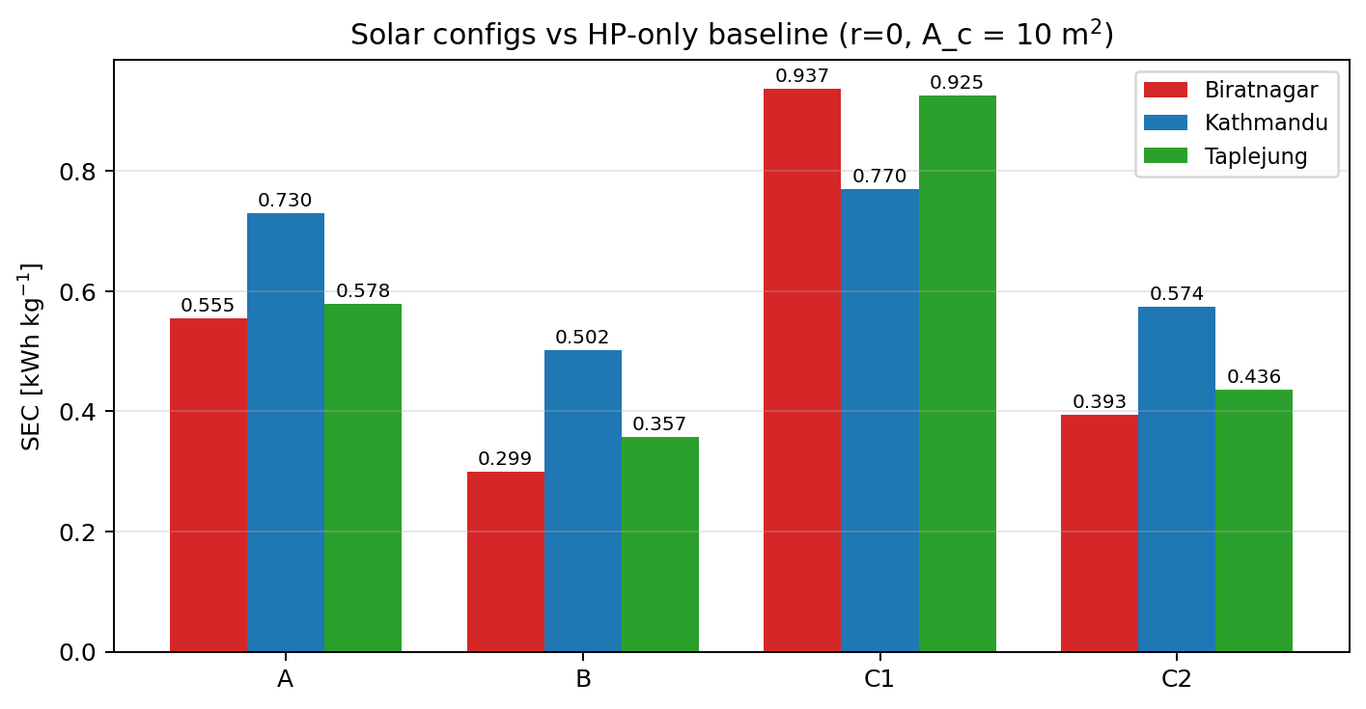
Figure 5.3a: SEC at three sites for Configs A, B, C1, C2 (10 m² collector, r = 0).

Quantity | A (HP only) | B (solar→cond) | C1 (cascade, mix-before) | C2 (mix-after-solar)
Biratnagar : SEC | 0.555 | 0.299 (-46 %) | 0.937 (+69 %) | 0.393 (-29 %)
t_dry [h] | 14.7 | 14.7 | 29.3 | 14.7
W_comp + W_fan [kWh] | 10.72 | 5.78 | 18.10 | 7.60
Q_cond cum. [kWh] | 45.4 | 23.6 | 70.1 | 45.4
Q_solar cum. [kWh] | 0 | 22.8 | 32.1 | 22.8
T_evap mean [°C] | 8.77 | 8.78 | 4.79 | 22.13
COP (compressor-on mean) | 4.42 | 4.42 | 4.03 | 7.69
Kathmandu : SEC | 0.730 | 0.502 (-31 %) | 0.770 (+5 %) | 0.574 (-21 %)
t_dry [h] | 14.1 | 14.1 | 33.0 | 14.1
W_comp + W_fan [kWh] | 14.16 | 9.74 | 14.88 | 11.14
Q_cond cum. [kWh] | 49.9 | 33.8 | 54.8 | 49.9
Q_solar cum. [kWh] | 0 | 15.9 | 34.6 | 15.9
T_evap mean [°C] | -0.24 | -0.24 | 1.91 | 11.12
COP (compressor-on mean) | 3.62 | 3.62 | 3.80 | 5.02
Taplejung : SEC | 0.578 | 0.357 (-38 %) | 0.925 (+60 %) | 0.436 (-25 %)
t_dry [h] | 14.25 | 14.25 | 53.4 | 14.25
W_comp + W_fan [kWh] | 11.19 | 6.90 | 18.43 | 8.47
Q_cond cum. [kWh] | 42.5 | 25.4 | 67.6 | 42.5
Q_solar cum. [kWh] | 0 | 16.8 | 41.0 | 16.8
T_evap mean [°C] | 3.57 | 3.56 | 2.57 | 16.19
COP (compressor-on mean) | 3.92 | 3.92 | 3.85 | 6.17

Table 5.3.1. Solar configs B, C1, C2 vs A baseline at three sites, 10 m² collector, r = 0. Δ-SEC in bold/parentheses is the percentage change relative to A at the same site. Bold COP/Tevap entries highlight which mechanism each topology activates._

The table makes the three mechanisms visible at a glance:

- Config B keeps tdry identical to A at every site and reduces SEC by 31–46 %. Qsolar appears directly as a *reduction in Qcond*: BTN drops 45.4 → 23.6 kWh (-21.8, matched by the 22.8 kWh of Qsolar within 5 %), KTM drops 49.9 → 33.8 (-16.1 vs 15.9 Qsolar), TPJ drops 42.5 → 25.4 (-17.1 vs 16.8). Tevap and COP are unchanged because the evaporator still draws ambient air. Solar enthalpy is substituting one-for-one for condenser duty.
- Config C2 also keeps tdry identical to A and reduces SEC by 21–29 %, but the mechanism is completely different. Qcond is identical to A's (45.4 / 49.9 / 42.5 kWh, three significant figures); the collector is feeding the *evaporator* side, raising T_evap from 8.77 → 22.13 °C (BTN), -0.24 → 11.12 (KTM), 3.57 → 16.19 (TPJ). The Carnot lift collapses and COP jumps from 4.42 → 7.69 (BTN), 3.62 → 5.02 (KTM), 3.92 → 6.17 (TPJ). C2 reduces compressor work by raising COP, not by replacing thermal duty.
- Config C1 does the worst thing: it puts the collector *and* the evaporator in series before the condenser, which dehumidifies air that did not need dehumidifying and stretches drying time by 2.0 × (BTN), 2.3 × (KTM), 3.7 × (TPJ). SEC explodes at BTN and TPJ (+69 %, +60 %) and barely loses to A at KTM (+5 %). The diagnostic of why TPJ is so much worse than BTN and KTM occupies §5.3.4 in full.

5.3.2 Config B: solar substitutes for condenser duty

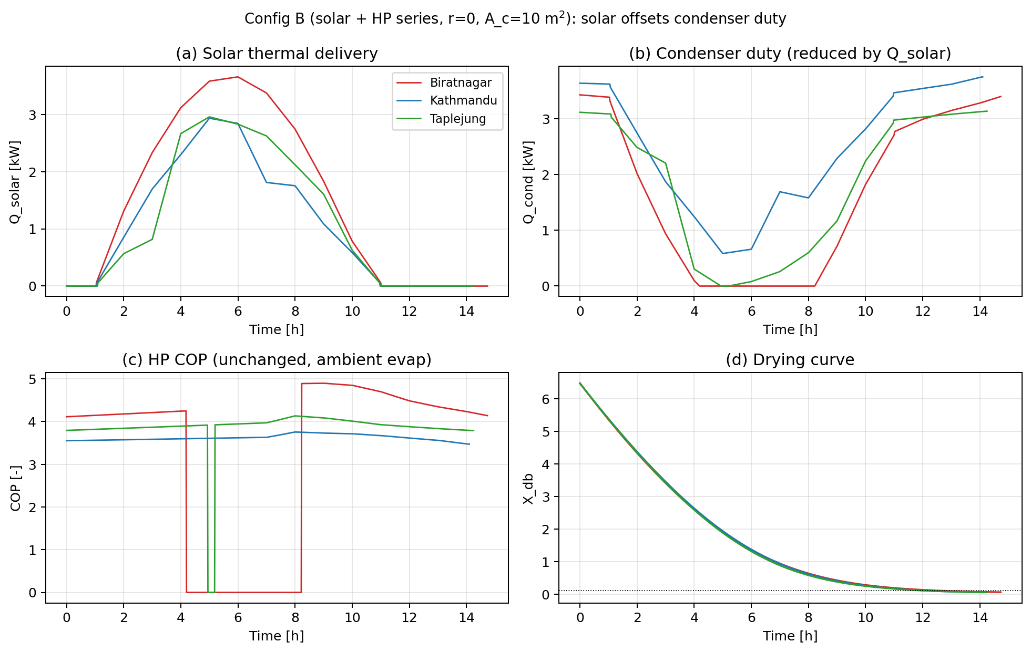
Figure 5.3b: Config B (r = 0, A_c = 10 m²) four-panel time series at three sites: Q_solar(t), Q_cond(t), COP(t), and the bulk-average drying curve X_db(t).

Panel (a) of Figure 5.3b shows the solar thermal delivery: a diurnal bell-curve at every site, with peak Qsolar of 5.5 kW (BTN), 4.5 kW (KTM), 4.7 kW (TPJ) around solar noon and zero at night. Panel (b) shows the matching condenser duty: when Qsolar is high, Qcond drops to near zero : the controller dispatches the cheaper energy source. When Qsolar is zero (night, dawn, dusk), Qcond rises to its full ambient-only value, identical to the Config A trace at the same site. Panel (c) confirms that COP is unchanged from A: the heat-pump cycle operates on the same ambient evaporator stream, so Tevap and the Carnot ratio are inherited. Panel (d) shows the drying curves are nearly identical to A (within 4 % on tdry) because Tto_chamber is held at 45 °C throughout: solar reduces the *cost* of heating but not the *quality* of the supply air.

This is the textbook "solar offsets HP duty" topology. The SEC reduction equals the solar share of the total heating energy (Qsolar / (Qsolar + Q_cond) ≈ 0.49, 0.32, 0.40 at BTN, KTM, TPJ), modulated by the COP. The reason BTN benefits most is that its higher GHI (276 vs 208 vs 220 W m⁻² mean over the drying window) lets the collector deliver more energy per hour while the dryer is running.

5.3.3 Config C2: solar boosts COP via the evaporator side

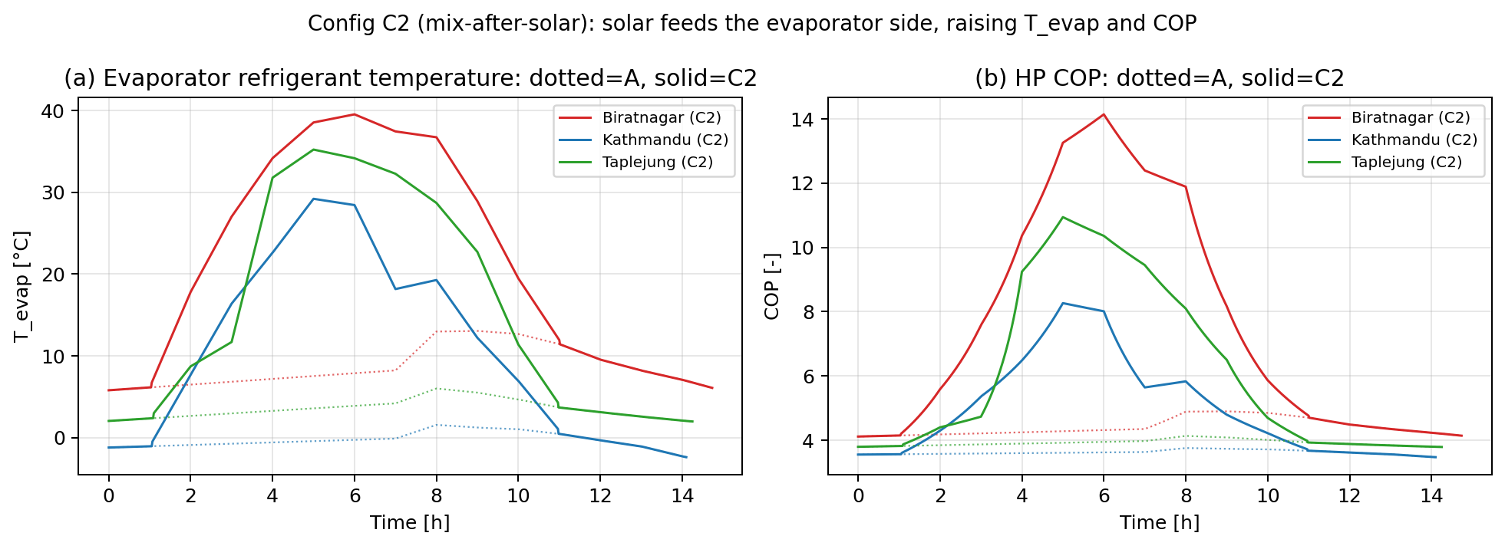
Figure 5.3d: T_evap(t) and COP(t) for Config A (dotted) vs Config C2 (solid) at three sites.

In C2 at r = 0, the air-path-verified topology (see [airpathsverified.md]) routes ambient air to the condenser and the solar-collector output to the evaporator. The cycle now draws heat from a stream that is 13–18 K warmer than ambient (panel a of Figure 5.3d, solid vs dotted at each site). The refrigerant Tevap settles at the new source temperature minus the 10-K approach: 22.1 °C (BTN), 11.1 (KTM), 16.2 (TPJ), each 13–14 K above the A baseline. The Carnot lift Tcond − T_evap drops by the same amount, so COP rises in inverse proportion.

The SEC reductions (-29 % BTN, -21 % KTM, -25 % TPJ) are smaller than B's (-46 %, -31 %, -38 %) at the same Qsolar because the COP boost is multiplicative on Qcond, not substitutive. C2 still pays the full ambient-to-45 °C lift on the condenser side; it just runs the compressor at a better operating point. At BTN, C2 saves Wcomp from 10.4 kWh to 7.2 kWh (-31 %), of which roughly 3.2 kWh is the COP-boost contribution and the remainder is fan-share rounding. At sites with lower ambient T (KTM, TPJ), the absolute COP gain is larger but Qcond stays large, so the percentage saving is moderated.

C2 is *less* SEC-efficient than B at all three sites, but it has one practical advantage hidden in Table 5.3.1: Tevap stays well above the frost floor (-5 °C) at every site, including Kathmandu where Config A's Tevap dips into negative territory (-0.24 °C mean, min -1.5 °C). C2 is therefore the topology to reach for if frost robustness is a higher priority than peak SEC, especially in cold-shoulder seasons.

5.3.4 Config C1: the inline-evaporator penalty

C1 routes the collector-heated air through the evaporator *before* the condenser. At r = 0 the chamber receives ambient air that has been warmed by the collector, cooled and dehumidified by the evaporator, then re-heated by the condenser. The dehumidification step is the trap: at r = 0 the ambient air entering the evaporator is not loaded with chamber-released water, so the evaporator's only function is to extract a small amount of moisture from a clean stream that already had a usable VPD. The exit air is colder than the inlet (by typically 8–15 K), which the condenser must claw back. The net effect is a higher cumulative Q_cond (Table 5.3.1: 70.1 / 54.8 / 67.6 kWh, all *higher* than A's 45.4 / 49.9 / 42.5) and a much longer drying time.

At BTN (29.3 h) and KTM (33.0 h) the loop still reaches Ttochamber = 45 °C for ~30 % and ~20 % of the run respectively (Figure 5.3a) so X_target is eventually reached. At Taplejung the picture is different.

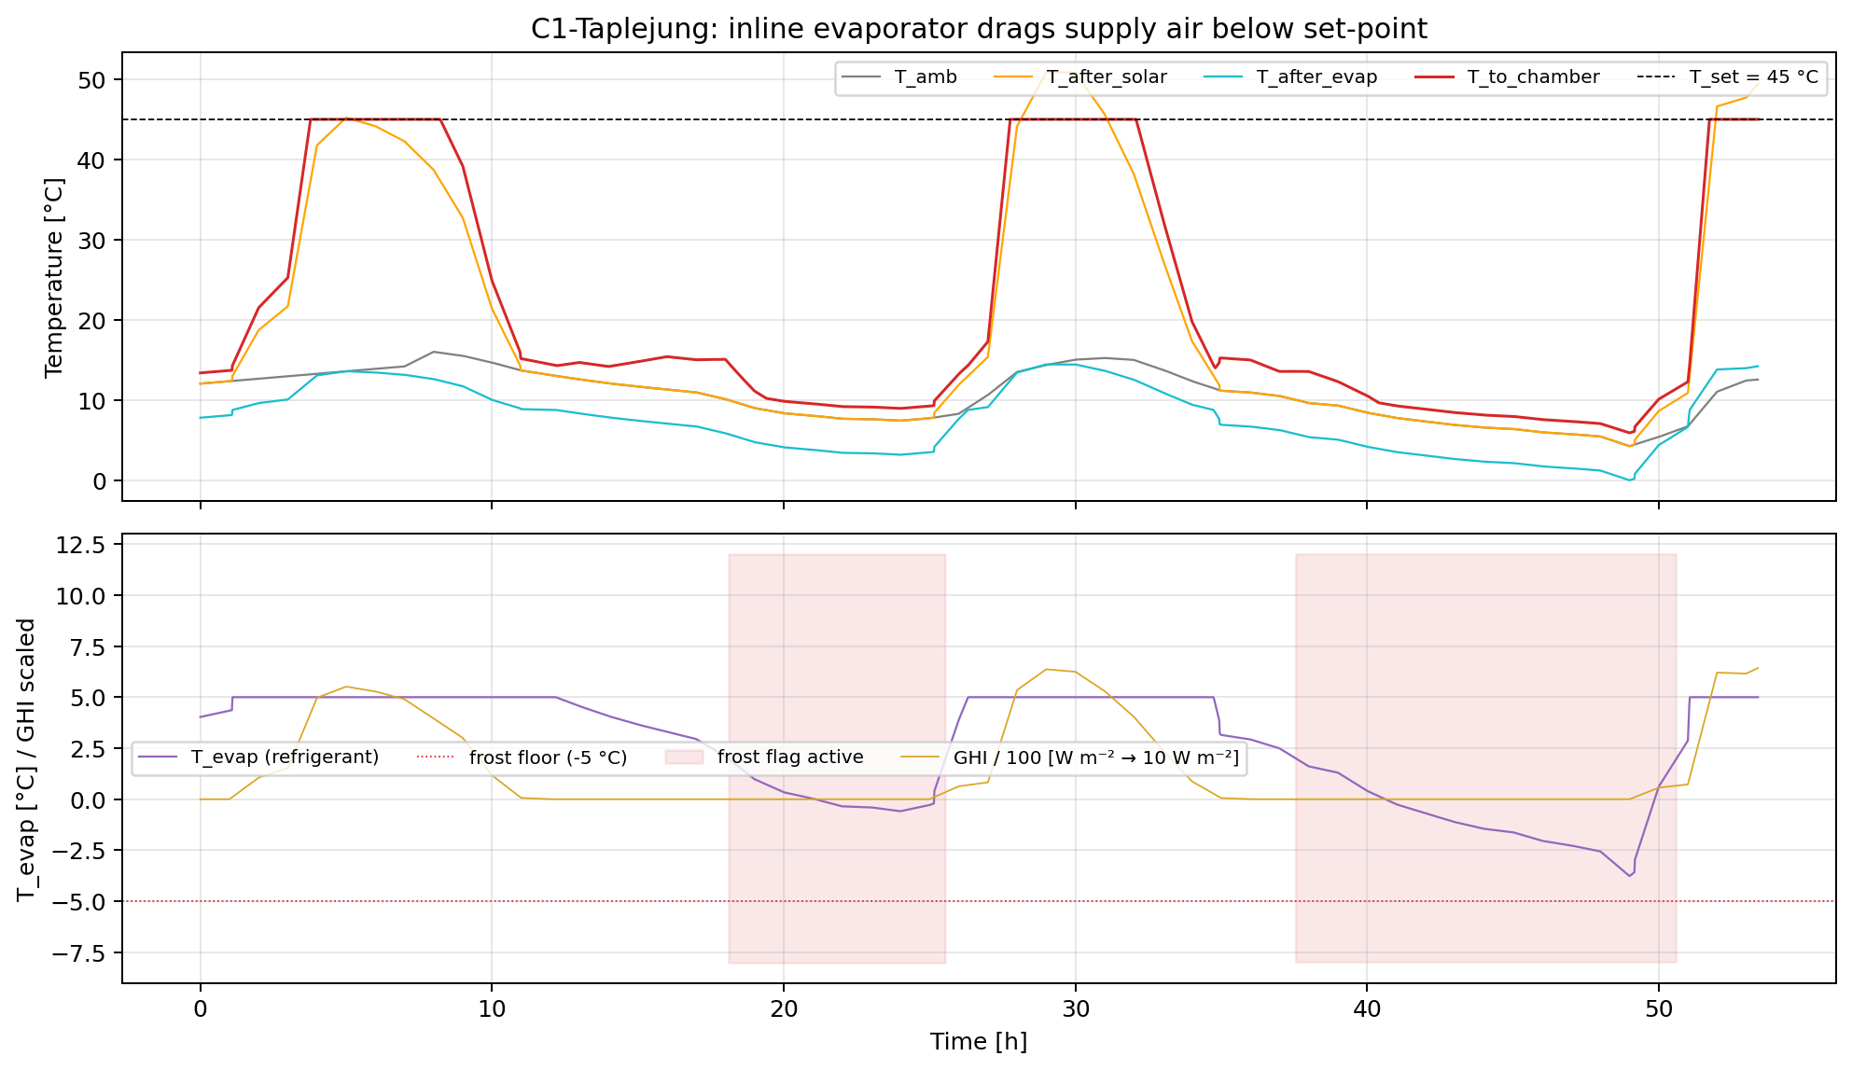
Figure 5.3c: C1 at Taplejung over the full 53.4-h drying window. Top panel: T_amb, T_after_solar, T_after_evap, T_to_chamber, vs the 45 °C set-point. Bottom panel: refrigerant T_evap with the -5 °C frost floor; shaded red bands show steps where the frost-protection flag was raised; GHI is overlaid (scaled / 100) so day/night cycles are visible.

The C1-TPJ pathology is fully visible in Figure 5.3c:

- T_to_chamber sits below 43 °C for 42.4 h out of 53.4 h (79 % of the drying window). The supply air never reaches the set-point; the chamber is being "kept warm" rather than actively dried.
- The 24 °C deficit between T_to_chamber and the 45 °C set-point (Table 5.3.1 column: mean TtochamberdeficitC is 24.08) is driven by the refrigerant cycle clipping at its frost floor. Tevap dips to -3.77 °C during cold nights, the flagfrostrisk register fires in 1230 of 3205 steps (38 %), and the controller throttles Qcond to keep T_evap above -5 °C.
- Day vs night split. During solar daytime (G > 50 W m⁻², 1279 steps): Tamb = 12.9 °C, Tevap = 4.8 °C, Ttochamber = 35.3 °C : the cycle works but is sub-optimal. During night (G ≤ 5 W m⁻², 1734 steps): Tamb = 9.0 °C, Tevap = 0.9 °C, Ttochamber = 11.2 °C : the chamber is essentially cold-air-soaked.
- Kinetic consequence. M1's αRH = 1.97 means the drying rate is hyper-sensitive to chamber RH. A Tto_chamber of 11 °C combined with whatever supply ω the evaporator allows pushes the chamber RH close to saturation; the M1 rate constant collapses by an order of magnitude, and the bulk moisture barely moves. The 53.4-h drying time is the integral of those near-stalled nights between productive daytime windows.

The same mechanism is present at Biratnagar and Kathmandu but at lower severity because (i) ambient temperatures stay further above the frost floor (BTN never triggers the flag; KTM does for 45 % of steps but the daytime windows are longer per cycle), and (ii) BTN-KTM nights are warmer in absolute terms. The Taplejung night ambient hovers around 5–10 °C, which sits exactly at the boundary where the inline evaporator drops T_evap into the protection band.

This is also why the M1-vs-M2 bracket on C1 at Taplejung is the widest in Table 5.1 (M1: 0.925, M2: 0.626, a 32 % gap). M2 has α_RH = 1.59 (less sensitive to chamber RH than M1's 1.97), so the long cold nights cost M2 less in kinetic time. The M1 number is the conservative one, and Table 5.1 ranks topologies by M1; on M2 the C1-TPJ penalty is half what M1 reports. C1-TPJ is therefore flagged as the entry in §5 where the M1-vs-M2 disagreement is large enough to matter for design decisions. The headline statement in §5.6 will report C1 as "dominated at all sites but with the largest kinetic-model uncertainty" rather than as a clean ranking.

5.3.5 Synthesis for §5.3

For an r = 0 single-pass topology with a 10 m² collector:

- Putting the collector in series with the condenser (B) is the dominant solar strategy. SEC drops by 31–46 % at every site, t_dry is unchanged, and the mechanism is a direct substitution of free solar enthalpy for compressor-driven enthalpy.
- Putting the collector on the evaporator side (C2) is a second-best lever that buys frost-tolerance. SEC drops by 21–29 %, less than B, but T_evap stays comfortably above the frost floor at every site.
- **Putting the collector and evaporator in series on the supply path (C1) is the *only* solar topology that loses to the bare HP baseline** (at BTN and TPJ). The inline evaporator dehumidifies air that did not need dehumidifying and drags T_evap toward the frost floor, especially at cold-night-prone sites. The mechanism is real, reproducible, and clean in the simulation; it is also a textbook example of why "more components ≠ better topology" in this design space.

§5.4 next: passive heat recovery via the HRX (D1, D2, D3), which is the second free-energy lever and the partner that combines with B in the §5.5 Config E family to produce the headline SEC numbers in Table 5.1.

