Every timestep, the simulation computes one number called VPD utilization:

utilization = (VPD_inlet − VPD_exhaust) / VPD_inlet

"How much of the air's drying thirst did the chamber actually use up on its way through?"
Both are evaluated at the same temperature (45 °C) so it's a fair comparison of moisture content only.
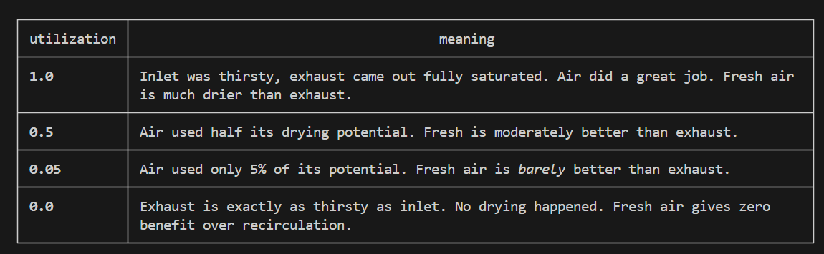
Step 2 — what the threshold does

The threshold is a cutoff line. If utilization falls below the threshold, the controller decides "fresh
air isn't worth it" and switches to exhaust-bypass mode.

So when we say "threshold = 0.05", we mean:

▎ "Bypass whenever the fresh air is contributing less than 5% extra drying over what the exhaust was
▎ already doing."

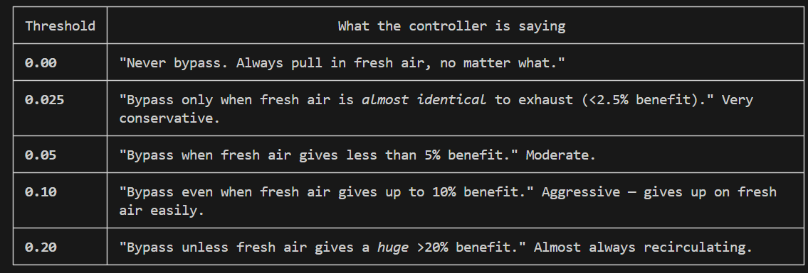

So as the threshold goes up, the controller becomes lazier about using fresh air and more eager to
recirculate exhaust.

Step 3 — "when is the air actually drier?"

This is the key intuition. The exhaust leaving the chamber is warmer and wetter than ambient, but once
you cool both to the same reference temperature, which one carries less water?

