Our impact –

Global Leaders

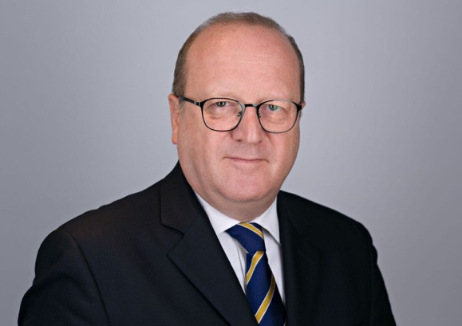
Sam Tully (GEL Programme delegate, Trustee – Pratham UK)

I was privileged to attend the Global Education Lab's Global India Leadership Programme at the Cambridge Judge Business School with a great cohort from India and a few other places.

What a week it was, covering AI, geopolitics, marketing, branding, strategy, rhetoric, enterpreneurship and so much more. All taught by energetic and engaging leaders in their respective fields. I also learnt so much from my fellow participants, not least coming away feeling hugely positive about the enduring potential and dynamism of Indian entrepreneurialism.

That too, in the confines of one of the world's finest Universities and one of its most beautiful cities. Somewhere everyone should visit at least once, you will not be disappointed.

That is why I called it a Rolls Royce.

Read about Sam’s experience - https://www.linkedin.com/posts/sam-tully_its-like-a-rolls-royce-thats-how-sam-activity-7480318064505462784-Fnbc

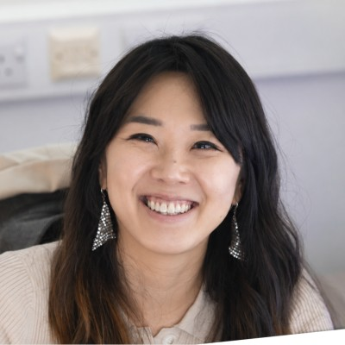
Lucy Jung, (GEL Mentor, Founder & CEO – LYEONS)

I was impressed by how far ventures (on GEL programme) got in such a short time, considering stakeholders and business models and how to make the sustainable growth of their ideas possible. Thank you for the opportunity to mentor, and I’m excited to follow more of GEL’s programmes.

Read about Lucy’s experience - https://www.linkedin.com/posts/lyeons_digitalhealth-innovation-brainhealth-activity-7474751134113619968-4SC6

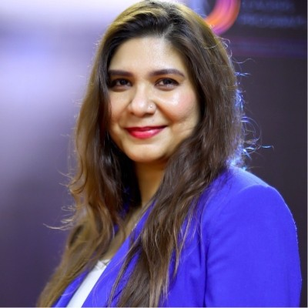
Bidisha Banerjee (GEL Programme delegate, Founder, Rysen Coaching, Author – Your Turn to Rise)

One of the best executive education experiences I’ve had.

A week at the University of Cambridge with leaders from across the world, learning from exceptional faculty and exchanging perspectives that challenged my thinking. The biggest takeaway? Every insight was practical enough to take back and apply immediately.

If you’re considering it and would like to know more from an alumnus’ perspective, feel free to reach out for a chat .

Read about Bidisha’s experience - https://lnkd.in/p/dvaQ_zx2

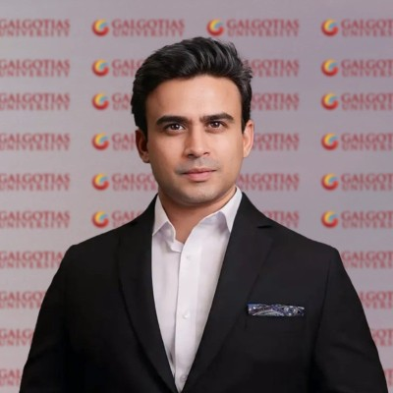
Dr. Dhruv Galgotia – CEO, Galgotias Education Group

An incredible week at the University of Cambridge filled with unforgettable memories, meaningful conversations, and the beginning of exciting new synergies and alliances. This journey has been a true milestone and a benchmark for many exciting initiatives ahead.
Grateful for the connections, collaborations, and shared vision that emerged throughout the week. Looking forward to announcing several new engagements and partnerships very soon.
The journey has just begun.

Read about Dhruv’s experience - https://lnkd.in/p/d7vJ9pPF

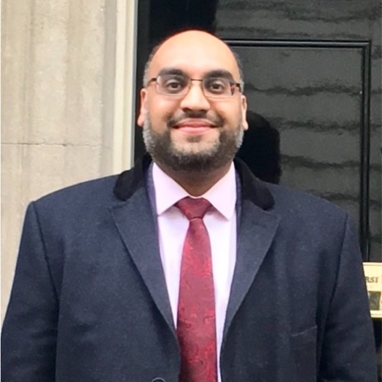
Amarjit Singh (GEL Programme delegate, CEO, India Business Forum)

Grateful for the practical insights, peer-to-peer learning, and collaborative spirit.
Kudos to the Global Education Lab and team for delivering such an impactful programme!

Read more about Amarjit’s experience - https://www.linkedin.com/posts/amarjit-singh-13860aa_great-leaders-know-that-learning-never-stops-activity-7485621706183688192-W-d7

University students
Linda Tang, Medicine & Natural Science Student at University of Cambridge
Good team vibe, good organisation, like the short content inserts

Academics

Entrepreneurship Programmes

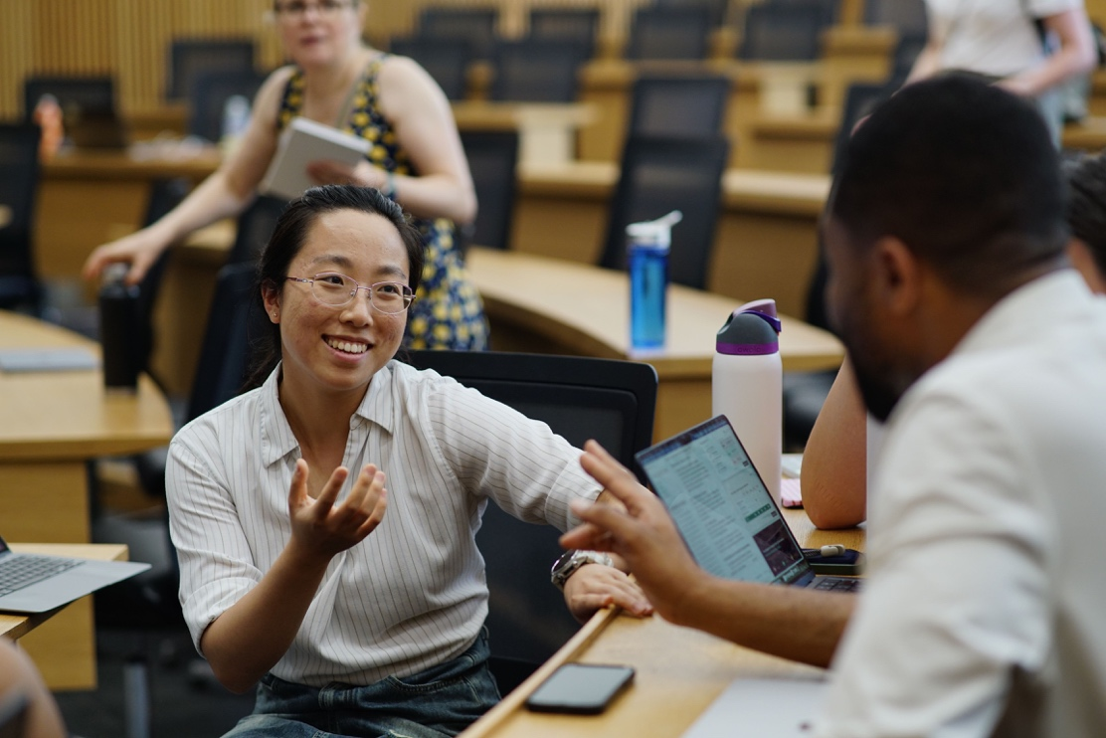

“Good team vibe, good organisation, like the short content inserts”
- Linda Tang, Medicine & Natural Science Student at University of Cambridge

Read about Linda’s experience with GEL - https://lnkd.in/p/dMFAm33S

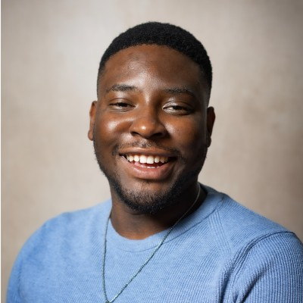
On GEL Zero-to-One what I liked the most was the ability to work with mentors as they really helped transform and learn new skills and ways of thinking. It helped me refine my idea by making me think and question about how to pitch. We didn't begin with a finished product. We began with a problem worth solving and the willingness to test our way toward it, fast.
- Tendai Nzonzo – Sana AI (Winning team – Zero-to-One)

Read about Tendai’s experience with GEL - https://lnkd.in/p/dXFGRKvV

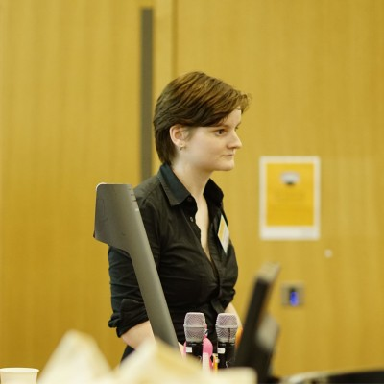
There were times during the weekend when I knew that what I was learning would stick with me throughout my career journey, and I hope to reflect more in depth on these experiences in future posts.
There aren't many experiences where you can feel yourself changing and growing in real time, but at every second of this weekend I felt myself growing in confidence, expertise and becoming more and more inspired.

I loved the individualised feedback sessions, really helped us build confidence in our ideas and create one idea from a collection of ideas. The session helped us figure out how to present the problem, and we then reverse engineered our concept to focus on really clearly addressing this.

Read about Rosalind’s experience with GEL - https://www.linkedin.com/posts/rosalind-howell-721b22298_i-am-almost-lost-for-words-to-explain-how-activity-7474891891080310784-91r3



The 48 hours pushed me to think about a problem I knew scientifically from a completely different angle, as a market structure failure, not just a research gap. That reframe was the most valuable part.
- Sydney Conner (PhD in Biomedical Engineering, University of Cambridge)

Read about Sydney’s experience - https://www.linkedin.com/posts/sydney-j-conner_cjbs-z21-zerotoone-activity-7474838677874065409-qcfI


- Yvonne Walburga Joko-Fru, MD PhD (Clinician and epidemiologist, Post-doctoral Research Affiliate- University of Cambridge)

“I was humbled and exhilarated for the recognition of the potential of EquiGen by our fellow cohort members and the judges.

This weekend emphasized the power of an amazing team, driven by a single vision and a clear purpose.

Building an entrepreneurial mindset as a researcher is a powerful toolkit. However, the right team and the right people to support and back your idea will make a huge difference.

As the African proverb goes.."If you want to go fast, go alone. If you want to go far, go together."

Read about Yvonne’s experience - https://www.linkedin.com/posts/yvonne-walburga-joko-fru_cjbs-z21-zerotoone-activity-7475125636232257536-GVF9/

Graduate immersion programme

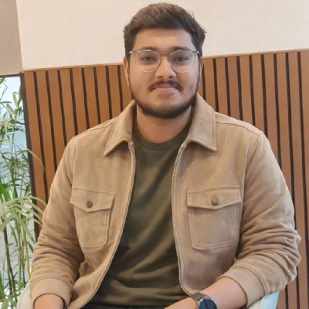
Pushkar Singh – GEL Graduate summer programme participant 2026 (Founder - CarbonSynq Earth)

“I carry back much more than souvenirs and photographs. I leave Cambridge with lifelong friendships, unforgettable memories, invaluable mentorship, and lessons that will stay with me forever.

These 12 days at Girton College, University of Cambridge, through the Global Education Lab, have transformed the way I think about entrepreneurship, leadership, and innovation. Every lecture, every discussion, every pitch, and every interaction has helped me grow-not only as the founder of CARBONSYNQ EARTH, but also as an individual.

A heartfelt thank you to the entire Global Education Lab team for creating such a remarkable experience.”

Read about Pushkar’s experience - https://lnkd.in/p/gePkxj4N

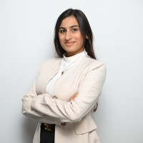
Jivika Vikamshi (GEL Summer immersion student 2025 (Co-Founder, Manashakti)

Sometimes life changes on a random Monday afternoon.

Mine did - at THE UNIVERSITY OF CAMBRIDGE !!!!!

What started as a quiet summer turned into a turning point I didn’t even know I needed. A place, a community, a classroom, conversations and souls that shifted my mind and my path, forever.

If there’s one thing this journey taught me, it’s that opportunities like this don’t just appear - they are created by people who believe in the power of education to change lives. And for that, I owe my deepest gratitude to Suyash Bhatt and Global Education Lab

Read about Jivika’s experience - https://www.linkedin.com/posts/jivika11_how-my-cambridge-summer-became-a-turning-activity-7404572610535043072-wgWJ

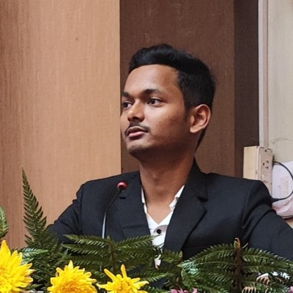
Abhishek Kumar (GEL Graduate summer programme participant 2026, Founder – Kavach AI)
𝗞𝗮𝘃𝗮𝗰𝗵𝗔𝗜 𝗳𝗶𝗻𝗶𝘀𝗵𝗲𝗱 𝗶𝗻 𝘁𝗵𝗲 𝗧𝗼𝗽 𝟯.

More importantly, KavachAI has been selected for the 𝗚𝗘𝗟 𝗚𝗹𝗼𝗯𝗮𝗹 𝗩𝗲𝗻𝘁𝘂𝗿𝗲𝘀 𝗣𝗿𝗼𝗴𝗿𝗮𝗺𝗺𝗲, unlocking support for global expansion and UK market exploration.

Building for the UK means meeting some of the world's highest expectations around privacy and accountability. Those standards don't just prepare us for a new market—they make our product stronger everywhere!!

Read about Abhishek’s experience - https://lnkd.in/p/gAwu3seA

Young Leaders

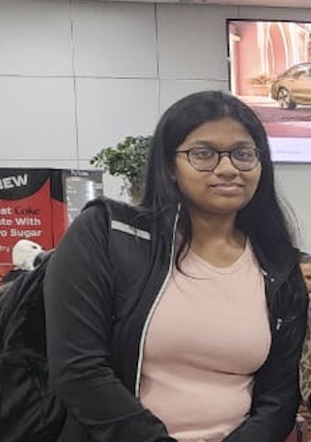
Samvritha (GEL student on young leaders summer programme)
My two weeks at the summer programme in Cambridge felt like a dream. At first, I was nervous about being so far from home, but very quickly it became one of the best experiences of my life. I met amazing people from different countries, made real friendships, and felt like I grew more confident every day. The classes were fun and inspiring, especially entrepreneurship, pitching, and public speaking, and I loved learning in such a beautiful university city. Outside lessons, we explored Cambridge, played sports, laughed constantly, and made memories I’ll never forget. I left feeling excited about my future

Read About Sam’s experience here - https://www.globaledulab.com/post/just-two-weeks-my-summer-at-cambridge-with-global-education-lab

