AQI Forecasting Project Documentation: Karachi

1. Project Overview
This project details the development of a 100% serverless machine learning pipeline designed for predicting the Air Quality Index (AQI) in Karachi, Pakistan. The pipeline encompasses automated data collection, feature engineering, machine learning model training, and the deployment of real-time predictions through an interactive web dashboard.

2. Technology Stack
The following technologies and tools were utilized in the development of this project:

Category | Technologies/Tools
Programming Language | Python
Machine Learning Libraries | Scikit-learn, TensorFlow
Data Sources | Open-Meteo API
Web Dashboard | Streamlit
Orchestration (Planned) | GitHub Actions
Explainability (Future Work) | SHAP, LIME

3. Data Collection and Backfill
Historical weather and air quality data for Karachi, Pakistan, spanning five months (September 2025 to February 2026), were collected. The geographical coordinates used for data retrieval were Latitude 24.86 and Longitude 67.00.

3.1 Data Parameters
The collected data included various meteorological and pollutant parameters:
- Pollutants: PM2.5, PM10, Carbon Monoxide (CO), Nitrogen Dioxide (NO2), Sulphur Dioxide (SO2), Ozone (O3).
- Weather: Temperature at 2m, Relative Humidity at 2m, Dew Point at 2m, Apparent Temperature, Precipitation, Rain, Weather Code, Pressure at Mean Sea Level (MSL), Surface Pressure, Cloud Cover, Wind Speed at 10m, Wind Direction at 10m, Wind Gusts at 10m.

3.2 Data Source
The primary data source for both historical weather and air quality information was the [Open-Meteo Historical Archive API][1]. This API was selected due to its comprehensive historical data availability and free-tier access, which was more suitable than other explored options like OpenWeatherMap for the required historical depth.

4. Feature Engineering
To enhance the predictive capability of the models, several features were engineered from the raw data:
- Time-based Features: Extraction of hour, day, month, and day_of_week from the timestamp to capture temporal patterns.
- Lagged Features: Inclusion of the previous hour's PM2.5 level (pm2_5_lag1) to account for temporal dependencies.
- Derived Features: Calculation of the rate of change in PM2.5 (pm2_5_diff) to represent the dynamic behavior of air quality.

5. Model Training and Selection
Three distinct machine learning models were trained and evaluated: Random Forest, Ridge Regression, and a TensorFlow-based Multi-Layer Perceptron (MLP). The models were assessed using standard regression metrics: Root Mean Squared Error (RMSE), Mean Absolute Error (MAE), and R-squared (R²).

5.1 Model Performance
The evaluation results are summarized in the table below:

Model | RMSE | MAE | R²
Random Forest | 7.33 | 5.33 | 0.73
Ridge Regression | 11.24 | 8.60 | 0.37
TensorFlow (MLP) | 9.94 | 7.56 | 0.50
The Random Forest model demonstrated superior performance with an R² value of 0.73, indicating that it explains 73% of the variance in the target PM2.5 levels. Consequently, the Random Forest model was selected as the best performing model for generating future predictions.

6. Results and Predictions
The selected Random Forest model was utilized to forecast PM2.5 levels for the next three days in Karachi.
- Current PM2.5: Approximately 42.0 µg/m³.
- Predicted PM2.5 (24 hours later): Approximately 38.5 µg/m³.

6.1 Feature Importance
Analysis of the Random Forest model revealed that previous PM2.5 levels and relative humidity were among the most influential factors in predicting future AQI. The feature importance plot is provided below:

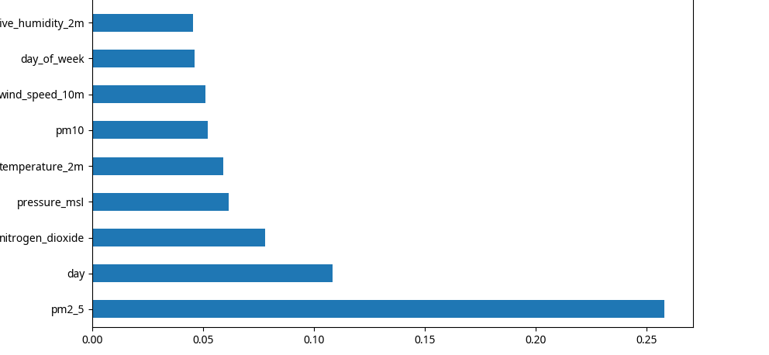

6.2 AQI Forecast Trend
The forecast trend for the next three days, comparing current/forecast input PM2.5 with the predicted PM2.5 levels 24 hours later, is visualized below:

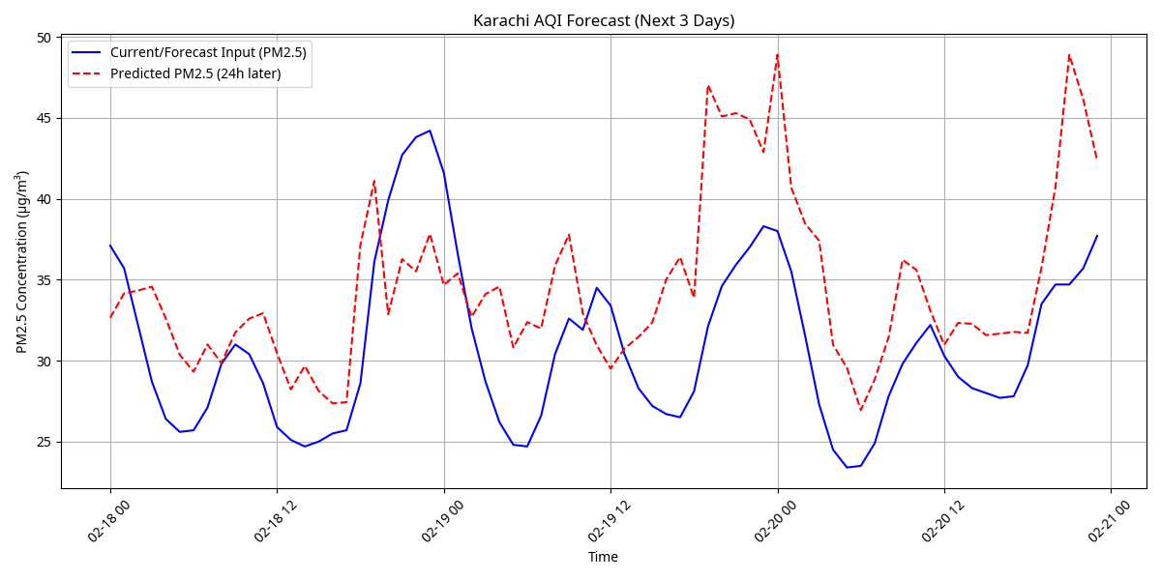

7. Web Application Dashboard
A web application dashboard was developed using Streamlit to provide an interactive interface for real-time and forecasted AQI data. The dashboard displays current PM2.5 levels, 24-hour ahead predictions, model performance metrics, and the forecast trend plot.

8. Challenges Faced and Solutions
- Data Source Selection: Initial attempts with OpenWeatherproved insufficient for the required historical data depth fetching current data perfectly but not convenient for previous months data . The solution involved switching to the Open-Meteo API, which offered more comprehensive historical data within its free tier.
- Dependency Management: Encountered ModuleNotFoundError for scikit-learn and tensorflow. These issues were resolved by manually installing the necessary packages within the sandbox environment using pip3.
- Prediction Target Definition: The target variable was defined as PM2.5 levels 24 hours in the future. This necessitated careful handling of data shifting and imputation of NaN values resulting from these operations during the feature engineering phase.

