Gumbel Extreme Value Distribution Statistical Software Package.(GEVD-SSP).

User’s manual

Version 1.0

October 2022

GEVD-SSP was prepared by the Diplom Engineer Homayoun Khoshnod and engineer Mohammad Sarwar Amini under the supervision of professor Mohammad Nasim Nasimi based on Gumbel’s Equion.

GEVD-SSP is designed to perform statistical analyses of hydrological data. The following is a description of the major capabilities of GEVD-SSP. Gumbel method, Gumbel defined flood as the largest of the 365 daily flows and the annual series of flood flows constitute a series of largest values of flows. (Pawan Bhattarai, Prajwal Khanal, et all., 2019). The Gumbel distribution is perhaps the most widely applied statistical distribution for problems in engineering. (Saralees Nadarajah, Samuel Kotz, 2004). Maximum likelihood equations for the estimation of Gumbel distribution parameters from censored samples are derived; expressions for their large-sample standard errors are also given. Censored samples arising in annual maximum flood series are described, and it is shown that a set of historic floodmarks may, under certain assumptions, be combined with recent no censored data, to form what is essentially a censored sample. (Morven N. Leese, 1973). In probability theory and statistics, flood frequency analysis is used to obtain the probability distribution of floods. The distribution models can be summarized as the generalized extreme value, Gumbel or extreme value type 1, Log-Normal, and the Log Pearson type III distributions. The Gumbel distribution provides the best fit according to the extreme value analysis studies. The performance of the prediction models was evaluated with an illustrative example for 2, 5, 10, 20, 50, 100, 200-, 250-, 500- and 10000-year floods. In probability theory and statistics, flood frequency analysis is used to obtain the probability distribution of floods. (Fevzi Onen & Tamer Bagatur , 2017).

## 1. Gumbel extreme-value distribution method

Gumbel's Equation for analyzing the flood frequency is used below.

XT= value of variate X of a random hydrological series with a return period T.

Mean of variates.

Standard deviation of the sample of size N.

K= Frequency Factor expressed as

Which, YT = reduced variate, a function of T is given by

= reduced mean, the function of sample size N and is given in Table 7.3; for = reduced standard deviation, a function of sample size N and is given in Table 7.4; N

2.Flow Duration Curve (FDC)

The flow-duration curve, which displays the percentage of time that specified discharges were met or exceeded within a certain period, is a cumulative frequency curve. If the curve's base period corresponds to a stream's long-term flow, it can be used to forecast future flow distributions for water-power, hydropower design, and water supply. The unpredictability of stream flow and how a stream's discharge is sustained over time in the basin are both determined by flow duration curves. Numerous factors, including as climate, watershed land cover and usage, soil type, and topography, influence these variables.

For anyone who wants to understand the how’s and whys of hydropower design, understanding the flow duration curve is an excellent place to start. It is one of the most essential pieces of information that enters into the design of a hydroelectric project. Building a Flow Duration Curve from scratch is the simplest method to comprehend it.

1. Steps for Drawing Flow Duration Curve

1. Calculate the total number of data, say N.

2. Give rank to the data for the data 1,2,3., N; say n.

3.Compute frequency(f)  
N= Total numbers of data(N) / Rank(m)

4.Compute the probability of exceedance(p)  
p=m/(N+1)  
pp= m/(N+1)*100

5. Now place the discharge in descending order.

6. Draw the probability of exceedance or % of the time versus discharge.  
This curve is the FDC.

This application is an desktop application which is used based on Country > Provence > District > River Name.

**Requirements:**

* **Microsoft Access**
* **.net framework 3.5 or higher**
* **Microsoft Access component**

When you installed this application on your computer then you will see the following page:

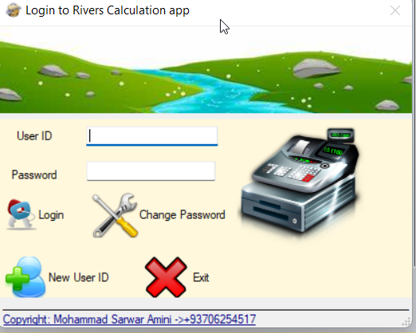

If you have already a user id then you need to enter your user id and password then login. Otherwise you need to create a new user id by using  after clicking on this option you will see the following dialog:

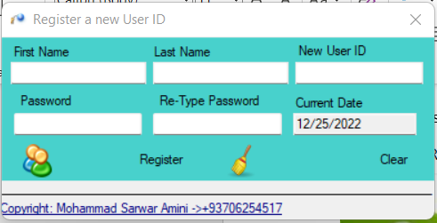

* First Name: enter your first name here. For example Homayoun
* Last Name: Enter your Last Name here. For example Khoshnode
* New User ID: Enter your user id name. for example hkhoshnode
* Password: enter a password. For example 1234
* Re-Type Password: re type your password. For example 1234
* Current Date: you are not need to do anything with this option.
* Register: after clicking on this option you will see a successful message:

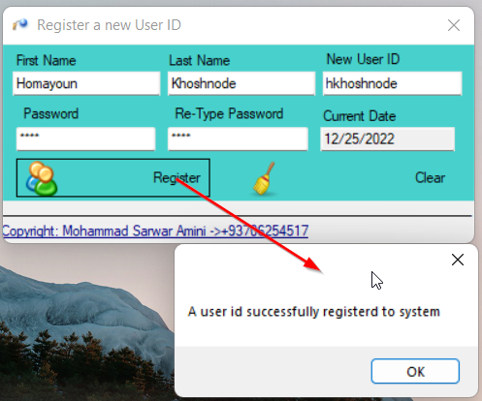

* Then click on Ok button and enter your credential and login it.

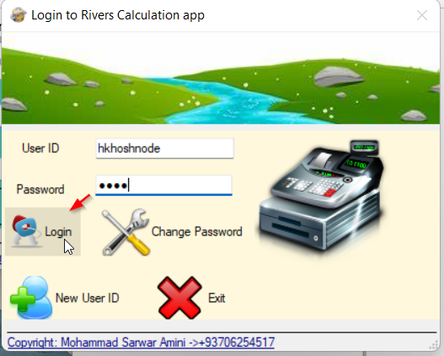 click on Login button to login successfully.

If you want to change your password then click on 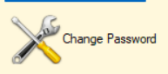 and you will see the following dialog:

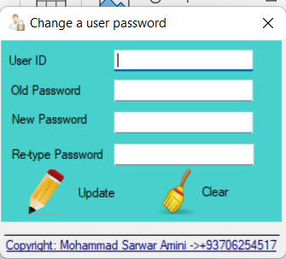

* User ID: enter the User id you want to change the password. For example hkhoshnode
* Old Password: enter the Old Password. For example 1234
* New Password: enter new password. For example 12345
* Re-Type password: enter the password again. For example 12345
* Click on Update button to update the password.

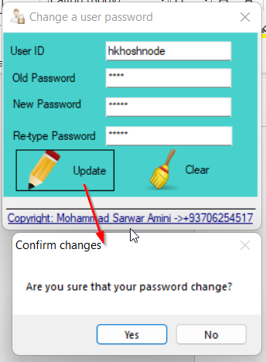 click on Yes to change you password or click No to cancel your changing password.

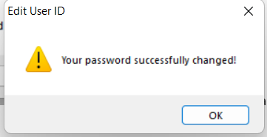 click on Ok to close the dialog.

When you login successfully then you will see the main page:

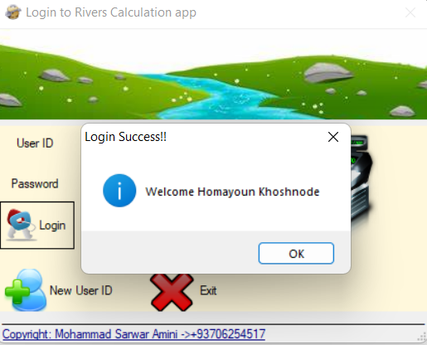 click on Ok and you will see the following main page:

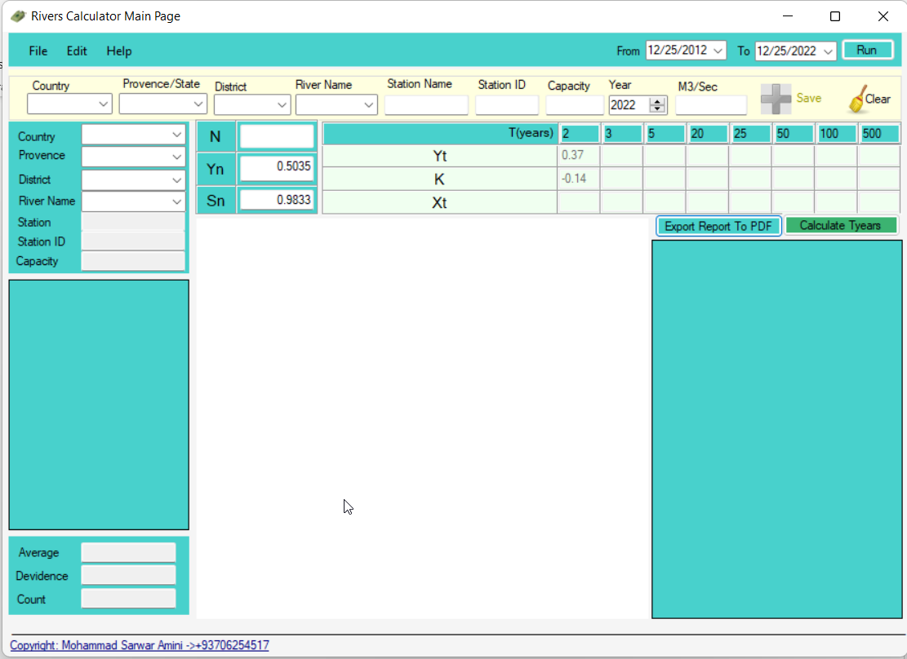

In this page you will see different part and we will describe each part of the main page:

1. Menu bar: there is three menu:
   1. File: this menu contains the following options:

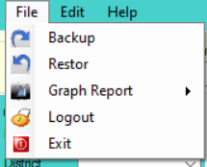

* 1. Edit: this menu contains the following options:

* 1. Help: this menu contains the following options:



1. Run Report bar: this bar contains the following options which is used for running reports based on date range (From – To):



1. Single entry data:



1. Options for selecting river based country:

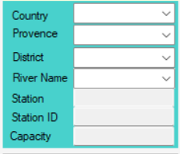

1. Time period Years options:

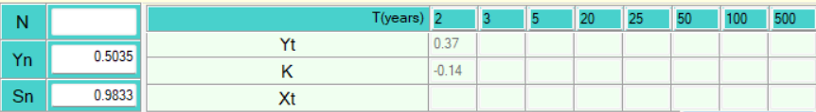

1. Left side reports:

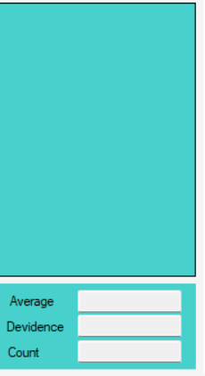

1. Graph side reports:



1. Right side reports:

1. PDF report options:



When you login there is no data to see the reports. There is two types of data inserting:

1. Single mode: you can load a single data into database:
   1. From **Edit** menu select at the first time you need to add a country like the following:

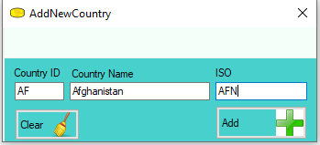 Then click on **Add** button to add records, after adding a new country the application will start and ask you relogging after you relogging you will see the a record in country DDL

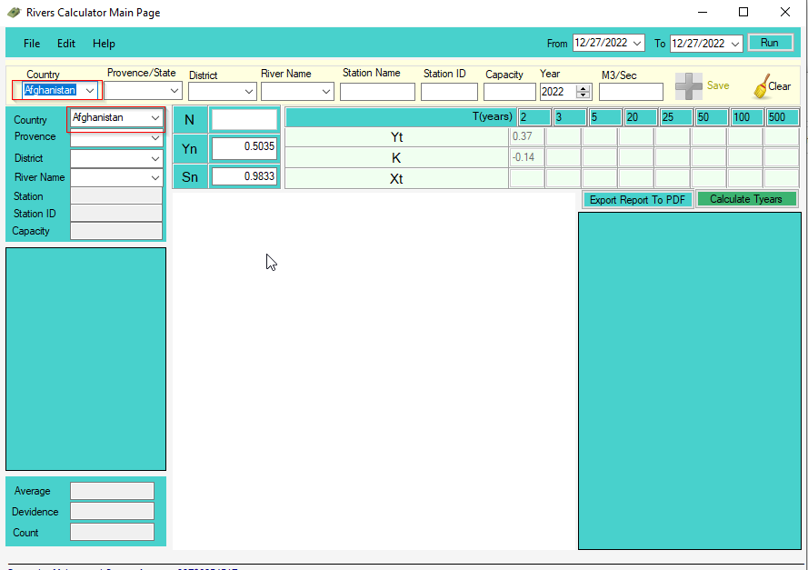

You still need to add provinces, district, river for this you need to use **Edit** menu and then select and you will see the following dialog:

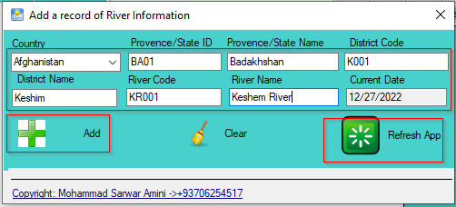

Click on **Add** button to Save the record and you need to click on Refresh App to relogging and you will see the data like the following:

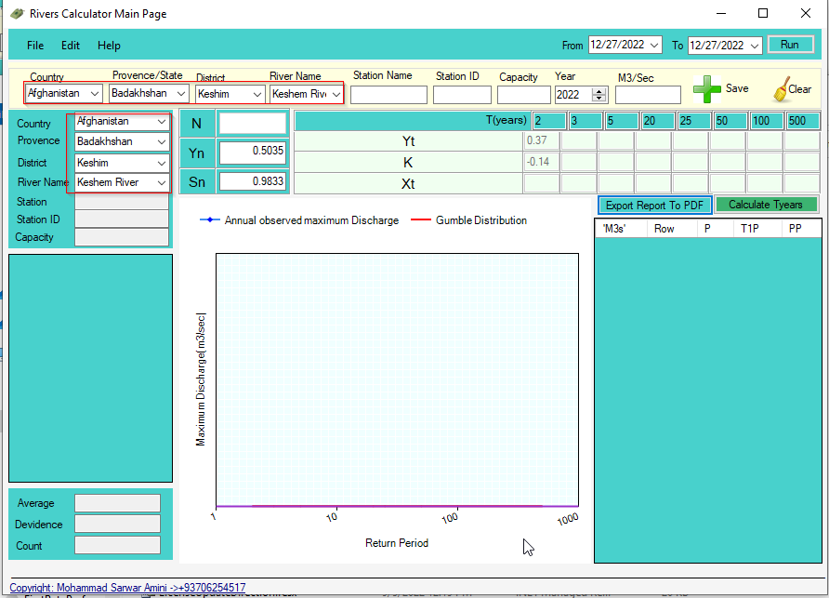

Now there is no data for River and then you need to add some data using the following options:



Click on **Save** button to save River information.

The river report is showing based  options, after clicking on **Run** you will see the following reports:

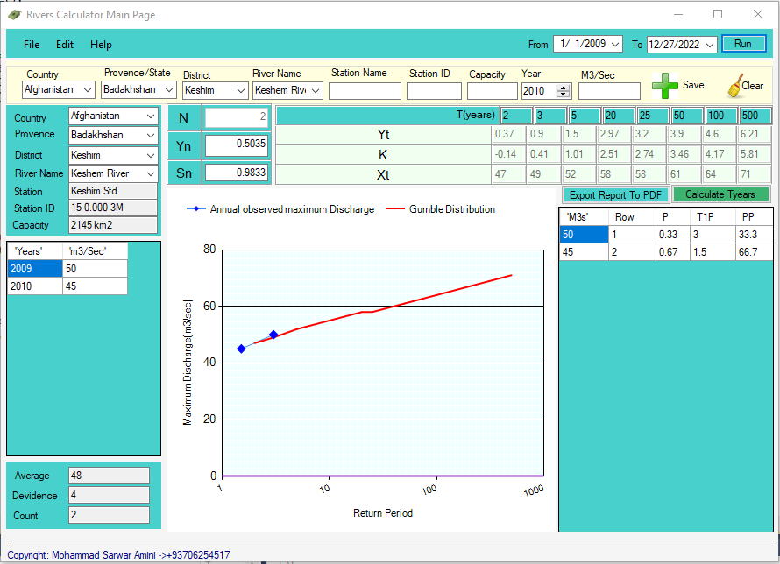

1. The second method for adding record is Multi-Row editor which is Excel.
   1. From **Edit** menu select **Upload Data From Excel** and then Select  **Download Excel Sample**

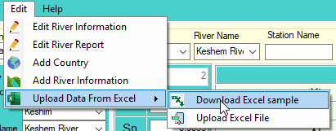

1. Save the excel sample in your computer

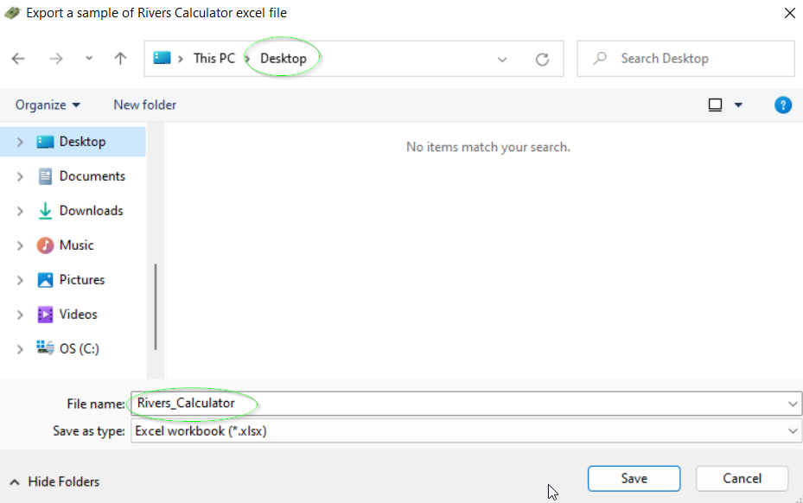

1. Open the Excel

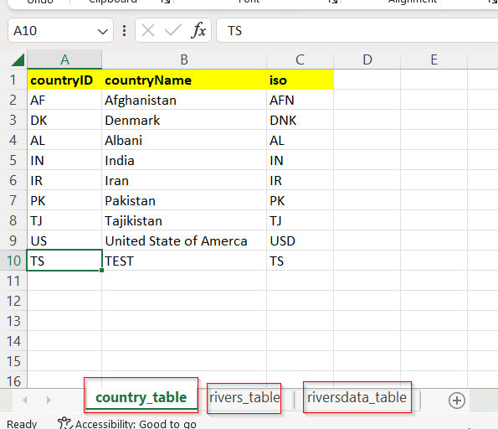

There is three table that is need to fill carefully.

Note: this application is working based on **Country** > **Province** > **District** > **Rivers Name**

So the data analyzing should be professional and give unique codes for each of the above options.

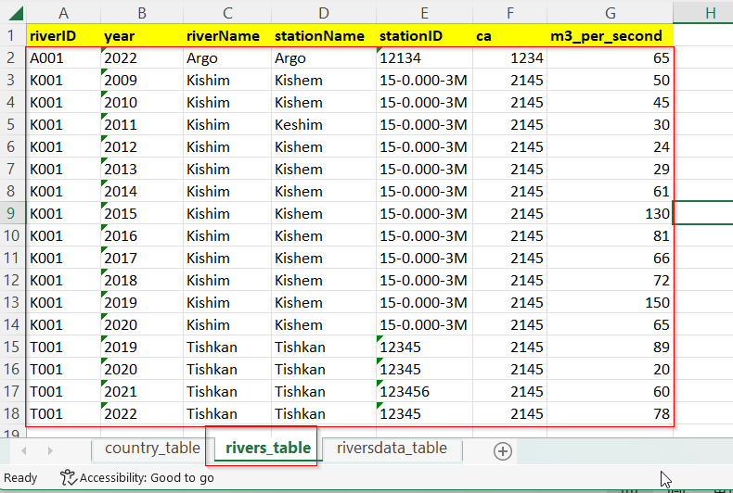

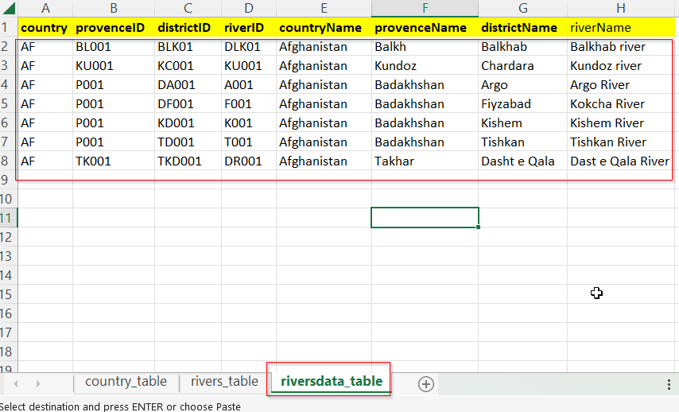

1. Save your data and import the excel using the following:

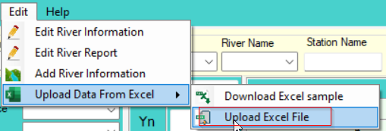

After clicking on **Upload Excel File** you will see the following:

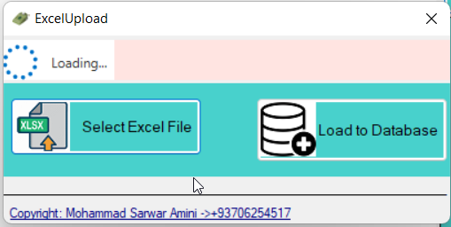

At the first you need to upload excel and then load the excel, so click on **Select Excel File**

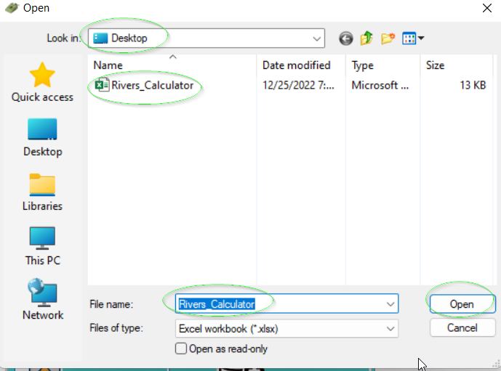

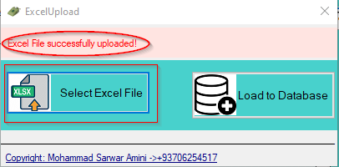

1. Load the excel into database: Click on **Load to Database**

**If the load is not successful then you will see the following error:**

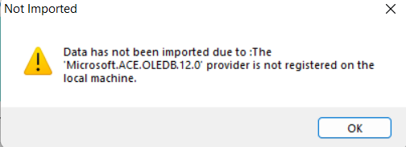

**Download the MS Access component from the following link:**

[**https://www.microsoft.com/en-in/download/details.aspx?id=13255**](https://www.microsoft.com/en-in/download/details.aspx?id=13255) **and install in computer.**

After the above installation

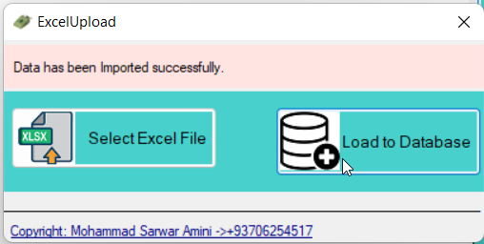

1. Close the above and logout and re-login

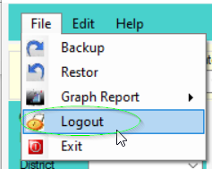

After relogging and running report on date ranges you will see the following page:

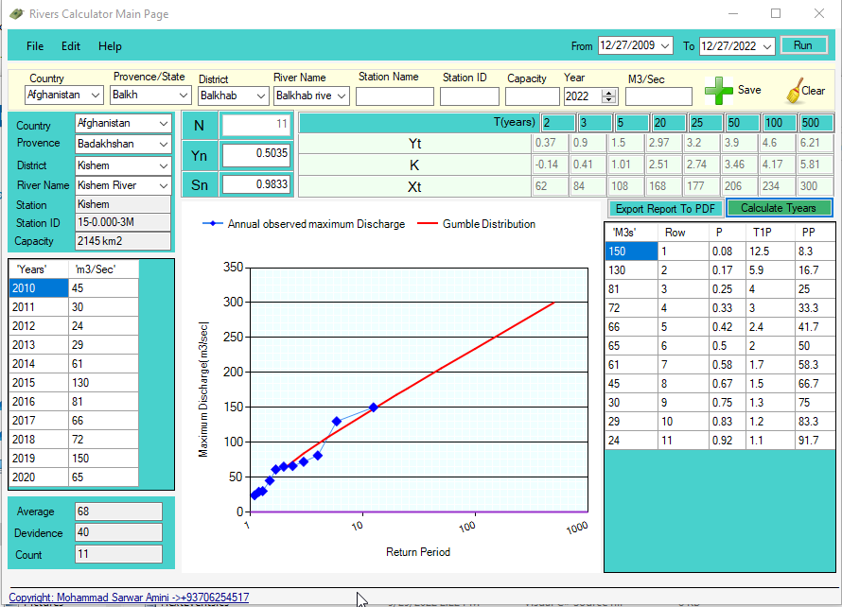

How to run report?

After you load your data into system you can run the report from the following options:

1. Set the Date Range (From – To):



1. This application is working based on Country>State>District>River Then from the following options you can select and the report is automatically runs by changing the following options:

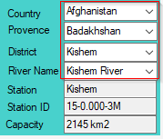 for example I am going to change the Provence and the District DDL is updating automatically based on the selected Provence:

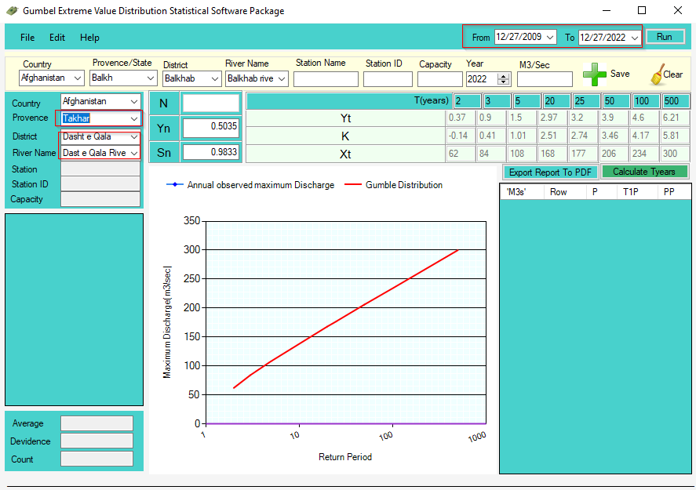

1. For knowing the Flow Duration Curve graph run from **File > Graph Report > Flow Duration curve** like the following options:

Or you can run the Return from **File > Graph Report > Return Period**

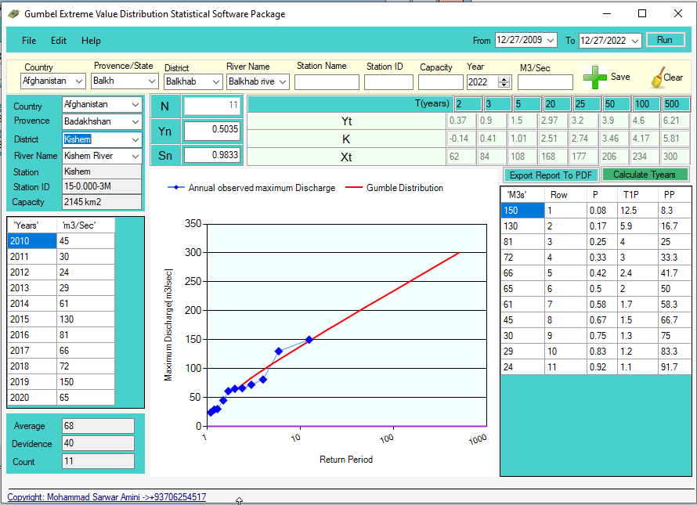

**Run Time Period years**

To run the T Years report do the following:

This boxes are editable and you can enter any value on these boxes:



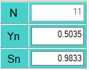 the ‘N’ Boxes is not editable and this is the number of records, ‘Yn amd Sn’ are editable boxes and you can enter your own data.

When you entered your own data in the above boxes then click on  button and the report will changed also the graph will changed:

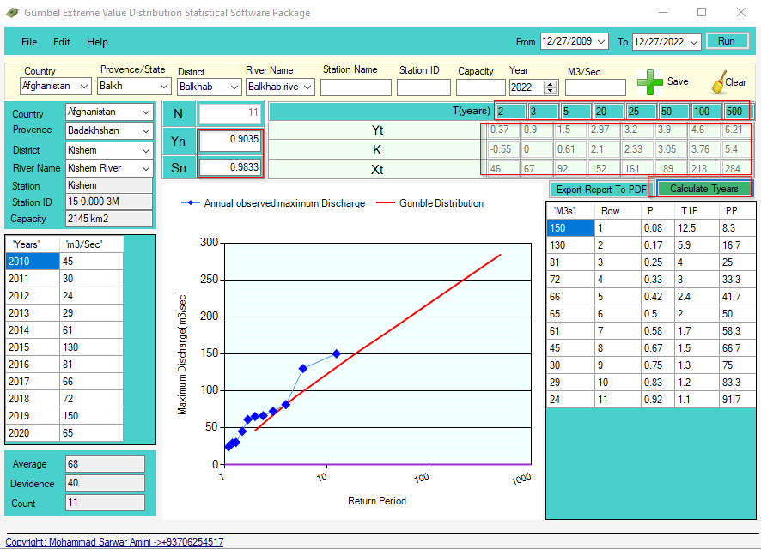

**How to Export the report into PDF**

Just click on  and save the output to your favorite path:

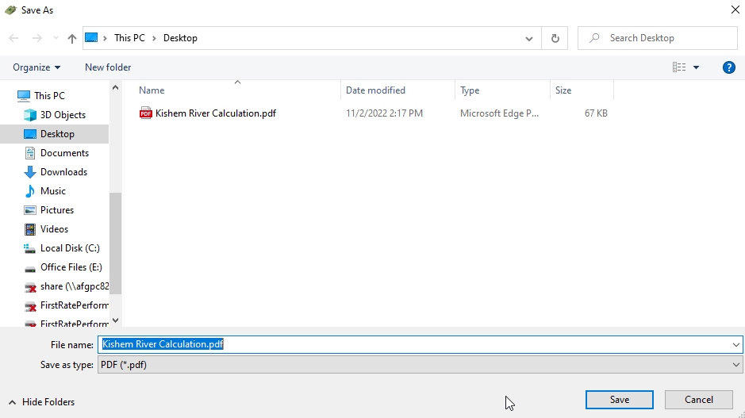

And now the data is successfully imported to PDF:

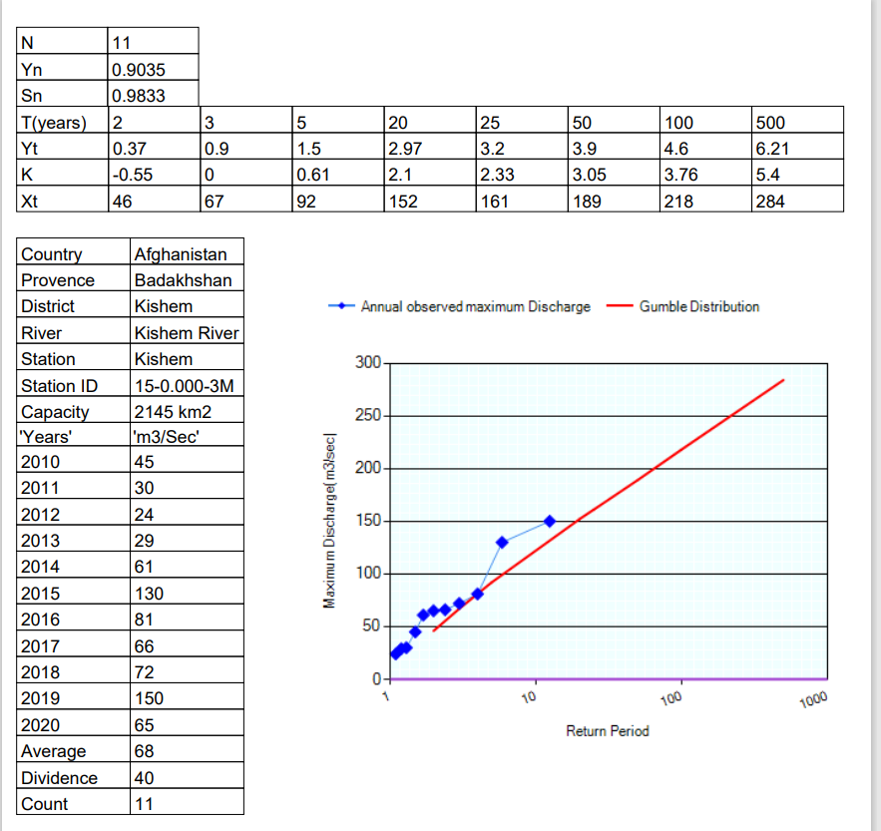

Page 2:

**How to edit and existing River information**

From **Edit** click the ****and the following dialog is open:

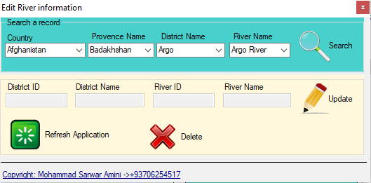

then the information of the river will be on following boxes:

to update the existing data with the new one or click the  to delete the existing data.

After update/delete you need to restart the application to apply the changes.

**How to edit and existing river report**

From **Edit** menu click the option and the following dialog is open:

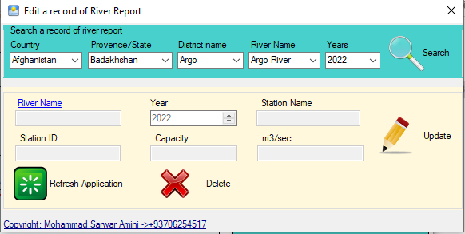

button and you will see the information of that records:

After editing you can click on Update button to update or click on Delete button to delete.

After update/delete you need to restart the application to apply new changes.

**How to backup/restore**

From **File** menu click the option to backup your database and save that into your specific path:

and then click Ok to save a copy of database.

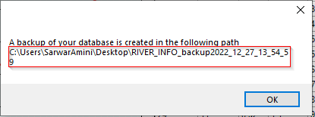

For restoring from **File** menu and then click on and confirm if you like to restore your data.

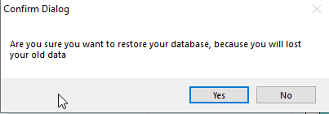

Note: Restoring data will cause to remove all of your data and replace the old data.

After clicking on ‘Yes’ you will see the following

select the backup folder and click on ‘Ok’

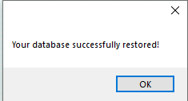 now log off and re-login