EECS 3311 – Project Report

Fall 2019

TEAM  
Sarwat Shaheen (214677322)

Nafis Ahmed Awsaf (215306095)

EECS Logins of team members:

sarwat12

awsaf11

EECS login of submitting account:

sarwat12

BON DIGRAMS OF OUR DESIGN

BON DIAGRAM 1

The following diagram details the relationship between all relevant classes within the project implementation. All classes in this diagram are shown in concise/compact view.

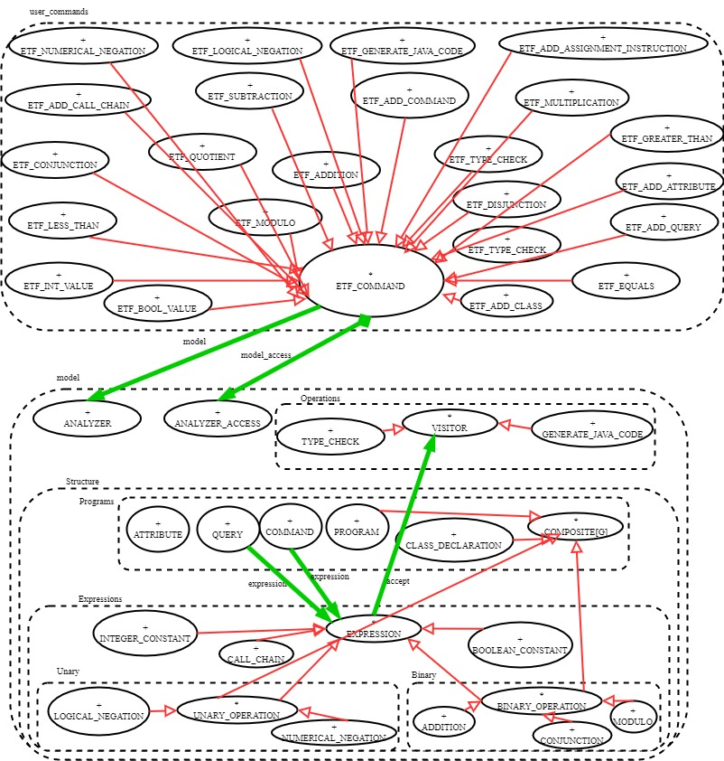

BON DIAGRAM 2

The following diagram details the architecture between all relevant classes within the programming language/expressions structure. Critical classes are shown in expanded/detailed view.

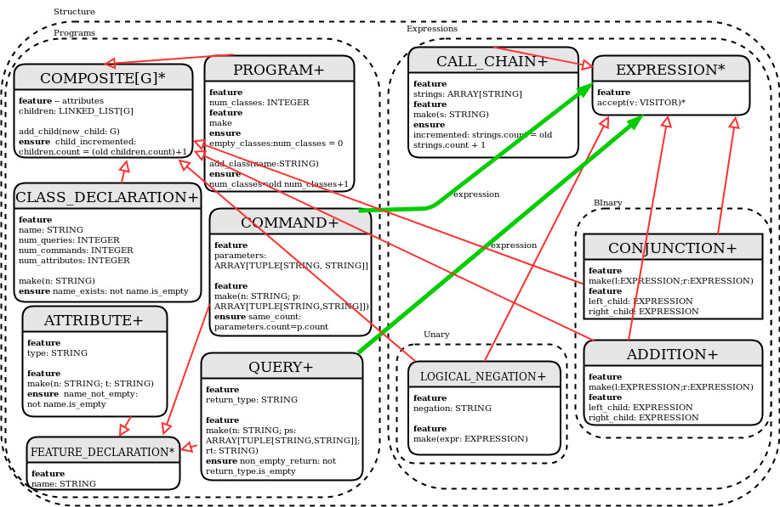

BON DIAGRAM 3

The following diagram details the architecture between all relevant classes within the programming language/expressions operations. Critical classes are shown in expanded/detailed view.

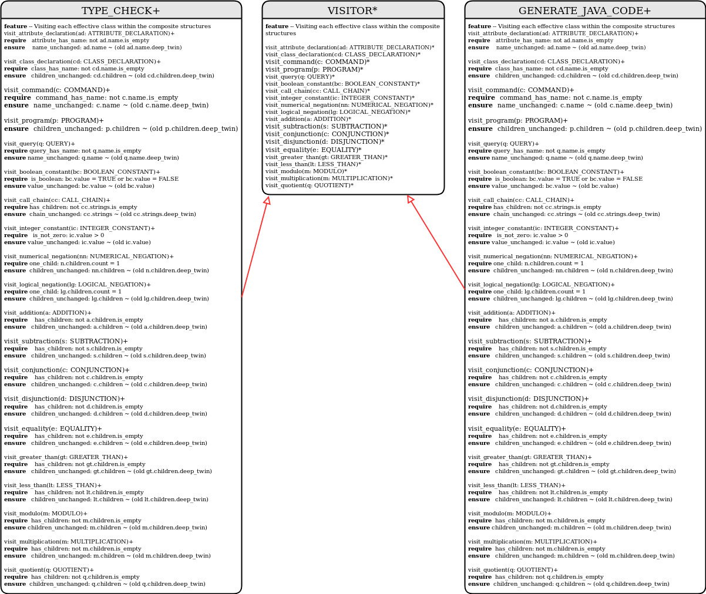Details of how our design follows the following design principles:

– Information Hiding (what is hidden and may be changed? what is not hidden and stable?)

Ans:

– Single Choice Principle

– Open-Close Principle

– Uniform Access Principle

– Any other design principle that we discussed in lectures