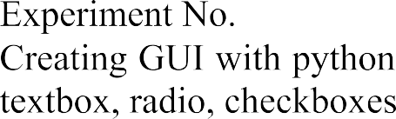

| 8 |
| --- |
|  |
| 20/3/24 |
| 27/3/24 |



           



**Code:**

import tkinter as tk

def greet():

name = entry.get()

gender = gender_var.get()

greeting_label.config(text=f"Hello, {name}! You are {gender}.")

# Create the main window

root = tk.Tk()

root.title("Simple GUI")

# Add a Label

label = tk.Label(root, text="Enter your name:")

label.pack()

# Add an Entry widget

entry = tk.Entry(root)

entry.pack()

# Add a Label for gender selection

gender_label = tk.Label(root, text="Select your gender:")

gender_label.pack()

# Variable to hold the selected gender

gender_var = tk.StringVar()

# Add Male and Female Radiobuttons

male_radio = tk.Radiobutton(root, text="Male", variable=gender_var, value="male")

male_radio.pack()

female_radio = tk.Radiobutton(root, text="Female", variable=gender_var, value="female")

female_radio.pack()

# Set default gender

gender_var.set("male")

# Add a Button

button = tk.Button(root, text="Greet", command=greet)

button.pack()

# Add a Label to display the greeting

greeting_label = tk.Label(root, text="")

greeting_label.pack()

# Start the GUI event loop

root.mainloop()

**Output:**

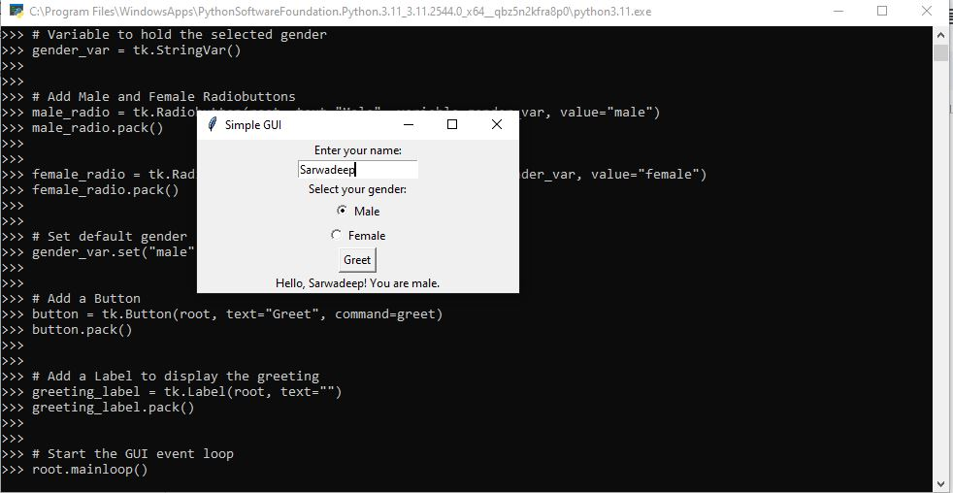

**Conclusion:**

Tkinter is a versatile and accessible GUI toolkit for Python, offering a range of widgets and geometry managers to create interactive and visually appealing applications. Its integration with Python and ease of use make it a popular choice for developing desktop applications with graphical interfaces.