





| Experiment No. 9 |
| --- |
| Program to manipulate arrays using Numpy |
| Date of Performace: 27/03/2024 |
| Date of Submission: 03/04/2024 |







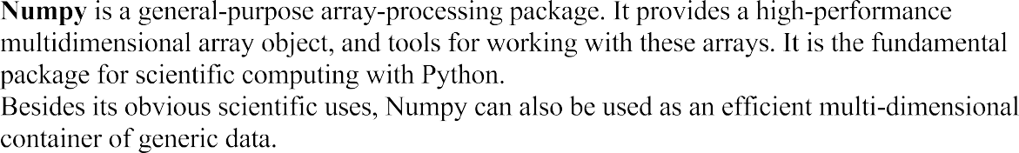









**Code:**

import numpy as Np

a=Np.array([2,3,4,5,6])

sum=0

# B=Np.array([1,2,3,4,5],[2,45,34,45,34])

# print(B)

# find a particular element in the array and add all elements

n=int(input("Enter the element you want to search: "))

flag=False

for i in range (len(a)):

if(a[i]==n):

flag=True

break

if not flag:

print("element not found")

print("Element {0} found at index: {1}".format(n,i))

print("The addition of all elements is: ")

for i in range (len(a)):

sum+=a[i]

print(sum)

**Output:**

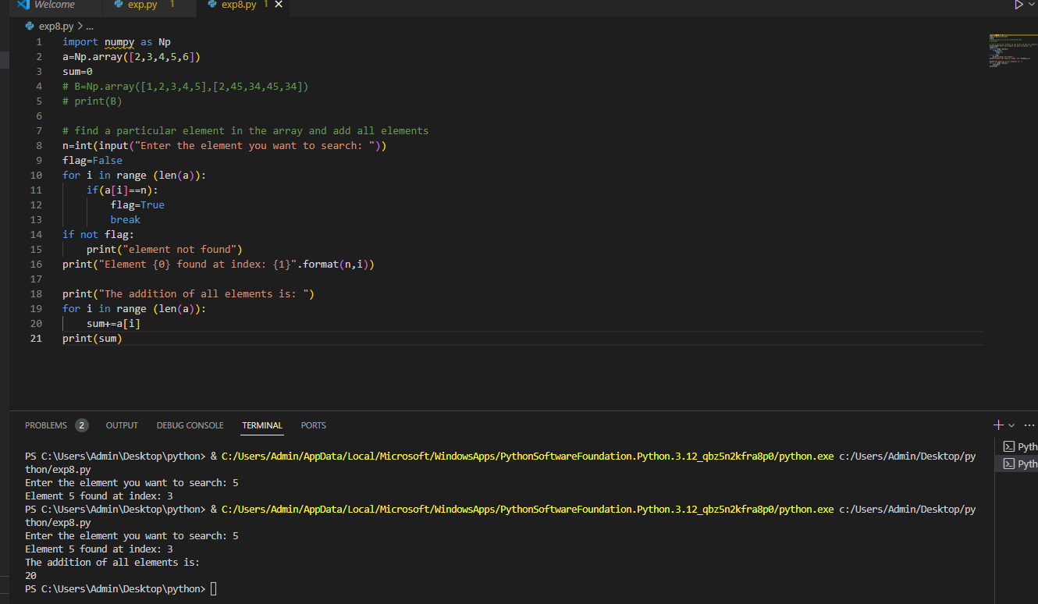

**Conclusion:**

NumPy is a powerful and versatile library for numerical computing in Python. Its support for multi-dimensional arrays, efficient array operations, advanced indexing techniques, and integration with other libraries make it indispensable for a wide range of scientific and engineering applications.