

|  |
| --- |
| Experiment No. 11 |
| Program to demonstrate manipulation using Pandas |
| Date of Performace: 10/04/2024 |
| Date of Submission: 17/04/2024 |

**Experiment No. 11**



**Code:**

import pandas as pd

df = pd.read_csv("country_code.csv")

print("DataFrame Type:", type(df))

print("\nFirst 5 rows of the DataFrame:")

print(df.head())

print("\nBasic statistics of the DataFrame:")

print(df.describe())

print("\nInformation about the DataFrame:")

print(df.info())

**Output:**

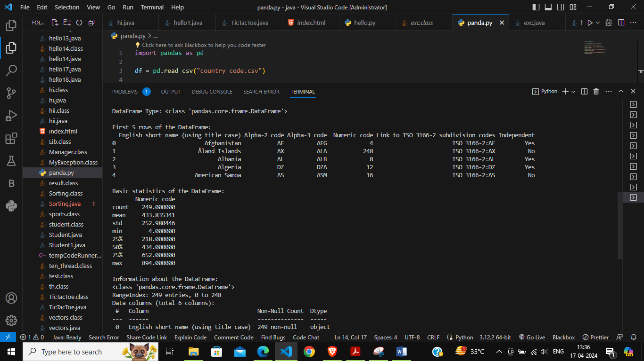

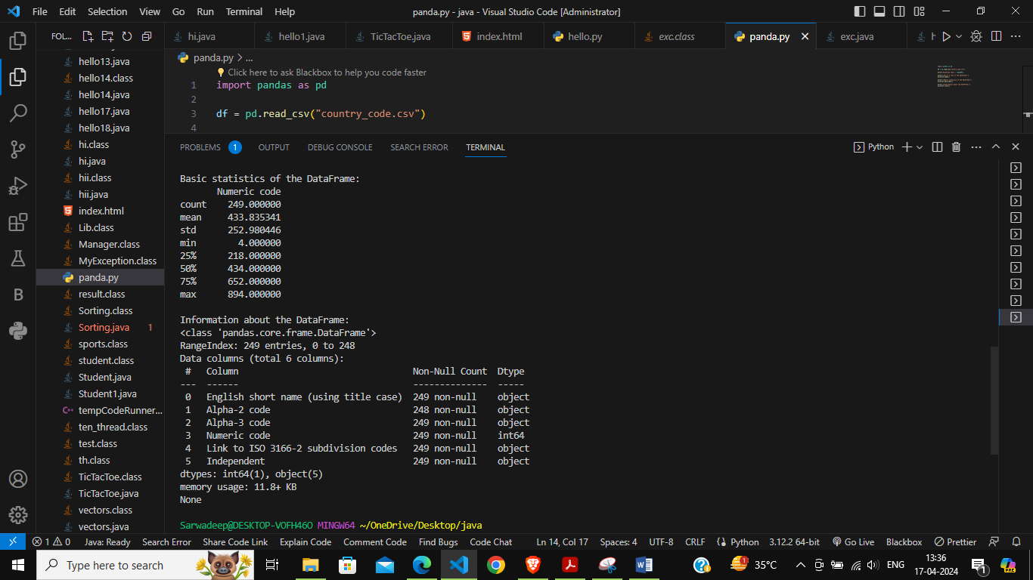



**Conclusion:**

Pandas is a versatile and powerful library for data manipulation and analysis in Python. Its rich set of features, including powerful data structures, data I/O tools, data manipulation capabilities, support for handling missing data, time series functionality, and integration with visualization libraries, make it an essential tool for data professionals and researchers alike.integration with Matplotlib and Seaborn.





