PROJECT REPORT: TELECOM CUSTOMER CHURN ANALYSIS
Author: Gaurav Sarwe | Dataset: IBM Telco Customer Churn (7,043 Customers) | Language: R
Executive Overview
Acquiring a new telecom subscriber costs 5 to 7 times more than retaining an existing customer. This report presents an end-to-end data science project evaluating customer demographics, contract types, service plans, statistical significance, machine learning predictions, customer segmentation, and project limitations to mitigate churn.

Table of Contents / Index
Section Number & Title | Page / Topic Focus
1. Project Introduction & Business Context | Market Dynamics, Cost of Acquisition, Problem Statement
2. Project Objectives & Roadmap | Key Technical Objectives (01 to 04) & Analytical Roadmap
3. Executive Summary | High-Level Findings, Overall Churn Metrics & Core Results
4. Data Cleaning & Preprocessing | Handling Blank TotalCharges, Factor Transformations
5. Exploratory Data Analysis (EDA) | Contract Type & Tenure Group Churn Visualizations
6. Statistical Hypothesis Testing | Chi-Square Tests (Cramer's V) & Wilcoxon Rank-Sum Tests
7. Predictive Modeling (Logistic vs Decision Tree) | Confusion Matrices, Accuracy, ROC Curve (AUC), Odds Ratios
8. Customer Segmentation (K-Means) | Elbow Plot, Cluster Profiling, 2D Visualization
9. Project Limitations & Strategic Recommendations | Data Constraints, Algorithmic Limits & Actionable Business Rules

1. Project Introduction & Business Context
In the highly competitive telecommunications sector, subscriber acquisition costs (SAC) have surged significantly over the past decade. Retaining existing subscribers is estimated to be 5 to 7 times more cost-effective than acquiring new ones. When a telecom subscriber cancels their contract or ports their number to a competitor (a process known as 'churn'), the firm not only forfeits predictable monthly recurring revenue (MRR) but also fails to amortize customer acquisition expenses.
The primary goal of this business analyst project is to conduct a rigorous, data-driven analysis of the IBM Telco Customer Churn dataset using R. By combining exploratory data visualization, non-parametric and parametric statistical testing, supervised machine learning (Logistic Regression and Decision Trees), and unsupervised customer segmentation (K-Means Clustering), this study identifies the root causes of customer loss and provides actionable retention strategies for management.
2. Project Objectives & Analytical Roadmap
The analytical framework of this project was structured into four core objectives, executed systematically using modular R scripts:
- Objective 1 (Data Cleaning & EDA): Clean raw dataset records, convert text fields into factors, fix data type mismatches in TotalCharges, and analyze churn rates across core demographics, contract structures, and tenure buckets.
- Objective 2 (Statistical Testing): Perform Chi-Square tests of independence (with Cramer's V effect sizes) and Wilcoxon rank-sum tests to statistically evaluate key features against churn.
- Objective 3 (Predictive Churn Modeling): Build Logistic Regression and Decision Tree classification models on a 70/30 train/test split, evaluate them using Confusion Matrices, Accuracy, Precision, Recall, and ROC/AUC, and extract key risk factors via Odds Ratios.
- Objective 4 (Customer Segmentation): Perform K-means clustering on standardized customer tenure and financial charges, determine optimal clusters via an Elbow Plot, profile segment behaviors, and produce a 2D cluster visualization.
3. Executive Summary
Customer churn represents a direct hit to recurring revenue in the telecommunications industry. This project utilizes R (tidyverse, caret, rpart, pROC, cluster, factoextra) to perform an empirical analysis of the IBM Telco Customer Churn dataset, establishing statistical relationships and building predictive models to guide retention strategies.
- Overall Churn Rate: 26.58% across 7,032 analyzed customer accounts.
- Contract Type Impact: Month-to-month subscribers experience an alarming churn rate exceeding 40%, whereas long-term contract churn drops below 12%.
- Predictive Accuracy: Logistic Regression achieved an Accuracy of 80.79% and an AUC of 0.856, outperforming Decision Trees.
- Customer Segmentation: K-Means clustering identified 3 distinct customer profiles, with high-spending, short-tenure customers exhibiting a 47.2% churn rate.
4. Data Cleaning & Preprocessing
Telecommunications datasets often contain missing values and improper formatting due to legacy billing systems.
- Raw dataset size: 7,043 records and 21 features.
- Missing Values: 11 missing values in TotalCharges were converted from character blanks to numeric NAs and removed, leaving 7,032 clean observations.
- Feature Formatting: Categorical text features were converted into factors, customerID was removed, and SeniorCitizen was re-encoded as a factor.
5. Exploratory Data Analysis (EDA)
Exploratory analysis reveals that customer commitment and tenure are the primary macro-drivers of subscription longevity.
5.1 Churn Rate by Contract Type
Customers on Month-to-month contracts churn at a rate of 42.7%, compared to 11.3% for One-year contracts and 2.8% for Two-year contracts.
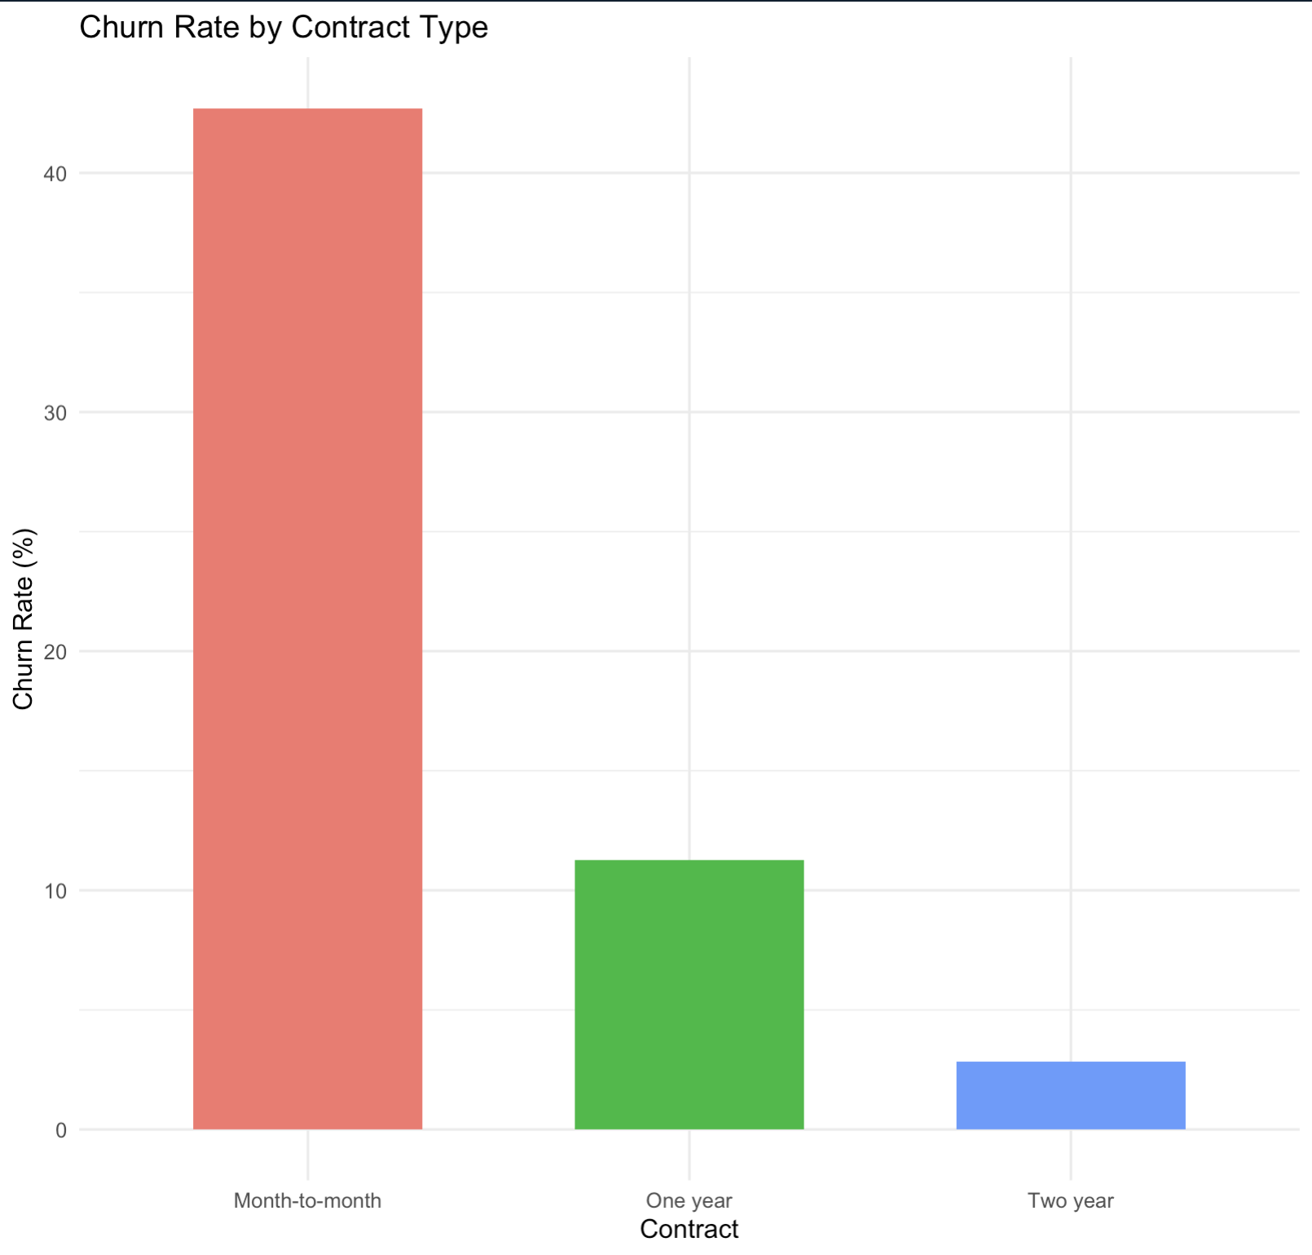
Figure 1: Churn Rate (%) by Contract Type (Month-to-month vs. One year vs. Two year)
5.2 Churn Rate by Tenure Group
Attrition is heavily front-loaded. Customers with 0–12 months of tenure exhibit a 47.7% churn rate, whereas those with 49+ months drop to under 10%.
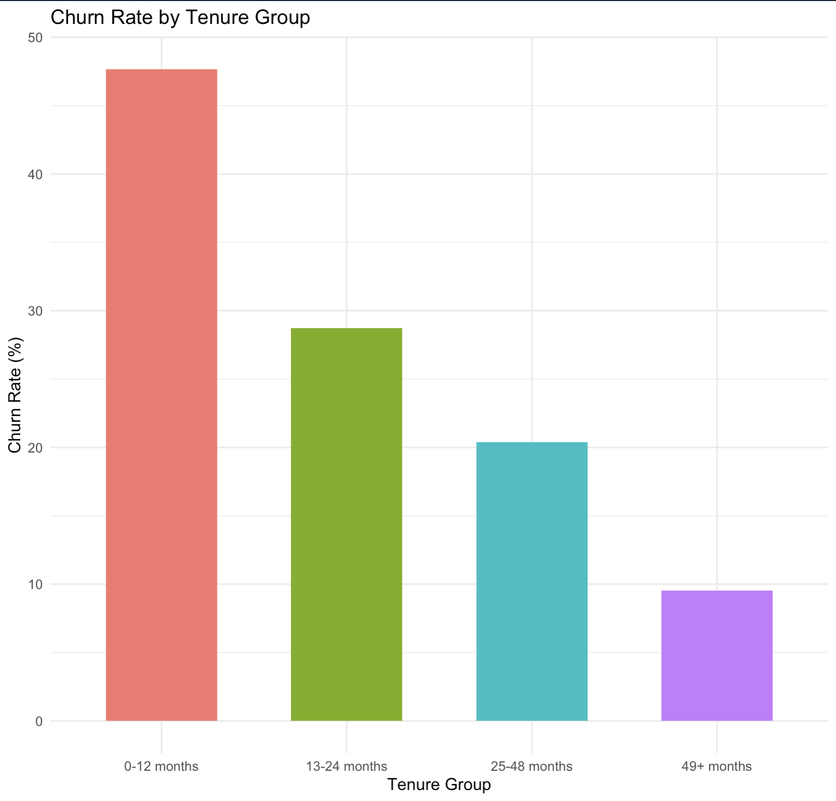
Figure 2: Churn Rate (%) by Customer Tenure Group
6. Statistical Hypothesis Testing
Chi-Square tests of independence and Non-parametric Wilcoxon Rank-Sum tests were conducted to confirm feature significance (alpha = 0.05):
Test / Variable | Test Type | Test Statistic & p-value | Effect Size / Interpretation
Contract | Chi-Square | X² = 1179.5, p < 2.2e-16 | Cramer's V = 0.410 (Strong association)
Payment Method | Chi-Square | X² = 645.43, p < 2.2e-16 | Cramer's V = 0.303 (Electronic check risk)
Internet Service | Chi-Square | X² = 728.70, p < 2.2e-16 | Cramer's V = 0.322 (Fiber optic churn risk)
Monthly Charges | Wilcoxon | W = 3,663,498, p < 2.2e-16 | Churned pay significantly higher charges
Tenure | Wilcoxon | W = 7,154,668, p < 2.2e-16 | Retained have significantly longer tenure

7. Churn Prediction Modeling
A 70/30 train/test split was performed to train and evaluate Logistic Regression and Decision Tree models.
Model | Accuracy | Sensitivity | Specificity | Pos Pred Value | AUC
Logistic Regression | 80.79% | 55.89% | 89.79% | 66.45% | 0.856
Decision Tree (rpart) | 78.94% | 46.61% | 90.63% | 64.29% | N/A
Top Odds Ratios (Logistic Regression)
- Internet Service (Fiber Optic): Odds Ratio = 2.55 (2.55x higher likelihood of churn)
- Payment Method (Electronic Check): Odds Ratio = 1.46
- Paperless Billing (Yes): Odds Ratio = 1.42
- Multiple Lines (Yes): Odds Ratio = 1.39
- Senior Citizen (Yes): Odds Ratio = 1.34
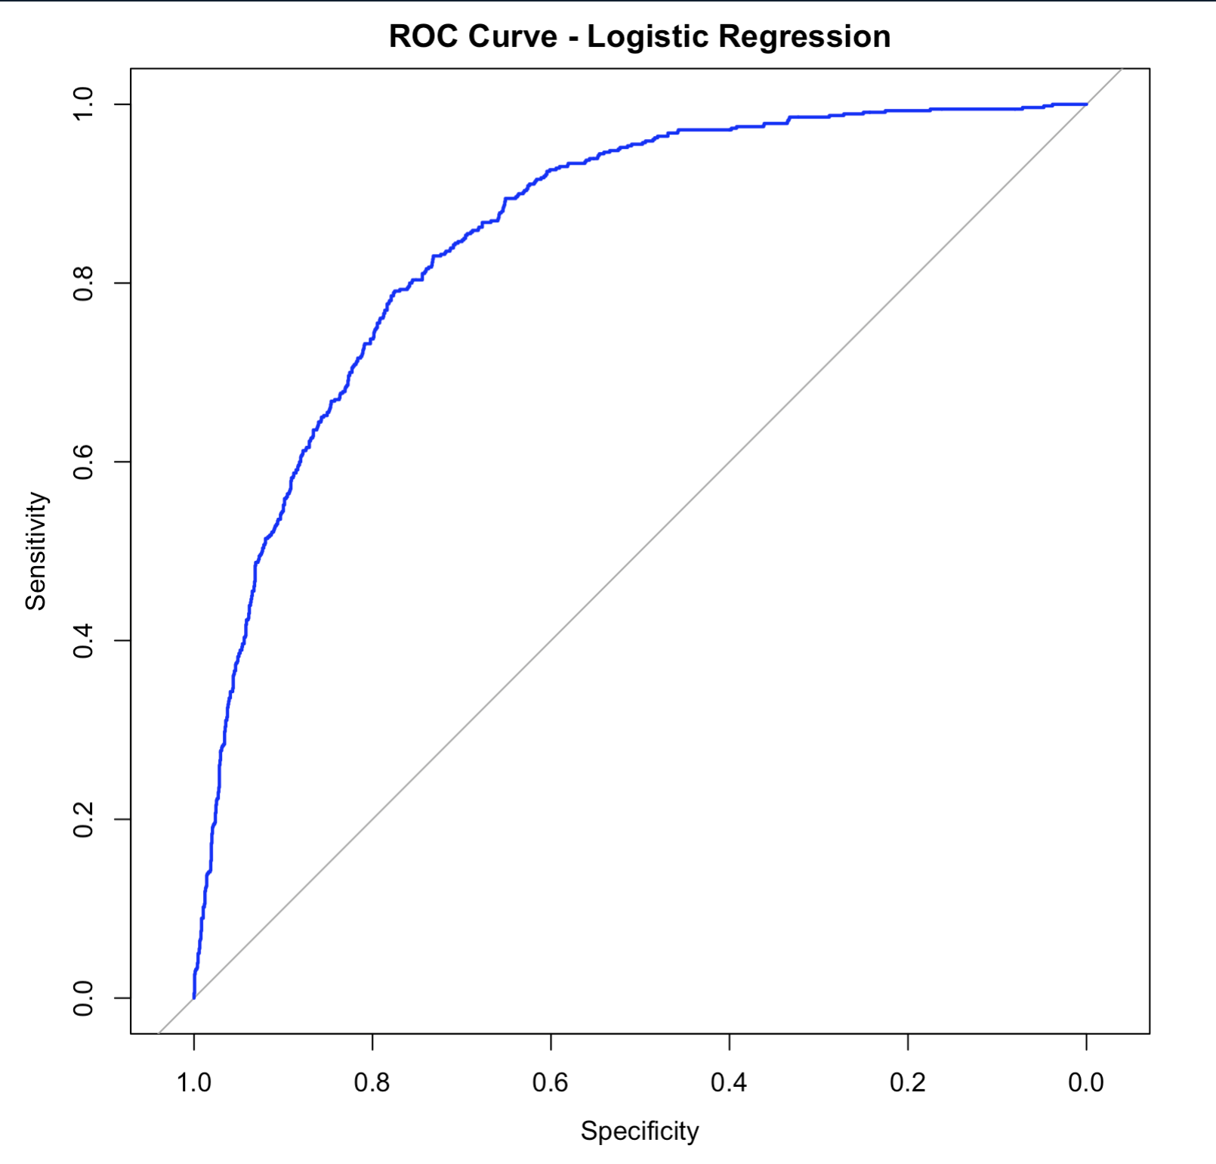
Figure 3: ROC Curve for Logistic Regression Model (AUC = 0.856)
8. Customer Segmentation (K-Means Clustering)
Customer tenure, MonthlyCharges, and TotalCharges were normalized and clustered using K-Means. An elbow plot confirmed k = 3 as optimal.
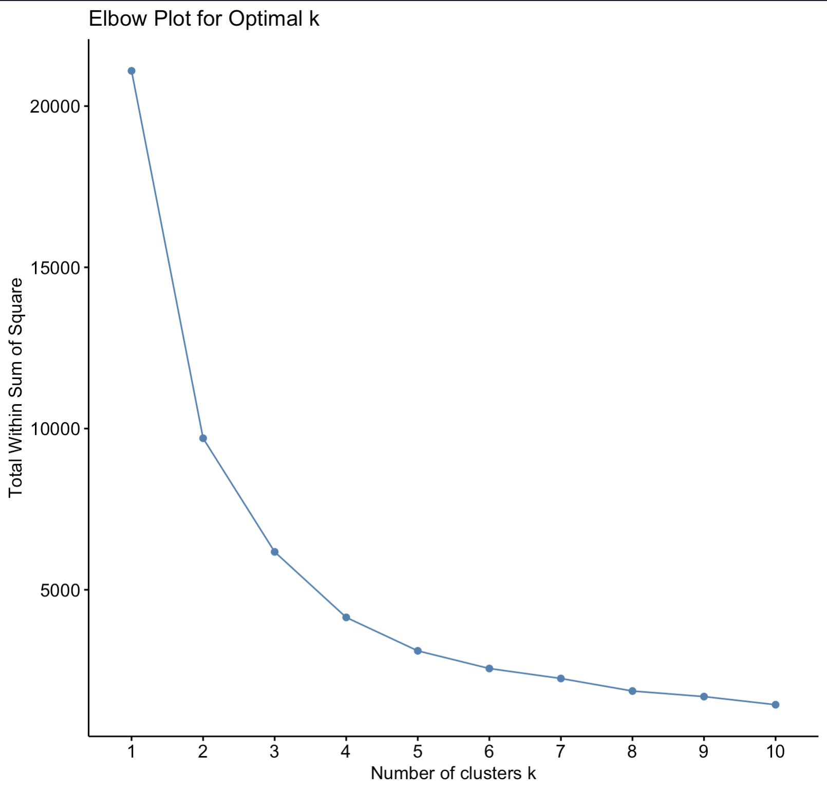
Figure 4: Elbow Plot for Optimal Cluster Count k
Cluster | Count | Avg Tenure | Avg Monthly | Avg Total | Churn Rate | Segment Profile
Cluster 1 | 2,147 | 29.6 mos | $26.60 | $812.00 | 12.3% | Loyal Low-Cost
Cluster 2 | 2,200 | 58.6 mos | $89.70 | $5,246.00 | 15.4% | Long-Term Premium
Cluster 3 | 2,685 | 13.3 mos | $75.00 | $1,032.00 | 47.2% | High-Risk New / At-Risk
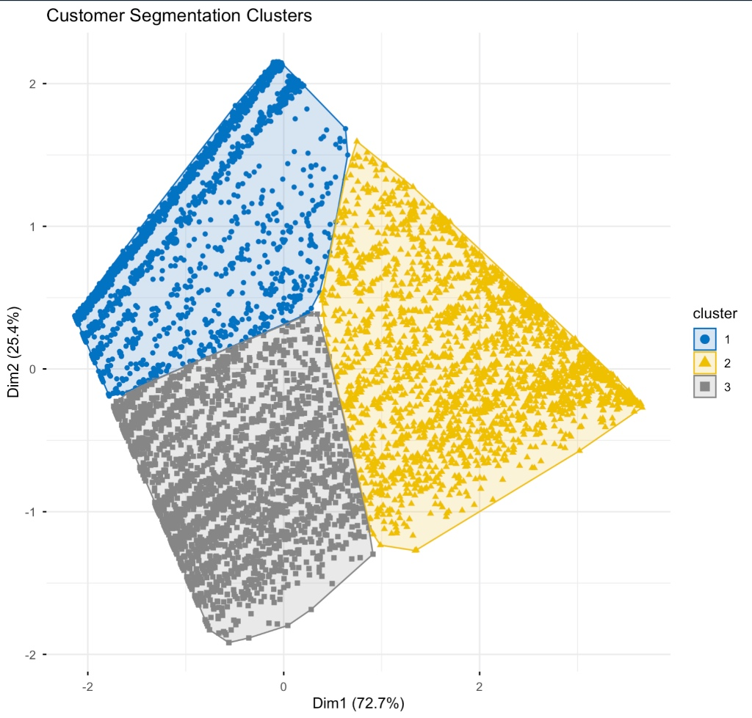
Figure 5: 2D Cluster Visualisation of Customer Segments (Dim1: 72.7%, Dim2: 25.4%)
9. Project Limitations & Strategic Business Recommendations
9.1 Project Limitations
- Data Constraints:Static & Historical Data: The IBM Telco dataset represents a cross-sectional snapshot. It lacks temporal timestamps, call logs, customer support tickets, or recent macroeconomic shifts.
- Model Sensitivity:Class Imbalance Impact: With ~26.58% churners, logistic regression achieved 55.89% sensitivity and decision tree 46.61%, leaving room to improve recall through sampling techniques (ROSE/SMOTE) or probability threshold tuning.
- Granularity Limits:Feature Granularity: Metrics like InternetService or PaymentMethod lack sub-tier bandwidth details or specific bank transaction logs.
- Cost Unawareness:Equal Cost Assumption: Models assume symmetric misclassification costs, whereas losing a high-value customer (False Negative) is financially far more costly than sending an unnecessary discount (False Positive).
9.2 Strategic Business Recommendations
- Targeted Onboarding Program: Focus retention campaigns on Cluster 3 (high-paying new customers) during their first 6–12 months to lower the 47.2% churn rate.
- Contract Incentive Discounts: Offer small promotional discounts to month-to-month subscribers to transition them onto 1-year or 2-year plans.
- Fiber Optic & Billing Friction Audit: Investigate service reliability and billing pain points among fiber optic subscribers and electronic check users to reduce systemic dissatisfaction.

