ChatterBox – Architecture & Design (SQLite Version)

Contents
Architecture Diagram 2
Database Schema 2
Project Objective 2
Technology Stack 3
System Architecture 3
Frontend (React Client – Browser) 3
Backend (FastAPI – Python) 3
API Endpoints (REST): 3
WebSocket Endpoint: 4
Database (SQLite) 4
Workflow Overview 4

Architecture Diagram
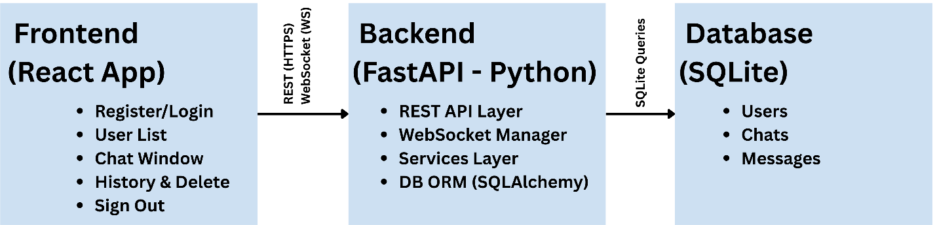

Database Schema
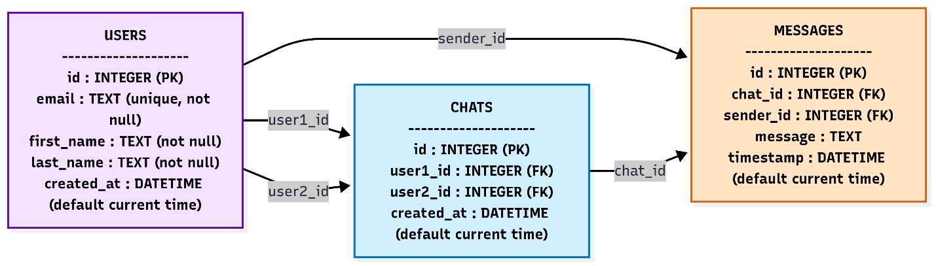

Project Objective
ChatterBox is a lightweight, real-time chat application that enables users to:
- Register with email, first name, and last name.
- Log in using only an email address (no password).
- View a list of all registered users.
- Start one-to-one real-time chats.
- Access and manage past conversations (view or delete).
- Sign out securely.
The solution follows a modular, layered architecture to ensure scalability, maintainability, and clear separation of concerns.

Technology Stack
- Frontend (Client): React (JavaScript/TypeScript)
- Backend (Server): Python (FastAPI framework)
- Database: SQLite (lightweight, file-based DB)
- Real-Time Communication: WebSockets (FastAPI WebSocket support)
- Version Control & CI/CD: Git + GitHub
- Deployment (Optional): Docker containers for backend + SQLite file volume

System Architecture

Frontend (React Client – Browser)
- Handles registration, login, user list, chat window, history, and sign out.
- Communicates with backend via REST APIs and WebSockets.
Key Components:
- RegisterForm, LoginForm, UserList, ChatWindow, ChatHistory, SignOut.

Backend (FastAPI – Python)
- Responsibilities:
  - REST APIs: registration, login, user list, chat history, delete chats.
  - WebSocket endpoints for real-time chat.
  - SQLite persistence via ORM (SQLAlchemy).

API Endpoints (REST):
- POST /register
- POST /login
- GET /users
- GET /chats/{user_id}
- DELETE /chats/{chat_id}

WebSocket Endpoint:
- WS /ws/chat/{chat_id}

Database (SQLite)
Users Table
| id (PK) | email (unique) | first_name | last_name | created_at |
Chats Table
| id (PK) | user1_id (FK) | user2_id (FK) | created_at |
Messages Table
| id (PK) | chat_id (FK) | sender_id (FK) | message | timestamp |
- Indexes:
  - email index on Users for fast login lookup.
  - (chat_id, timestamp) composite index on Messages for fast history queries.

Workflow Overview
- Registration: React form → REST API → SQLite insert.
- Login: Email lookup in Users.
- User List: Fetched via /users.
- Start Chat: New Chats row created if needed.
- Messaging: WebSocket connection → messages broadcast + stored in Messages.
- Chat History: Retrieved from SQLite.
- Delete Chat: Removes related messages + chat row.
- Sign Out: Clears session + closes WebSocket.

