PRODUCT RECOMMENDATION SYSTEM

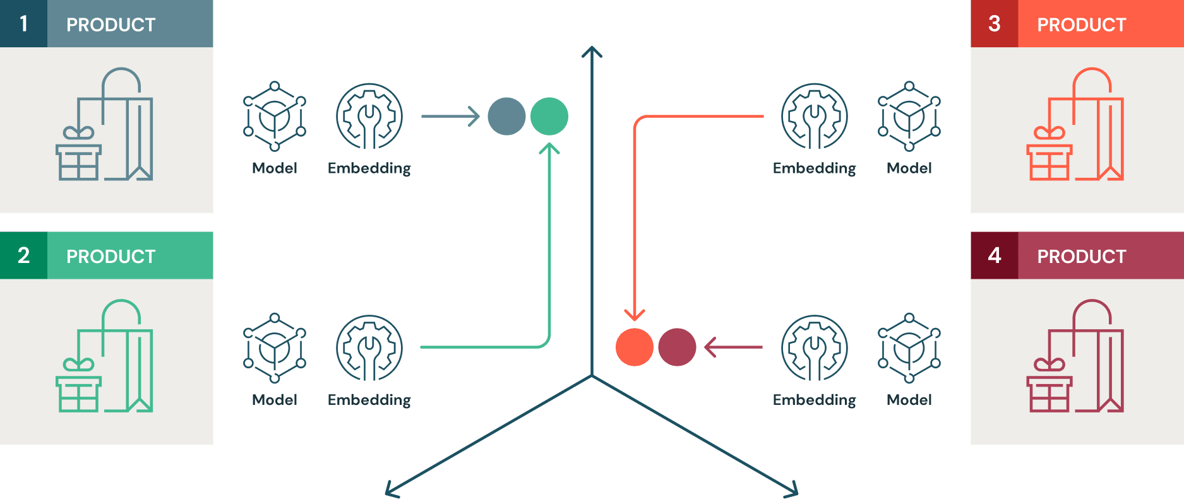

A Project Report
Submitted by Sarweshwar Buddolla
Python Developer Internship – Elevate Labs
Academic Year: 2024–2025

DECLARATION

I hereby declare that the project entitled “Product Recommendation System Using Python” is an original work carried out by me during the Python Developer Internship Program provided by Elevate Labs. This project has not been submitted previously to any university or institution for the award of any degree, diploma, or certification. All the information and materials used in this project have been obtained from legitimate sources and have been properly acknowledged. The work presented in this report is a result of my own efforts and learning during the internship period.

CERTIFICATE

This is to certify that Sarweshwar Buddolla has successfully completed the project entitled “Product Recommendation System” as part of the Python Developer Internship Program conducted by Elevate Labs. The project work has been carried out under appropriate guidance and has been evaluated to be satisfactory. This project fulfills the academic and practical requirements of the internship program and demonstrates the effective application of Python programming and recommendation system concepts.

ACKNOWLEDGEMENT

I would like to express my sincere gratitude to Elevate Labs for providing me with the opportunity to undertake the Python Developer Internship and work on this project. I am thankful to the mentors and coordinators for their valuable guidance, support, and encouragement throughout the internship. I also extend my appreciation to my peers and family members for their constant motivation and support, which helped me successfully complete this project.

ABSTRACT

Recommendation systems play a crucial role in modern digital platforms by helping users discover relevant products efficiently. This project presents the design and development of a Product Recommendation System using Python, implemented as part of a Python Developer Internship at Elevate Labs. The system aims to reduce information overload by providing personalized product suggestions based on user preferences and similarity measures. User and product data are processed using Python to analyze relationships and generate recommendations.
The system follows a modular architecture that ensures simplicity, scalability, and ease of maintenance. By applying similarity-based filtering techniques, the recommendation system produces meaningful suggestions that enhance user experience and decision-making. Experimental results on sample datasets demonstrate the effectiveness of the approach. This project highlights the practical application of Python programming and basic recommendation algorithms in real-world scenarios and serves as a foundation for future enhancements using machine learning and advanced personalization techniques.

INTRODUCTION

With the rapid growth of e-commerce and online platforms, users are exposed to an overwhelming number of product choices. This information overload makes it difficult for users to identify products that match their interests and requirements. Recommendation systems address this challenge by analyzing user behavior and product attributes to suggest relevant items. These systems are widely used by leading digital platforms to improve user engagement, satisfaction, and sales conversion rates.
This project focuses on developing a Product Recommendation System using Python, demonstrating how recommendation techniques can be implemented using simple yet effective algorithms. The system processes user and product data to generate personalized suggestions, improving the overall user experience. Developed as part of a Python Developer Internship at Elevate Labs, the project emphasizes practical learning, modular design, and real-world applicability. It also provides a strong foundation for understanding recommendation system concepts and their role in intelligent software applications.

PROBLEM STATEMENT

Online shopping platforms often contain a large number of products, making it challenging for users to find items that suit their preferences. Manual searching and browsing are time-consuming and inefficient, leading to poor user experience and decision fatigue. Many users abandon platforms due to irrelevant product suggestions or the inability to discover suitable products quickly.
Traditional search-based systems rely heavily on keyword matching and do not effectively capture user preferences or behavioral patterns. There is a need for an automated system that can intelligently analyze user-product relationships and provide personalized recommendations. The problem addressed in this project is to design and implement a Product Recommendation System that reduces information overload and assists users in product discovery. The system should be efficient, easy to implement, and capable of generating relevant recommendations using Python-based data processing and similarity techniques.

OBJECTIVES
The primary objective of this project is to develop a Product Recommendation System using Python that provides personalized product suggestions to users. The specific objectives of the project are as follows:
- To understand the fundamental concepts of recommendation systems and their real-world applications.
- To analyze user and product data for generating relevant recommendations.
- To implement similarity-based or filtering-based recommendation techniques using Python.
- To design a modular and scalable system architecture that is easy to maintain and extend.
- To enhance user experience by reducing product search time and improving recommendation relevance.
- To apply Python programming concepts such as data processing, functions, and modular design in a practical project.
- To gain hands-on experience in building real-world applications as part of the Python Developer Internship at Elevate Labs.

SYSTEM ARCHITECTURE
The Product Recommendation System follows a simple and modular architecture designed for efficiency and ease of implementation. The system consists of three main layers: data input, recommendation logic, and output generation. User and product data are first provided to the system through input files or predefined datasets. This data is processed using Python scripts to clean, structure, and prepare it for analysis.
The core recommendation logic layer applies similarity-based or filtering techniques to analyze relationships between users and products. Based on this analysis, relevant product recommendations are generated. The output layer presents the recommended products in a structured and readable format.
The architecture is lightweight and does not require complex infrastructure or databases, making it suitable for local execution and easy deployment. Its modular design allows future enhancements such as machine learning integration, real-time data processing, and web-based interfaces.
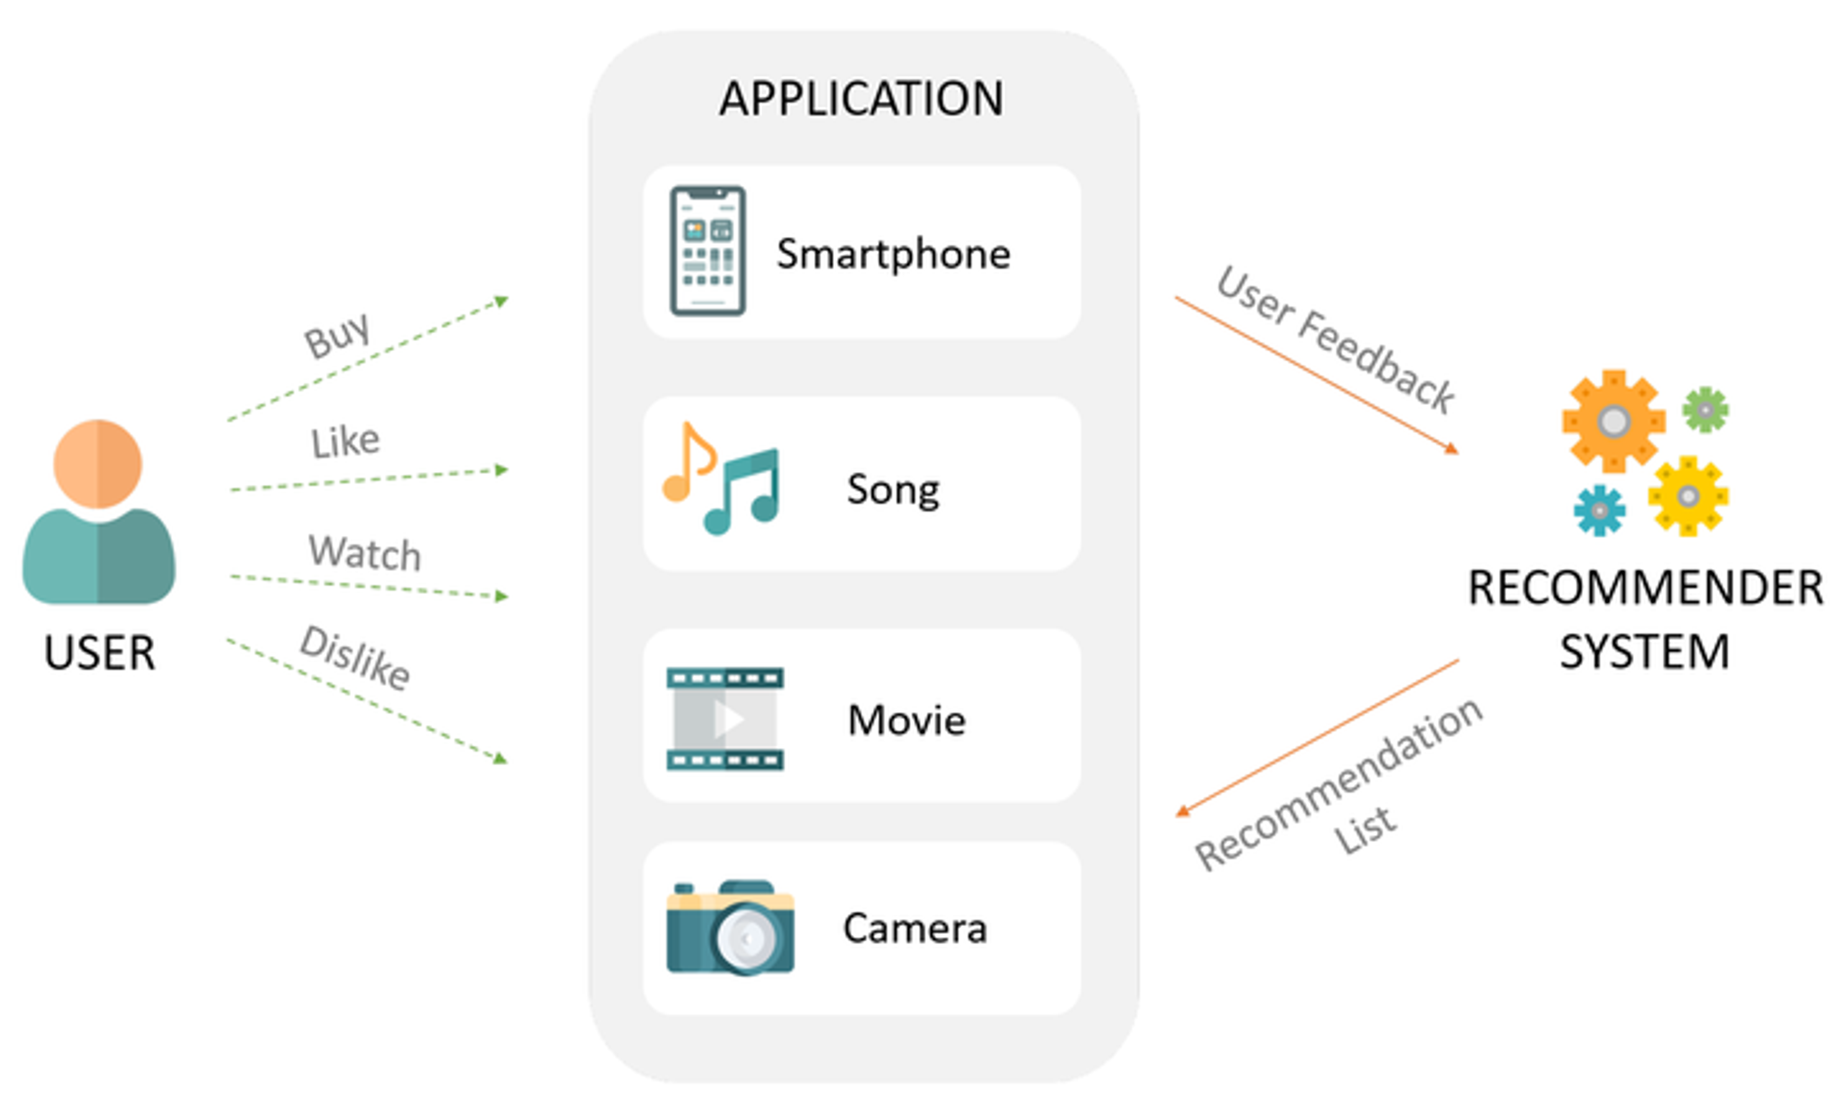

TECHNOLOGIES USED
A. Software Requirements
- Programming Language: Python
Used for implementing recommendation logic, data processing, and overall system development.
- Development Environment: Visual Studio Code
Provides code editing, debugging, and project management support.
- Libraries and Frameworks:
  - Pandas: For data manipulation and preprocessing
  - NumPy: For numerical computations and array operations
- Version Control System: Git
Used to track code changes and manage project versions.
- Code Hosting Platform: GitHub
Used for repository management and collaboration.
- Operating System:
Windows / Linux / macOS

B. Hardware Requirements
- Processor: Intel Core i5 or equivalent (minimum)
- RAM: 8 GB (minimum recommended)
- Storage: 10 GB free disk space
- System Type: 64-bit architecture
- Internet Connectivity: Required for accessing online resources and GitHub
The system does not require specialized hardware such as GPUs, making it cost-effective and suitable for local execution.

MODULE DESCRIPTION

The Product Recommendation System is divided into multiple functional modules to ensure clarity and maintainability. The Data Input Module is responsible for loading user and product data from datasets or input files. It ensures that the data is properly formatted and ready for processing.
The Data Processing Module handles cleaning, filtering, and organizing the data. This module prepares the dataset by removing inconsistencies and structuring it for analysis.
The Recommendation Module is the core component of the system. It applies similarity-based or filtering algorithms to identify products that closely match user preferences.
Finally, the Output Module displays the recommended products in a clear and user-friendly format. This modular structure allows each component to function independently, making the system easy to understand, debug, and enhance in future versions.

ALGORITHMS USED

The Product Recommendation System primarily uses similarity-based recommendation algorithms to generate personalized product suggestions. These algorithms analyze relationships between products or users by comparing their attributes or interaction patterns. Similarity measures such as cosine similarity or basic matching techniques are commonly applied to determine how closely related products are.
The system evaluates user preferences and compares them with available products to identify items with the highest similarity scores. Products with higher similarity values are recommended to the user. This approach is computationally efficient and easy to implement using Python.
The algorithm does not require complex machine learning models or large computational resources, making it suitable for small to medium-sized datasets. Although simple, similarity-based algorithms are effective in demonstrating the core principles of recommendation systems and serve as a strong foundation for future enhancements using advanced machine learning or collaborative filtering techniques.

IMPLEMENTATION DETAILS

The Product Recommendation System is implemented using Python with a modular coding structure to improve readability and maintainability. The system begins by loading user and product data into Python data structures using data processing libraries. Preprocessing steps such as filtering and organizing the data are performed to ensure accuracy.
The recommendation logic is implemented through Python functions that calculate similarity scores between products or user preferences. Based on these scores, the system identifies and ranks relevant products. The final recommendations are displayed as output in a structured format.
The implementation avoids the use of complex frameworks or databases, making the system lightweight and easy to execute on a local machine. This approach allows beginners to understand the internal working of recommendation systems while applying Python programming concepts learned during the internship.

OUTPUT SLIDES

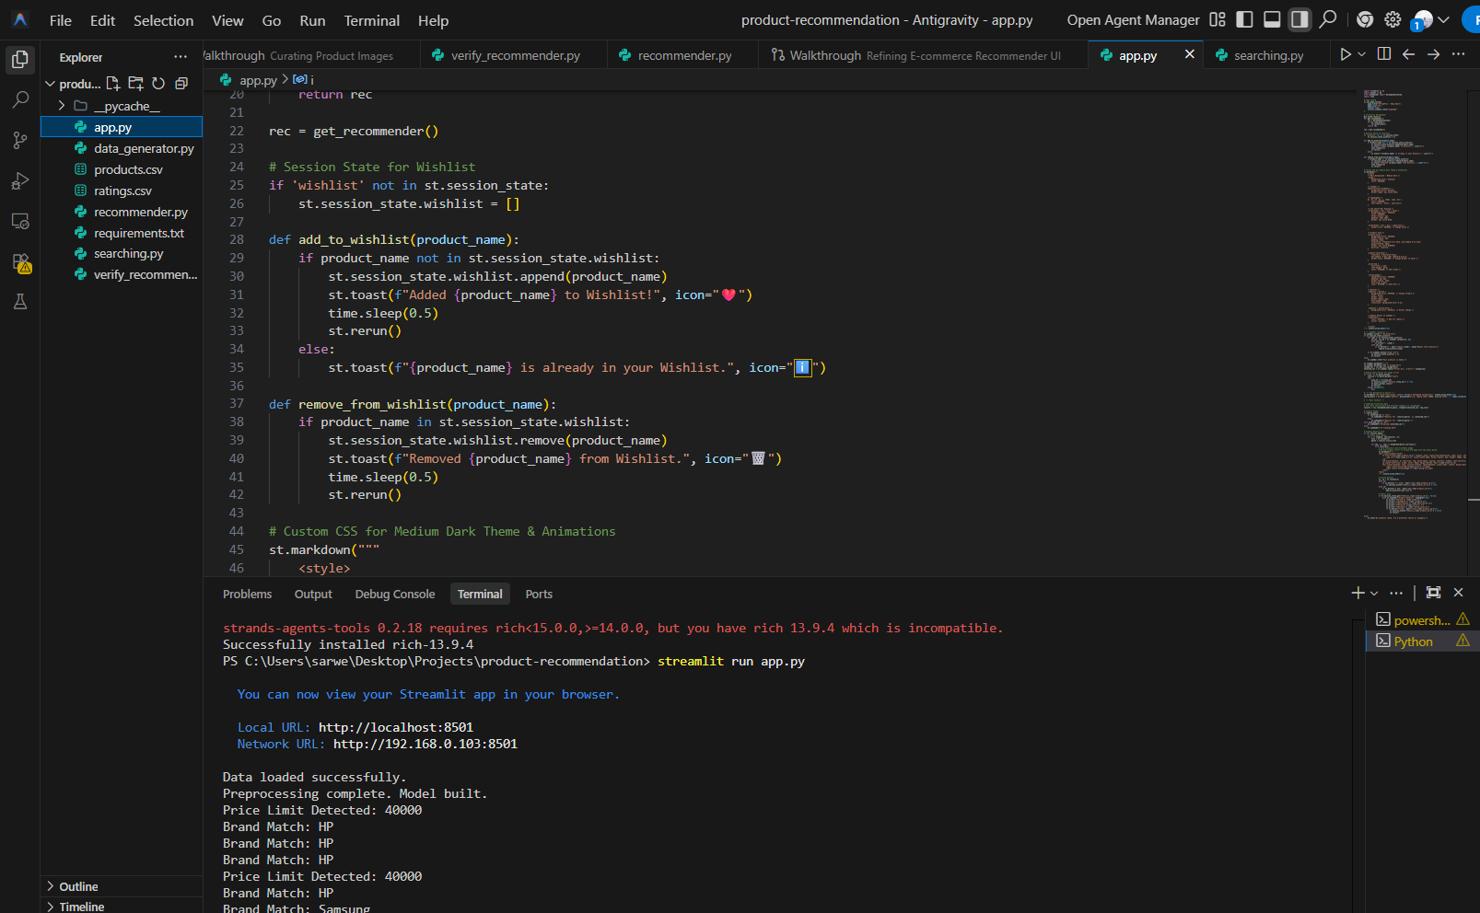

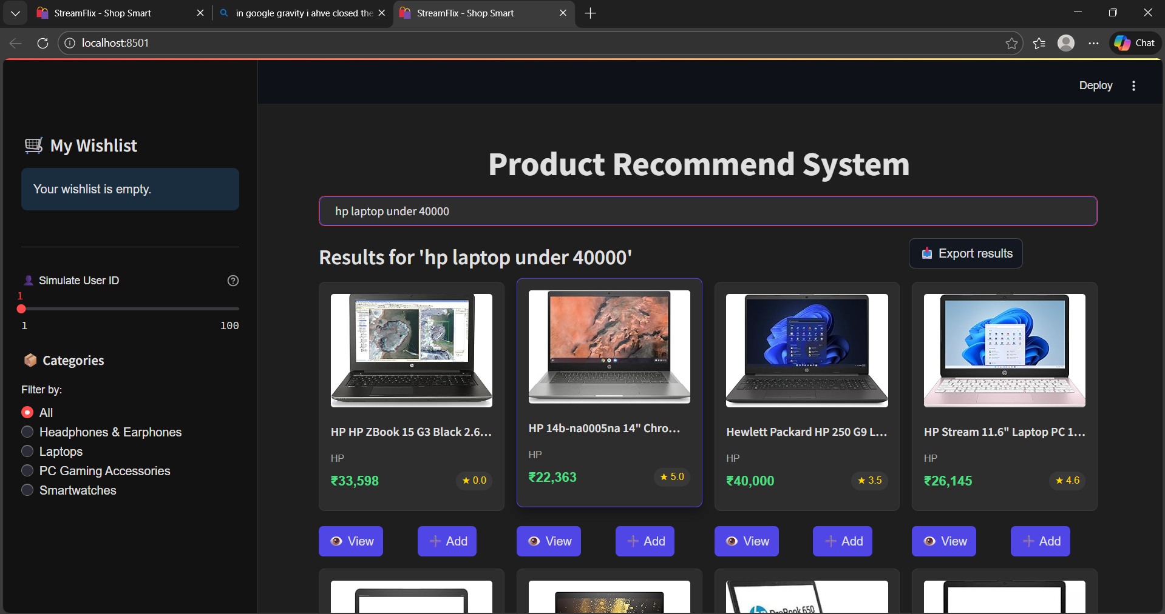
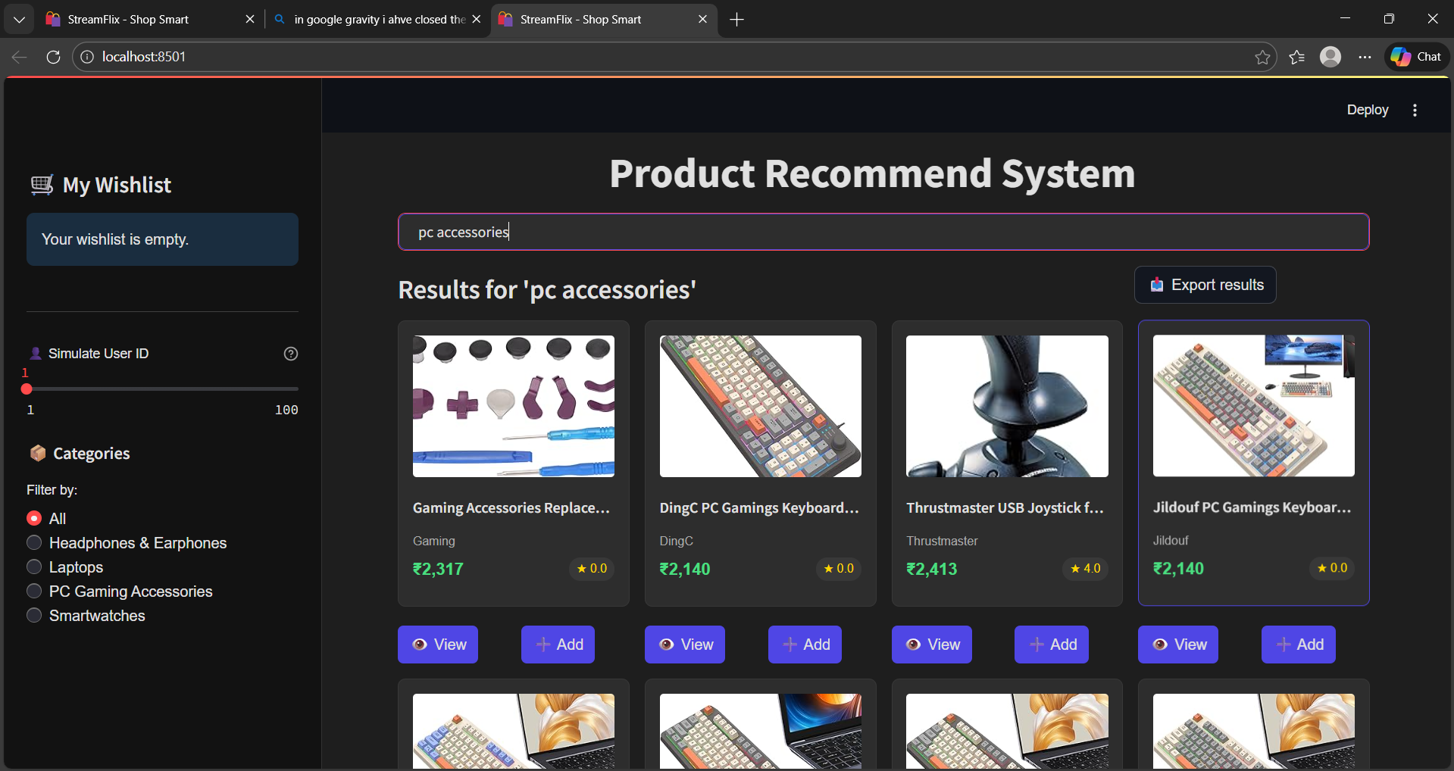

RESULTS

The Product Recommendation System successfully generates relevant product suggestions based on the provided input data. The system effectively analyzes user preferences and product similarities to produce meaningful recommendations. Testing with sample datasets shows that the recommended products closely align with user interests, thereby improving decision-making and reducing product search time.
The results demonstrate that even simple similarity-based algorithms can provide effective recommendations when implemented correctly. The system performs efficiently with small to medium-sized datasets and produces consistent outputs.
This project validates the practical application of Python programming in developing recommendation systems and highlights how personalization techniques can enhance user experience. The obtained results also indicate that the system can be further improved by incorporating larger datasets, real-time user behavior, and advanced machine learning algorithms.

INTERNSHIP LEARNING OUTCOMES

The Python Developer Internship at Elevate Labs provided valuable hands-on experience in applying theoretical programming concepts to real-world applications. Through this project, a strong understanding of recommendation systems and their role in modern digital platforms was gained. Practical exposure to Python programming enhanced skills in data processing, algorithm implementation, and modular code design.
The internship helped develop problem-solving abilities by translating user requirements into functional system components. Experience with version control using GitHub improved collaborative development and code management practices. Additionally, the project enhanced documentation and reporting skills by following academic and industry-standard formats.
Overall, the internship strengthened confidence in building intelligent Python-based applications and provided insight into how personalization systems improve user engagement. The knowledge and skills acquired during this internship form a strong foundation for future work in data-driven application development and software engineering.

CONCLUSION

This project successfully demonstrates the design and implementation of a Product Recommendation System using Python, highlighting the practical application of recommendation techniques in real-world scenarios. The system effectively addresses the challenge of information overload by providing personalized product suggestions based on similarity and filtering logic. Through a modular and lightweight architecture, the project ensures simplicity, maintainability, and ease of enhancement.
The results indicate that similarity-based recommendation algorithms can generate meaningful and relevant suggestions even with limited data and computational resources. The project also emphasizes the importance of personalization in improving user experience and decision-making on digital platforms. Developed as part of the Python Developer Internship at Elevate Labs, this project strengthens foundational knowledge in recommendation systems and Python programming. Overall, the system serves as a strong baseline for further development using advanced machine learning techniques and real-time user data integration.

FUTURE ENHANCEMENTS

The Product Recommendation System can be extended in several ways to improve accuracy and usability. Future enhancements may include implementing collaborative filtering techniques to analyze user behavior more effectively. Machine learning models such as matrix factorization or clustering algorithms can be integrated to provide more personalized recommendations.
A graphical user interface or web-based application can be developed to improve user interaction. Real-time data processing can also be introduced to update recommendations dynamically based on user actions. Additionally, integrating user authentication and feedback mechanisms can help refine recommendation accuracy.
The system can be deployed on cloud platforms to support scalability and remote access. These enhancements would transform the project into a more advanced and production-ready recommendation system suitable for real-world applications.

REFERENCES
- Ricci, F., Rokach, L., & Shapira, B., Recommender Systems Handbook, Springer, 2015.
- Python Software Foundation, Python Documentation.
- Aggarwal, C. C., Recommender Systems: The Textbook, Springer, 2016.
- Pandas Development Team, Pandas Documentation.
- NumPy Developers, NumPy User Guide.
- Online tutorials and learning resources on recommendation systems and Python programming.

