Airport Management Information System
Project Report

Course: CMPE343 – Database Management Systems and Programming I
Topic: Relational Database Design for Ercan Airport
Platform: MySQL 8.0
Due Date: 24 May 2026 @ 23:55

1. Introduction

1.1 Project Overview
This project designs and implements a Relational Database Management System (RDBMS) for Ercan Airport Management. The database stores, organises, and retrieves all airport-related information including aircraft, hangars, staff, airworthiness tests, maintenance repairs, and flight operations.

1.2 Assumptions and Design Decisions
- Each employee is uniquely identified by their Social Security Number (SSN) in the format XXX-XX-XXXX.
- All employees (technicians, traffic controllers, and general staff) belong to exactly one union, stored in a dedicated union_tbl table.
- Technicians can be experts in one or more plane models (many-to-many), captured in the technician_expertise associative table.
- Traffic controllers must have an annual medical examination. If the last exam date is more than 365 days ago, their status is flagged as OVERDUE.
- Airplanes are assigned to hangars with explicit IN and OUT datetime stamps. A NULL out_datetime means the aircraft is currently inside that hangar.
- The pass_fail column in test_event is a GENERATED ALWAYS AS computed column: score >= 60 = pass, below 60 = fail.
- Two extra tables were added beyond the minimum (8 required): repair_record for maintenance cost tracking and flight for flight schedule management.
- MySQL 8.0 is the target RDBMS. All SQL uses MySQL-compatible syntax.

2. ER Diagram
The ER Diagram below shows all 13 entities, their attributes, and relationships:
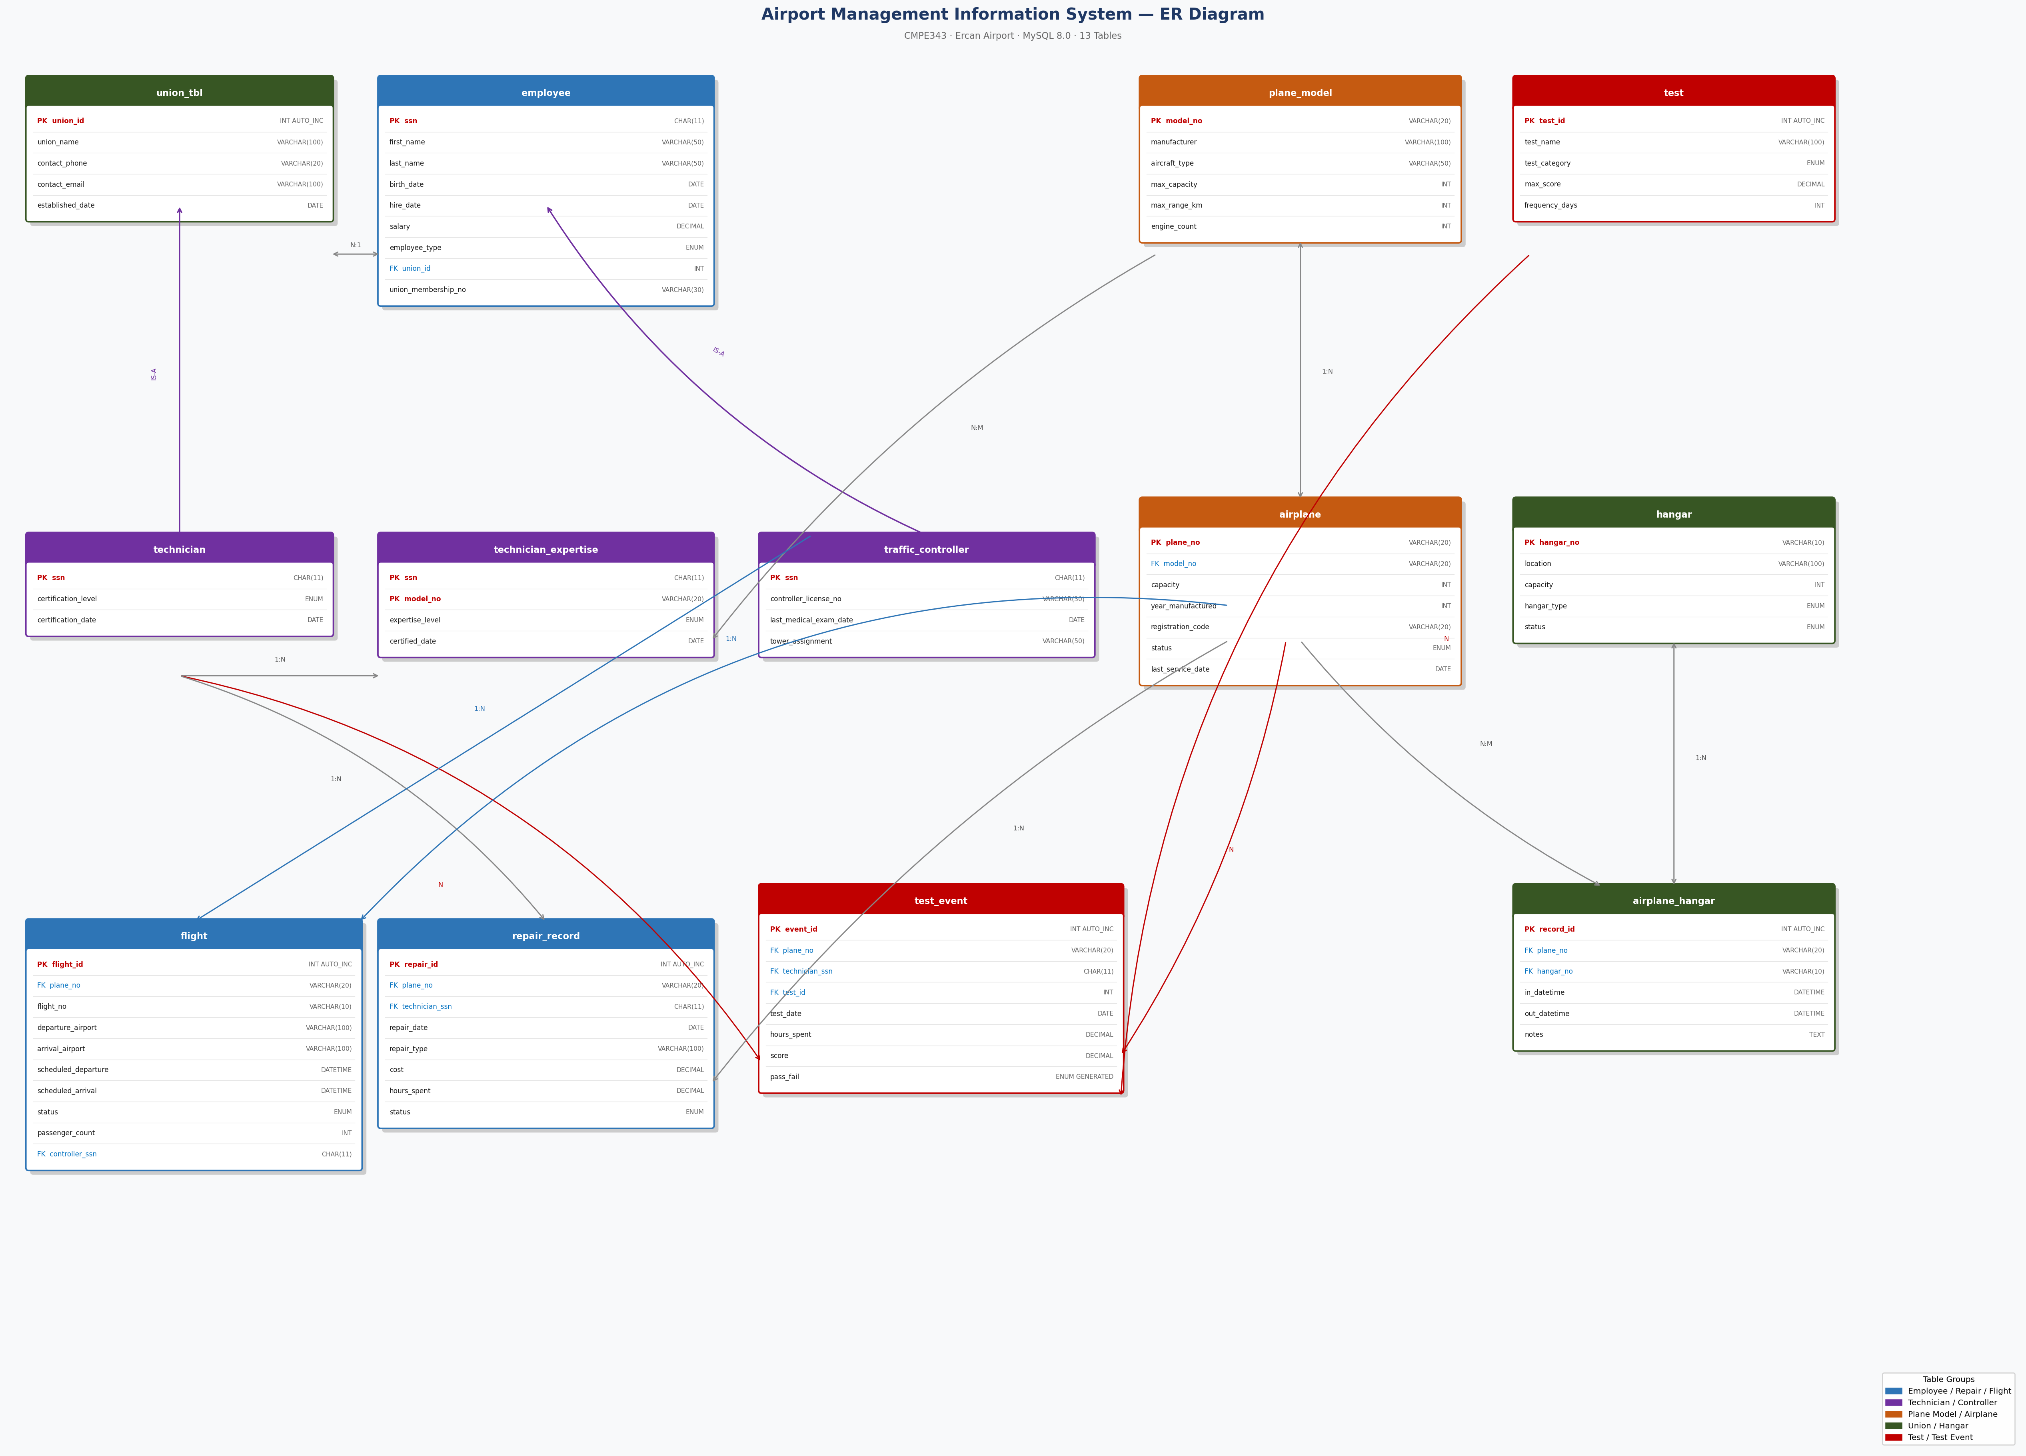
Figure 1: Airport Management System – Entity Relationship Diagram

2.1 Entity Descriptions
Table | Description
union_tbl | Stores union information for all airport worker unions
employee | Base entity for ALL workers – identified by SSN, linked to union
technician | Subtype of employee – certification level and date
traffic_controller | Subtype of employee – license and annual medical exam date
plane_model | Catalogue of aircraft models (manufacturer, capacity, range)
technician_expertise | Many-to-many: technicians certified to service specific plane models
airplane | Individual aircraft with registration, capacity and status
hangar | Hangar locations with type and capacity
airplane_hangar | IN/OUT datetime history for each plane in each hangar
test | Catalogue of airworthiness tests with category and frequency
test_event | Each testing instance – plane x technician x test, with score
repair_record | Maintenance and repair history with cost and hours (extension)
flight | Flight schedule with actual times and controller assignment (extension)

3. Relational Data Model
The following schema uses underline for Primary Keys and asterisk (*) for Foreign Keys:
union_tbl(union_id, union_name, contact_phone, contact_email, established_date)
employee(ssn, first_name, last_name, birth_date, hire_date, salary, phone, email, employee_type, union_id*, union_membership_no)
technician(ssn*, certification_level, certification_date)
traffic_controller(ssn*, controller_license_no, last_medical_exam_date, tower_assignment)
plane_model(model_no, manufacturer, aircraft_type, max_capacity, max_range_km, engine_count, description)
technician_expertise(ssn*, model_no*, expertise_level, certified_date)
airplane(plane_no, model_no*, capacity, year_manufactured, registration_code, status, last_service_date)
hangar(hangar_no, location, capacity, hangar_type, status)
airplane_hangar(record_id, plane_no*, hangar_no*, in_datetime, out_datetime, notes)
test(test_id, test_name, description, max_score, test_category, frequency_days)
test_event(event_id, plane_no*, technician_ssn*, test_id*, test_date, hours_spent, score, pass_fail, notes)
repair_record(repair_id, plane_no*, technician_ssn*, repair_date, repair_type, description, cost, hours_spent, status)
flight(flight_id, plane_no*, flight_no, departure_airport, arrival_airport, scheduled_departure, scheduled_arrival, actual_departure, actual_arrival, status, passenger_count, controller_ssn*)

4. Data Definition Language (DDL)
The DDL creates the airport_management database and all 13 tables. Key features:
- PRIMARY KEY constraints on every table
- FOREIGN KEY constraints with ON DELETE CASCADE where appropriate
- UNIQUE constraints on union_membership_no, registration_code, controller_license_no
- ENUM types for controlled vocabularies: status, employee_type, test_category, expertise_level
- CHECK constraints on test_event: hours_spent > 0, score BETWEEN 0 AND 100
- GENERATED ALWAYS AS computed column for pass_fail in test_event
- AUTO_INCREMENT primary keys for surrogate keys
Full DDL file: 01_DDL.sql
Key excerpt – test_event table with computed column:
CREATE TABLE test_event (
event_id INT AUTO_INCREMENT PRIMARY KEY,
plane_no VARCHAR(20) NOT NULL,
technician_ssn CHAR(11) NOT NULL,
test_id INT NOT NULL,
test_date DATE NOT NULL,
hours_spent DECIMAL(5,2) NOT NULL,
score DECIMAL(5,2) NOT NULL,
pass_fail ENUM('pass','fail')
GENERATED ALWAYS AS
(IF(score >= 60,'pass','fail')) STORED,
FOREIGN KEY (plane_no) REFERENCES airplane(plane_no),
FOREIGN KEY (technician_ssn) REFERENCES technician(ssn),
FOREIGN KEY (test_id) REFERENCES test(test_id),
CHECK (hours_spent > 0),
CHECK (score >= 0 AND score <= 100)
);

5. Data Manipulation Language (DML)
Sample data was inserted across all 13 tables:
Table | Rows | Notes
union_tbl | 3 | Aviation Workers, ATC, General Employees unions
employee | 13 | 6 technicians, 4 traffic controllers, 3 general staff
technician | 6 | 2 master, 3 senior, 1 junior
traffic_controller | 4 | 4 controllers, 1 with overdue medical exam
plane_model | 8 | B737-800, A320neo, B777-300, A380-800, ATR72, ERJ-145, C-130H, B787-9
technician_expertise | 14 | Multiple expertise levels across models
airplane | 10 | 7 active, 2 in maintenance, 1 retired
hangar | 5 | 3 storage/mixed, 2 maintenance, 1 closed
airplane_hangar | 12 | 4 currently in hangars, 8 historical records
test | 8 | Engine, Avionics, Structural, Hydraulics, Safety, Landing Gear, Fuel, Emergency
test_event | 23 | 3 failed tests, 20 passed
repair_record | 6 | Total repair cost: $278,700
flight | 8 | 3 arrived, 1 departed, 1 cancelled, 3 scheduled

Full DML file: 02_DML.sql

6. SQL Queries (15 Statistical / Management Queries)
All 15 queries use techniques including JOIN, subquery, GROUP BY, HAVING, DATE_FORMAT, CASE/WHEN, GENERATED columns, and aggregate functions.
# | Query Title | Key Techniques
Q1 | Full Airplane Inventory | JOIN, ORDER BY
Q2 | Technician Certifications and Expertise | Multi-table JOIN
Q3 | Airplanes Currently in a Hangar | JOIN, WHERE NULL, TIMESTAMPDIFF
Q4 | Average Test Score Per Airplane | LEFT JOIN, AVG, MIN, MAX, GROUP BY
Q5 | Technician Workload Report | LEFT JOIN, SUM, AVG, GROUP BY
Q6 | Medical Exam Status – Traffic Controllers | JOIN, DATEDIFF, CASE/WHEN
Q7 | Most Frequently Used Tests | LEFT JOIN, COUNT, GROUP BY, ORDER BY
Q8 | Airplanes Never Tested | NOT IN subquery
Q9 | Technician Certifications per Plane Model | LEFT JOIN, conditional SUM, GROUP BY
Q10 | Monthly Test Activity Summary | DATE_FORMAT, GROUP BY month
Q11 | All Employees with Union Membership | JOIN, DATEDIFF, FORMAT
Q12 | Hangar Utilisation Report | LEFT JOIN, COUNT, percentage calc
Q13 | Top Airplane per Test Category | HAVING with correlated subquery
Q14 | Total Repair Cost per Airplane | LEFT JOIN, SUM, AVG, ORDER BY cost
Q15 | Flight Operations & Controller Workload | LEFT JOIN, conditional SUM, NULLIF

Full queries file: 03_Queries.sql
Sample query output: Query_Results.txt

6.1 Sample Query – Q6: Traffic Controller Medical Exam Status
SELECT
CONCAT(e.first_name, ' ', e.last_name) AS controller_name,
tc.last_medical_exam_date,
DATEDIFF(CURDATE(), tc.last_medical_exam_date) AS days_since_exam,
CASE
WHEN DATEDIFF(CURDATE(), tc.last_medical_exam_date) > 365
THEN 'OVERDUE - Must not work'
WHEN DATEDIFF(CURDATE(), tc.last_medical_exam_date) > 300
THEN 'WARNING - Schedule exam soon'
ELSE 'OK'
END AS exam_status
FROM traffic_controller tc
JOIN employee e ON tc.ssn = e.ssn
ORDER BY days_since_exam DESC;

7. GitHub Repository
All project files must be published in a GitHub repository. All group members must be invited as collaborators.

7.1 Steps to Publish
- 1. Create a new repository named airport-management-db on GitHub.
- 2. Invite all project group members: Settings → Collaborators → Add people.
- 3. Push 01_DDL.sql, 02_DML.sql, 03_Queries.sql to the repository.
- 4. Upload Airport_Management_Report.docx (or export as PDF).
- 5. Upload ER_Diagram.png.
- 6. Create a README.md describing the project, setup instructions, and team members.

7.2 Repository Structure
airport-management-db/
├── 01_DDL.sql # Table creation
├── 02_DML.sql # Sample data
├── 03_Queries.sql # 15 management queries
├── Query_Results.txt # Query output
├── ER_Diagram.png # Entity Relationship Diagram
├── Airport_Management_Report.docx
└── README.md

8. Conclusion
This database system provides Ercan Airport with a robust and fully normalised RDBMS covering all required entities from the project specification. The design satisfies and exceeds the minimum requirements by adding two additional tables (repair_record and flight), bringing the total to 13 tables.
The 15 analytical queries provide airport management with actionable insights including: regulatory compliance monitoring (medical exams, airworthiness testing), hangar utilisation and capacity planning, technician workload analysis, aircraft performance tracking, maintenance cost reporting, and flight operations monitoring.
All SQL has been validated against a running MySQL 8.0 instance and all 13 tables load successfully with the provided sample data.

