Prototype Design for Patient Portal

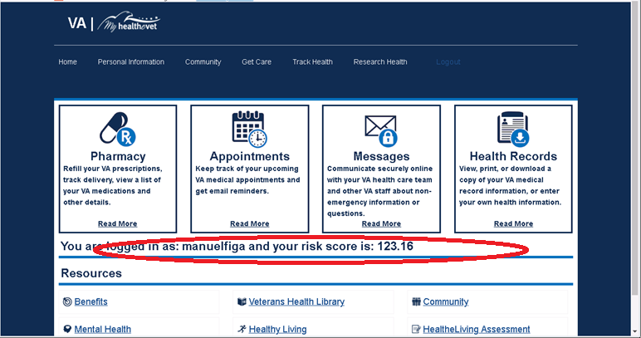

* Front Page
  + Username
  + COUNTY Risk Score
  + PATIENT RISK SCORE with Narrative - TBD
* Pharmacy
  + VA SDK Visualizations-—SEE GatherIQ
* Appointments🡪Scenario Planning
  + **Login to Server**
  + **Change Data**
  + **Change Models**
  + **Scenario Planning – change input parameters**
* Messages
* Health Records

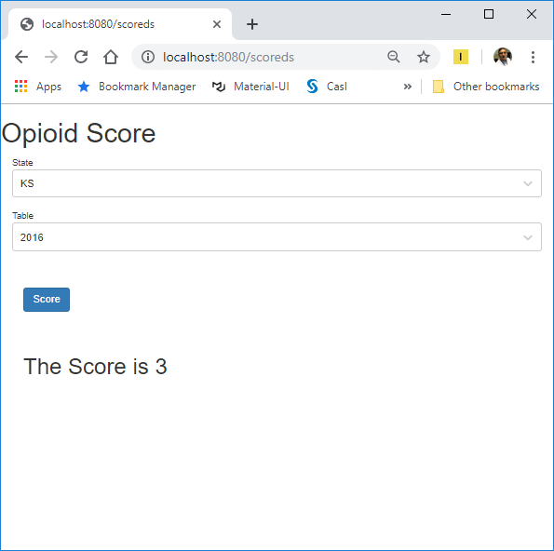

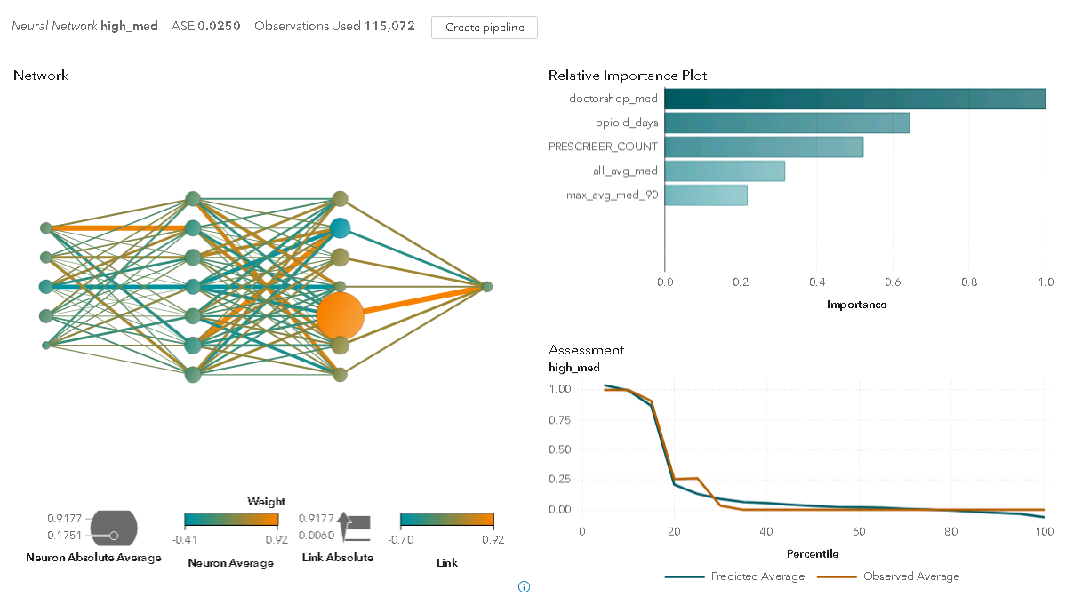

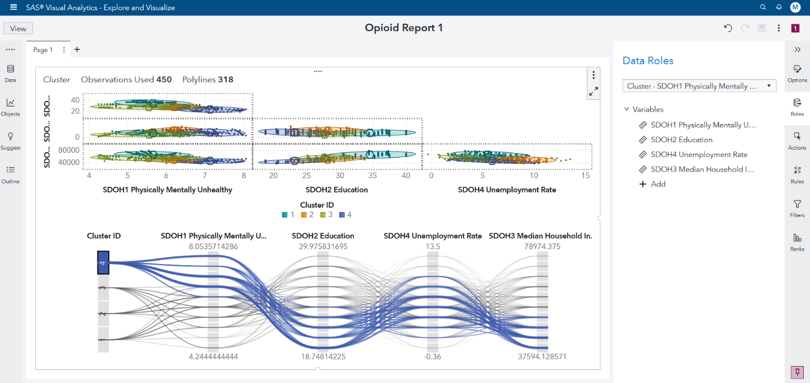

AGENDA:  
1. Review Deva’s work ---FOR DEMO!

-GRAPHQL, etc

2. Business strategy for Serverless

-customers

*external (e.g., CPI and Ray Wedgeworth)

*internal

-

3. Run restaf on Manuel’s laptop

4. SDK

cloud native--use all cloud services. not dependendent on local resources. can still mount drives

docker-compose up

http://localhost:4000/viya-app

layers:

1.alpine unix

2. alpine_nodejs

3. viya app

Security

*serverles token is created in AWS Lambda and embedded in their web page

jkj

TODO:

1. label cluster ID's (Manuel)

2. What if scenario. goal seeking (Sundaresh)

3. modify front page from GITHUB/LAB (Manuel)

4.marketing

Embed into python workflow

Health OS

5.

Next time:

1. AWS Lambda demo
2. Migrate to Astore

Selling Points:

1. Open architecture
2. Providing close to real-time results
3. What if
4. Goal seeking

<http://kdkbosh3.stobosh.sashq-d.openstack.sas.com/SASLogon/timedout?callbackUrl=/SASStudioV/>

GOAL:

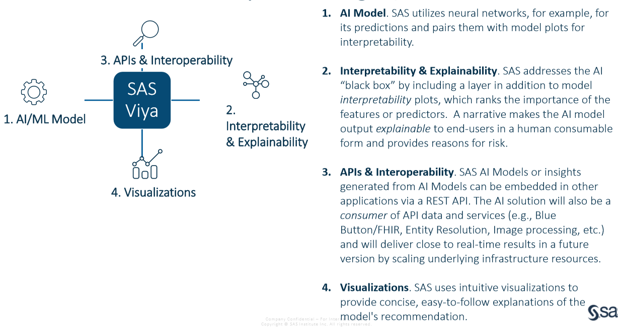

**Identifying Medicare Beneficiaries at Risk of Opioid Use**

**Disorder and Providers at Risk of Fraud with SAS Machine Learning and AI**

This demo demonstrates SAS Machine Learning (ML) and AI algorithms which can identify bene_ciaries who may be

at high risk of opioid use disorder. The ML and AI models are trained using publicly available social determinants

of health data, which are signi_cant predictors.

Opioid disorder is a topic of concern for any health organization focused on value-based care, such as the

Centers for Medicare and Medicaid Services (CMS). CMS is particularly concerned because its programs have

grown considerably. Since 2006, the CMS program which covers prescription drugs has ballooned by 137%.

Using Medicare synthetic data, this project will provide the SAS community with valuable guidance on four

critical components to make ML and AI function successfully:

1. ML and AI algorithms that automate training;

2. A layer for interpretability and explainability;

3. API’s in the Cloud to embed ML and AI functions in applications (e.g. Dashboards); and,

4. Visualizations to make the ML and AI models easily digestible by those responsible for identifying and

treating at-risk patients.

SAS ML, AI, and Viya capabilities will allow for the iterative and incremental traversal of the analytics lifecycle in

order to build and deploy accurate models. This paper will also help fraud investigators, providers, and payers

understand and identify populations at risk of opioid use disorder. Also, this project will show how the Viya

Platform can help organizations quickly move from data to actionable insights.

sdf

sdf