Jiahong Hu

Jh3561

HW5

Stat 4315

3.16

Part b

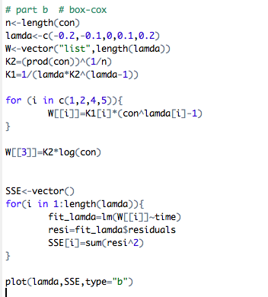

Macintosh HD:Users:jiahongHu:Desktop:Screen Shot 2015-03-02 at 12.15.55 PM.png

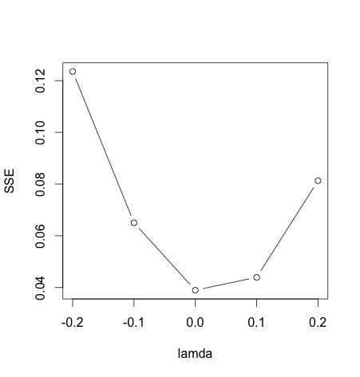

I suggest to use the y’= ln(y) transformation because when $λ=0$, the error of sum of squared is minimized.

4.14

Part a:

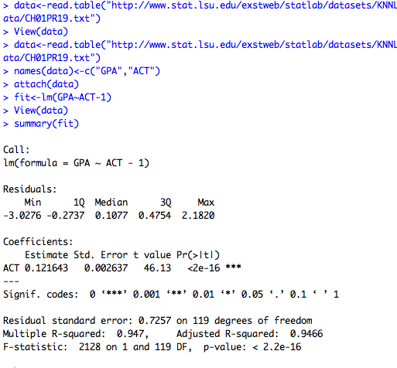

Estimated regression function: GPA_hat = 0.121643*ACT

Part b:

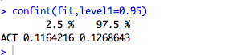

95% confidence interval of $β1$ is between 0.1164216 and 0.1268643.

Interpretation: With 0.95 confidence coefficient, we estimate that the mean GPA increases by somewhere between0.1164216 and 0.1268643 for each addition point of ACT scores.

Part c:

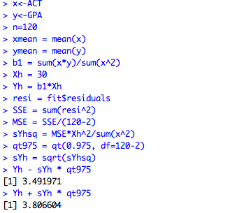

95% confidence interval for the mean response of x =30 is between 3.491971 and 3.806604

4.15

Part a

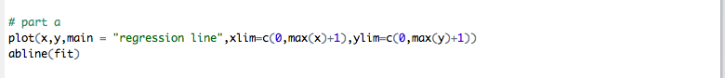

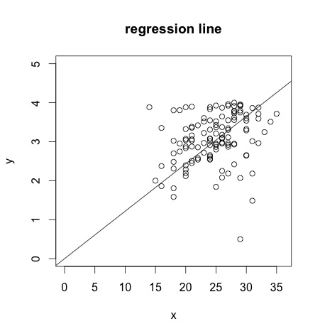

The linear regression through the origin does not seem to be a very bad fit but data points do not spread randomly enough on the two sides of the line. We need to take further test examination to tell if the model is a good fit.

Part b

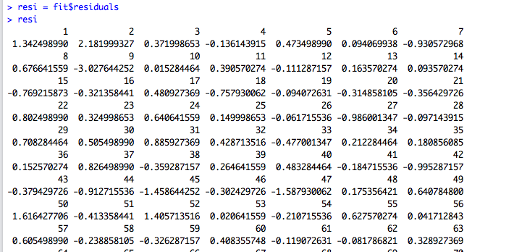

Macintosh HD:Users:jh3561:Desktop:Screen shot 2015-02-28 at 3.15.18 PM.png

The sum of residuals is not equal to 0.

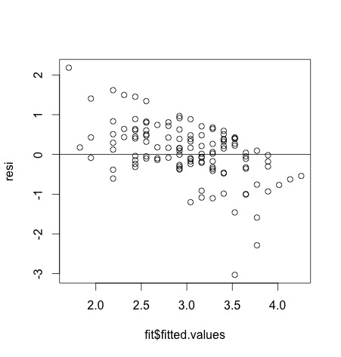

There exists a downward trend between the fitted values and residuals. The larger fitted values tend to have negative residuals while the smaller e fitted values have positive residuals. In addition, there are more positive residuals than negative residuals. Therefore, the model through the original is not a good fit for the data.

Part c

Lack of fit of linear regression

H0:  (Reduced Model)

Ha:  (Full Model)

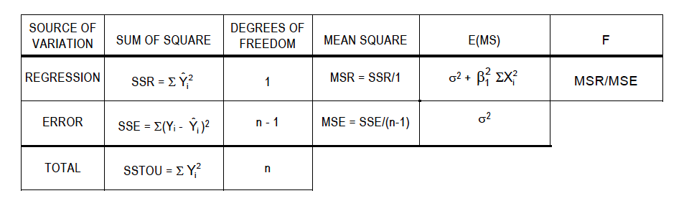F* = (SSR/1)/(SSE/(n-1))

.

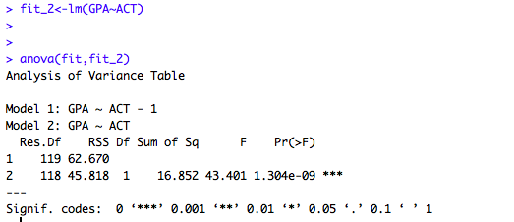

F-value=43.401. The corresponding P-value is 1.304*10^-9,which is smaller than α=0.005. Therefore, we reject Ho and conclude that regression model with intercept is more appropriate compared with the model through origin.