**Name: Jiahong hu**

**4315**

**HW1**

**Problem 1.19**

**Part a:**

**Code:**

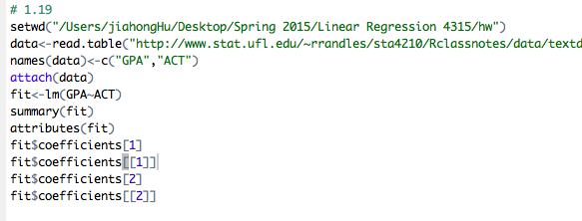

**Result:**

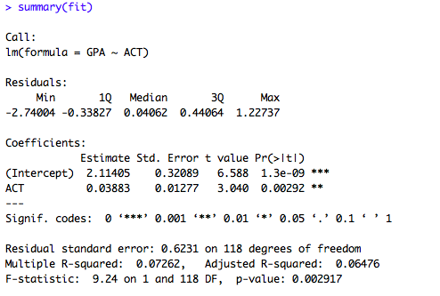

**As shown in the results produced by R above, the lease squares estimate for $β_{0 }$** **is b0= 2.11405, b1=0.03883 for $β_{1}$. Therefore, the estimated regression function is ${GPA}_{i}$ =** **2.11405 +0.03883 ${ACT}_{i}$ for i = 1,2…120**

**Part b:**

**Code:**

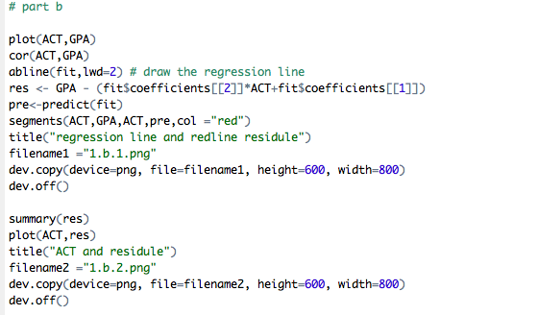

**Result:**

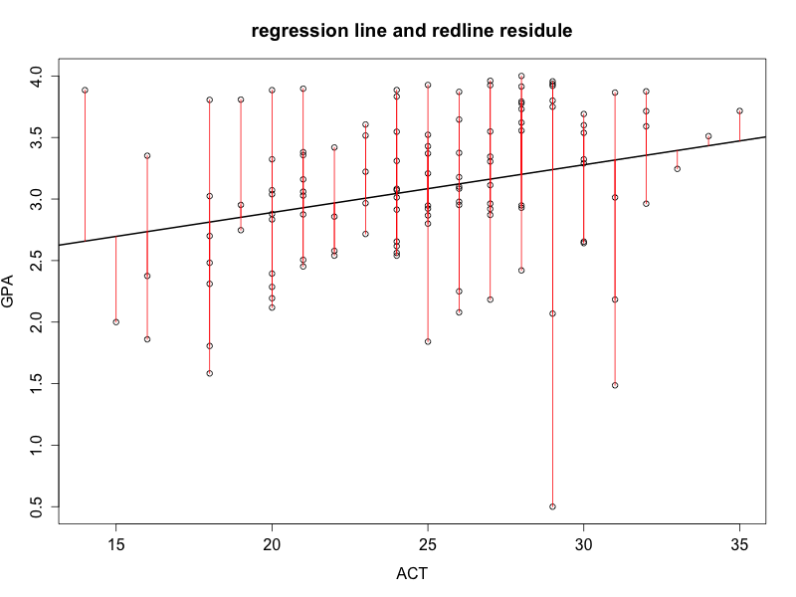

**The graph displaced above shows the regression function and data; In addition, the red color segments also show the measurement of the residuals for all the observations, which are calculated by the difference between real GPA data for each student and the pitted value produced by the regression function. Obviously, we can get a first impression that the residuals are large on average, which implied that the difference between read data and values predicted by the regression function is large. Therefore, this regression function does not appear to fit the data well.**

**The following chart shows more detailed summary of residuals.**

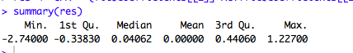

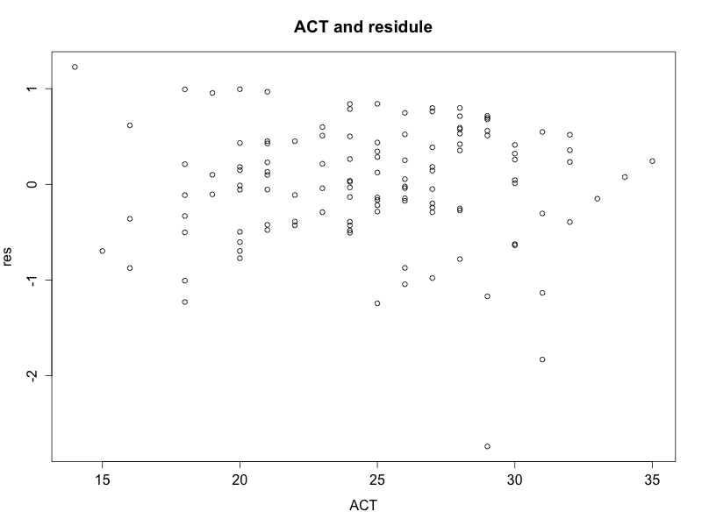

**Part c:**

**Code:**

**Macintosh HD:Users:jiahongHu:Desktop:Screen Shot 2015-02-03 at 11.43.03 AM.png**

**When ACT =30, the point estimate for the mean freshman GPA =b0+b1*30 = 2.11405 +0.03883*30 = 3.278863**

**Part d:**

**The change in the mean response for one point increase of the entrance test score is b1 = 0.0388**

**Problem 8**

**1.42**

**Part a)**

**Code:**

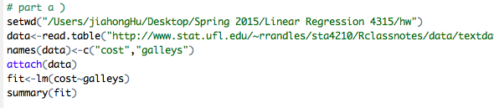

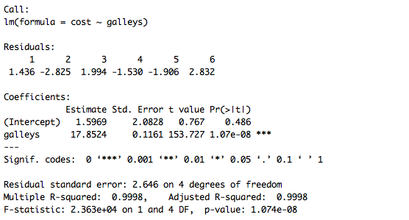

**Part b)**

**Code:**

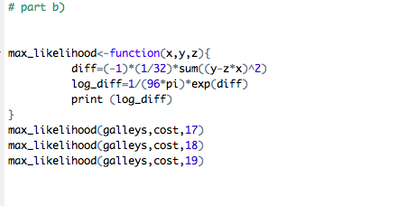

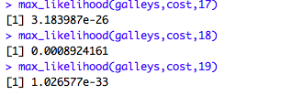

**It shows that $β=18$ gives largest value for the likelihood function. Note that the number 18 is also the value that is closet to the maximum likelihood function estimator or the least square error estimator, shown in the part a graph.**

**Part c:**

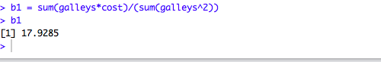

**The estimator b1 = 17.9285, is very close to 18 and thus it is consistent with the result in part b.**

**Part d:**