**2.4**

**Part a:**

**Code:**

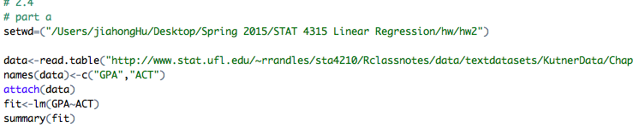

**Result:**

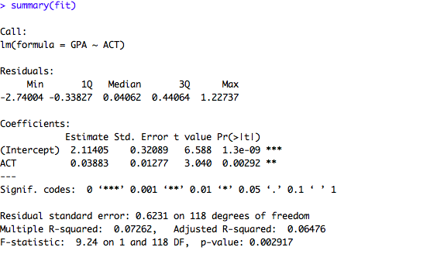

**:**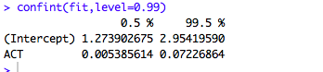

**Comment:**

As shown in the screen shot of r above, the point estimator of $β1$, namely b1, is equal to 0.3883.

99% CI for $β1$ = [0.005385614, 0.07226864]

The 99% CI means that if 120 [calculated by the number of observations] independent samples are taken where the levels of X (ACT) are the same as in the data set and a 99 % confidence interval is constructed for each sample, 99% of the interval will contain true value of $β1$. In this case, almost 99% of estimates of $β1$ will be included in [0.005385614, 0.07226864]

The office admission is interested in whether the confidence level include zero because it determines if there is linear association with ACT and GPA. If confidence interval includes 0, it means that there is no linear association between ACT and GPA. The office admission should not make the admission decision based on the ACT score. If confidence interval does not include 0, it means that there is linear association between ACT and GPA. ACT score is related to the performance of student and thus a valuable factor in the college making admission decision.

The 99% CI of $β1$ does not contain 0, which implies that there is linear association between Y (GPA) and X (ACT). Thus, with confidence coefficient 0.99, we estimate that the mean GPA increase by somewhere between 0.005385614 and 0.07226864 for each additional unit in ACT.

**Part b:**

**Code:**

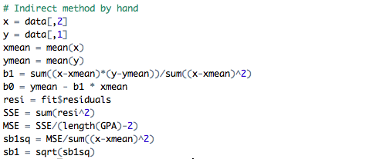

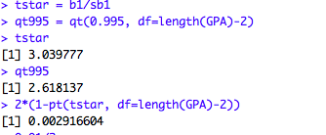

**Result:**

To test if there is linear association between GPA and ACT score, I set up hypothesis test as follows.

H0: $β1=0$

Ha: $β1≠0$.

Also, I set level of significance $α$ equal to $0.01$ in advance.

Test statistic is calculated as

$$t* = \frac{b1}{s\left\{b1\right\}}$$

The decision Rule:

If |t*|t (1- $\frac{α}{2}; n-2)=t (0.995; 118)$, conclude H0

If |t*|t (1- $\frac{α}{2}; n-2)=t (0.995; 118)$, conclude Ha

Conclusion:

As indicated above, the test statistic t* = 3.039777.

Because |t*|=3.039777>t(0.995;118)=2.618137,conclude Ha. The data shows enough evidence to reject H0 and support Ha. Therefore, there exists linear association between GPA and ACT.

Part C:

**Code:**



**Result:**

The p-value is 0.002916604, which is less than $α=0.01$

It support my conclusion to reject H0 in part b