HW4

STAT 4400

Name: Jiahong Hu

UNI:jh3561

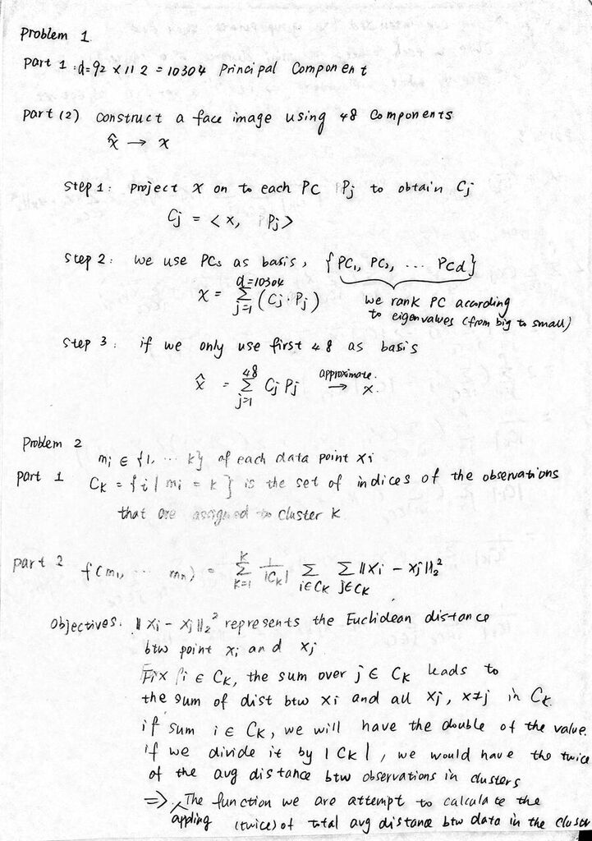

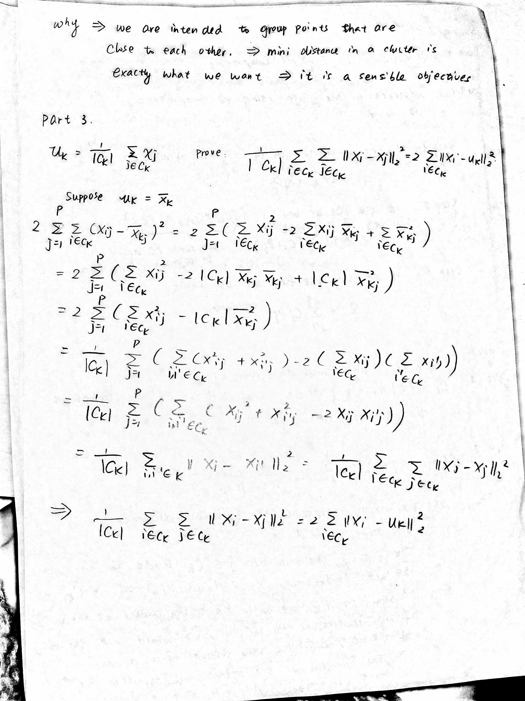

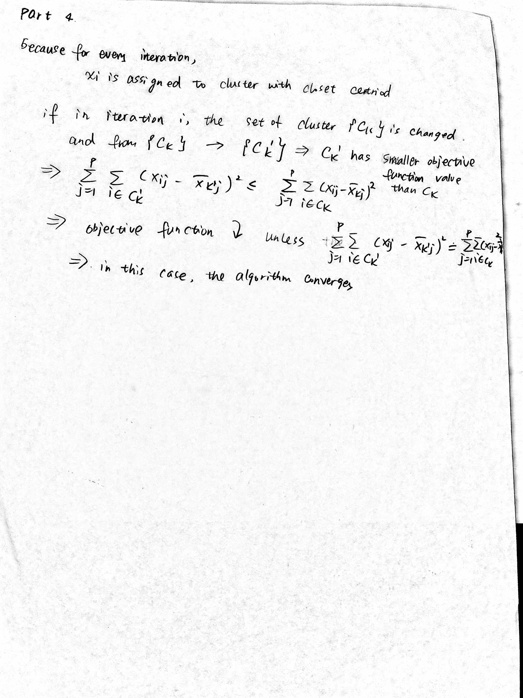

Problem 3

Part 1

See Code In the End

Part 2

I choose tau=10,50,100. I think tau=10,100 give a reasonable result and tau =100 gives too much tolerance.

* When tau=10, K=3

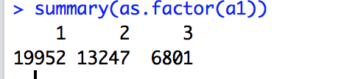

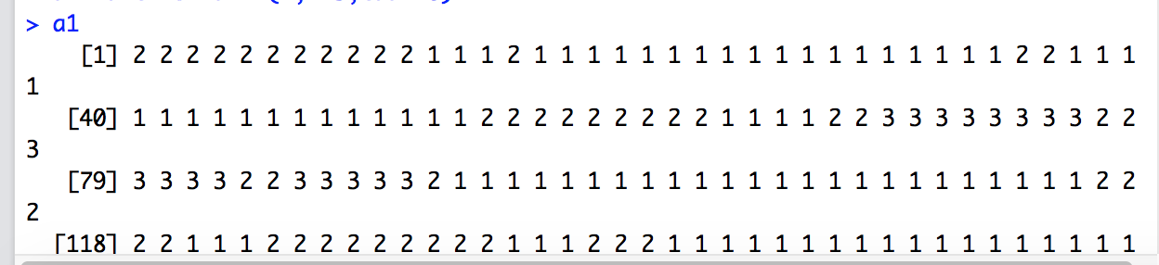

* when tau=10, K=4

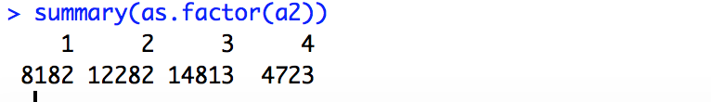

* when tau=10, K

-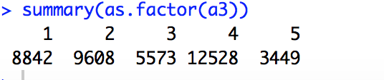

* When tau=50, K=3

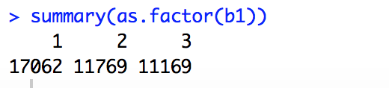

* When tau =50, K=4

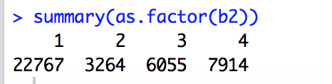

* When tau= 50, K=5

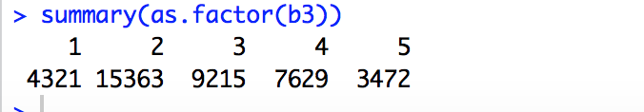

I figure out that there are some difference between tau=10 and tau=50.

I will choose tau =10 for further demonstration

Part c

Tau=10, K=3

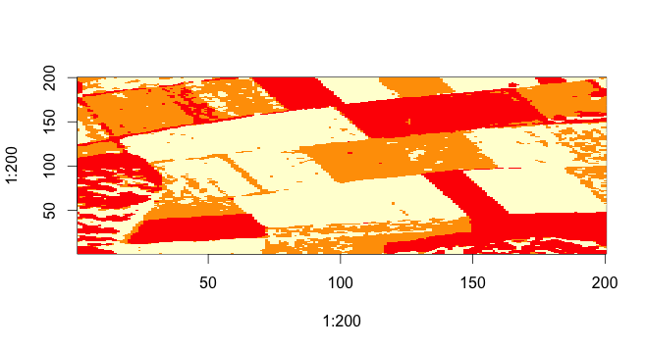

Tau=10, K=4

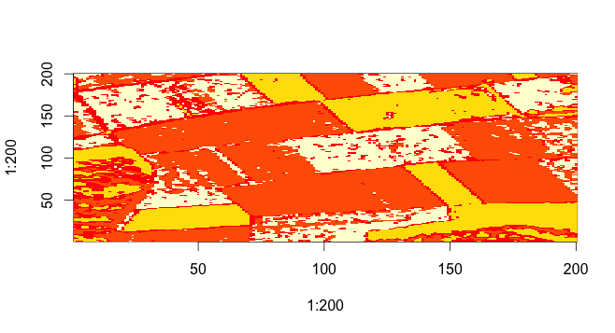

Tau=10, K=5

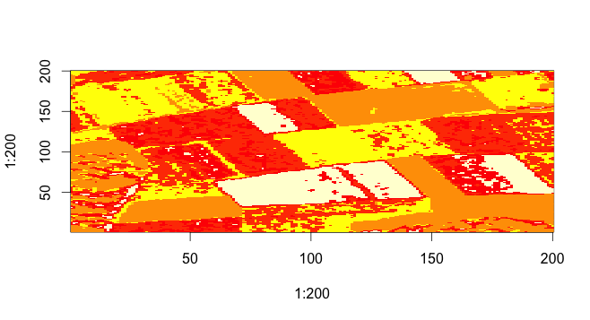

Tau=50, K=5

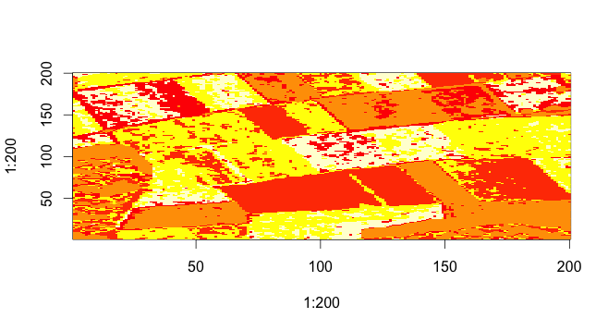

Code

setwd("/Users/jiahonghu/Desktop/hw4")

H<-matrix(readBin("histograms.bin","double",640000),40000,16)

dim(H)

for(i in 1:40000){

for(j in 1:16){

if (H[i,j]==0){

H[i,j]=H[i,j]+0.01

}

}

}

##Problem 1##

#EM algorithm

###input###

#H - dim=n*d

#K - number of clusters

#tau - terminate threshold paramter

MultinomialEM=function(H,K,tau){

n=nrow(H) # number of histograms

d=ncol(H) # number of bin per histogram

delta=1000 # meansure the change of assigments between iteraiton i and i+1

i=1 # the number of iteration of the algorithm

prop=rep(1/K,K) # initiate a cluster proportion

# step 1:Initial centriod by selecting K rows from n rows of H matrix

# ctd is a matrix of dim = k*d and represents the centriod of K clusters, each row represents a centriod of a cluster

set.seed=1

ctd=H[sample(1:n,K),]

dim(ctd)

# step 2: EM algorithm

# the algorithm stops only if the change is less than tau

while(delta>tau){

# E-step

phi=exp(H%*%t(log(ctd)))

phi_cp=phi*prop

row_sum_phi_cp=apply(phi_cp,1,sum)

inv_row_sum=1/row_sum_phi_cp

A_matrix=matrix(rep(inv_row_sum,K),n,K)

A=A_matrix*phi_cp

# M-step

ctd_current=ctd # theta at the iteration i

ctd=t(A)%*%H

col_sum_ctd=apply(ctd,1,sum)

inv_col_sum=1/col_sum_ctd

ctd_matrix=matrix(rep(inv_col_sum,d),K,d)

ctd=ctd_matrix*ctd # new theta at the iteraiton i +1

prop_sum=sum(apply(A,2,sum))

prop=prop/prop_sum # update proportion for clusters

i=i+1

delta=norm(ctd_current-ctd,type="O")

}

return(result=apply(A,1,which.max))

}

##Problem 2 ##

# for tau=10,50,100

a1=MultinomialEM(H,K=3,tau=10)

a1

summary(as.factor(a1))

a2=MultinomialEM(H,K=4,tau=10)

a2

summary(as.factor(a2))

a3=MultinomialEM(H,K=5,tau=10)

a3

summary(as.factor(a3))

b1=MultinomialEM(H,K=3,tau=50)

summary(as.factor(b1))

b2=MultinomialEM(H,K=4,tau=50)

summary(as.factor(b2))

b3=MultinomialEM(H,K=5,tau=50)

summary(as.factor(b3))

## problem 3 ##

img_function=function(x){

x_matrix=matrix(x,nrow=200,byrow=TRUE)

img_matrix=NULL

ind=nrow(x_matrix)

for( i in 0:(ind-1)){

img_matrix=cbind(img_matrix,x_matrix[ind-i,])

}

image(x=1:200,y=1:200,img_matrix)

}

img_function(a1)

img_function(a2)

img_function(a3)

img_function(b3)