1.

#!/usr/bin/python

import sys

import time

import Adafruit_DHT

import json

import httplib, urllib

import RPi.GPIO as GPIO

sensor_args = { '11': Adafruit_DHT.DHT11,

'22': Adafruit_DHT.DHT22,

'2302': Adafruit_DHT.AM2302 }

if len(sys.argv) == 3 and sys.argv[1] in sensor_args:

sensor = sensor_args[sys.argv[1]]

pin = sys.argv[2]

else:

print('Usage: sudo ./Adafruit_DHT.py [11|22|2302] <GPIO pin number>')

print('Example: sudo ./Adafruit_DHT.py 2302 4 - Read from an AM2302 connected$

sys.exit(1)

while(1):

# Try to grab a sensor reading. Use the read_retry method which will retry up

humidity, temperature = Adafruit_DHT.read_retry(sensor, pin)

# Un-comment the line below to convert the temperature to Fahrenheit.

# temperature = temperature * 9/5.0 + 32

# Note that sometimes you won't get a reading and

# the results will be null (because Linux can't

# guarantee the timing of calls to read the sensor).

# If this happens try again!

if humidity is not None and temperature is not None:

print('The current temperature is {0:0.1f}* C'.format(temperature))

time.sleep(0.5)

else:

print('Failed to get reading. Try again!')

sys.exit(1)



2.

#!/usr/bin/python

import sys

import time

import json

import RPi.GPIO as GPIO

GPIO.setmode(GPIO.BCM)

GPIO.setup(23, GPIO.IN, pull_up_down=GPIO.PUD_UP)

while 1:

SwitchStatus = GPIO.input(23)

if (SwitchStatus == 0):

print('Turn on the switch')

else:

print('Turn off the switch')

time.sleep(1)



3.

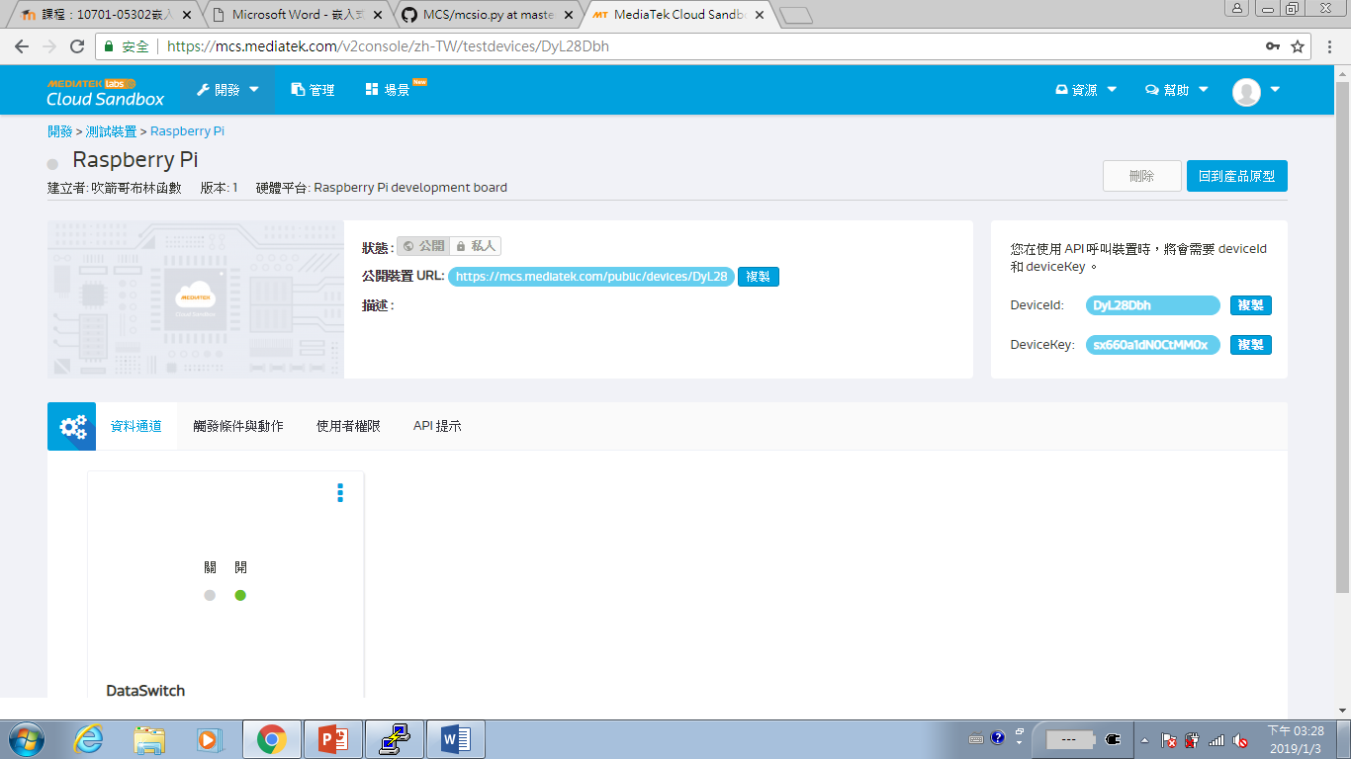

4.

開: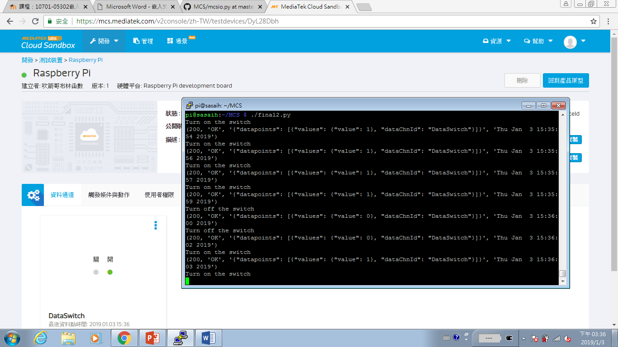

關:

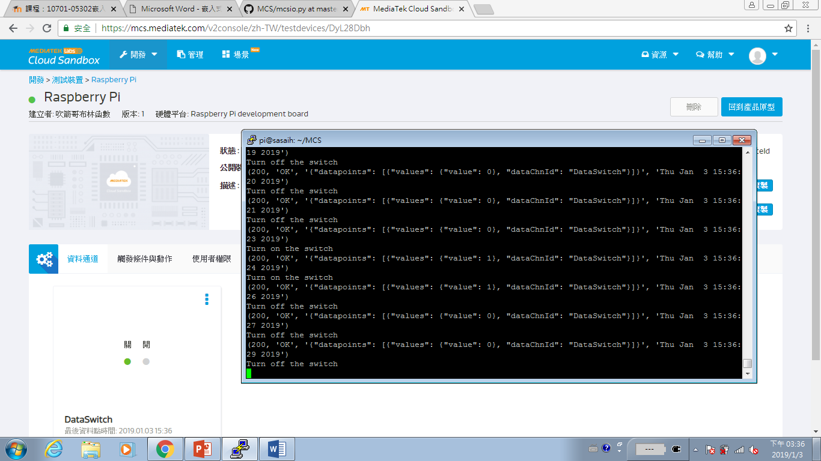

#!/usr/bin/python

import sys

import time

import httplib, urllib

import json

import RPi.GPIO as GPIO

GPIO.setmode(GPIO.BCM)

GPIO.setup(23, GPIO.IN, pull_up_down=GPIO.PUD_UP)

deviceId = "DyL28Dbh"

deviceKey = "sx660a1dN0CtMM0x"

def post_to_mcs(payload):

headers = {"Content-type": "application/json", "deviceKey": deviceKey}

not_connected = 1

while (not_connected):

try:

conn = httplib.HTTPConnection("api.mediatek.com:80")

conn.connect()

not_connected = 0

except (httplib.HTTPException, socket.error) as ex:

print "Error: %s" % ex

time.sleep(1)

conn.request("POST", "/mcs/v2/devices/" + deviceId + "/datapoints", json.dumps(payload), headers)

response = conn.getresponse()

print( response.status, response.reason, json.dumps(payload), time.strftime("%c"))

data = response.read()

conn.close()

while 1:

SwitchStatus = GPIO.input(23)

if (SwitchStatus == 0):

print('Turn off the switch')

else:

print('Turn on the switch')

payload = {"datapoints":[{"dataChnId":"DataSwitch","values":{"value":SwitchStatus}}]}

post_to_mcs(payload)

time.sleep(1)

5.

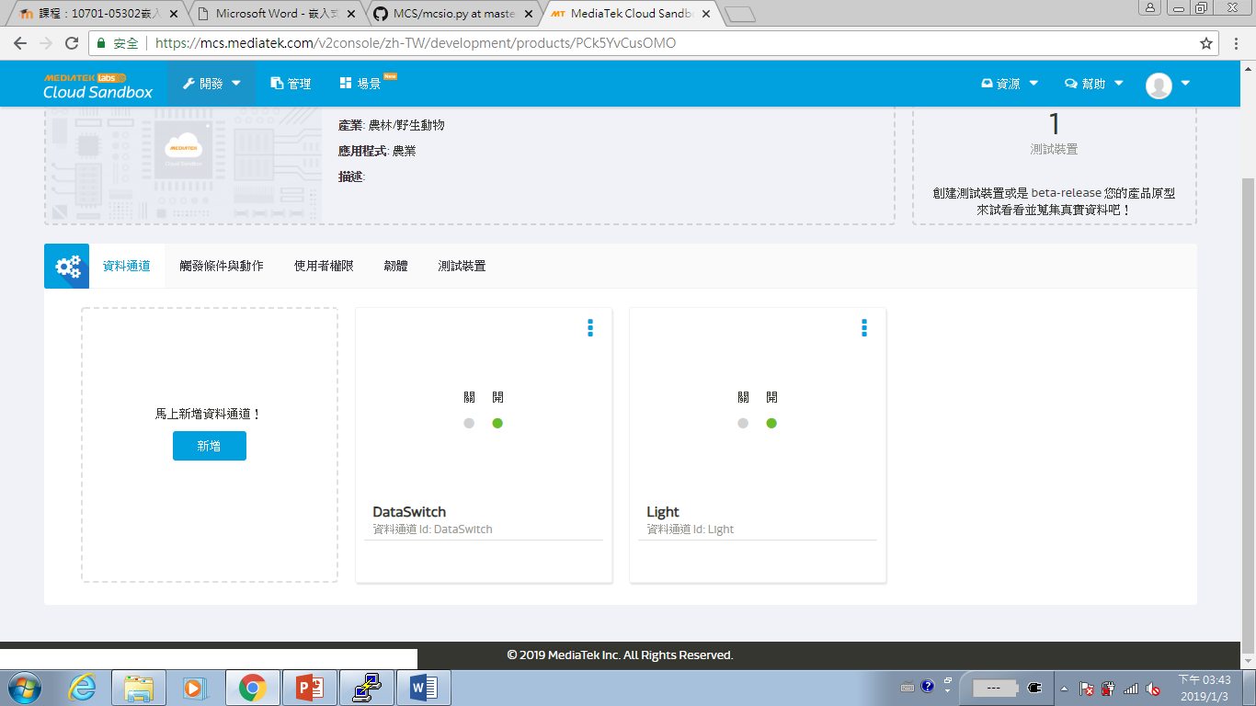

6.

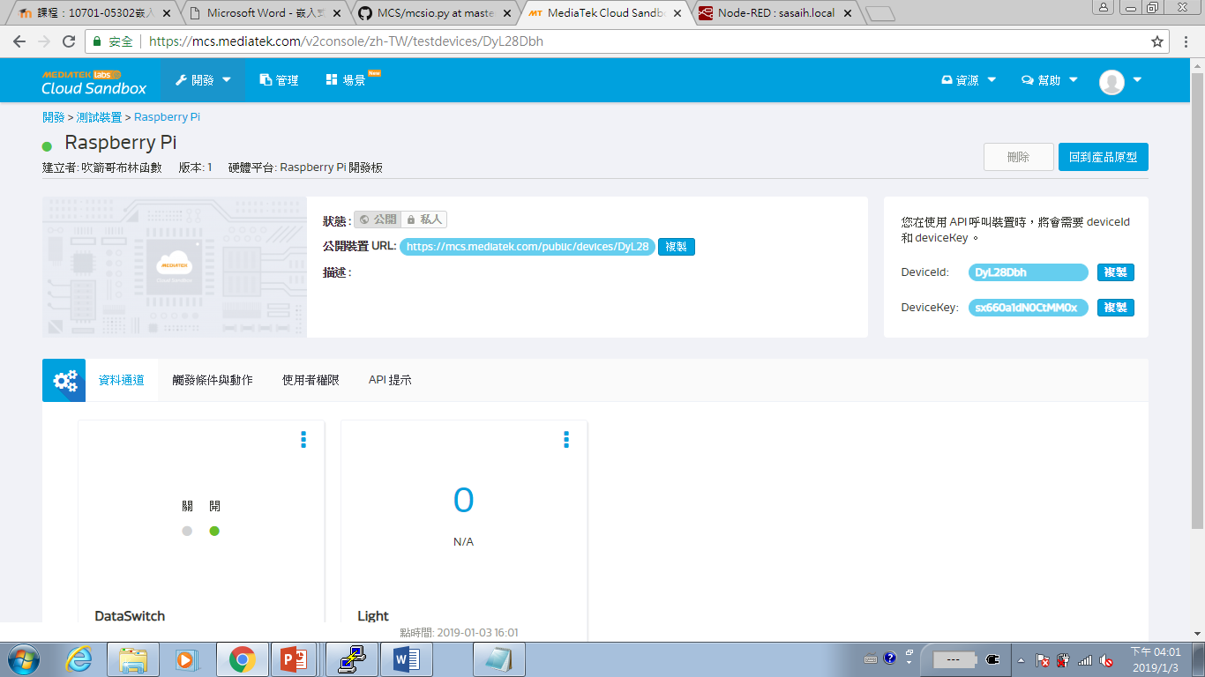

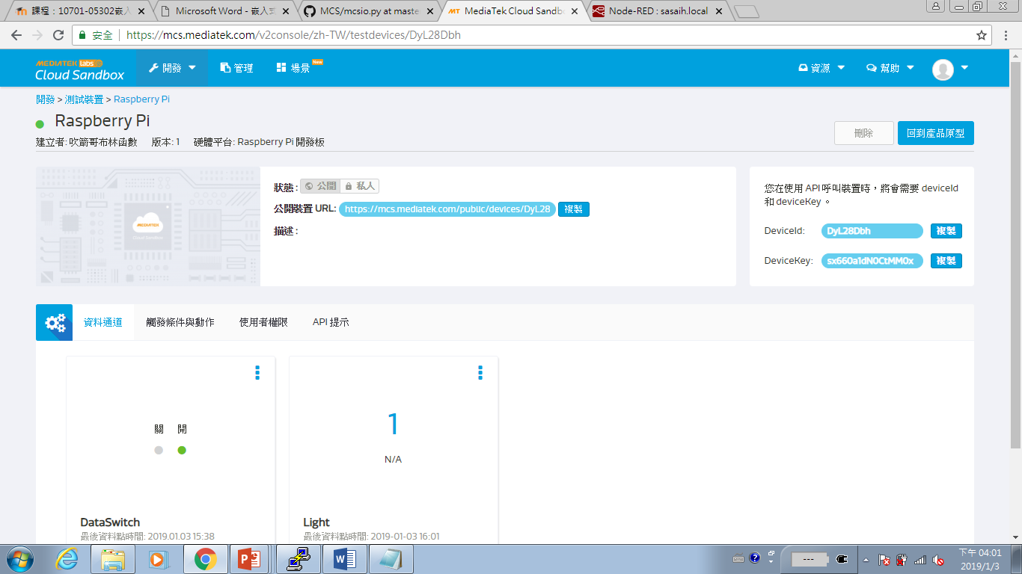

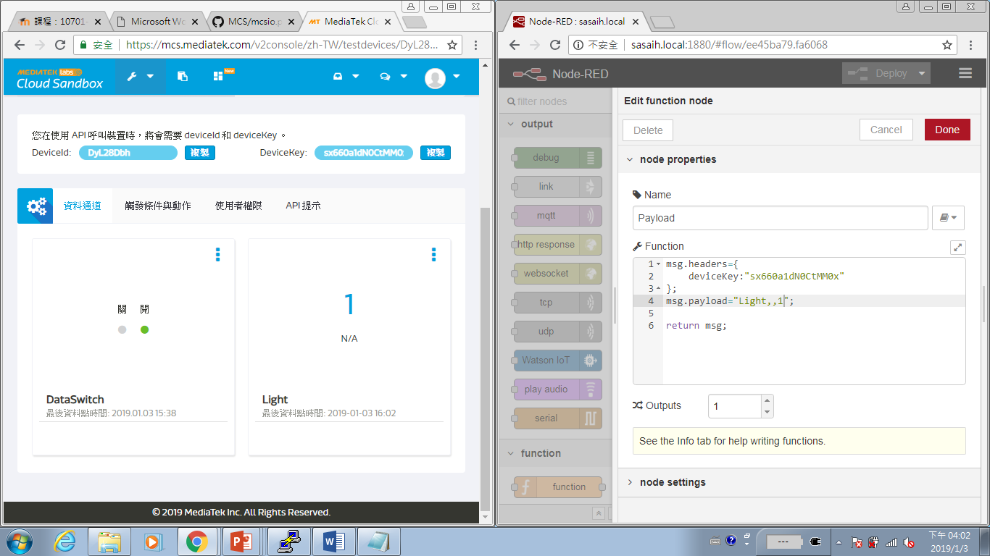

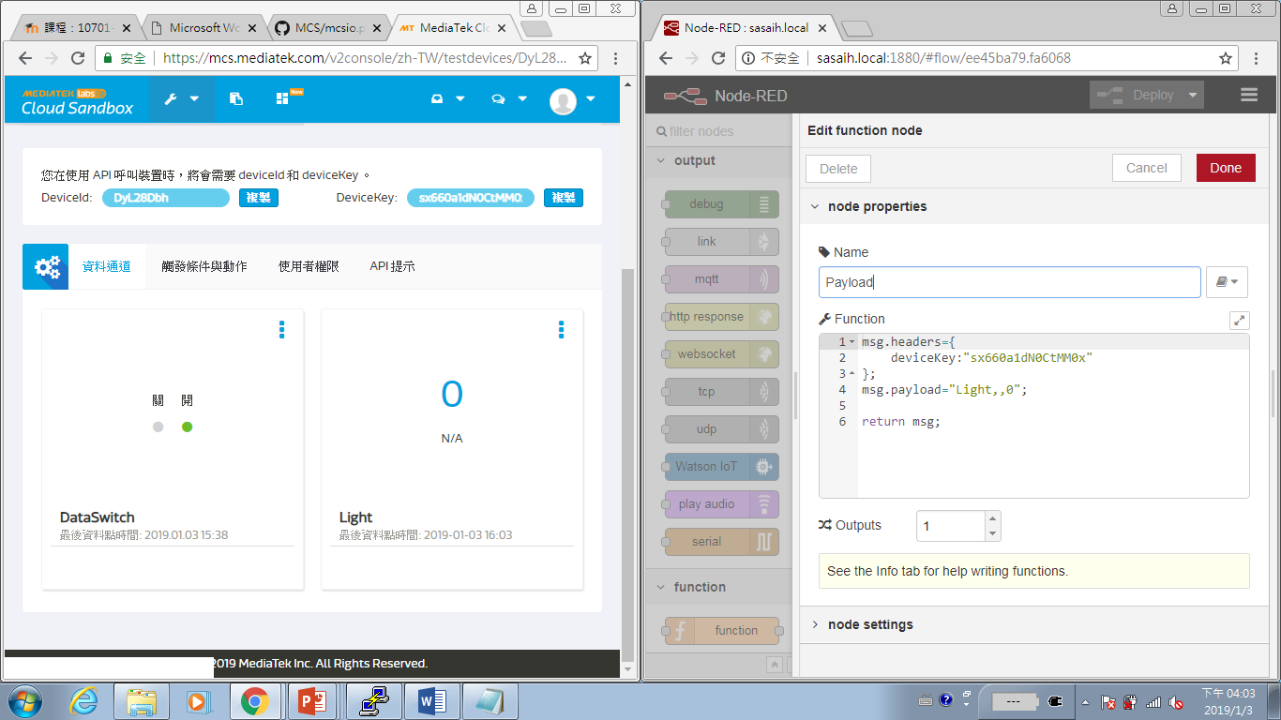

7.

