電通二乙微處理器實驗 實驗結報

實驗名稱 | 四合一七段顯示器
組別 | 16 | 組員 | 曹允誠

- 實驗目的
了解七段顯示器之顯示原理
- 實驗步驟
(1)接好似合一七段顯示器之電路 四合一七段顯示器每隔0.3秒鐘會跳一個數字
從0000->2359歸零
(2)於pin6按鍵 按下後歸零顯示
於pin17接一個按鍵 按下後倒數計時
- 程式碼
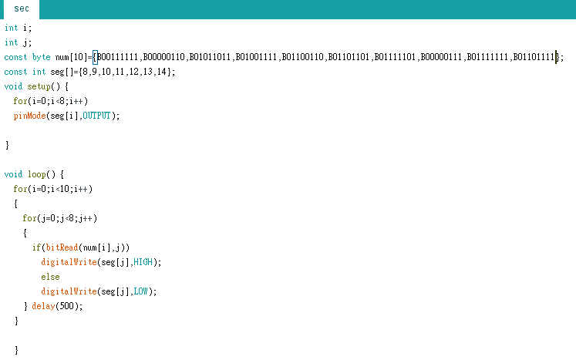
#include "SevSeg.h"
SevSeg sevseg; //Instantiate a seven segment controller object

void setup() {
byte numDigits = 4;
byte digitPins[] = {2, 3, 4, 5};
byte segmentPins[] = {8,9,10,11,12,13,14,15};
bool resistorsOnSegments = false; // 'false' means resistors are on digit pins
byte hardwareConfig = COMMON_CATHODE; // See README.md for options
sevseg.begin(hardwareConfig, numDigits, digitPins, segmentPins, resistorsOnSegments);
sevseg.setBrightness(90);
pinMode(6,INPUT);
}

void loop()
{
static unsigned long timer = millis();
static int deciSeconds = 0;
boolean val=digitalRead(6);
if(val)
{
sevseg.setNumber(0000, 0);
sevseg.refreshDisplay();
deciSeconds=0;
}
else
{
sevseg.setNumber(deciSeconds, 0);
if (millis() - timer >= 300)
{
timer += 300;

if (deciSeconds%100 == 59)
{
deciSeconds=deciSeconds+41;
}
else
{
deciSeconds++;
}
if (deciSeconds == 2400)
deciSeconds =0 ;
}

sevseg.refreshDisplay(); // Must run repeatedly
}
}
- 實驗結果及分析

- 心得討論
- 修正電路圖
- 修正程式碼

