電通二乙微處理器實驗 實驗結報

實驗名稱 | Blink
組別 | 16 | 組員 | 曹允誠

- 實驗目的
使用Tinkercad 模擬Arduino UNO 電路及程式
繪製電路圖
觀察Arduino UNO之輸出
- 實驗步驟
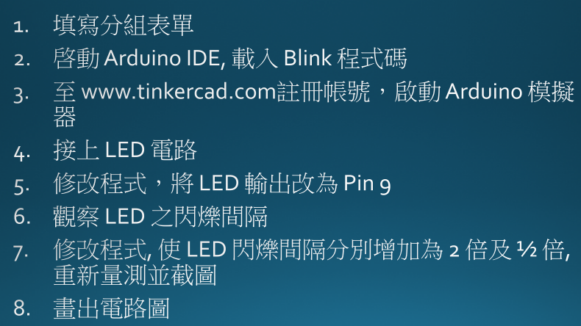
- 程式碼

void setup() {
// initialize digital pin LED_BUILTIN as an output.
pinMode(LED_BUILTIN, OUTPUT);
}

// the loop function runs over and over again forever
void loop() {
digitalWrite(LED_BUILTIN, HIGH); // turn the LED on (HIGH is the voltage level)
delay(1000); // wait for a second
digitalWrite(LED_BUILTIN, LOW); // turn the LED off by making the voltage LOW
delay(1000); // wait for a second
}

- 實驗結果及分析
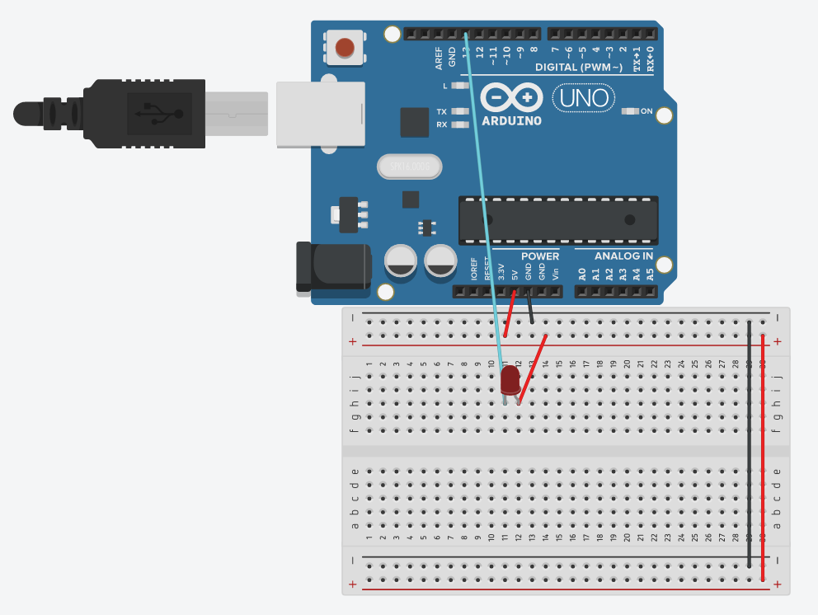
- 心得討論
第一次實驗非常簡單
- 修正電路圖
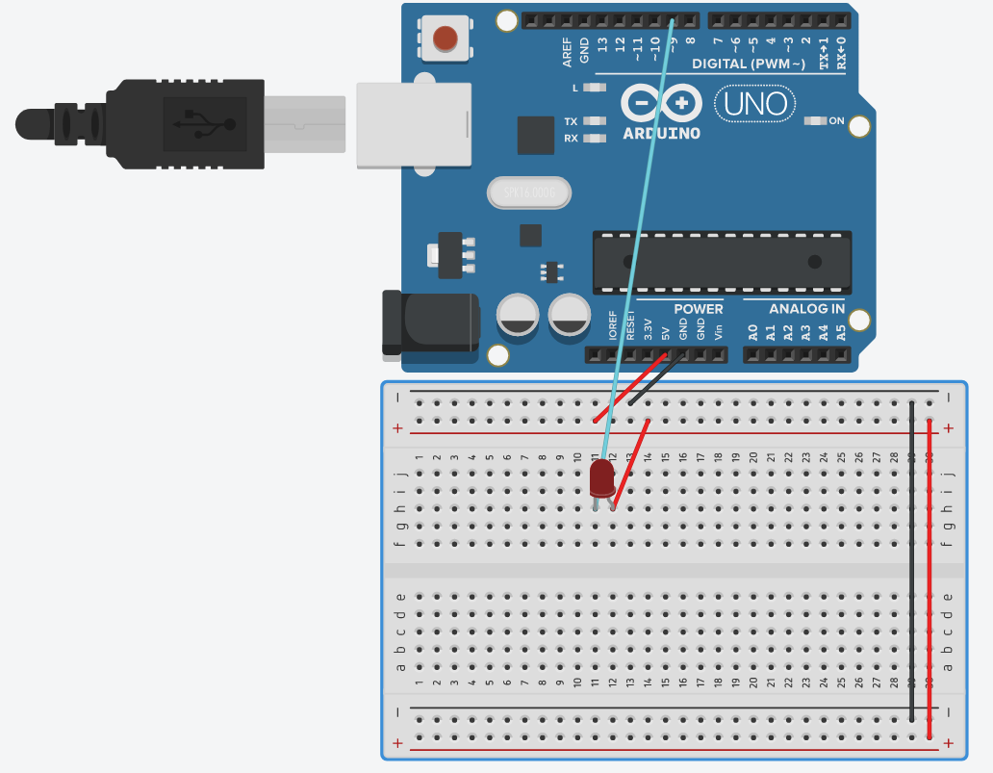
修正程式碼

void setup() {
// initialize digital pin LED_BUILTIN as an output.

pinMode(9, OUTPUT);
}

// the loop function runs over and over again forever
void loop() {
digitalWrite(9, HIGH); // turn the LED on (HIGH is the voltage level)
delay(500); // wait for a second
digitalWrite(9, LOW); // turn the LED off by making the voltage LOW
delay(500); // wait for a second
}

