UAT-01 – Login & Entry Selection
Version: 5.1.0 Status: 🟢 Live

Objective
Verify users can log in and select a survivor entry.

Test Accounts
User | Password
SAS | SAS
CNS | CNS
UWOSH | UWOSH
ADMIN | ADMIN

Test Steps

1. Login
Open:
https://semisharp.steveschilhabel.com/
Enter username and password.
Expected
- Login successful.
- Entry Selection page displayed.
☐ Pass

2. Select Entry
Choose an available entry.
Select:
Confirm & Proceed
Expected
- Dashboard opens.
- Selected entry becomes Active Entry.
☐ Pass

Definition of Done
☐ Login successful.
☐ Entry selection displayed.
☐ Dashboard opens.
☐ Active Entry correct.

Screenshots
Login Screen

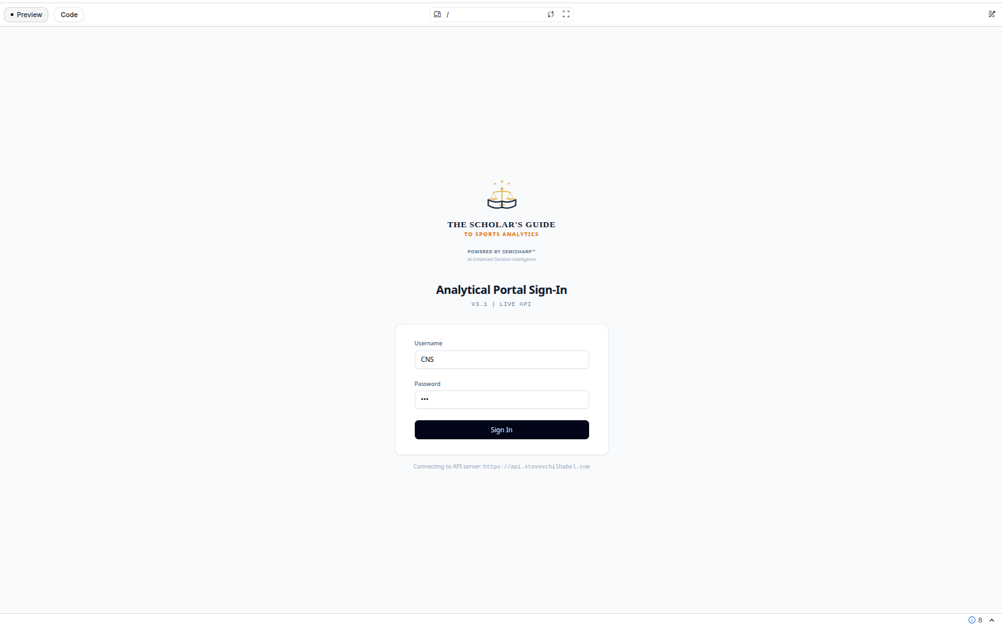
Entry Selection
