Community Water Billing System
Capstone Project Document | Institute of Data template alignment
Prepared by: project developer • October 2026
Repository: https://github.com/sasamilo2025/CommunityWaterBilling
Submission edition | 23 October 2026. Actual application screenshots included; testing limitations and approximate planning dates disclosed.

1. Introduction

1.1 Purpose
The project addresses manual community water administration in Samoa. Water-meter installation and maintenance, monthly readings, invoicing, payment recording and management reporting have historically relied on paper records and Excel support. This workflow can be time-consuming, difficult to audit and susceptible to transcription errors.
The desired state is a role-controlled system that stores consistent records in MySQL and provides forms, billing workflows and management reporting. Its community-service motivation arose from direct volunteering experience in the community office.

1.2 Industry / domain
Domain: community water utility management and municipal-style customer billing. The operational value chain is customer registration → meter management → periodic readings → consumption calculations → invoices → payments → reporting. Key concepts include meter identifiers, billing periods, tariff rates, outstanding balances and auditability. The approach could be adapted for other small utilities.

1.3 Stakeholders
Stakeholder / role | Need and expected access
Community administrators (ADMIN) | Register and maintain customer and meter records; enter readings; manage invoices and payments; approved user administration.
Community managers (MANAGER) | Maintain tariffs, review operational and financial reports, and monitor service performance.
Customers (CUSTOMER) | Read-only access to their own customer account, meters/readings, invoices and payment history.
Course instructor / assessor | Review GitHub development history, architecture, testing evidence and working demonstration.

2. Product Description

2.1 Architecture diagram
The application is a three-tier development system:
Layer | Key components / responsibilities
Client (browser) | React application built with Vite (development server typically localhost:5173); forms, lists, dashboards and role-specific screens.
API / business logic | Node.js + Express REST API (localhost:3000); input processing; JWT authentication and role-based middleware.
Persistence | mysql2 connection pool → MySQL 8.0 database community_water_billing; relational data, constraints and transactions as implemented.
Flow: User → React UI → HTTP/JSON request → Express routes + authorization → mysql2 → MySQL → JSON response → React display.
Figure 1 illustrates the application layers and responsibility boundaries. The arrows represent HTTP/JSON requests and database access; responses return to the browser through the API.
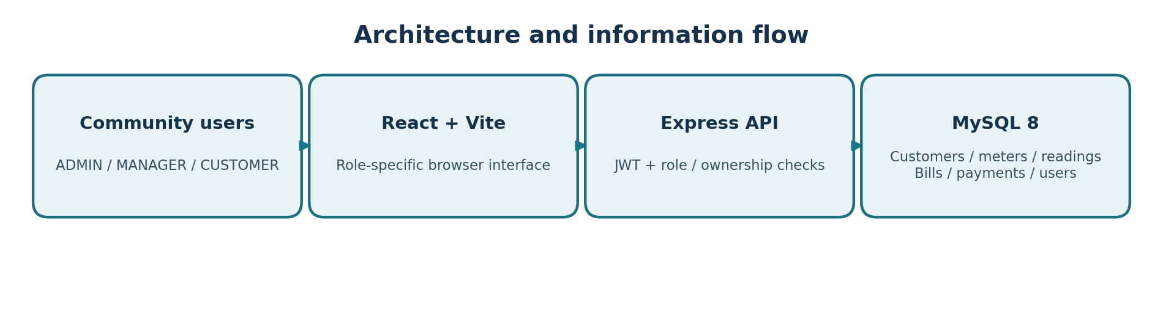
Figure 1. High-level logical architecture (documentation diagram).

2.2 User stories
# | User story | Priority | Acceptance evidence to attach
US01 | As an ADMIN, I can create and review customer records so service accounts are maintained. | High | Customer form, list and validation screenshot.
US02 | As an ADMIN, I can register meters to a customer so meter ownership is traceable. | High | Meter form/list with assigned customer.
US03 | As an ADMIN, I can record INITIAL and MONTHLY readings and confirm billing month so late physical readings are billed correctly. | High | Reading form and sample monthly record.
US04 | As an ADMIN, I can generate and review bills so consumption is charged at the applicable rate. | High | Invoice list and calculation.
US05 | As an ADMIN, I can record partial/full payments so balances reflect collections. | High | Payment form and updated bill status.
US06 | As a MANAGER, I can review management/statistical reports and maintain rates for informed oversight. | High | Report and rate-screen screenshots.
US07 | As a CUSTOMER, I can see only my own billing history to protect other customers’ information. | High | Authorized versus unauthorized access evidence.

2.3 User flow
ADMIN example: Login → JWT issued → Dashboard → Customers / Meters → Enter reading → Confirm billing month → Generate invoice → Record payment → Review results. MANAGER example: Login → Rate maintenance / Reports → Review trends. CUSTOMER example: Login → Own account → Own readings / invoices / payments (read-only).
Figure 2 shows a representative ADMIN transaction path. Features available depend on the authenticated role; INITIAL meter readings do not generate invoices.
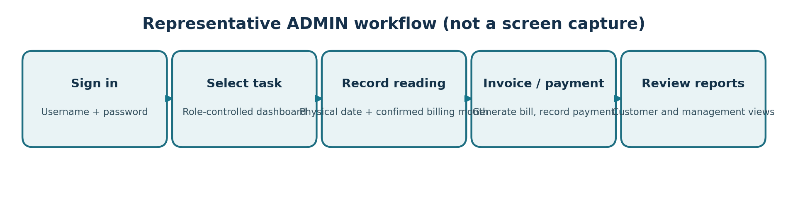
Figure 2. Representative ADMIN flow (conceptual diagram; not a screenshot).

2.4 Wireframe design
The following figures document actual pages captured from the locally running React application. These are implementation screenshots, not pre-development wireframes. Initial wireframes were not preserved as separate dated artifacts.
Page | Header / controls | Main display
Login | Username | Password | Sign in | Authentication status and cultural video section.
ADMIN records | Navigation | Customer/Meter/Reading form | Save | Existing-record table with action controls.
Billing and payments | Invoice or payment entry fields | Invoice/payment list and status feedback.
Management reporting | Report filters / metrics | Summary cards, statistics and customer comparison chart.
The screenshots illustrate the login interface, authenticated ADMIN navigation, reading registration/history, and MANAGER reporting with a July–September 2026 comparative chart.
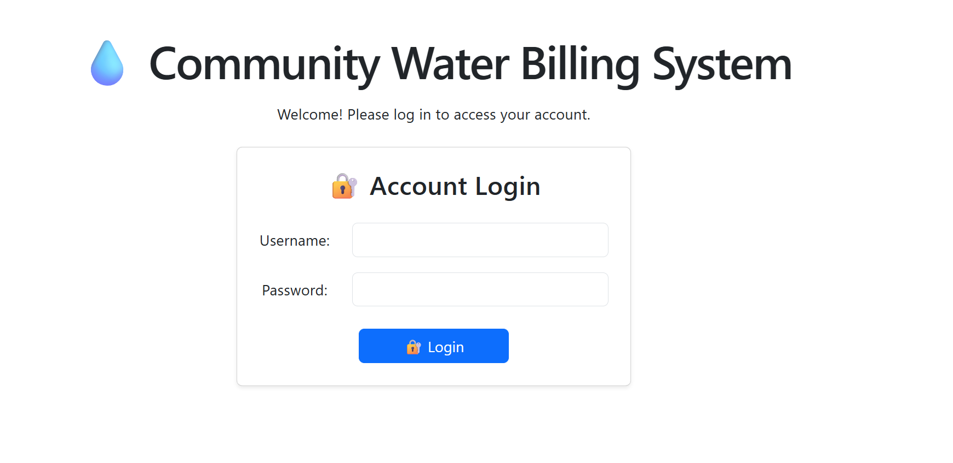
Figure 4. Login page: username/password entry and authentication interface.
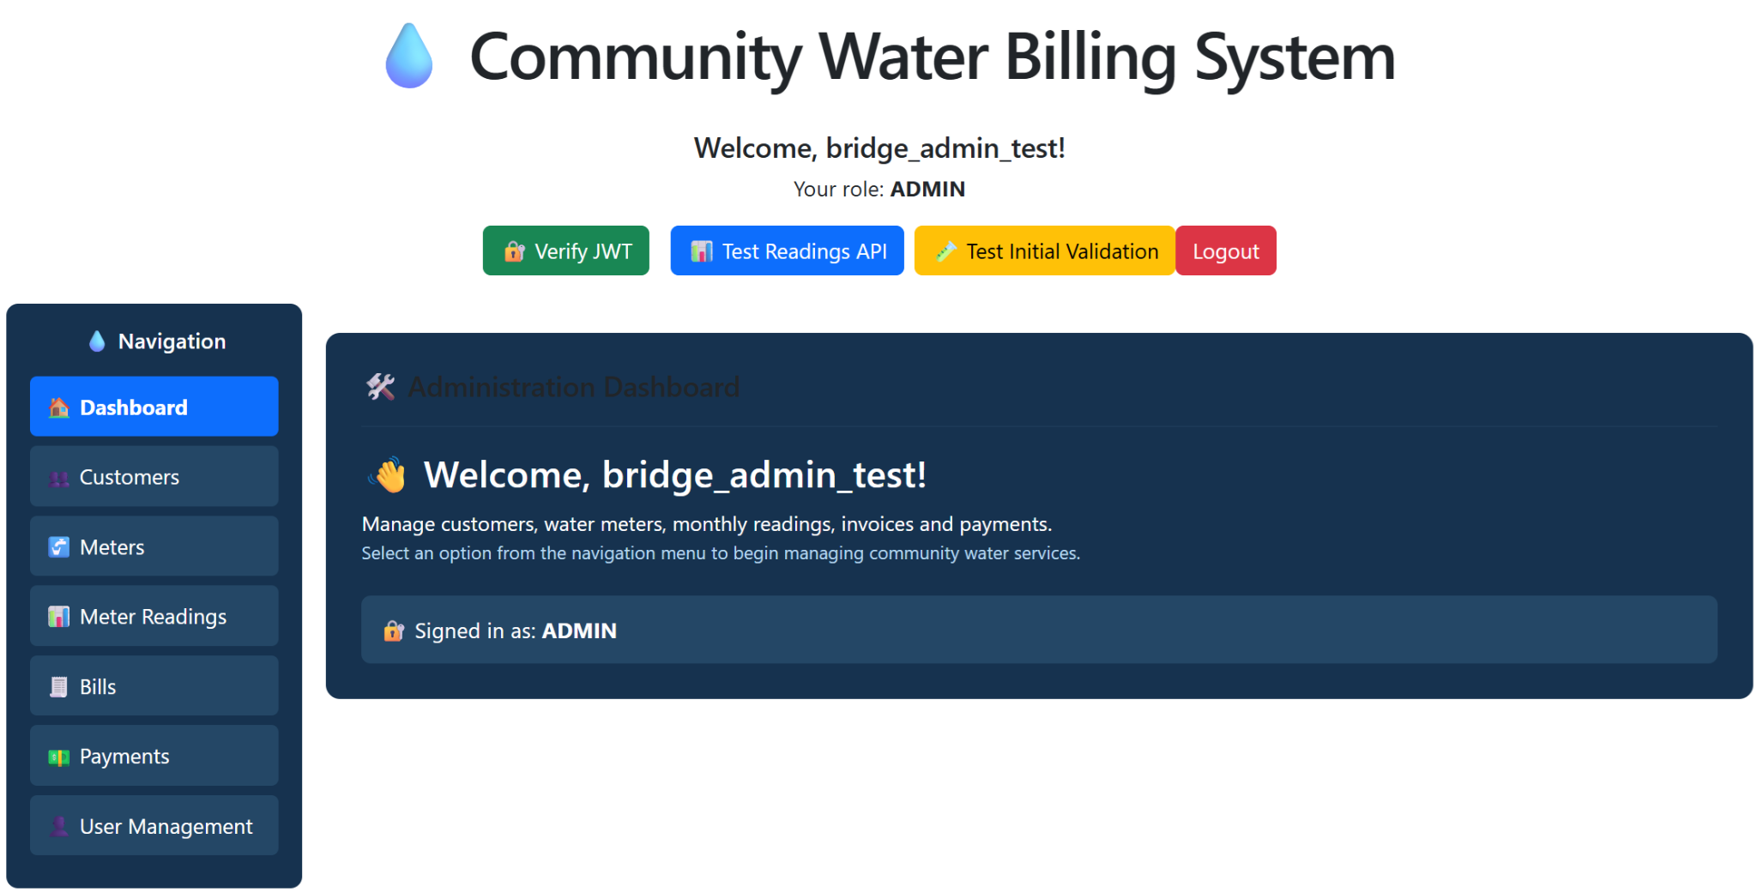
Figure 5. ADMIN dashboard: authenticated role and administrative navigation.
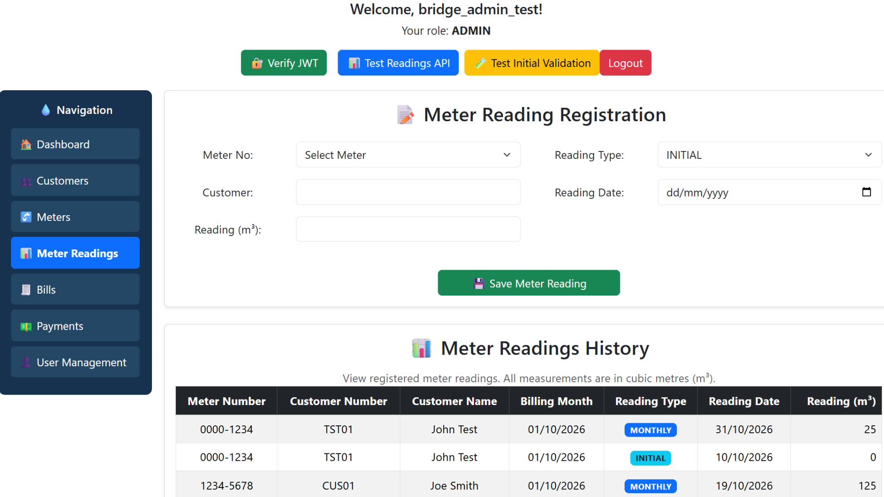
Figure 6. Meter reading entry and history: INITIAL and MONTHLY readings, dates and billing month.
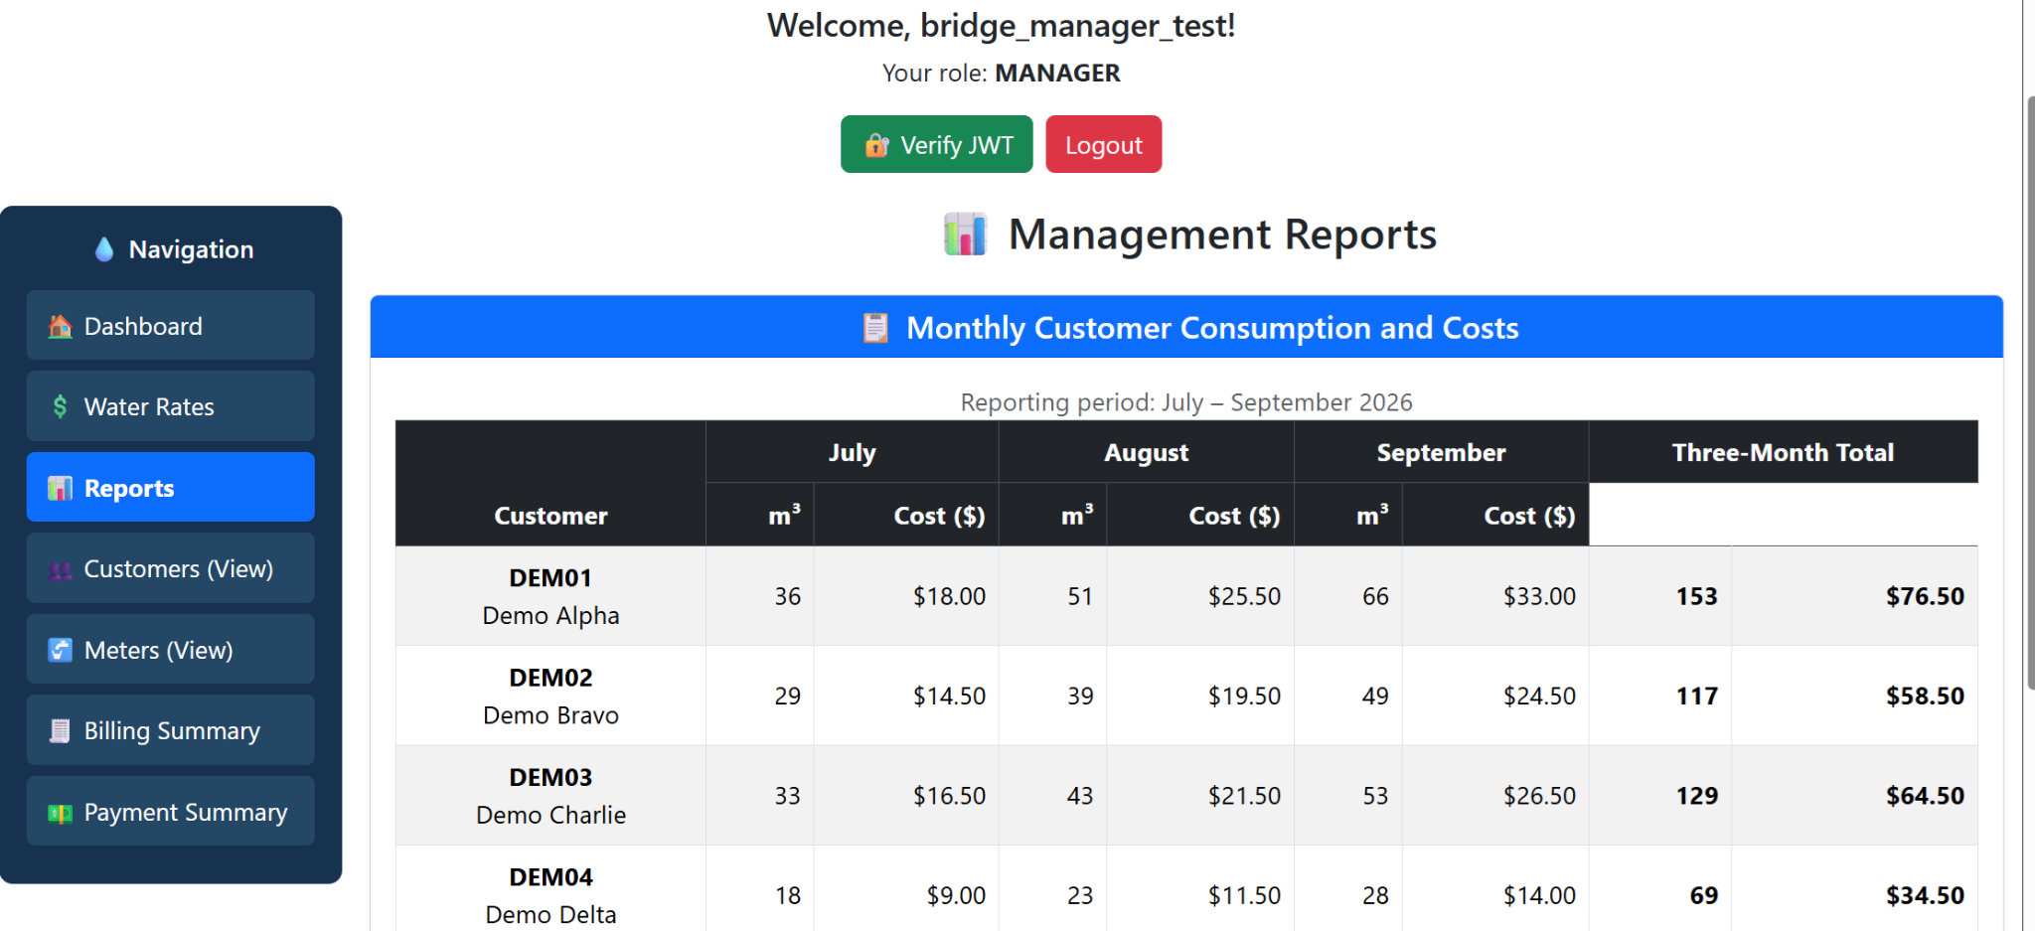
Figure 7. MANAGER monthly customer consumption and billing report, July–September 2026.
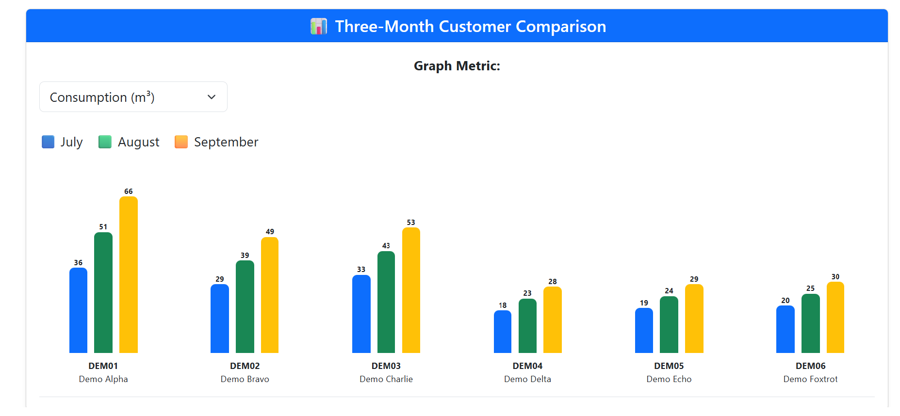
Figure 8. MANAGER three-month customer consumption comparison, July–September 2026.

2.5 Open questions / out of scope
The capstone was developed and demonstrated locally. Public hosting, production-grade customer onboarding, external online payment gateways, mobile optimization and comprehensive auditing are future enhancements unless the repository demonstrates otherwise. Field workflow and data-retention policies would require community review before actual deployment.

2.6 Non-functional requirements
Area | Design expectation / available evidence
Security | Argon2id password hashes, JWT authentication, role-specific authorization; ensure CUSTOMER ownership by customer_id. Secrets in ignored .env (not committed).
Data integrity | MySQL foreign keys, unique identifiers, date/reading constraints and historical per-invoice tariffs.
Usability | Consistent horizontal label/input forms, feedback for invalid data and responsive navigation.
Performance and availability | Local demonstration verified; no measured peak transaction throughput, latency SLA or uptime metric is claimed.
Maintainability | Separated React UI, Express route/middleware logic, MySQL connection module, Git commit history and README.

3. Project Planning
The timeline summarizes approximate development phases reconstructed from project work and Git history. It is retrospective and is not represented as a contemporaneous Gantt chart.
Period | Milestone | Evidence
8–11 Oct 2026 | Repository, database schema, initial Express and MySQL connectivity | Commits / schema.sql
12–14 Oct 2026 | Authentication, middleware, frontend login and basic API tests | Auth routes, test scripts
15–17 Oct 2026 | Customer/meter management and reading workflow | React components, route changes
18–20 Oct 2026 | Bills, payments, reporting, demo data and presentation | Recent commits, screenshots, capstone demo
After presentation | Documentation, security review and deployment preparation | This document; repository review
Simple milestone timeline: Schema ━━━ Authentication ━━━ CRUD & Readings ━━━ Billing & Reports ━━━ Demo / Documentation.
Figure 3 summarizes development phases reconstructed from the project timeline. Dates are approximate planning windows, not an exported Trello board. Confirm exact milestones against Git history.
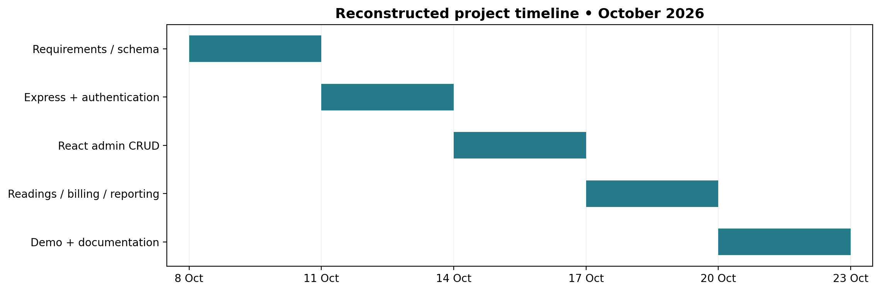
Figure 3. Indicative timeline; approximate, not a contemporaneous Gantt log.

4. Testing Strategy
Quality assurance used manual frontend/API checks, database integrity constraints, and Node.js fetch-based API integration scripts. The repository has no configured automated unit-test suite: server/package.json contains the default failing test placeholder, and client/package.json has no test script. Oxlint is static analysis, not unit testing. The test cases below specify the source and expected outcome; reported historical observations are distinguished from tests not rerun for this submission.
Feature / condition | Test approach | Evidence status
Backend/database health | GET API health and database-health endpoints; inspect HTTP 200 vs 503 when MySQL80 unavailable. | Previously exercised; attach terminal outputs.
Authentication | Test successful ADMIN/MANAGER login, incorrect credentials, absent token and expired/invalid token. | Previously exercised; attach response logs.
Authorization | Try restricted endpoints with role-appropriate and unauthorized accounts. | Previously exercised; verify final routes and results.
Customer and meter validation | Check required fields, unique identifiers and format constraints. | Attach UI screenshots + SQL constraint evidence.
Reading validation | Check initial vs monthly reading, reading_date versus billing_month, non-negative and non-decreasing readings. | Confirm actual test outcomes from final build.
Billing / payments | Verify consumption, applicable tariff, partial/full payments and corresponding status transitions. | Attach real test outputs.
Reports | Compare report counts / totals with demonstration database entries. | Attach screenshot and a sample reconciliation.
Automated unit tests | Run repository test command(s), report actual test names, assertions and pass/fail output. | NOT VERIFIED — do not claim coverage without evidence.
Table 2. Selected testing evidence and coverage. Script expectations are not claimed as newly executed results.
Scenario / method | Evidence or observed result | Interpretation
Backend–database connection | 23 Oct preparation: GET /api/health/db returned HTTP 200; status OK, database community_water_billing, result 1. | Observed successful integration check.
Invalid authentication | Earlier development checks: invalid credentials returned HTTP 401; empty fields returned HTTP 400. | Historically observed API validation.
ADMIN meter creation | server/scripts/testMeterAdmin.js uses fetch; checks for expected HTTP 201. | Integration script exists; not rerun for this report.
MANAGER denied meter creation | server/scripts/testMeterAuthorization.js uses fetch; checks for expected HTTP 403. | Authorization integration script exists; not rerun for this report.
Customer status update | server/scripts/testCustomerStatus.js performs a PATCH and logs HTTP response and status. | Potentially mutating test; not rerun.
UI and reports | Actual logged-in ADMIN and MANAGER screenshots document views and reports. | Visual evidence; not comprehensive correctness test.
Automated unit tests | No backend/frontend test runner or isolated unit suite configured in package.json. | Known testing coverage gap.

4.1 Edge cases and error handling
- Duplicate customer number or meter serial: database uniqueness should prevent duplicate records.
- Unknown or deleted record: API should return an appropriate not-found response.
- Unauthorized role / wrong customer owner: prevent cross-customer disclosure.
- Stopped MySQL service: distinguish API-running status from database-available status.
- Late monthly readings: maintain separate actual reading_date and billing_month.

5. Implementation

5.1 Main implemented areas
Project uses a React/Vite client, Node.js/Express backend and relational MySQL model. Database tables recorded during development include customers, meters, meter_readings, bills, payments and users. The system’s demonstrated functionality included record entry, billing, payments and management/statistical reporting.

5.2 Database and billing rules
- customers.customer_no uses the XXX99 identifier pattern.
- meters.meter_serial stores eight digits; a customer can own more than one meter.
- Monthly readings store billing_month separately from physical reading_date; INITIAL readings provide opening values.
- Bills preserve the tariff charged at invoice time; consumption is derived from the difference between current and prior readings.
- Payments can be partial or full; the invoice status reflects payment state.
The documented field names and business rules reflect recorded project development. Refer to database/schema.sql for the authoritative current schema and to the repository code for route behaviour.

5.3 Security and deployment considerations
Application secrets should remain in local environment configuration rather than committed source. The database must use restricted credentials for any production deployment; TLS, backups, production monitoring, access-review policies and secure hosting should be specified before onboarding real customers. The capstone was demonstrated locally; no production deployment is asserted.

6. End-to-end Solution
The system met its capstone demonstration goal: a real-world community water administration scenario was modeled in a client–server application with MySQL-backed record management and reporting. Following the demonstration, the remaining work is to validate complete automated tests, final documentation evidence, security controls and production readiness. The intended community benefit is improved accuracy and accessibility compared with primarily manual records.

7. References and Submission Evidence
- GitHub repository: https://github.com/sasamilo2025/CommunityWaterBilling
- Technologies: React, Vite, Node.js, Express, mysql2, MySQL, JWT, Argon2id, Git/GitHub.
- Assessment sources: Institute of Data “Capstone Project” brief and “SE Capstone Project Document Template” (uploaded by student).

Evidence and limitations at submission
- Reproduction: the application is demonstrated locally; production hosting and deployment hardening remain outside capstone scope.
- Limitations: no preserved early wireframe/Gantt artifacts or formal automated unit-test suite; report figures demonstrate screens and example data, not exhaustive test coverage.
- Included evidence: architecture and conceptual user-flow diagrams; retrospective indicative timeline; five actual application screenshots; identified API integration scripts and observed database health response.

