EXERCISE 1 – PORTFOLIO WEBSITE

Requirements

- Display my name and role
- Show About Me Section
- Display Projects
- Display Contact Information
- Include navigation links

Paper Drawings

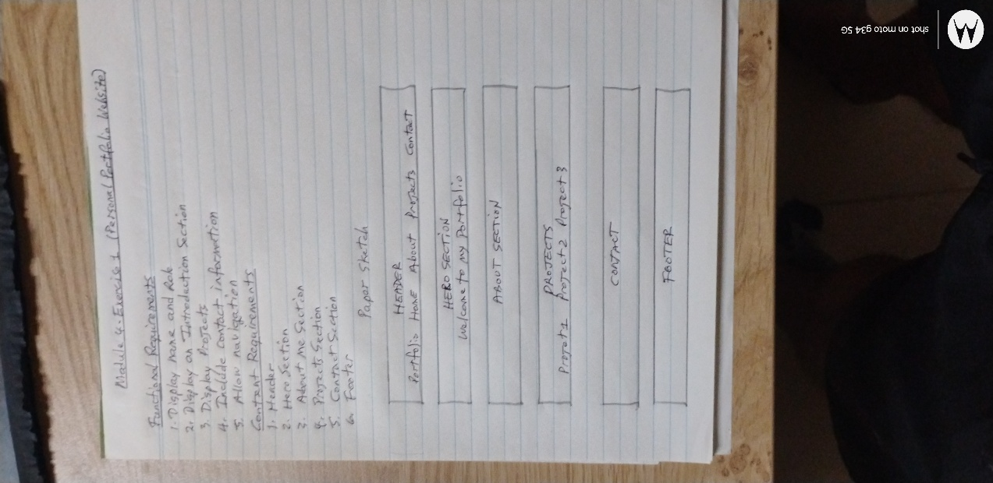

Link to Figma Draft Design

https://www.figma.com/design/lfNJUmkBILdz9AEzWLMlgT/Module4_LabExrcise1?node-id=0-1&m=dev&t=yutvWWaqZEcYFBfM-1

