

**FACULTY OF APPLIED SCIENCES**

**COMPUTER SCIENCE DEPARTMENT**

**BTECH INFORMATION TECHNOLOGY**

**DATA MANAGEMENT AND ANALYTICS**

**LEVEL 300**

**@2025 MINI PROJECT Ⅳ | DOCUMENTATION**

**GROUP 10**

**SHOPPING PORTAL – E-COMERCE WEBSITE**

**PROJECT**



**Online Shopping**

**REPORT BY**

**NAME : INDEX N_O:**

SYLVESTER QUAINOO BC/ICT/22/341

BENEDICT WORDEY BC/ICT/22/075

JOSEPHINE YANKEY BC/ICT/22/087

NANA PASQUIN SEKYI BC/ICT/22/305

KELSEY ETREW BC/ICT/22/088

MENSAH COLLINS BC/ICT/22/277

TISH EWURAKUA ATTA-BINEY BC/ICT/22/044

WILLIAM MURRAY CHIEKA BC/ICT/22/398

**DECLARATION**

We, the undersigned, hereby declare that this project, **"Shopping Portal – E-Commerce Website,"** is our original work and has been carried out as part of our academic and technical learning. The project has been developed using PHP, MySQL, Bootstrap, and Paystack for payment integration.

We affirm that all information and concepts presented in this documentation and the project implementation are based on our research, learning, and efforts. Any external sources referenced have been duly acknowledged.

This project has not been submitted, either in part or whole, for any other academic or professional qualification.

|  |  |
| --- | --- |
| NAME | SIGNATURE |
| BENEDICT WORDEY |  |
| SYLVESTER QUAINOO |  |
| WILLIAM MURRAY CHIEKA |  |
| JOSEPHINE YANKEY |  |
| NANA PASQUIN SEKYI |  |
| KELSEY ETREW |  |
| MENSAH COLLINS |  |
| TISH EWURAKUA ATTA-BINEY |  |

**ABSTRACT**

The **Shopping Portal – E-Commerce Website** is a web-based platform designed to provide a seamless online shopping experience for customers while ensuring efficient product and order management for administrators. The system enables users to sign up, browse products by categories, add items to their cart, and complete purchases using a secure online payment gateway (Paystack).

The platform features an intuitive user interface developed using **Bootstrap** for responsiveness and **PHP with MySQL** for backend functionalities. The payment system is securely integrated with **Paystack**, ensuring smooth and reliable online transactions. Additionally, an **admin dashboard** is provided to manage product listings, user accounts, and order fulfilment.

The primary objectives of this project are:  
✔ To provide a secure and user-friendly shopping experience.  
✔ To facilitate easy product management for administrators.  
✔ To integrate seamless online payment methods for faster transactions.  
✔ To ensure data integrity and security in all transactions.

This project is structured to serve as a scalable solution for small to medium-sized businesses looking to establish an online marketplace. Future enhancements may include the introduction of AI-driven product recommendations, live order tracking, and multi-language support.

**ACKNOWLEDGMENT**

We would like to express our sincere gratitude to everyone who contributed to the successful completion of this project, **"Shopping Portal – E-Commerce Website."**

First, we extend our heartfelt appreciation to **Mr. Kenneth Broni**, whose guidance, insightful feedback, and expertise helped shape our project. Your support has been invaluable in refining our ideas and ensuring a high-quality outcome.

We also acknowledge the contributions of our **team members**, each of whom played a vital role in the development process

Furthermore, we are grateful for the resources provided by **TTU**, as well as online platforms and forums that guided us in troubleshooting technical challenges.

Lastly, we extend our appreciation to our **families and friends** for their unwavering support and encouragement throughout this journey.

**Thank you all for your support!**

**Team Members: GROUP 10**

**Date:** [ 04 / 03 / 2025 ]

**TABLE OF CONTENTS**

Page

**Introduction ………………………………………………………………..**

**Features …………………………………………………………………..**

**Technology Stack …………………………………………………………**

**System Requirement ……………………………………………………**

**Installation & Setup .………………………………………………….**

**Project Structure …………………………………………………………**

**Database Design …………………………………………………………**

**Features &Modules …………………………………………………….**

**API Documentation …………………………………………………….**

**Payment Integration (Paystack) …………………………………..**

**Security Considerations …………………………………………………**

**Deployment Guide ……………………………………………………….**

**Troubleshooting & FAQs ………………………………………………**

**Future Enhancements …………………………………………………**

**Contact & Support …………………………………………………….**

**1. Introduction**

The Shopping Portal – E-Commerce Website is an advanced web-based platform designed to facilitate seamless online shopping for customers while enabling efficient product and order management for administrators. Built using PHP, MySQL, and Bootstrap, the system provides a responsive and intuitive interface, making it easy for users to browse products, add items to their cart, and complete secure transactions through Paystack payment integration. With the rapid growth of e-commerce, businesses need reliable and scalable digital platforms to manage their online stores effectively. This project addresses the need for an affordable, easy-to-use, and secure e-commerce solution, especially for small to medium-sized businesses that want to establish an online presence.

The Shopping Portal simplifies the online shopping experience by providing essential functionalities such as user authentication, product search, order tracking, and multiple payment options. Administrators can efficiently manage products, categories, users, and orders from a dedicated admin dashboard, ensuring smooth business operations.

**1.2 Key Features of the System**

For Customers:

✔ User Registration & Login: Customers can sign up and log in securely.  
✔ Product Browsing & Search: Users can explore products categorized for easy navigation.  
✔ Shopping Cart & Checkout: Customers can add items to their cart and proceed with secure checkout.  
✔ Order Management: Users can view order history and track purchases.  
✔ Secure Payments: Integration with Paystack allows for smooth and secure online transactions.

For Administrators:

✔ User Management: Admins can manage registered users and their access levels.  
✔ Product & Category Management: Admins can add, edit, or remove products and categories.  
✔ Order Processing: The admin panel enables tracking and managing customer orders.  
✔ Payment Management: Transactions are securely recorded and managed through the Paystack API.  
✔ Dashboard Analytics: Admins can monitor sales performance and generate reports.

**1.3 Target Audience & Use Cases**

The Shopping Portal is designed for:

* Entrepreneurs & Small Businesses: Who need a cost-effective e-commerce platform.
* Customers & Online Shoppers: Who prefer a convenient and secure shopping experience.
* E-commerce Startups: Who require an easy-to-manage online store with payment integration.

Use Cases:

1. A customer browses products, adds items to the cart, and completes a purchase using Paystack.
2. An admin adds a new product category, updates stock, and processes customer orders.

**1.4 Scope of the Project**

This project focuses on:  
✔ Developing a fully functional e-commerce website with essential shopping and management features.  
✔ Implementing secure payment processing via Paystack.  
✔ Providing a single-vendor platform for small to medium-sized businesses.

Limitations:

❌ Does not support multi-vendor functionality (only one store manages all sales).  
❌ Currently lacks a mobile application version (website only).  
❌ Future enhancements may include AI-powered recommendations and live order tracking.

1. **Feature & Modules**

**User Features:**

✔ Secure Sign Up & Login ✔ Browse Products by Categories

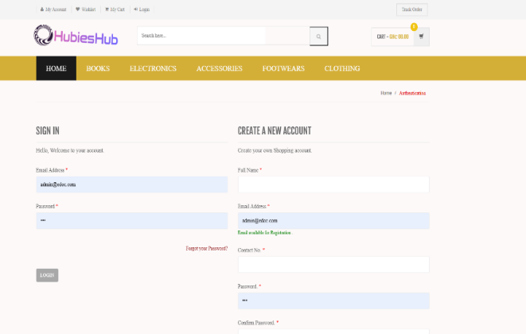 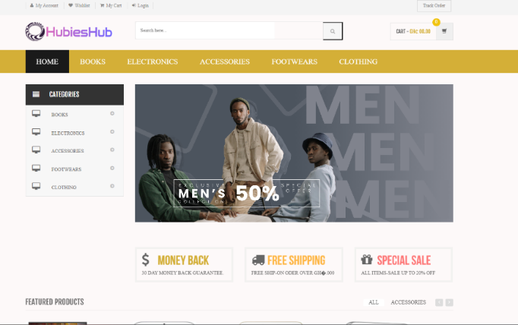

✔ Search for Products

  
✔ Add Products to Cart & Checkout

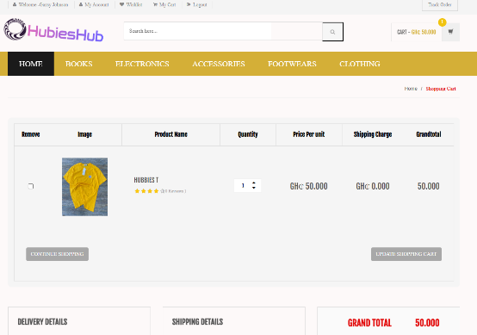 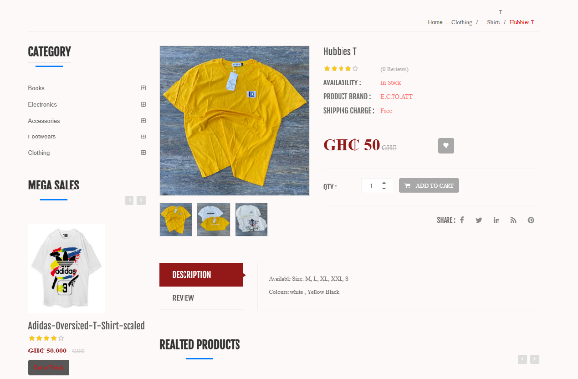

✔ Multiple Payment Methods (Paystack Integrated) ✔ View Order History

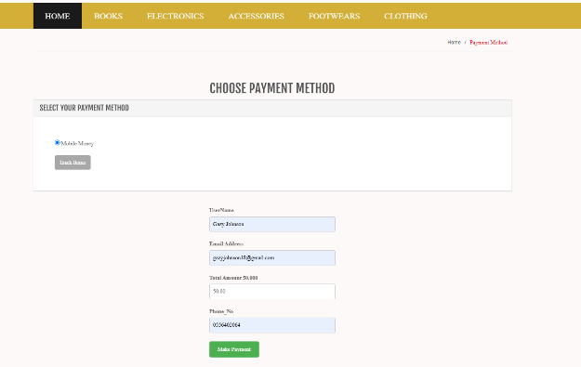 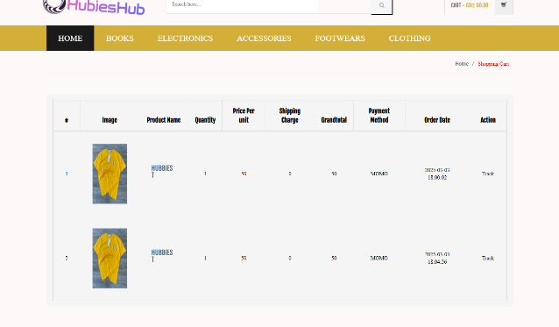

**Admin Features:**

✔ Create & Manage Product Categories ✔ Insert, Update, and Delete Products

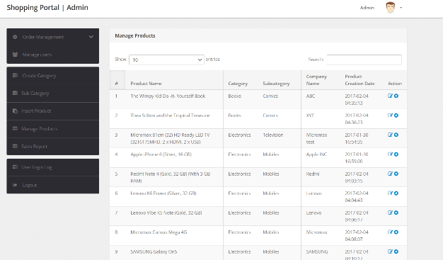 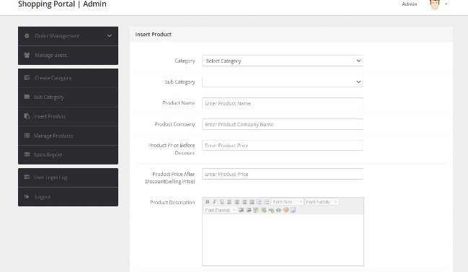

✔ Manage User Accounts & Permissions ✔ Process Orders & Update Order Status

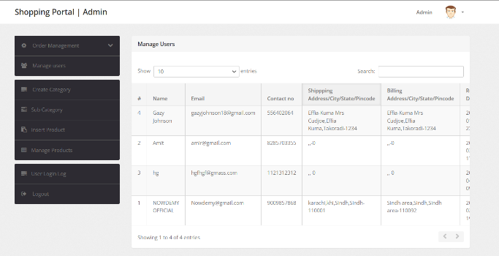 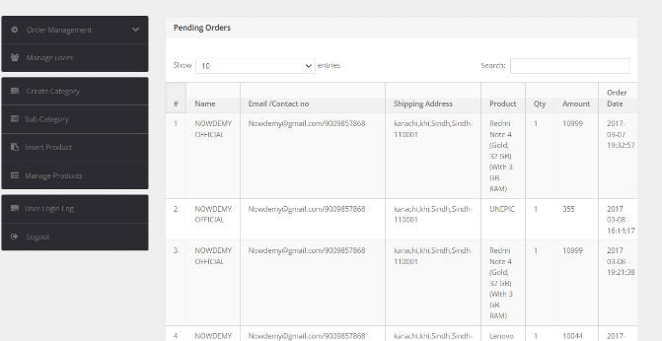

**3. Technology Stack**

**Frontend:**

* HTML, CSS3
* JavaScript
* Bootstrap (for responsive UI)
* Boxicons (icons )

**Backend:**

* PHP (Core PHP)
* MySQL (Relational Database)

**Payment Gateway:**

* Paystack

**Server Requirements:**

* Apache (via XAMPP or WAMP)
* PHP 8.1 or higher
* MySQL

**4. System Requirements**

**Minimum Requirements:**

* Processor: Intel Core i3 or equivalent
* RAM: 4GB
* Disk Space: 2GB free
* OS: Windows, macOS, or Linux
* Internet Connection for payment processing

**Recommended Requirements:**

* Processor: Intel Core i5 or higher
* RAM: 8GB+
* SSD storage for faster performance

**5. Installation & Setup**

**Step 1: Download & Extract Files**

1. Download the project from [GitHub/your-source].
2. Extract the files to the following directory:
   * **For XAMPP:** C:/xampp/htdocs/shopping_portal/
   * **For WAMP:** C:/wamp/www/shopping_portal/

**Step 2: Database Setup**

1. Open a web browser and navigate to http://localhost/phpmyadmin.
2. Create a new database **shopping**.
3. Click on **Import**, select the provided SQL file, and execute it.

**Step 3: Configure Database Connection**

Modify the config.php file with your database credentials:

php

$servername = "localhost";

$username = "root";

$password = "";

$dbname = "shopping";

$conn = new mysqli($servername, $username, $password, $dbname);

if ($conn->connect_error) {

die("Connection failed: " . $conn->connect_error);

}

**Step 4: Run the Application**

1. Open a browser and go to: http://localhost/shopping_portal/
2. The homepage should load successfully.

**6. Project Structure**

├── assets/ # CSS, JS, images

├── admin/ # Admin panel files

├── includes/ # Reusable PHP files

├── config.php # Database connection

├── index.php # Home Page

├── login.php # User Login Page

├── register.php # User Registration

├── cart.php # Shopping Cart

├── checkout.php # Payment & Order Processing

├── admin/

│ ├── dashboard.php # Admin Dashboard

│ ├── manage-products.php # Product Management

│ ├── manage-orders.php # Order Management

└── sql/

├── shopping_portal.sql # Database file

**7. Database Design**

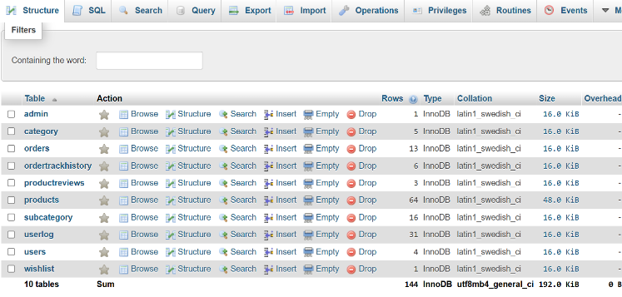

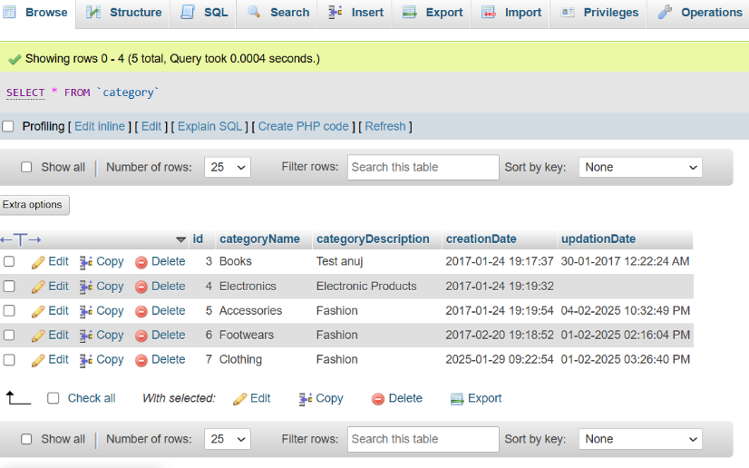

**9. API Documentation**

Authentication API:

POST /api/register

{

"name": "John Doe",

"email": "john@example.com",

"password": "securepassword"

}

Payment API (Paystack):

bash

POST /api/payment

{

"amount": 5000,

"currency": "NGN",

"payment_method": "paystack"

}

10. Payment Integration (Paystack)

1. Sign up on Paystack and get API keys.
2. Set Paystack API Key in config.php:

php

CopyEdit

define('PAYSTACK_SECRET_KEY', 'your-secret-key');

1. Process payments using Paystack API in checkout.php.
2. Handle webhooks to update order status after payment.

**11. Security Considerations**

✔ Use hashed passwords (bcrypt)  
✔ Secure database queries using prepared statements  
✔ Implement HTTPS for secure transactions

**12**. Deployment Guide

1. Upload files to a live server.
2. Set up a remote database.
3. Update config.php with live database credentials.
4. Configure Paystack for production.

**13. Troubleshooting & FAQs**

* Database connection error? Check config.php settings.
* Paystack payment issue? Ensure API keys are correct.
* Images not loading? Check file paths in assets/.

**14. Future Enhancements**

**✔ Discount coupons  
✔ Live order tracking  
✔ multi-language support**