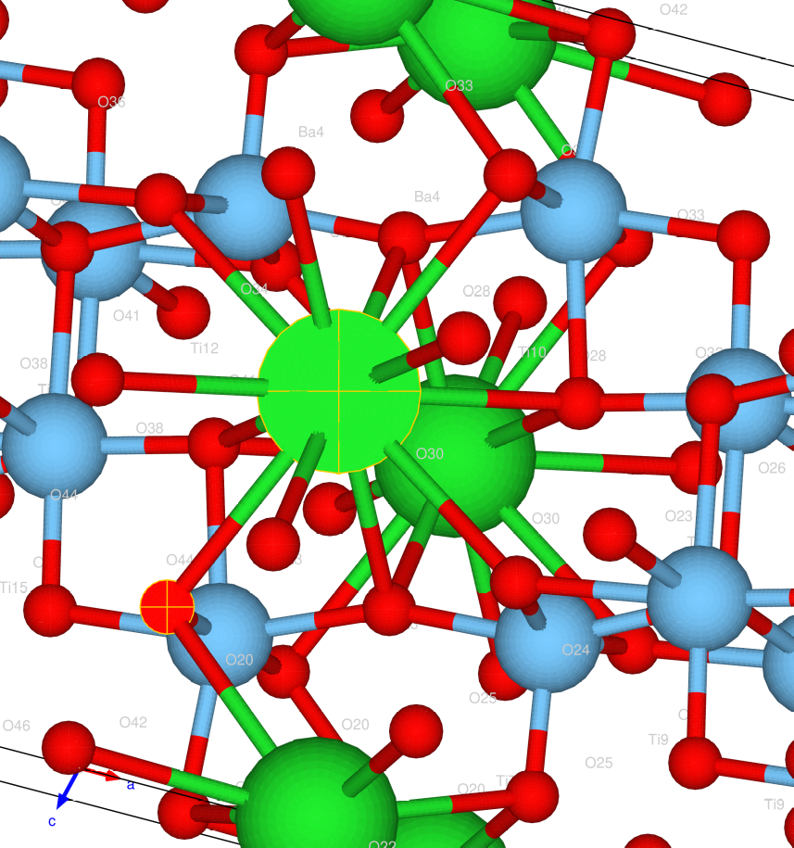
Material_id: mp-3943

computed distances: Ba 0 [2.84388 2.88486 3.02279 3.05964]

Vesta distances : Ba 02.88486, 2.84388, 3.02279, 3.05964,

===========

computed distances: Ba 1 [2.7191 2.7229 2.729 2.98682 3.00039 3.01399 3.32627]

Vesta distances : Ba 1 2.7191, 2.7229, 2.729, 2.98682, 3.00039, 3.01399, 3.3267,

===========

computed distances: Ba 2 [2.7191 2.7229 2.729 2.98682 3.00039 3.01399 3.32627]

Vesta distances : Ba 2 2.7191 , 2.7229 , 2.729 , 2.98682, 3.00039, 3.01399, 3.32627

===========

computed distances: Ti 3 [1.7373 1.8905 1.99969 2.08764]

Vesta distances : Ti 3 1.73730, 1.89050, 1.99969 , 2.08764

===========

computed distances: Ti 4 [1.7373 1.8905 1.99969 2.08764]

Vesta distances : Ti 4 1.73730, 1.89050, 1.99969, 2.08764

===========

computed distances: Ti 5 [1.82514 1.84376 2.02785 2.14168 2.20437]

Vesta distances : Ti 5 1.82514, 1.84376, 2.02785, 2.14168, 2.20437

===========

computed distances: Ti 6 [1.82514 1.84376 2.02785 2.14168 2.20437]

Vesta distances : Ti 6 1.82514, 1.84376,2.02785, 2.14168, 2.20437

===========

computed distances: Ti 7 [1.95899 1.9684 1.98338 2.0057 2.14242]

Vesta distances : Ti 7 1.95900, 1.96840 , 1.98338, 2.00570, 2.14242

===========

computed distances: Ti 8 [1.95899 1.9684 1.98338 2.0057 2.14242]

Vesta distances : Ti 8 1.95900, 1.96840 , 1.98338, 2.00570, 2.14242

===========

