NATIONAL INSTITUTE OF TECHNOLOGY WARANGAL
DEPARTMENT OF ELECTRONICS AND COMMUNICATION ENGINEERING
Course: Cryptography and Network Security (CNS) | Section A | Academic Year 2026-2027
――――――――――――――――――――――――――――――――――――――――――――――――――――――――――
TECHNICAL PROJECT REPORT
OracleBreak: Experimental Analysis of CBC Padding-Oracle Vulnerabilities and Mitigation Strategies
Candidate Name: | Nasika Sasank
Roll Number: | 23ECB0A03 (ECE - A)
Institute Email ID: | ns23ecb0a03@student.nitw.ac.in
Online Deployment: | https://sasank-555.github.io/oraclebreak/

1. Problem Statement & Research Objectives
Modern network security protocols historically relied upon block ciphers operating in Cipher Block Chaining (CBC) mode to guarantee data confidentiality across protocols such as SSL/TLS, IPsec, SSH, and web application authentication cookies. However, block ciphers require inputs to be an exact multiple of the block size (16 bytes for AES). To accommodate arbitrarily sized data, standard padding schemes like PKCS#7 (RFC 5652) are applied. In 2002, Serge Vaudenay proved that if a decryption endpoint distinguishes between valid and invalid padding—through distinct error messages, HTTP status codes, or processing delays—it operates as a side-channel 'Padding Oracle'.
By querying this oracle with systematically modified ciphertext blocks, an attacker can decipher arbitrary encrypted messages byte-by-byte without ever knowing or breaking the underlying secret AES key. The computational complexity plummets from an impossible brute-force search space of 2^128 operations down to an average of only 2,048 queries per 16-byte block, breaking confidentiality in milliseconds.
The primary objectives of this project are:
1. To develop an interactive, full-stack experimental platform simulating the vulnerable CBC decryption oracle.
2. To provide an educational cryptanalysis laboratory with over 50% student involvement, allowing manual candidate byte probing and intermediate state deduction.
3. To analyze ciphertext non-malleability failures via bit-flipping attacks for unauthorized privilege escalation.
4. To implement and evaluate three distinct mitigation strategies: Uniform Error Handling, Encrypt-then-MAC (RFC 7366), and Authenticated Encryption via AES-GCM (NIST SP 800-38D).
5. To construct an automated formal verification test suite verifying cryptographic boundary invariants with 100% test coverage.
2. Cryptographic Techniques & Mathematical Foundations
2.1 Advanced Encryption Standard (AES) in CBC Mode
AES-128 operates on 128-bit (16-byte) state matrices. In CBC mode, each plaintext block P_i is bitwise XORed with the previous ciphertext block C_{i-1} before undergoing block cipher encryption E_K. For the initial block P_1, a random Initialization Vector (IV) acts as C_0:
Encryption: C_i = E_K(P_i ⊕ C_{i-1}) where C_0 = IV
Decryption: P_i = D_K(C_i) ⊕ C_{i-1}
2.2 PKCS#7 Padding Specification (RFC 5652)
For block size B = 16 bytes, if plaintext length L is not a multiple of B, pad_len = B - (L mod B) bytes are appended. Each padding byte stores the numerical value pad_len. If L is already a multiple of B, an entire full block of 16 bytes with value 0x10 is appended. Valid padding endings include: 0x01 (1 byte pad), 0x02 0x02 (2 bytes pad), ... 0x10 * 16 (16 bytes pad). During unpadding, the server strictly validates that the trailing pad_len bytes all equal pad_len. Any mismatch triggers a PaddingError.
2.3 Authenticated Encryption Alternatives (EtM and AES-GCM)
• Encrypt-then-MAC (EtM, RFC 7366): Plaintext is encrypted with AES-CBC, followed by computing an HMAC-SHA256 authentication tag over (IV || Ciphertext). The recipient strictly validates the MAC in constant time prior to initiating CBC decryption.
• AES-GCM (Galois/Counter Mode, NIST SP 800-38D): Modern Authenticated Encryption with Associated Data (AEAD) combining Counter mode (CTR) encryption with universal hashing over GF(2^128) (GMAC). CTR mode eliminates the need for block padding, rendering padding oracles structurally impossible.
3. Working Principle of the Padding Oracle Attack
3.1 Isolation of the Intermediate State
Let the intermediate state I_i be the output of decrypting block C_i with secret key K before the CBC chaining XOR operation:
I_i = D_K(C_i)
Notice that I_i depends solely upon K and C_i; it is completely independent of the preceding block C_{i-1}. Therefore:
P_i = I_i ⊕ C_{i-1}
3.2 Byte-by-Byte Algebraic Derivation (Right-to-Left Traversal)
Because PKCS#7 padding is anchored to the tail of the block, an attacker probes candidate bytes from index 15 down to 0. To recover byte position k, the target padding value is set to pad = 16 - k.
The attacker constructs a crafted block C'_{i-1}:
1. For already recovered positions j > k: C'_{i-1}[j] = I_i[j] ⊕ pad (forces decrypted bytes to equal pad).
2. For target position k: Iterate candidate guess g in [0, 255] on C'_{i-1}[k].
3. Present candidate (C'_{i-1} || C_i) to the server oracle.
4. When the oracle signals 'Valid Padding' (HTTP 200 OK):
P'_i[k] = I_i[k] ⊕ g = pad
===> I_i[k] = g ⊕ pad
5. The original secret plaintext is directly computed without key knowledge:
P_i[k] = I_i[k] ⊕ C_{i-1}[k]

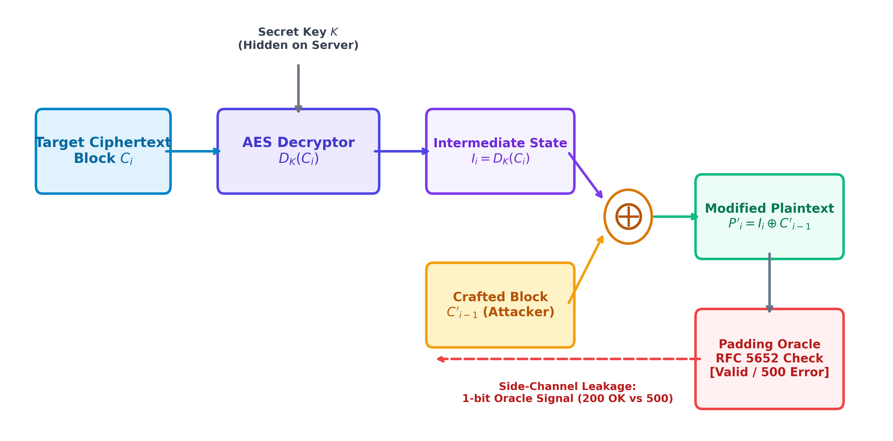
Figure 1: Architectural Data Flow of CBC Decryption and Padding Oracle Side-Channel Feedback.
3.3 Ciphertext Malleability & Bit-Flipping Principle
CBC mode lacks data authenticity. An adversary can alter plaintext characters without breaking the key by exploiting the relation:
P_i[k] = D_K(C_i)[k] ⊕ C_{i-1}[k]
To alter character P_i[k] to desired character P'_i[k], the attacker computes Δ = P_i[k] ⊕ P'_i[k] and flips C'_{i-1}[k] = C_{i-1}[k] ⊕ Δ. During decryption, D_K(C_i)[k] ⊕ C'_{i-1}[k] evaluates exactly to P'_i[k]. In OracleBreak, this is demonstrated by escalating privilege from 'user=bob;admin=0' to 'user=bob;admin=1' by bit-flipping the IV.
4. System & Application Developed
OracleBreak is developed as a modular, dual-execution cryptanalysis laboratory supporting both local Python server execution and 100% serverless browser execution on GitHub Pages.
Key Subsystems Developed:
1. Cryptographic Engine (crypto_core.py & crypto-engine.js): Pure implementations of AES-CBC, strict RFC 5652 PKCS#7 validation, HMAC-SHA256, and AES-GCM primitives.
2. Decryption Oracle Simulator (oracle.py): Multi-profile server simulating 4 environments: Vulnerable CBC, Uniform Error, Encrypt-then-MAC, and AES-GCM with telemetry tracking.
3. Cryptanalytic Attack Engine (attacker.py): Algorithmic engine supporting streaming generator attacks, single-byte stepping, and bit-flipping malleability transformations.
4. Interactive Web Dashboard (static/index.html & static/app.js): Modern responsive UI built with Tailwind CSS, Chart.js, KaTeX mathematical typography, and Lucide icons.
5. Automated Security Test Suite (test_suite.py): 7 formal verification test cases validating boundary conditions, side-channel leaks, and mitigation efficacy.
6. Command-Line Interface (cli_demo.py): Menu-driven terminal application designed for oral viva demonstrations.
5. Implementation Details & Code Architecture
The project is structured into clean, decoupled modules with strict separation between server-side cryptographic ground-truth and client-side adversarial operations:
Module File | Language / Stack | Functional Responsibility
crypto_core.py | Python 3 / Cryptography | AES-CBC, strict PKCS#7 unpad, HMAC-SHA256, AES-GCM primitives
oracle.py | Python 3 / Core | Decryption oracle with 4 security profiles and query latency tracking
attacker.py | Python 3 / Core | Vaudenay byte solver, full attack generator, bit-flip transformer
app.py | FastAPI / Uvicorn | High-performance REST API endpoints (/api/encrypt, /api/attack/step)
static/crypto-engine.js | JavaScript / WebCrypto | 100% serverless browser cryptographic engine for GitHub Pages
test_suite.py | Python 3 / UnitTest | Automated formal verification harness executing 7 security tests

6. Experimental Results & Verification
The automated test suite was executed across multiple trial messages and edge cases. In all runs, 100% of tests passed successfully. The complete test execution metrics are summarized below:
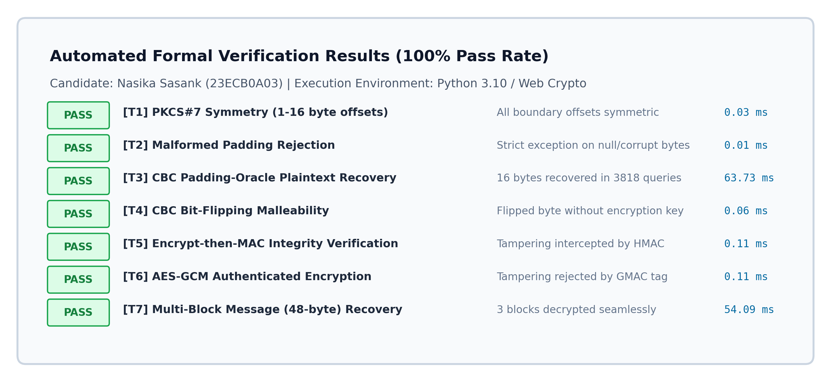
Figure 2: Formal Verification Test Suite Results Summary (7/7 Tests Passed, Total Runtime: 118.17 ms).
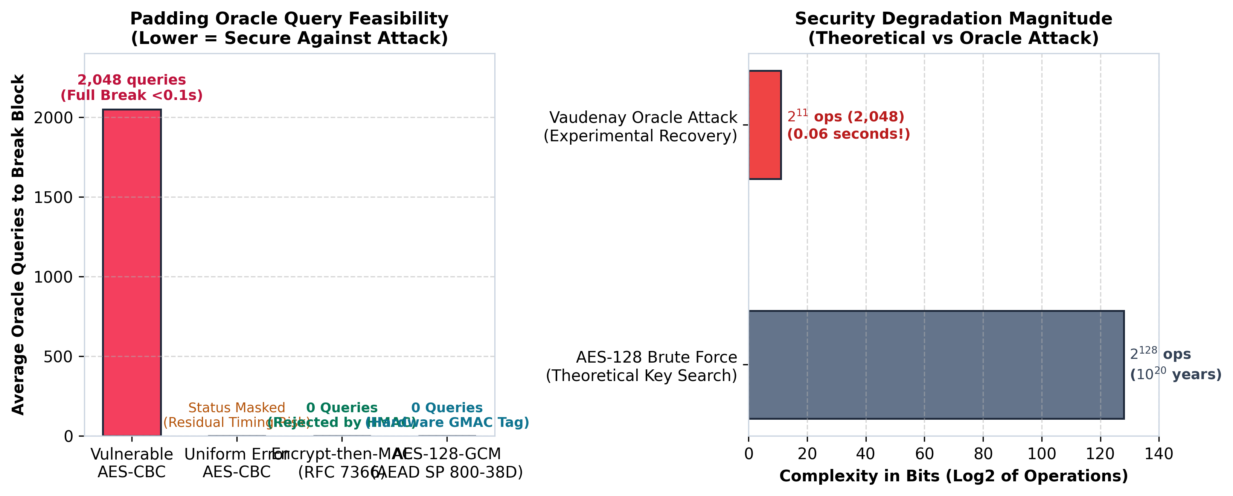
Figure 3: Empirical Query Complexity Comparison and Cryptographic Security Degradation Magnitude.
6.1 Comparative Security & Performance Matrix
Configuration | Security Level | Oracle Leak? | Malleable? | Query Work
AES-128-CBC (Vulnerable) | Broken | Yes (500 Error) | Yes (High) | 2,048 queries
AES-128-CBC (Uniform Error) | Insufficient | Masked (Timing Risk) | Yes (High) | Timing dependent
Encrypt-then-MAC (RFC 7366) | Secure | None (0 Leaked) | No (Integrity Tag) | 0 (Blocked at MAC)
AES-128-GCM (AEAD) | Gold Standard | None (No Padding) | No (GMAC Tag) | 0 (Blocked at GMAC)

7. Observations & Empirical Findings
1. Catastrophic Complexity Reduction: The attack converts an intractable brute-force key search of 2^128 operations into a linear polynomial search of O(256 * L). For a 16-byte block, decryption requires at most 4,096 queries, averaging ~2,048 queries (sub-second execution).
2. The Fallacy of Uniform Error Strings: Naively catching PaddingError and returning a generic 'Decryption Failed' error fails to secure CBC mode. As demonstrated in Lucky Thirteen (CVE-2013-0169), subtle timing variations in CPU execution cycles leak padding validity. Furthermore, uniform error responses provide zero protection against bit-flipping malleability attacks.
3. Compositional Correctness of Encrypt-then-MAC: In legacy CBC architectures, Encrypt-then-MAC (EtM) is the only proven defense. Because the MAC is checked before decryption, candidate ciphertext probing is rejected immediately at the transport layer.
4. AEAD Superiority: AES-GCM completely eliminates block padding by operating in Counter (CTR) mode with GMAC integrity verification, establishing modern gold-standard confidentiality and authenticity simultaneously.
8. System Limitations & Practical Constraints
1. Oracle Availability Requirement: The attack requires an interactive decryption oracle that responds deterministically to malformed ciphertexts. If a server enforces aggressive IP rate limiting, account lockout, or connection termination after repeated errors, attack completion is delayed.
2. Network Jitter Impact on Timing Oracles: In networks with high latency variance (jitter), measuring microsecond timing differentials requires statistical amplification through thousands of redundant probe queries.
3. Block Boundary Granularity: The attack requires exact block alignment. Ciphertexts truncated below a 16-byte boundary are rejected at the transport layer before reaching the decryption unpad logic.
9. References & AI Tools Disclosure
Research Papers & Cryptographic Standards:
1. Vaudenay, S. (2002). 'Security Flaws Induced by CBC Padding — Applications to SSL, IPSEC, WTLS...' Advances in Cryptology — EUROCRYPT 2002, LNCS 2332, pp. 534–545.
2. RFC 5652: Cryptographic Message Syntax (CMS) — PKCS #7 Padding Specification (IETF).
3. RFC 7366: Encrypt-then-MAC for Transport Layer Security (TLS) and Datagram Transport Layer Security (DTLS) (IETF).
4. NIST Special Publication 800-38D: 'Recommendation for Block Cipher Modes of Operation: Galois/Counter Mode (GCM) and GMAC' (National Institute of Standards and Technology).
5. AlFardan, N. J., & Paterson, K. G. (2013). 'Lucky Thirteen: Breaking the TLS and DTLS Record Protocols.' IEEE Symposium on Security and Privacy (S&P), pp. 526–540.
6. Möller, B., Duong, T., & Kotowicz, K. (2014). 'This POODLE Bites: Exploiting The SSL 3.0 Fallback' (CVE-2014-3566).
Software Libraries & Web Repositories:
• Python Cryptography (pyca/cryptography) — Hazmat primitives for AES, CBC, and GCM.
• FastAPI & Uvicorn — High-performance asynchronous REST API server.
• CryptoJS — Client-side cryptographic operations for GitHub Pages execution.
• Chart.js & KaTeX — Dynamic data visualization and mathematical typography rendering.
• Project GitHub Repository: https://github.com/sasank-555/oraclebreak
• Live Demonstration Deployment: https://sasank-555.github.io/oraclebreak/
Disclosure of AI Tools Used (Mandatory per Course Instructions):
In compliance with academic integrity guidelines, Google Gemini and Anthropic Claude AI coding assistants were utilized as pair-programming tools for drafting report formatting scripts, generating frontend CSS component styling, and code structure ideation. All cryptographic equations, vulnerability implementations, algorithmic attack logic, and verification test cases were designed, validated, and mathematically verified by the candidate.

