Question 1
Create a NumPy array containing the integers from 1 to 20. Perform the following operations:
1. Display the array.
2. Find the shape of the array.
3. Find the maximum and minimum values.
4. Calculate the mean and standard deviation.
5. Reshape the array into a 4 × 5 matrix.
6. Display the second row of the matrix.
7. Display the third column of the matrix.
CODE:
import numpy as np

arr = np.arange(1,21)
print("\nArray: ", arr)

print("\nShape of the array: ")
print(arr.shape)

print("\nMax value: ")
print(arr.max())

print("\nMin value:")
print(arr.min())

print("Mean: ")
print(arr.mean())

print("\nSTandard deviation: ")
print(arr.std())

matrix = arr.reshape(4,5)
print("\nMatrix: ", matrix)

print("\n2nd row of matrix: ", matrix[1])
print("\n3rd column: ", matrix[:,2])
output:
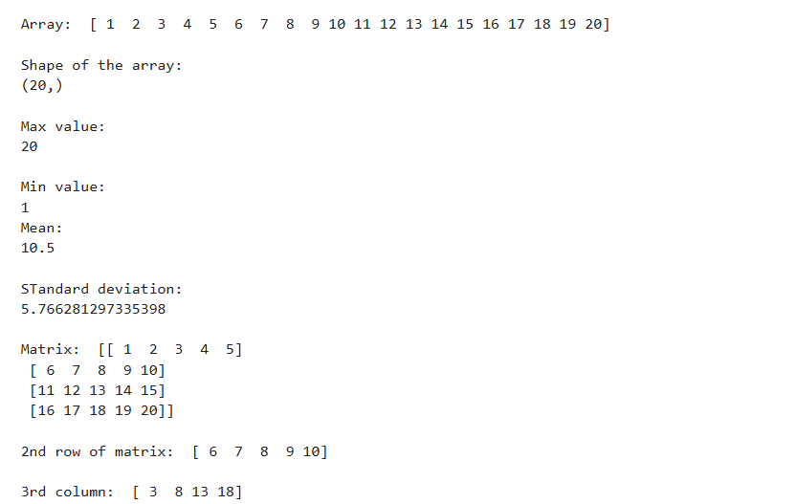

Question 2
Create two NumPy arrays:
A = [10, 20, 30, 40, 50]
B = [5, 10, 15, 20, 25]
Perform:
1. Addition of A and B.
2. Subtraction of B from A.
3. Element-wise multiplication.
4. Element-wise division.
5. Find the sum of all elements in A.
Code:
import numpy as np

A = np.array([10,20,30,40,50])
B = np.array([5,10,15,20,25])

addition = A + B
print("\nAddition: ", addition)

subtraction = A - B
print("\nSubtraction: ", subtraction)

mult = A * B
print("\nMultiplication: ", mult)

div = A / B
print("\nDivision : ", div)

sum_A = np.sum(A)
print("\nSum of A: ", sum_A)

Output:
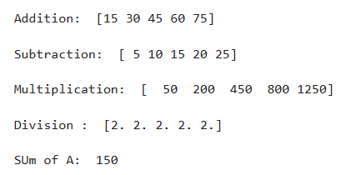

Question 3
Create a DataFrame using the following student data:
Roll No Name Marks
101 Ravi 85
102 Priya 92
103 Kiran 78
104 Anu 88
105 Sita 95
Perform the following operations:
1. Display the DataFrame.
2. Display the first three records.
3. Find the average marks.
4. Find the student with the highest marks.
5. Find the student with the lowest marks.
6. Add a new column called "Grade" using:
o A for Marks ≥ 90
o B for Marks between 80 and 89
o C for Marks < 80

CODE:
import pandas as pd

data = {
"Roll no":[101,102,103,104,105],
"NAme":["Ravi", "Priya", "Kiran", "Anu", "Sita"],
"Marks":[85,92,78,88,95]
}

df = pd.DataFrame(data)
print("\nDataframe\n", df)

print("\nFirst 3 recs: ", df.head(3))

avg_marks = df["Marks"].mean()
print("\nAverage marks: ", avg_marks)

max_mark = df["Marks"].max()
print("\nMaximum marks: ", max_mark)

min_marks = df["Marks"].min()
print("\nMinimum marks", min_marks)

def grade(Marks):
if Marks >= 90:
return "A"
elif Marks >= 80 and Marks <= 89:
return "B"
else:
return "C"
df["Grade"] = df["Marks"].apply(grade)
print(df)
Output:
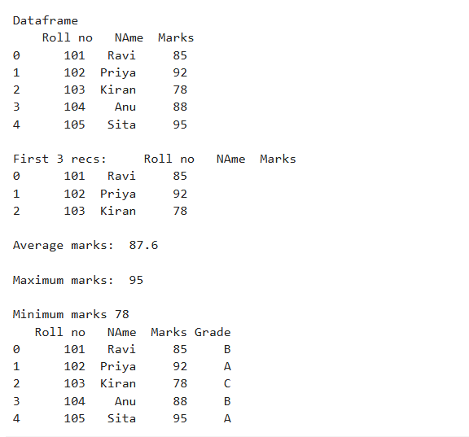

Question 4
Create a DataFrame containing the following information:

Product | Price | Quantity
Laptop | 50000 | 10
Mouse | 500 | 50
Keyboard | 1200 | 30
Monitor | 10000 | 15

Perform:
- Calculate the total value of each product using:
- Total Value = Price × Quantity
- 2. Add the Total Value column.
- 3. Find the product with the highest total value.
- 4. Calculate the overall inventory value.

CODE:
import pandas as pd

data = {
"Product":["Laptop", "Mouse", "Keyboard", "Monitor"],
"Price":[50000,500,1200,10000],
"Quantity":[10,50,30,15]
}
df = pd.DataFrame(data)
print("\nDataframe\n", df)

df["Total"] = df["Price"] * df["Quantity"]

highest_val_pdt = df.loc[df["Total"].idxmax()]
print("\nHighest value product: ", highest_val_pdt)

inventory_value = df["Total"].sum()
print("\nOverall inventory value: ", inventory_value)

OUTPUT:
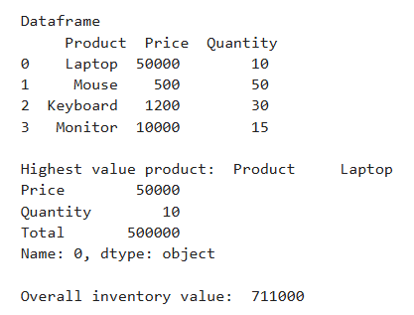
Question 5
Download the Iris dataset from Scikit-learn and perform the following:
1. Load the dataset into a Pandas DataFrame.
2. Display the first five records.
3. Find the number of rows and columns.
4. Display column names.
5. Check for missing values.
6. Generate summary statistics using describe().
7. Find the number of samples belonging to each class.

CODE:
import pandas as pd
from sklearn.datasets import load_iris

iris = load_iris()
df = pd.DataFrame(data=iris.data, columns=iris.feature_names)
df['species'] = iris.target

species_map = {i: name for i, name in enumerate(iris.target_names)}
df['species'] = df['species'].map(species_map)

print("2. First five records:")
print(df.head())
print("\n" + "="*50 + "\n")

rows, cols = df.shape
print(f"3. Number of Rows: {rows}")
print(f" Number of Columns: {cols}")
print("\n" + "="*50 + "\n")

print("4. Column names:")
print(list(df.columns))
print("\n" + "="*50 + "\n")

print("5. Missing values per column:")
print(df.isnull().sum())
print("\n" + "="*50 + "\n")

print("6. Summary statistics:")
print(df.describe())
print("\n" + "="*50 + "\n")

print("7. Number of samples per class:")
print(df['species'].value_counts())

OUTPUT:
