PRAGATI ENGINEERING COLLEGE
FINTRACK PRO
Intelligent Expense & Budget Management Software
Using Java and Advanced Data Structures
Advanced Data Structures – Mini Project
Java 17+ | Spring Boot | MySQL | HTML, CSS & JavaScript
CSE – Second Year
Presented by
TALLURI JAHNAVI
Pragati Engineering College

PROJECT DETAILS
Project Title: FinTrack Pro – Intelligent Expense & Budget Management Software Using Java and Advanced Data Structures
Project Type: Advanced Data Structures Mini Project
Primary Language: Java 17 or later
Backend: Spring Boot
Frontend: HTML5, CSS3 and JavaScript
Database: MySQL
Student: TALLURI JAHNAVI
Institution: Pragati Engineering College | CSE – Second Year

1. Introduction
FinTrack Pro is a web-based expense and budget management system designed to help students record, organize and understand their daily spending. Users can add, edit, delete, search and filter transactions, create budgets, and view spending summaries.
The project uses Java as its primary programming language and applies Advanced Data Structures to practical features. A Trie supports category autocomplete, an AVL Tree organizes transactions for efficient searching, a Segment Tree supports expense range-sum queries, and a weighted Graph represents relationships between spending categories.
The application is designed for multiple users. Each authenticated user must be able to access only their own profile, expenses, budgets and analytics.

2. Problem Statement
Students may find it difficult to maintain accurate records of daily expenses and monitor whether they are staying within a monthly budget. Searching older transactions and understanding spending patterns can also become time-consuming when records grow.
A suitable system is needed to organize expense records, support efficient searching and range calculations, visualize spending information, and protect each user's private financial data.

3. Objectives
Develop a web-based expense and budget management application using Java.
Allow users to register, sign in, sign out and manage their own accounts.
Provide operations to add, edit, delete, search and filter expense transactions.
Support monthly and category-wise budget management.
Implement Trie, AVL Tree, Segment Tree and weighted Graph manually in Java.
Connect the data structures to meaningful application features.
Display interactive visualizations to explain data structure operations.
Protect user information through authentication, authorization and user-specific data isolation.

4. Proposed System
FinTrack Pro provides a browser-based interface connected to a Java Spring Boot backend and a MySQL database. Users first create an account or sign in. After successful authentication, they can access their dashboard and manage their own expenses and budgets.
The backend validates each request and obtains the current user's identity from the authenticated security context. Transaction and budget operations are restricted to that user. MySQL acts as the permanent data store, while in-memory data structure indexes are rebuilt from stored records and synchronized when records change.
The application also includes a dedicated Advanced Data Structures Lab with visualizers for AVL Tree, Trie, Segment Tree and Graph. These visualizers should demonstrate operations performed by the actual Java implementations.

5. Concepts and Data Structures Used
AVL Tree: A self-balancing Binary Search Tree used to maintain transactions in sorted order. Each node stores height information, and rotations restore balance after insertions or deletions. A composite key such as (transaction timestamp, transaction ID) can distinguish transactions with equal timestamps.
Trie: A prefix tree used for category autocomplete. For example, entering “Fo” can suggest categories such as “Food” and “Fuel”. Its search and prefix operations depend on the length of the input string.
Segment Tree: A tree structure used to maintain daily expense totals and answer range-sum queries, such as finding the total spending from day 5 to day 15. It supports point updates when a daily total changes.
Weighted Graph: A graph in which vertices represent spending categories and weighted edges represent a documented relationship between categories. One proposed rule is to connect categories that occur in the same week, with the weight counting the number of weeks in which they co-occur. BFS and DFS can explore the category network.
Adjacency List: The graph can be stored using an adjacency list, requiring O(V + E) space for V vertices and E edges.

6. Algorithms and Operations
AVL Tree operations: insertion, deletion, search and traversal. The implementation calculates node heights and balance factors and applies LL, RR, LR or RL rotations when required. Search, insertion and deletion take O(log N) time in a balanced AVL tree; traversal takes O(N).
Trie operations: insert a category, search for a complete category and find words matching a prefix. For a string of length L, insertion and search take O(L), excluding the cost of returning all autocomplete matches.
Segment Tree operations: build the tree from daily totals, update one day's value and query a selected interval. Building takes O(N), while point updates and range-sum queries take O(log N).
Graph operations: add vertices and edges, perform BFS and DFS, and identify connected components. BFS and DFS take O(V + E) time using an adjacency-list representation.

7. System Workflow
- The user opens the FinTrack Pro website.
- The user registers or signs in using the authentication page.
- Spring Security authenticates the user and establishes an application session.
- The user adds, edits, deletes or searches expense transactions.
- The Java service layer validates the request and checks ownership.
- MySQL stores the permanent transaction and budget records.
- The relevant user-specific Trie, AVL Tree, Segment Tree or Graph index is updated.
- The dashboard displays summaries, charts and query results.
- On logout, the application invalidates the session.

8. Sample Input and Output
Example expense entries (illustrative):
- Expense 1: Food – ₹150 – 08 November 2026
- Expense 2: Transport – ₹60 – 08 November 2026
- Expense 3: Books – ₹450 – 09 November 2026
Example monthly budget: ₹10,000
Example total spending: ₹660
Example remaining budget: ₹9,340
Example usage: 6.6%
Trie example: Prefix “Fo” may return “Food”.
Segment Tree example: A query over the two listed days returns ₹660, assuming these are the only recorded expenses in that interval.
Note: These are illustrative examples, not measured results from a completed application.

9. Complexity Analysis
AVL Tree: Search, insertion and deletion are O(log N) when the tree remains balanced; a full traversal is O(N).
Trie: Insert and exact search are O(L), where L is the category string length. Autocomplete also depends on the number and total length of returned suggestions.
Segment Tree: Build is O(N), point update is O(log N), and range-sum query is O(log N).
Weighted Graph: Adjacency-list storage is O(V + E). BFS and DFS are O(V + E).
Here, N is the number of transactions or daily values, L is the length of a category string, V is the number of category vertices and E is the number of graph edges.

10. Testing
Authentication tests: successful registration, duplicate email rejection, valid and invalid login, logout, session expiration and protected-page access.
Privacy tests: verify that Student A cannot read, edit or delete Student B's transactions by changing an ID or request parameter.
AVL Tree tests: insertion, deletion, searching, all four rotation cases, traversal and balance-factor validation.
Trie tests: insertion, exact search, prefix search and autocomplete.
Segment Tree tests: tree construction, point update and range-sum query against manually calculated totals.
Graph tests: vertex and edge creation, BFS, DFS and connected-component detection.
Note: Test status should be marked Pass only after the corresponding test has been executed and its result recorded.

11. Limitations
The application requires a configured Java backend and MySQL database.
Email verification and password reset require a configured email service.
Google Sign-In requires valid OAuth credentials and correct redirect configuration.
Data structure indexes are in-memory and must be rebuilt from the database after application restart.
Graph relationships depend on the chosen definition of category co-occurrence.
Charts and analytics are only as accurate as the transaction data entered by users.
Automatic bank or UPI transaction imports are not included unless a real authorized integration is developed.

12. Conclusion and Future Enhancements
FinTrack Pro combines practical expense management with the implementation of Advanced Data Structures in Java. It demonstrates how Trie, AVL Tree, Segment Tree and weighted Graph structures can support category search, transaction organization, range calculations and relationship analysis.
The project also emphasizes secure authentication and the separation of each user's private records. The interactive visualizers are intended to help students understand how the structures operate.
Future enhancements may include downloadable PDF or Excel reports, advanced financial insights, optional authorized bank integrations, improved analytics, and additional graph-based spending analysis.

References
Oracle Java Documentation: https://docs.oracle.com/en/java/
Spring Boot Documentation: https://docs.spring.io/spring-boot/
Spring Security Documentation: https://docs.spring.io/spring-security/reference/
MySQL Documentation: https://dev.mysql.com/doc/
Chart.js Documentation: https://www.chartjs.org/docs/
Data structure and algorithm concepts: https://www.geeksforgeeks.org/data-structures/

Feature-to-Data-Structure Mapping
Data Structure | Application Use | Main Operations
AVL Tree | Transaction ordering and date-based searching | Insert, delete, search, traversal, rotations
Trie | Expense category autocomplete | Insert, exact search, prefix search
Segment Tree | Daily expense range totals | Build, update, range query
Weighted Graph | Relationships between spending categories | BFS, DFS, connected components

13. System Flowchart
The flowchart below shows the main application sequence, from user login through expense and budget operations, Advanced Data Structure processing, database access and logout.
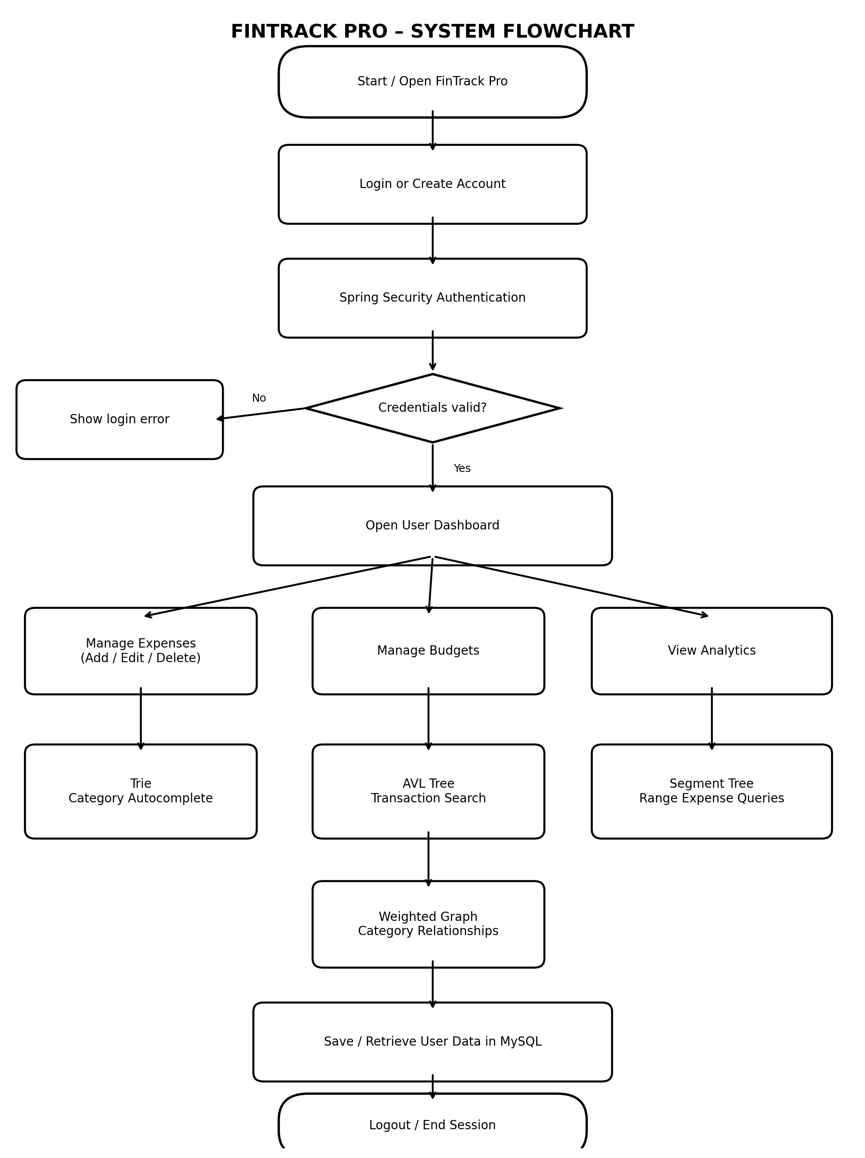
Figure 1: FinTrack Pro system flowchart

