SMART CITY ROUTE OPTIMIZATION SYSTEM
Advanced Data Structures and Algorithm Analysis – Mini Project
C++17 | Pragati Engineering College | CSE – Second Year
Team Members: Sasank , Venkatesh, Jhanavi ,mallikarjun
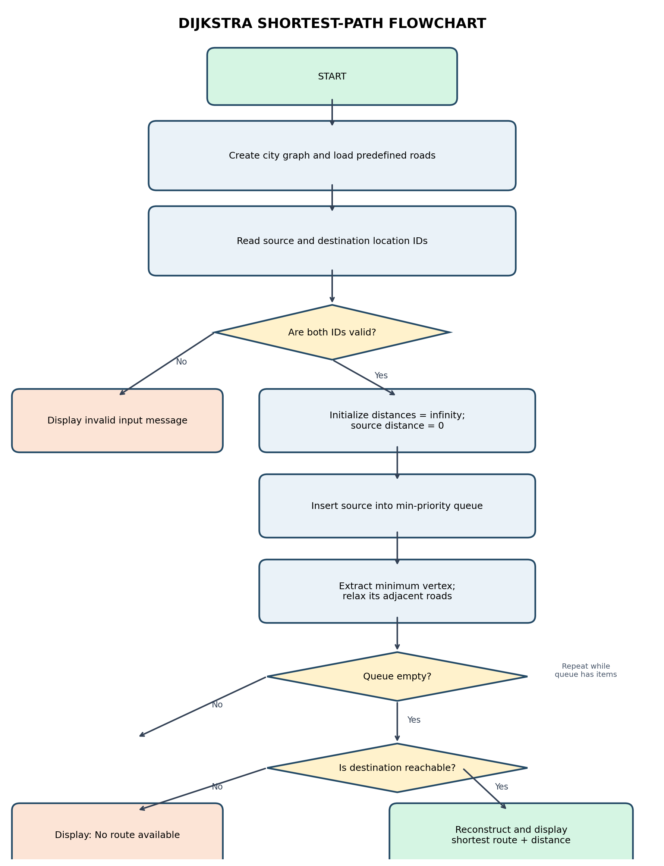

1. Introduction
The Smart City Route Optimization System is a simple C++ application that models a city road network as a weighted, undirected graph. Each location is represented by a vertex and each road by an edge whose weight represents distance. The system uses Dijkstra's shortest-path algorithm to identify a minimum-distance route between a source and destination.

2. Problem Statement
As the number of locations and connecting roads increases, manually identifying the shortest route becomes difficult. This project demonstrates how graph data structures and shortest-path algorithms can solve this problem efficiently.

3. Objectives
- Represent city locations and roads using a weighted graph.
- Store connections using an adjacency list.
- Find the shortest route between two selected locations.
- Display the route and total distance.
- Validate input and identify unreachable destinations.
- Provide a foundation for future web-based route visualization.

4. Proposed System
The program loads a predefined sample city containing six locations. The user enters source and destination IDs. Dijkstra's algorithm processes the graph using a min-priority queue. A distance array stores the best-known distance to each vertex, while a parent array stores the predecessor needed to reconstruct the final route.

5. Concepts and Data Structures Used
- Weighted undirected graph: models locations and roads with distances.
- Adjacency list: stores only the existing edges, using O(V + E) graph space.
- Min-priority queue: selects the unprocessed vertex with the smallest tentative distance.
- Distance array: stores shortest known distances from the source.
- Parent array: reconstructs the shortest route after the algorithm finishes.

6. Algorithm
ALGORITHM: DIJKSTRA'S SHORTEST PATH
Input:
A weighted, undirected graph G(V, E), source vertex s, destination vertex t.
Every road distance must be positive.
Output:
Shortest route from s to t and its total distance, or a no-route message.
Steps:
1. Create a distance array and initialize every distance to infinity.
2. Set distance[source] = 0.
3. Insert (0, source) into a min-priority queue.
4. While the priority queue is not empty:
a. Remove the vertex u having the smallest tentative distance.
b. If the removed distance is outdated, skip it.
c. For every adjacent vertex v connected by an edge of weight w:
i. If distance[u] + w < distance[v]:
- Update distance[v].
- Set parent[v] = u.
- Insert (distance[v], v) into the priority queue.
5. If destination distance is infinity, report that no route exists.
6. Otherwise, follow parent pointers from destination to source.
7. Reverse the collected sequence and display the route and distance.
Time Complexity:
O((V + E) log V), using an adjacency list and binary min-heap.
Space Complexity:
O(V + E), including graph storage and auxiliary arrays.

7. Algorithm Flowchart

8. Sample Input and Output
Sample input: source ID = 0 (College); destination ID = 3 (Government Hospital).
Expected output: College → Bus Stand → Government Hospital; total distance = 13 km.
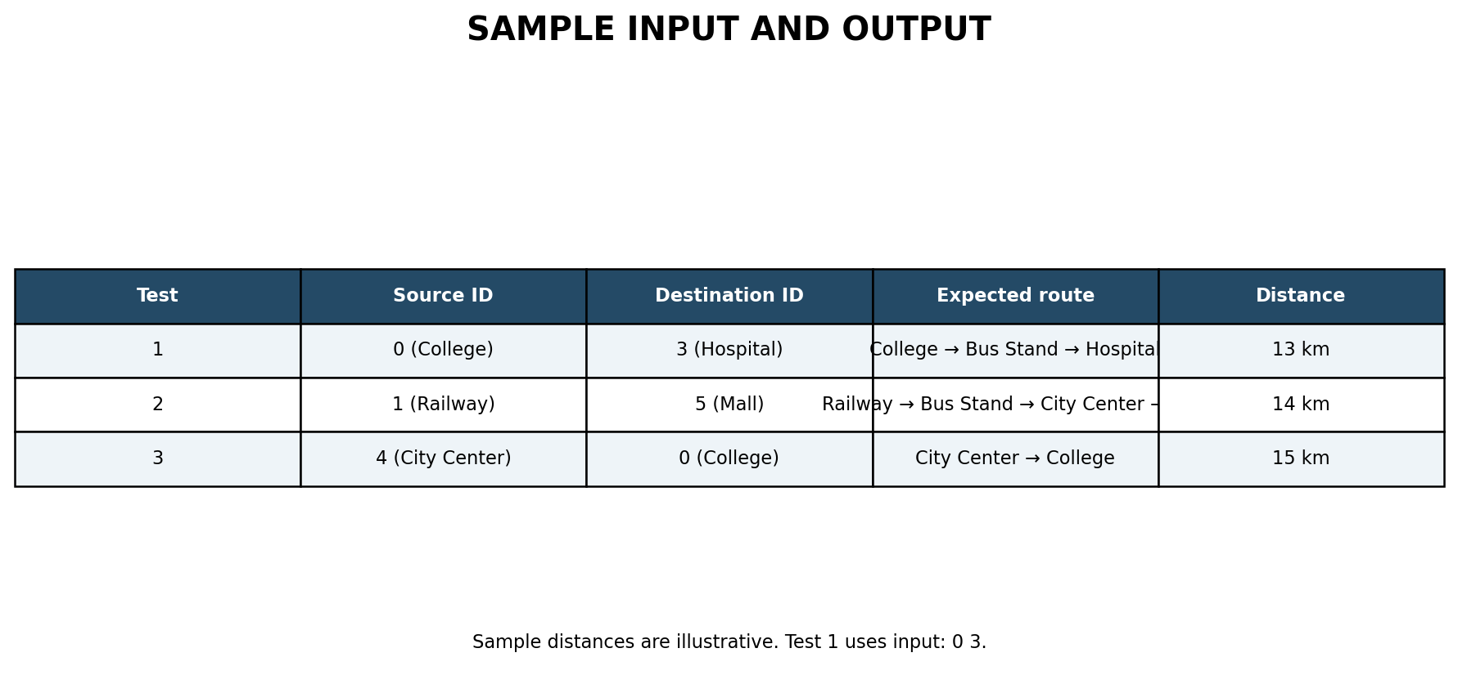

9. Complexity Analysis
Time Complexity: O((V + E) log V), using an adjacency list and binary min-heap.
Space Complexity: O(V + E), including graph storage and auxiliary arrays.
Here, V is the number of locations (vertices) and E is the number of roads (edges).

10. Testing
Test | Input | Expected result | Status
1 | 0 → 3 | College → Bus Stand → Hospital; 13 km | To verify
2 | 1 → 5 | Railway → Bus Stand → City Center → Mall; 14 km | To verify
3 | 4 → 0 | City Center → College; 15 km | To verify
4 | Invalid ID | Error message | To verify
Note: The listed values are expected results from the sample graph. Run the program and verify them on your development machine.

11. Limitations
- The current version uses a fixed sample city map.
- Road distances are illustrative, not live geographic measurements.
- Dijkstra's algorithm assumes non-negative edge weights.
- Live traffic, GPS tracking and real-time road conditions are not included.

12. Conclusion and Future Enhancements
The project demonstrates how a weighted graph, adjacency list and min-priority queue can be used to solve a shortest-route problem. Future enhancements include adding and deleting locations and roads, simulating road closures, implementing BFS, DFS and Prim's algorithm, saving data in a database, and building a web interface with a C++ REST API and interactive map.

References
- C++ reference: https://en.cppreference.com/
- Dijkstra's algorithm: https://en.wikipedia.org/wiki/Dijkstra%27s_algorithm
- C++ Standard Library priority_queue documentation: https://en.cppreference.com/w/cpp/container/priority_queue

