Implement a RESTFul API spring-boot application that provides the following APIs:

• API to upload a file with a few meta-data fields. Persist meta-data in persistence store (In memory DB or file system and store the content on a file system)

• API to get file meta-data

• API to download content stream (Optional)

• API to search for file IDs with a search criterion (Optional)

• Write a scheduler in the same app to poll for new items in the last hour and send an email (Optional)

1. To start off with, I have used the H2 in memory database for this codingChallenge/project. Below is the screenshot for the application.properties file.

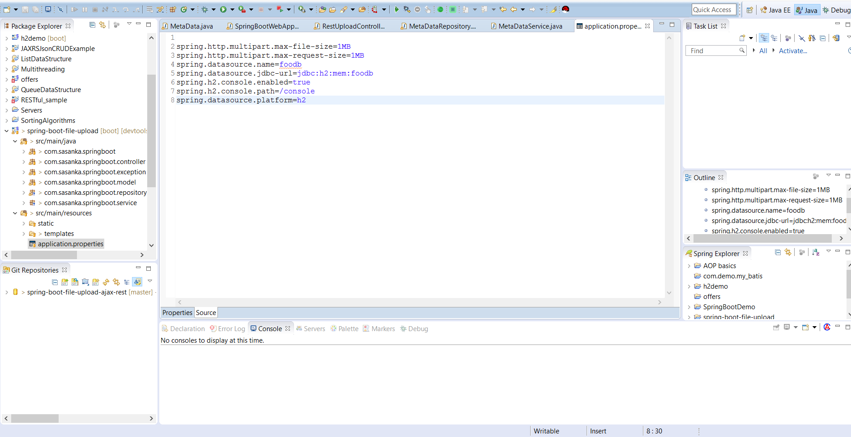

1. When the spring boot application is started up, the tomcat runs on default port:8080 and the landing page comes up like so,3

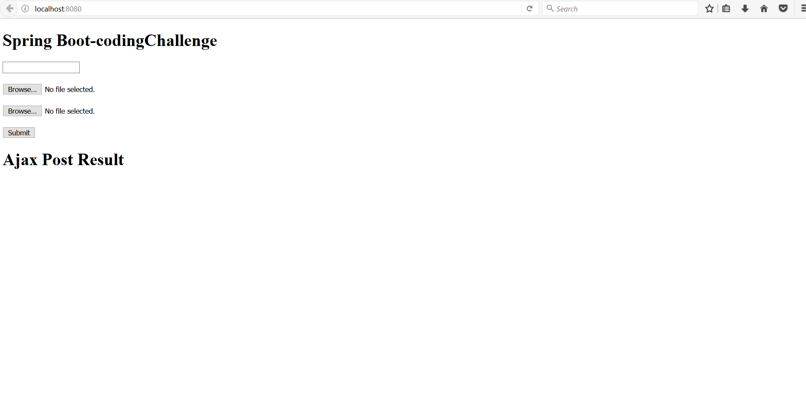

1. Since the question was generic, I decided to choose .txt files and the files were in JSON format for easier development to achieve the said requested goals. Once the file is uploaded the post upload message is shown as follows:

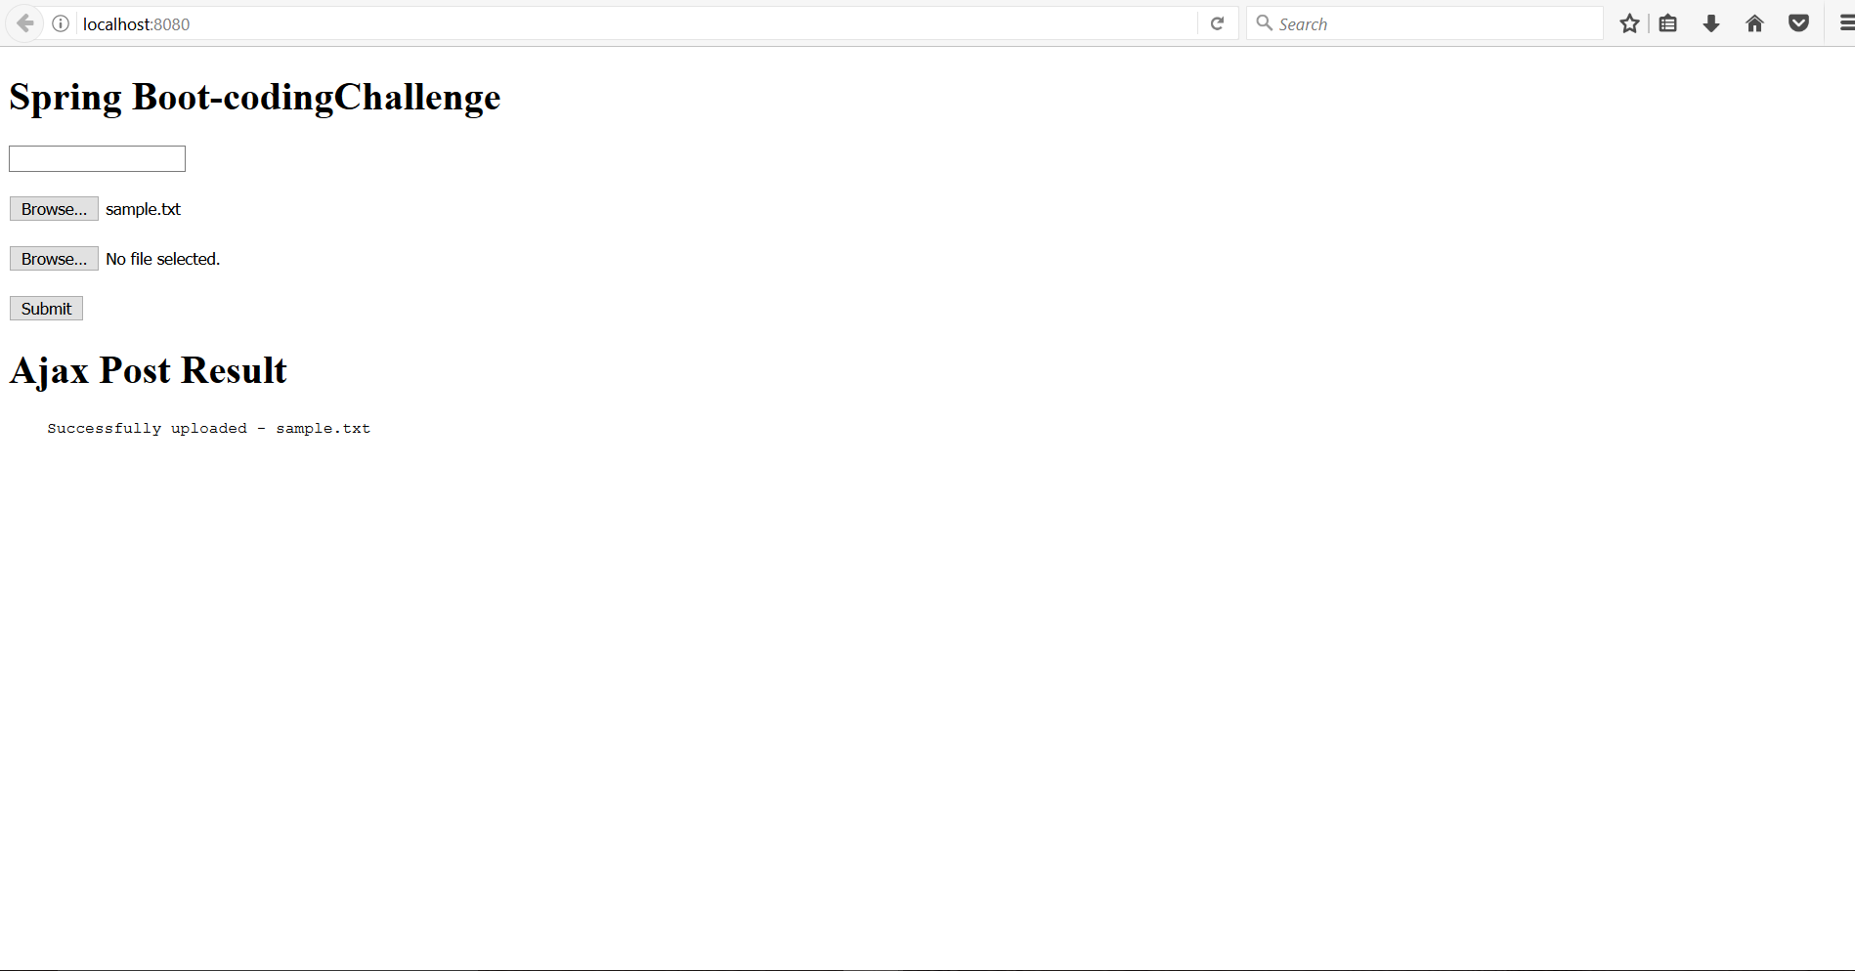

1. After the upload into the system, it is temporarily stored in the File System. I have stored it in a folder in the F:// drive. The in-memory database also gets affected and we can see the results being uploaded into the database. We can access the database through <http://localhost:8080/console> and clicking on connect with the correct jdbc-url for that check the properties file:

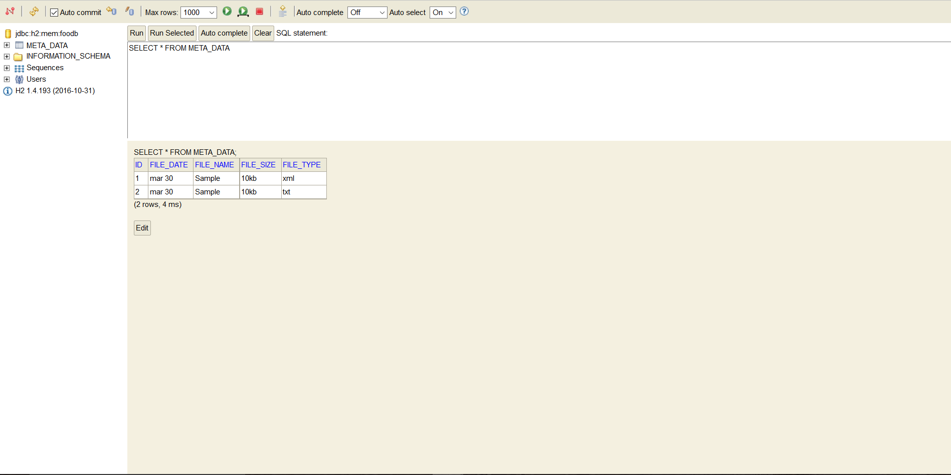

1. Now we go into postman to see the api in action: Notice the api links on the URL bar on the

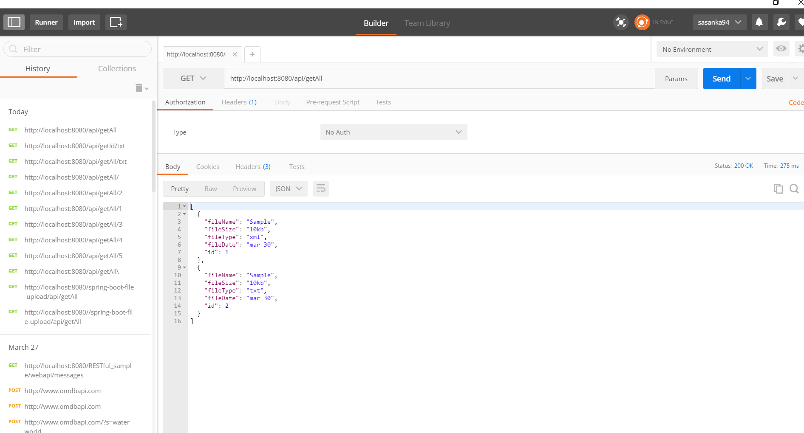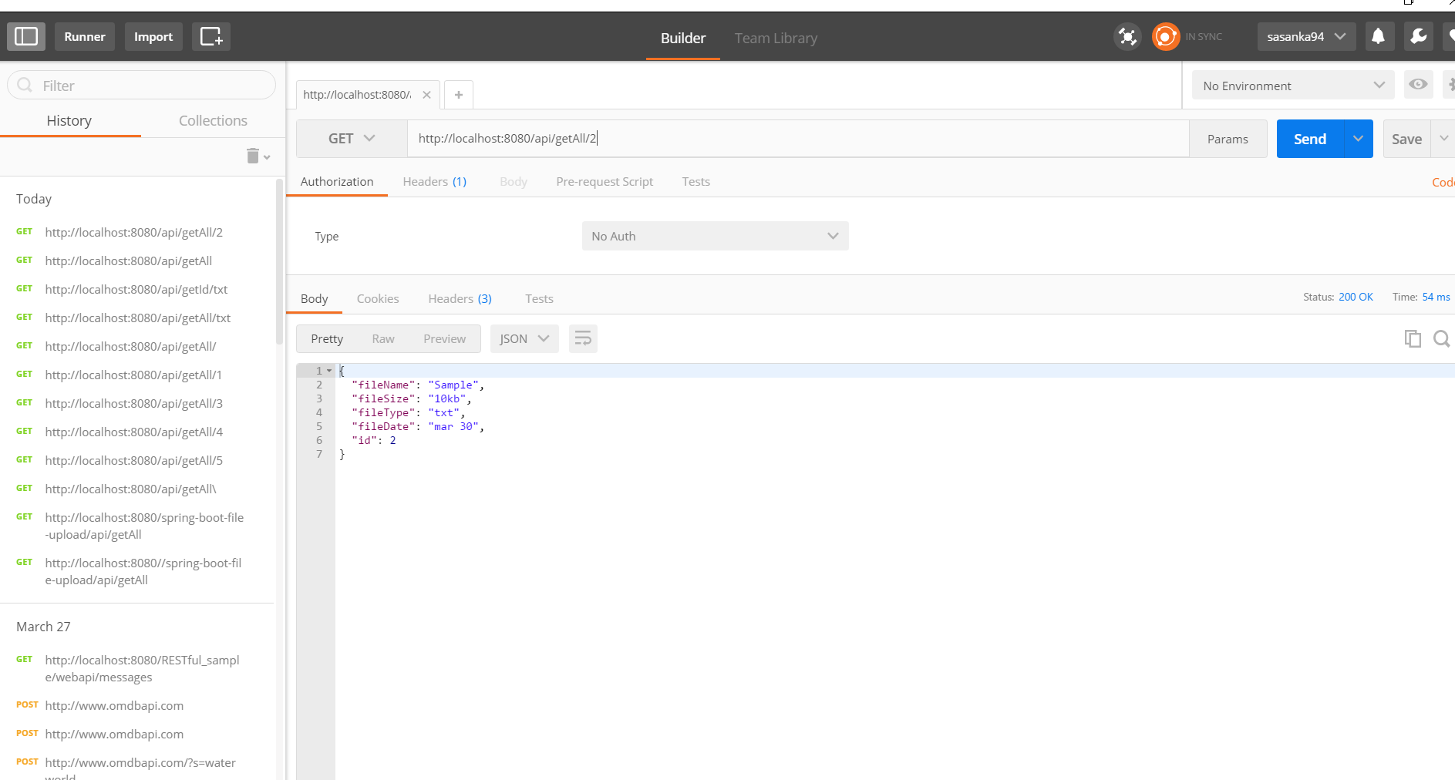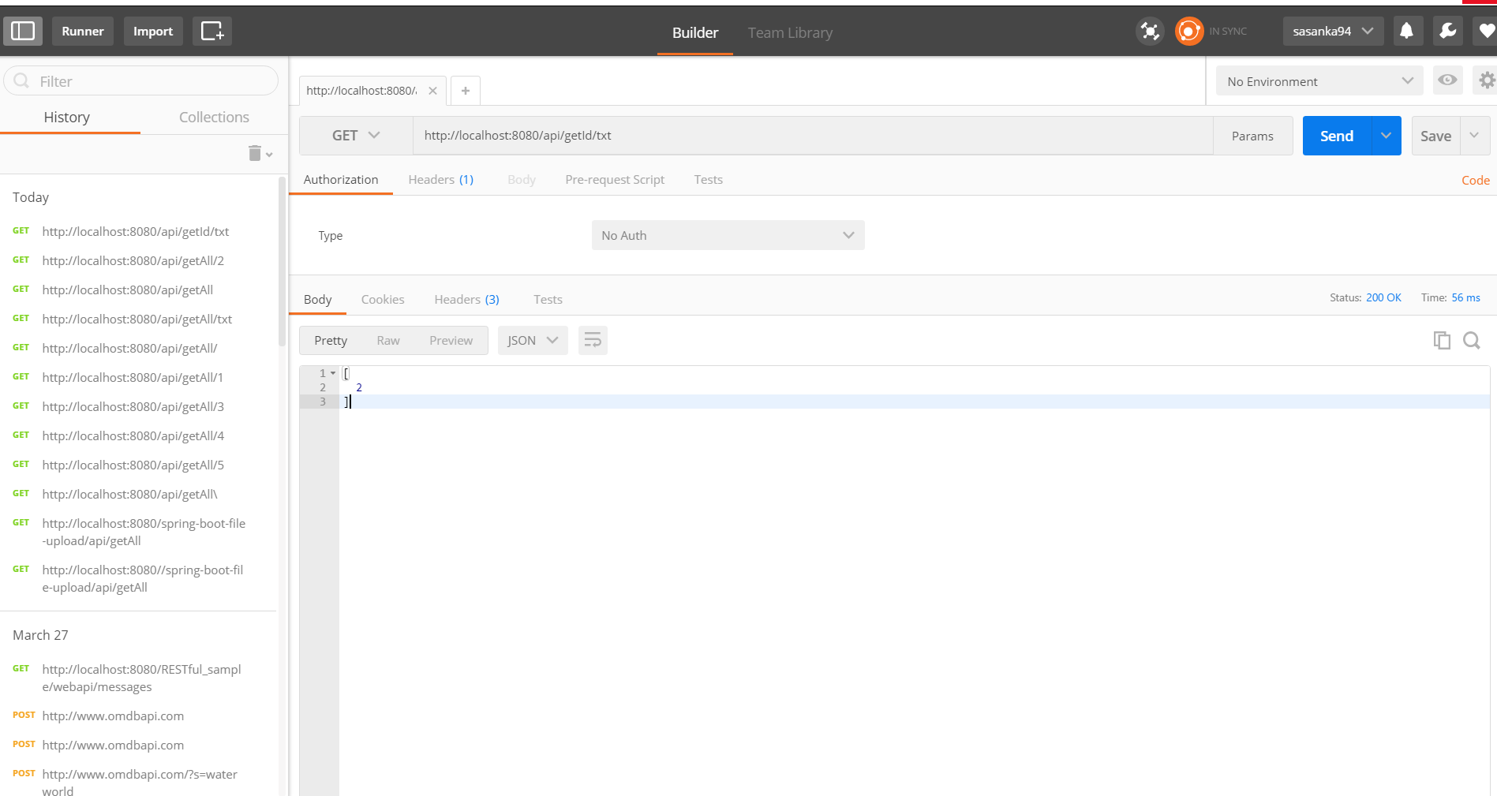

1. The api links are:

* /api/upload
* /api/upload/multi
* /api/upload/multi/model
* /api/getAll
* /api/getAll/{id}
* /api/getId/{name} (name criteria for fetching the file Id)

1. The MetaDataService class has the final destination of the file that is being uploaded and the a file size restriction has been placed and regular validation are done and Exception to an extent are handled with a custom mapper. The project also has a front end and the rest api will also send out error messages in a readable format.