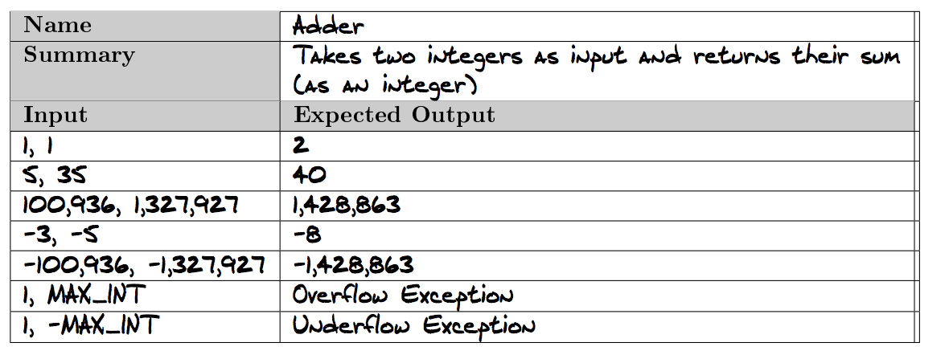

I would reject the test spec as the last test case is ambiguous from the last but one. If the function was expected to handle numbers within [-MAX_INT to MAX_INT] then 1, -MAX_INT shouldn’t be an Underflow exception but -1, -MAX_INT is expected to.