Comment out code in the play book is used here to provide better formatting.

The code and the output is provided here.

DISK USAGE:

LINUX- ansible all -m ansible.builtin.shell -a "df -h"

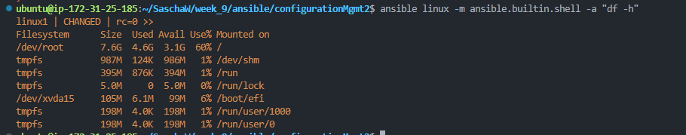

Windows- ansible windows -m win_command -a 'powershell "Get-WmiObject -Class Win32_LogicalDisk | Select-Object DeviceID, FreeSpace, Size"'  
  
or ansible windows -m win_shell -a "Get-PSDrive C"

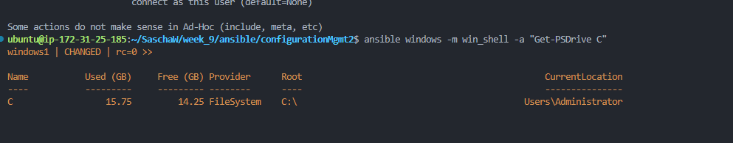

Windows TASK LIST – ansible windows – m win_shell -a “tasklist”

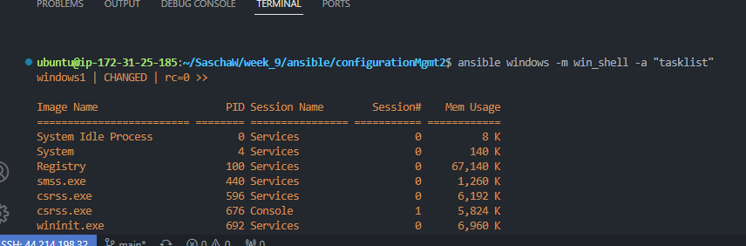

Windows shell -ansible windows -m win_shell -a "Get-Host"

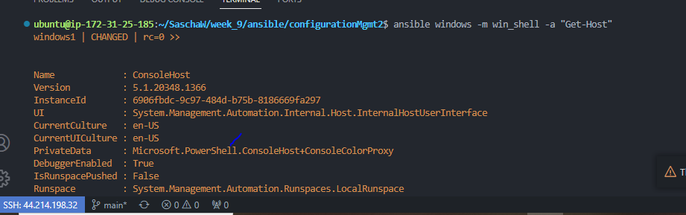

Ls -l root partition- ansible linux -m ansible.builtin.shell -a "ls -l /"

