**OpenPGP**

Since I use Windows 10 as an operating system, I had to install a software for creating a PGP key pair. The software that I used in this case was GPG4Win, which is an open source privacy and encryption software[1]. After installing the software, I could create a new keypair with the GPG4Win GUI Kleopatra, by opening the assistant for creating a new keypair. I chose RSA 2048 Bit encryption and set an expiration date on the 04.01.2019 (see fig. 1).

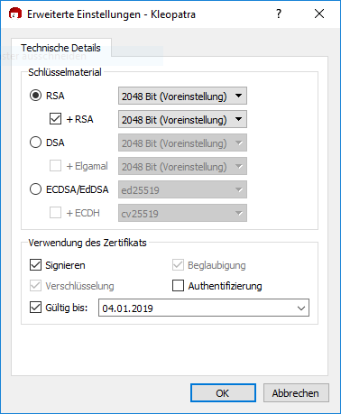

Figure 1 Settings for OpenPGP key generation

To create a revocation certificate, the generated Key has to be right-clicked in the Kleopatra key list and “details” should be selected. There, the option “Sperrzertifikat erstellen” (create revocation) needs to be clicked, and the passphrase for the key has to be entered.

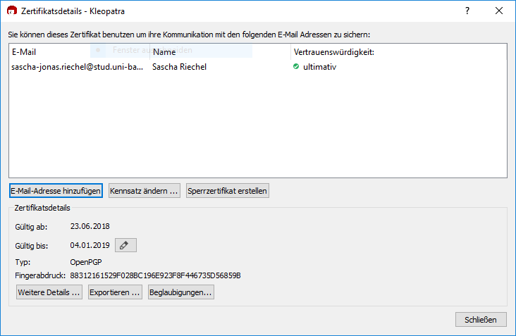

**S/MIME**

To get a certificate from the computer center, the following manual has to be followed:

<https://www.uni-bamberg.de/fileadmin/rz/zertifizierung/Outlook_zertifikat_importieren.pdf>

In short, a form has to be filled out and handed in to the computer center with a personal id card.

1. https://www.gpg4win.org/