# Exploring Universal Studios’ Amusement Park Wait Times with SAS Visual Analytics

## Description

This use case walks through a basic visualization task within SAS Visual Analytics. Participants will explore the *Universal Studios Wait Time* dataset to analyze data about the amusement park, such as attractions, temperature, precipitation, and wait times. To complete the task, hackers will be asked a series of questions about their findings.

## Objectives

* Load the **WAITING_TIMES** datasets into a SAS Visual Analytics report.
* Explore the variables and trends with point-and-click visualization tools.

## Step-by-step instructions

* Log into SAS Viya.
* Navigate to **Explore and Visualize** (SAS Visual Analytics) within the Application Menu.
* Start a **New report**.

* Add the *WAITING_TIMES* dataset to the report.

* Notice that the variables available in the **Data pane** are grouped into two main sections: **Category** and **Measure**. Take a moment to familiarize yourself with the variables available.

**QUESTION 1: How many attractions are listed in the data?**

* Many of the variables are far from perfect. To change the name of a variable to make them a bit more useful, click the **Edit properties** drop down arrows next to the variable name.

* Expand the properties for categorical, datetime, and measure variables – and notice that they have different options for what can be changed.
* For a better visualization, change the **Format** of “Datetime when the waittime was retrieved” to **Date**.

* **Measure** variables have a default aggregation of Sum, which is sometimes helpful… and sometimes leaves us with absurd numbers. Don’t believe me? Select “The main weather condition” and “Humidity in % from 0 to 100” from the **Data** pane and drag the two variables onto the page.

* You’ll get a popup saying “+Auto chart” before you drop.

* And your visualization will look something like the following. I told you it was crazy numbers!

* Take some time adjusting variable names and formats, as well as changing aggregations to **Average** for all **Measure** variables except *Frequency*. Fun fact: You can do this in one swoop by selecting all the variables and right-clicking, like so:

* Note that changing variable names might create discrepancies in further instructions and screenshots.

**QUESTION 2: Looking back at your bar chart for “Humidity in % from 0 to 100 by the main weather condition,” which weather condition has the highest humidity percent?**

* Let’s get down to exploring through visualizations!
* Drag-and-drop your *date* variable along with *Temperature* and *Current waiting time* *in minutes* variables onto the canvas.

* What do you see?

**QUESTION 3: Do you notice a particular trend between temperature and wait times?**

* Time to finish strong with one more visualization – a bubble plot! This will allow us to see several dimensions of data. You ready?
* From the **Objects** pane on the left sidebar, right click the **Bubble plot** object and select **Add to new page**.

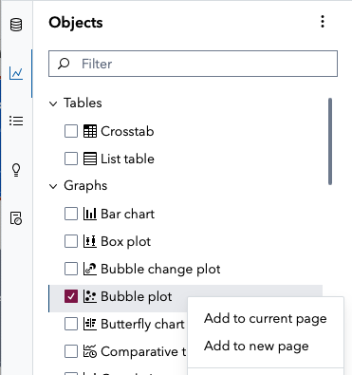

* You’ve added the bubble plot to your canvas, but you need to tell SAS which variables to use. Assign the following:
  1. X axis: Probability of precipitation
  2. Y axis: Temperature
  3. Size: Current Wait Time in minutes
  4. Group: Main Weather Condition
  5. Animation: Datetime when the waittime was retrieved

* You can now see snapshots of wait times by the temperature and precipitation, grouped by weather conditions – AND you can step throughout time to see how it changes.

**QUESTION 4: Find the snapshot for Monday, March 24, 2025. What were the weather conditions on that day, and which had the longer waittime?**