High Level Design
  - Design Goals
-Evaluate passwords using entropy, pattern rules, and a breach database simultaneously.
-Incorporate personal context (name, date of birth, city, username,ext) to catch personalised weak passwords.
-Getting available information available by using OAuth2 (Google / Facebook) to pre-fill context.
-Provide clear, actionable, educational feedback.
-Verify that they remember the password .
-Run entirely in the browser (no plaintext password leaves the client).

1.2 Scope
This HLD covers the front-end application, the analysis engine running inside the browser, integration points with, hopefully, external services (Google OAuth2, HIBP API),.

2. System Overview

The system is a single-page web application (SPA). All sensitive computations (hashing, pattern matching, context comparison) happen client-side. The only network calls are to the OAuth2 provider (to load user context).
2.1 High-Level Architecture

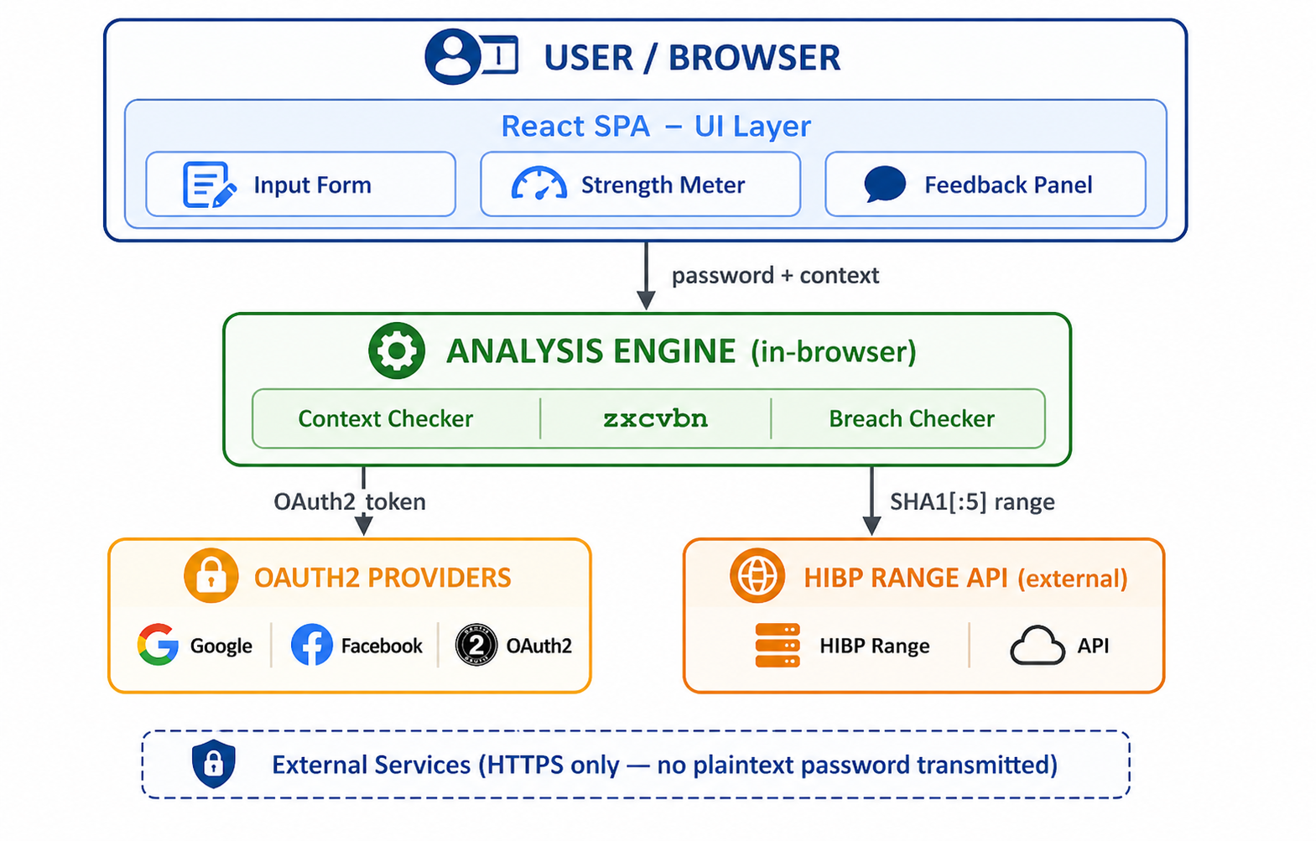

3. Component Descriptions

The system is divided into three layers: the Interface, the Analysis Engine, and External apps. Each is described below.
3.1Interface

Component | Responsibility
Input Form | Collects the password to evaluate, plus optional personal fields (first name, last name, date of birth, city, username). If OAuth2 succeeds, these fields are pre-filled automatically.
OAuth2 Button | Google or Facebook sign-in flow. On success, the returned ID token is decoded client-side to extract display name, email, and birth year (if available in the profile scope). No token is stored beyond the session.
Strength Meter | A visual bar (0–4 scale) updated in real time as the user types. Colour transitions: red (0–1) → orange (2) → yellow (3) → green (4). Also shows a crack-time estimate derived from zxcvbn.
Feedback Panel | Displays of every improvement possible: which pattern was detected, what personal data was found in the password, and whether the password appeared in a breach. Each item links to a suggested fix.
Confirmation Step | Only shown when all checks pass (score = 4). The user must retype the password from memory. A mismatch returns them to the input step with an encouragement message. A match triggers the final Approved state.

3.2 Analysis Engine (Client-Side)

Module | Logic
Personal Context Checker | Receives the user's personal fields and converts them into a list (e.g. first name, last name, birth year, city initials). The password is tested against every item exact match, substring and only need 90% match. Any hit lowers the score and generates a specific feedback message.
zxcvbn Wrapper | Calls the zxcvbn library with the password and injects the personal info into its user inputs parameter to extend its dictionary. Returns the raw score (0–4), crack-time estimates (online throttled, offline fast hash), and a list of matched patterns for display.
Breach Checker | Implements k-anonymity hashes the password with SHA-1 (using the Web Crypto API), sends only the first 5 hex characters to api.pwnedpasswords.com/range/{prefix}, then compares the remaining suffix against the returned list locally. Returns breach count or 0.
Passphrase Detector | Checks whether the password looks like a passphrase (3+ dictionary words separated by spaces, hyphens, or underscores). If it qualifies, applies a passphrase bonus. Also suggests passphrase adoption when the input is short and complex.
Score Aggregator | Combines results from all four modules. The final score is the minimum of the zxcvbn score and a penalty-adjusted score. Penalties: -2 for any personal context hit; -2 for a breach count > 0; -1 for passphrase miss opportunity. Score 4 required to reach the Confirmation Step.

3.3 External apps

Service | Purpose | Privacy Guarantee
Google OAuth2 | Loads user profile (name, email, DOB scope if granted) to pre-fill the personal context form. | Info decoded locally via jose/jwt-decode. Only requested scopes: profile, email, openid.
Facebook Login | Alternative OAuth2 provider for users without Google accounts. Same scopes. | Same client-side decode approach.
HIBP Range API | Returns all SHA-1 hash suffixes that share the sent 5-char prefix — used to check if the password was in a known data breach. | Only the first 5 of 40 hex characters are sent. The plaintext password never leaves the browser.
4. Data & Message Flows

4.1 Normal Evaluation Flow
The sequence below describes what happens from the moment the user starts typing until the system shows a result.
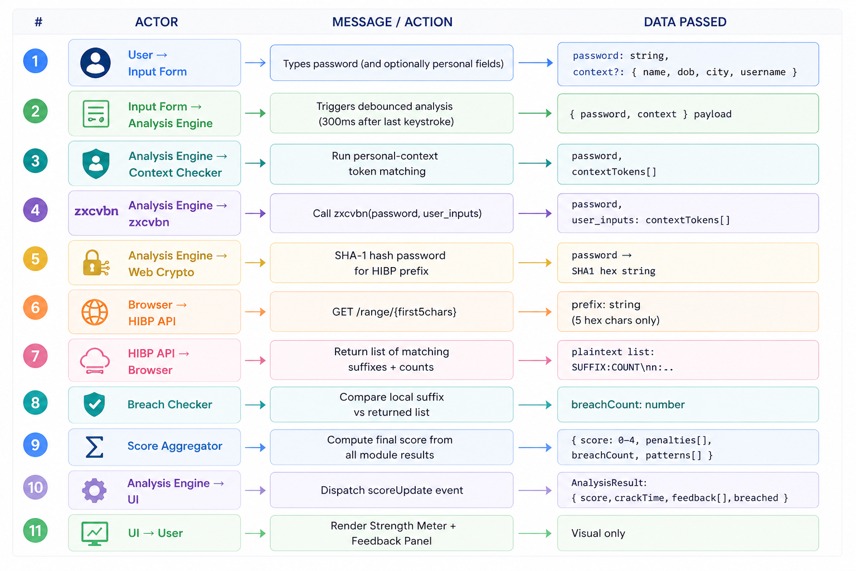

4.2 OAuth2 Flow (Google)
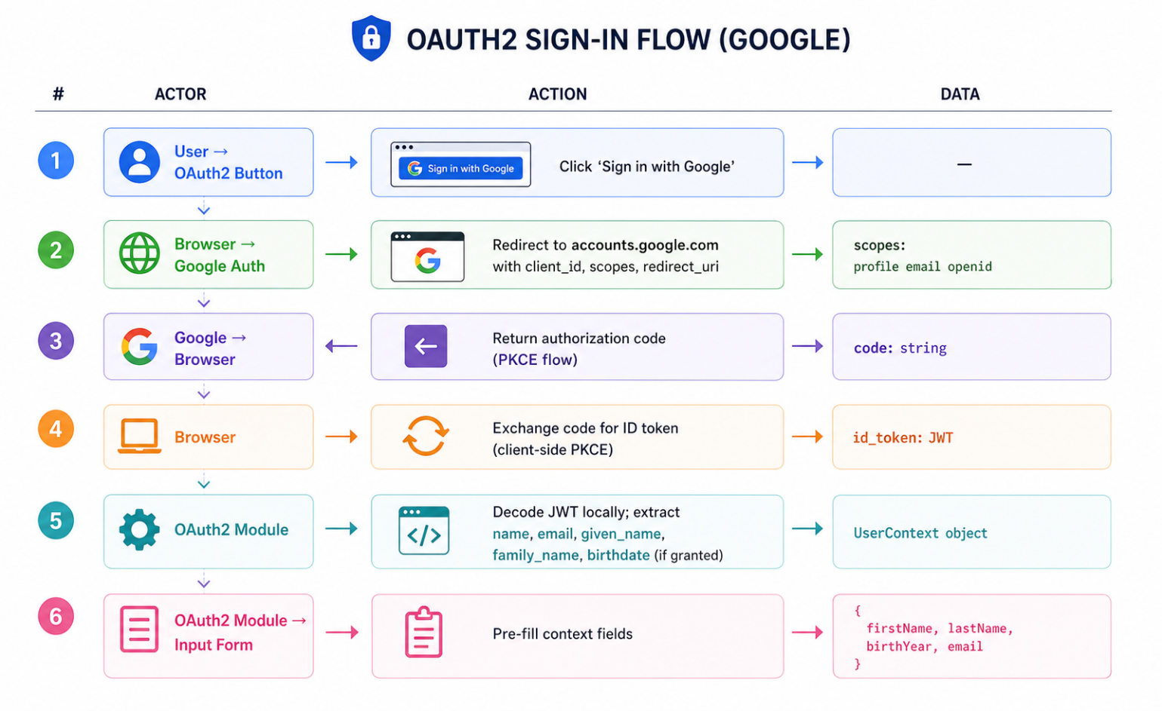

4.3 HIBP k-Anonymity Flow

Step | Client (Browser) | Server (HIBP)
Hash | SHA1('MyPassword!') → A3F9B2…C01D (40 chars) | —
Request | GET /range/A3F9B → sends only first 5 chars | Returns all suffixes matching A3F9B + their counts
Check | Compare '2…C01D' against returned list locally | Never sees full hash or plaintext
Result | breachCount = matched count, or 0 if not found | —

4.4 Fields

Field | Type | Description
score | 0 – 4 | Final aggregated strength score
crackTime | string | Human-readable estimate e.g. '3 hours' or 'centuries'
breachCount | number | Number of times the password was found in breach data (0 = not found)
contextHits | string[] | List of personal info found in the password (e.g. ['firstName', 'birthYear'])
patterns | string[] | zxcvbn pattern labels: 'dictionary', 'date', 'repeat', 'sequence', 'spatial'
isPassphrase | boolean | Whether the input was classified as a passphrase
feedback | FeedbackItem[] | Array of { severity, message, suggestion } objects rendered in the Feedback Panel
approved | boolean | True only after score=4 AND confirmation re-entry matches

5. Tools & Technology Stack

5.1 Frontend

Tool / Library | Version | Role
React | 18.x | Component-based UI framework; handles real-time state updates as the user types.
Vite | 5.x | Development server and production bundler. Fast HMR and native ES module support.
Tailwind CSS | 3.x | Utility-first CSS for styling the meter, cards, and feedback items without a heavy UI library.
zxcvbn | 4.x | Dropbox's password entropy estimator. Provides score 0–4, crack-time estimates, and matched patterns.
Web Crypto API | Browser native | SubtleCrypto.digest('SHA-1', ...) used for HIBP k-anonymity. No third-party crypto dependency.
jose / jwt-decode | latest | Client-side JWT decoding for OAuth2 ID tokens. No private key operations.

5.2 Authentication & External APIs

Service | Notes
Google Identity Services | Uses the new GIS JavaScript SDK (not the deprecated gapi.auth2). PKCE flow — no client secret required in the browser.
Facebook Login SDK | FB.login() with public_profile scope. Used as an alternative to Google for users without a Google account.
HIBP Pwned Passwords API | api.pwnedpasswords.com/range/{prefix} — free tier, no API key required. Rate-limited to ~10 req/s; debounced on the client to avoid excess calls.

5.3 Development & Quality Tools

Tool | Category | Purpose
Vitest | Testing | Unit tests for all Analysis Engine modules (context checker, score aggregator, passphrase detector).
React Testing Library | Testing | Integration tests for UI components — meter updates, feedback rendering, confirmation flow.
Playwright | E2E Testing | End-to-end tests simulating real user input, OAuth2 mock, and HIBP mock responses.
ESLint + Prettier | Code Quality | Enforces consistent code style; Prettier formats on save.
GitHub Actions | CI/CD | Runs lint, unit, and E2E tests on every pull request. Deploys to Vercel on merge to main.
Vercel | Hosting | Static SPA hosting with HTTPS, automatic preview deployments per branch, and edge CDN.

6. Development Phases

The project is divided into five incremental phases. Each phase produces a working, testable increment that can be demonstrated independently.
Phase 1 — Foundation & Basic UI (Weeks 1–2)

Goal: Set up project scaffolding and build the static UI shell.
Deliverables:
- Vite + React + Tailwind CSS project initialised with folder structure.
- Password input form with show/hide toggle.
- Personal context fields (name, DOB, city, username) — manual entry only at this stage.
- Static strength bar (no logic yet) and placeholder feedback panel.
- ESLint + Prettier + Vitest configured.

Phase 2 — Analysis Engine (Weeks 3–4)

Goal: Implement the full in-browser analysis engine.
Deliverables:
- Personal Context Checker with token generation and leet-speak substitution.
- zxcvbn integration wrapped in a custom hook (usePasswordAnalysis) with user_inputs injection.
- Passphrase Detector module.
- Score Aggregator combining all module outputs into AnalysisResult.
- Live Strength Meter and Feedback Panel wired to the engine.
- Unit tests for every Analysis Engine module.

Phase 3 — Breach Database Integration (Week 5)

Goal: Add real-time breach checking via HIBP.
Deliverables:
- Web Crypto SHA-1 hashing utility.
- HIBP Range API client with k-anonymity prefix/suffix split.
- Debounce logic (500ms) to avoid hammering the API on every keystroke.
- Breach warning card in the Feedback Panel showing count when > 0.
- Mocked HIBP responses in unit and Playwright tests.

Phase 4 — OAuth2 Integration (Week 6)

Goal: Enable automatic personal context loading via Google/Facebook OAuth2.
Deliverables:
- Google Identity Services integration (PKCE, no backend required).
- Facebook Login SDK integration.
- JWT decode module extracting UserContext fields.
- Auto-populate Input Form on successful sign-in; allow manual override.
- Privacy notice displayed before OAuth2 is triggered.

Phase 5 — Confirmation Flow, Polish & Deployment (Weeks 7–8)

Goal: Complete the gated approval step, accessibility pass, and deploy to production.
Deliverables:
- Confirmation Step modal — shown only at score=4, requires re-entry match.
- Approved state UI with a clear success message.
- Accessibility audit (WCAG 2.1 AA): keyboard navigation, ARIA labels on meter and feedback items.
- Full Playwright E2E test suite covering all five user journeys.
- GitHub Actions CI/CD pipeline and Vercel production deployment.

7. Feature Coverage vs. Existing Solutions

The table below reproduces and extends the comparison from the existing solutions review, showing how each feature is addressed in this design.

Feature | zxcvbn | HIBP | NIST | Browser | This Project
Pattern detection | ✓ | ✗ | ✓ | ✓ | ✓
Breach DB check | ✗ | ✓ | ✓ | ✗ | ✓
Personal info check | ✗ | ✗ | ✓ | ✗ | ✓
Passphrase support | ✗ | ✗ | ✓ | ✗ | ✓
Visual strength meter | ✓ | ✗ | ✗ | ✗ | ✓
Confirmation step | ✗ | ✗ | ✗ | ✗ | ✓
Educational feedback | ✗ | ✗ | ✗ | ✗ | ✓
OAuth2 context load | ✗ | ✗ | ✗ | ✗ | ✓

8. Security & Privacy Considerations

Because the application deals with passwords, the following constraints are enforced by design:
Concern | Mitigation
Password transmission | The plaintext password never leaves the browser. All analysis runs client-side. Only a 5-char SHA-1 prefix is sent to HIBP.
OAuth2 token storage | The ID token is decoded in memory only and never written to localStorage or cookies. The session is cleared on page unload.
Context field privacy | Personal context fields are used only within the analysis engine. They are not sent anywhere and are cleared when the user closes the tab.
HTTPS only | Vercel enforces HTTPS. The HIBP API is also HTTPS. Any mixed-content request would be blocked by the browser.
No server side | There is no backend server and no database. The attack surface is limited to the static CDN and two external APIs.

End of High Level Design Document — v1.0

