Responsive web application using angular – **Any Time Library**

The case study project **Any Time Library** is built on following technology stack.

1. Angular 7.2.6
2. Angular CLI: 7.3.3
3. Node 10.9.0
4. Mongo DB 4.0.10
5. Angular Material Design
6. Google Book API - <https://developers.google.com/books/>

The case study is hosted in a cloud.

1. URL: <http://dev.minchuvadi.com/>
2. Admin Credentials:
   1. Login URL: <http://dev.minchuvadi.com/login>
   2. Username: [admin@admin.com](mailto:admin@admin.com)
   3. Password: admin
3. User Credential’s:
   1. Login URL: <http://dev.minchuvadi.com/login>
   2. Register URL: <http://dev.minchuvadi.com/register>
   3. Username: [sasee@sasee.com](mailto:sasee@sasee.com)
   4. Password: sasee

Note: The entire code base were available in GIT <https://github.com/saseedharan88/angular-201> Kindly download.

To run in local:

1. In terminal go into the folder **anytime-library**
2. Run **ng serve**
3. In case of error, Kindly run **npm install** and then run **ng serve**

Angular Features used in the project

1. Template driven forms for Login & Register.
2. Reactive forms in Book Borrowing & Returning screens.
3. Used Angular materials components.
4. Used SCSS style sheet.
5. Used Google Book API to fetch Book details.
6. Used Google Authentication API.
7. Used Authguard to prevent unprivileged access to protected pages.
8. Used Mongoose library.

**Administrator Workflow**

1. Admin has a privilege to find and add a book from Google API to Application database.
2. Admin can update the number of copies in each book.
3. Admin has a privilege to see
   1. View the list of books issued.
   2. Number of copies issued.
   3. The list of borrowers.
   4. Issued date.
   5. Returned date.
   6. Issued Status.

**User Workflow**

1. Any person can register as a user of **Any Time Library**.
2. User can register through registration form, Google or Facebook.
3. User can see the list of books available in the application.
4. User can borrow any book by visiting the book details page.
5. User has to provide Email address and phone number in order to borrow the book.
6. User has access return the book.

**Books listing page:**

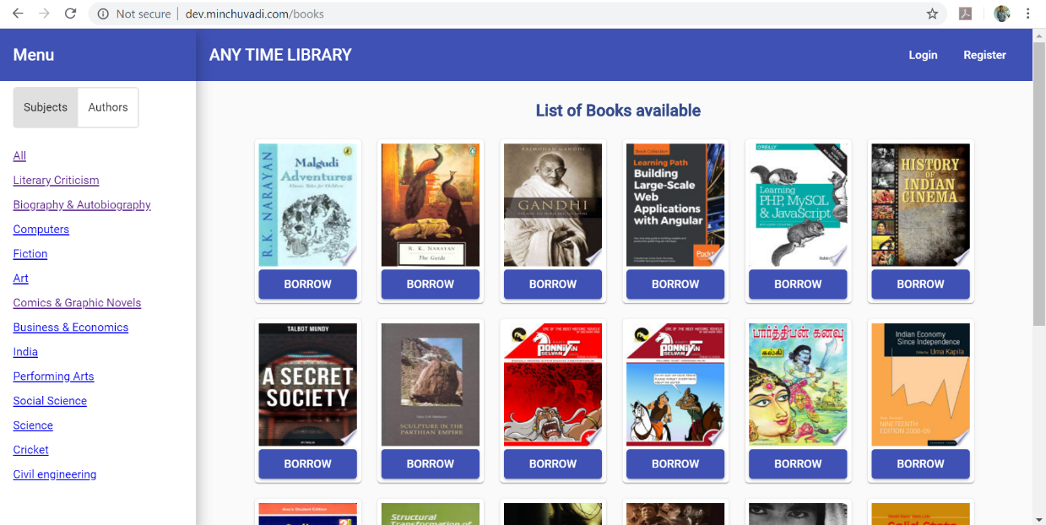

**Book Details page:**

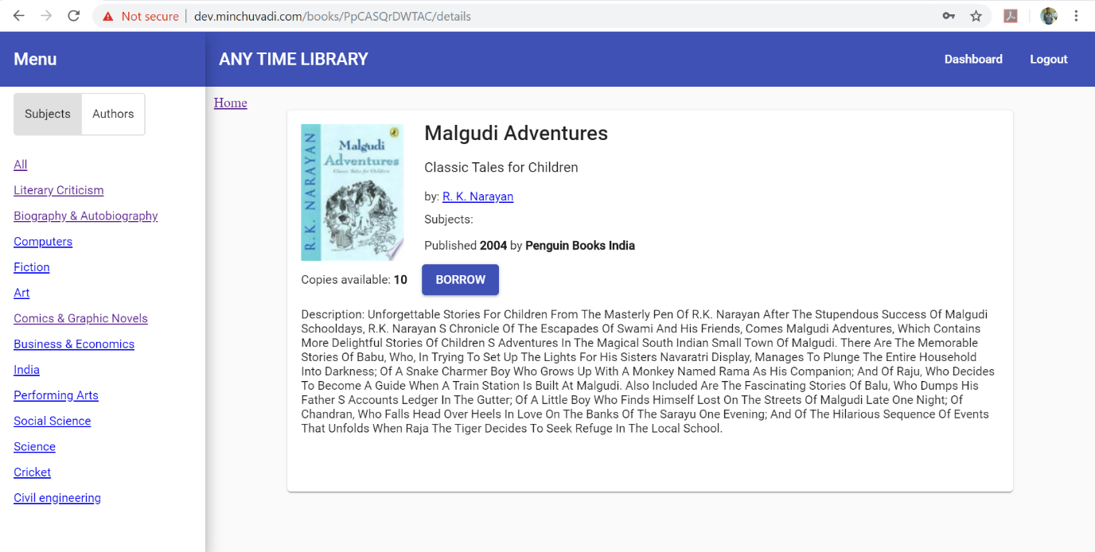

**Login form:**

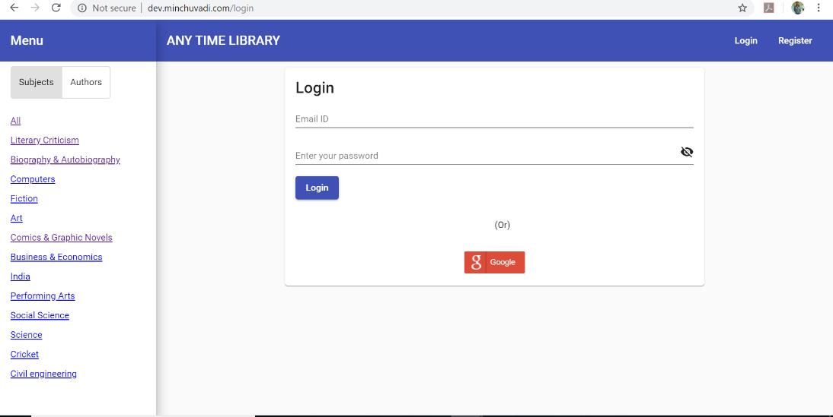

**Register form:**

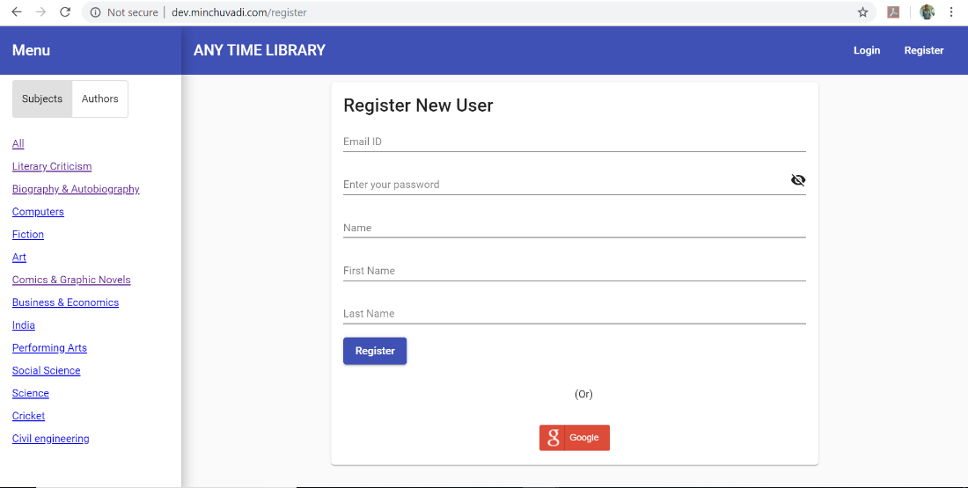

**Book Borrow form:**

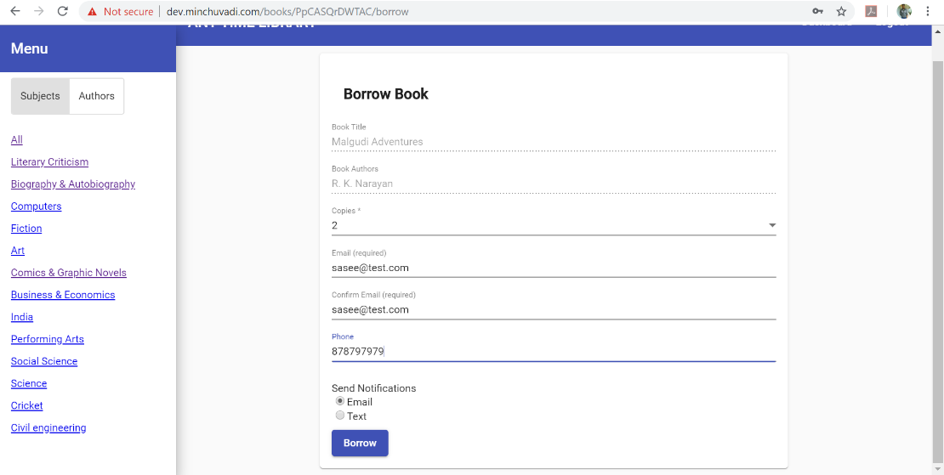

**List of books borrowed:**

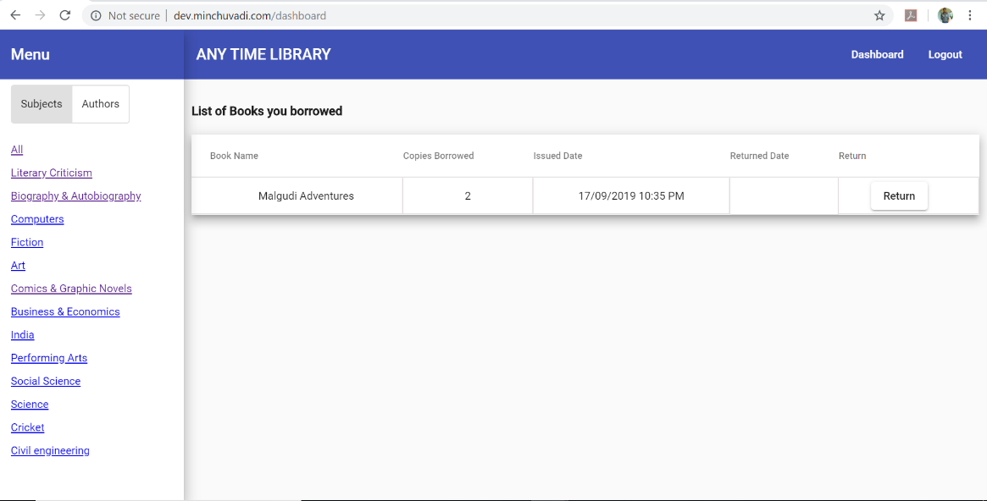

**Admin side book adding form:**

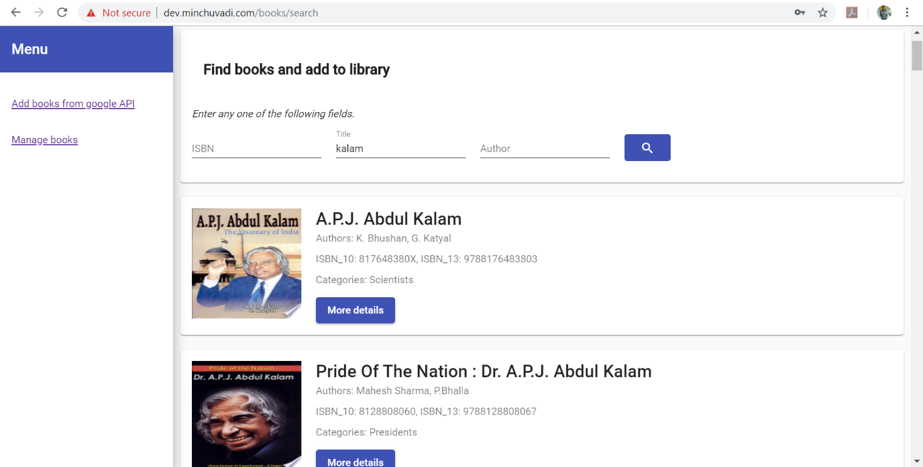

Books Inventory details:

